Run Hou 001090054

**Program Structures & Algorithms**

**Fall 2021**

**Assignment No. 2**

* **Task (List down the tasks performed in the Assignment)**
* **Relationship Conclusion: (For ex : z = a * b)**
* **Evidence to support the conclusion:**

**1. implement three methods of a class called *Timer*.**

**2. Implement InsertionSort  by simply looking up the insertion code used by Arrays.sort.**

**3.** **Implement a main program (or you could do it via your own unit tests) to actually run the following benchmarks: measur-the running times of this sort, using four different initial array ordering situations: random, ordered, partially-ordered and reverse-ordered**

**Task1&2**

**Code has been post in git hub**

**Link:**

<https://github.com/JRunust/INFO6205/tree/Fall2021/src/main/java/edu/neu/coe/info6205/util>

https://github.com/JRunust/INFO6205/tree/Fall2021/src/main/java/edu/neu/coe/info6205/sort

**Relation Conclusion**

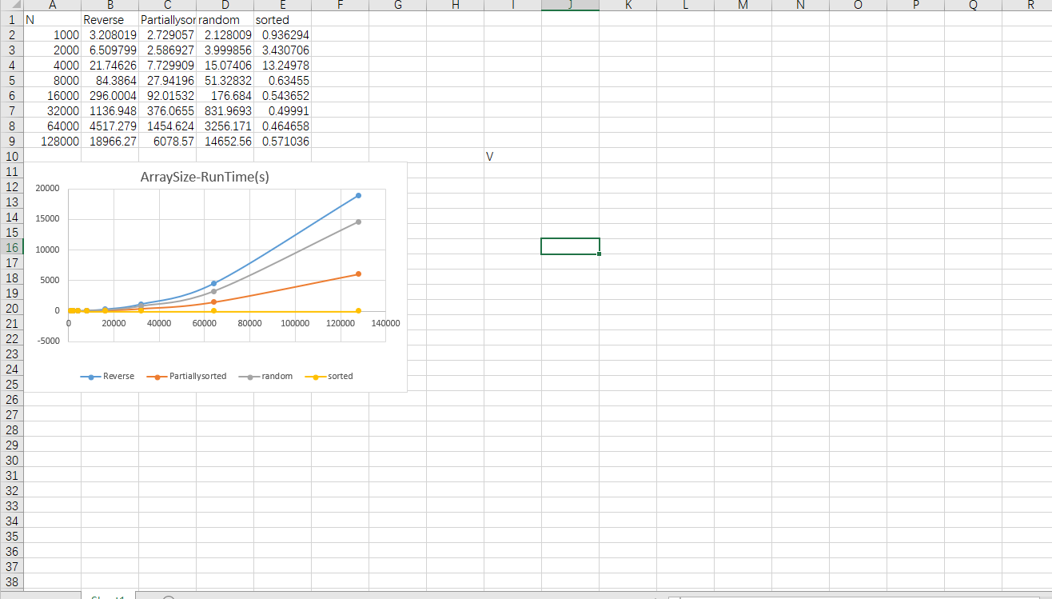

Except for the all sorted array,which running time is almost constant. All the other curve running time is square of N.

Their relation is:

T reverse > T random > T partially-sorted > T sorted.

**Unit Tests Passing**

**Benchmark Test**

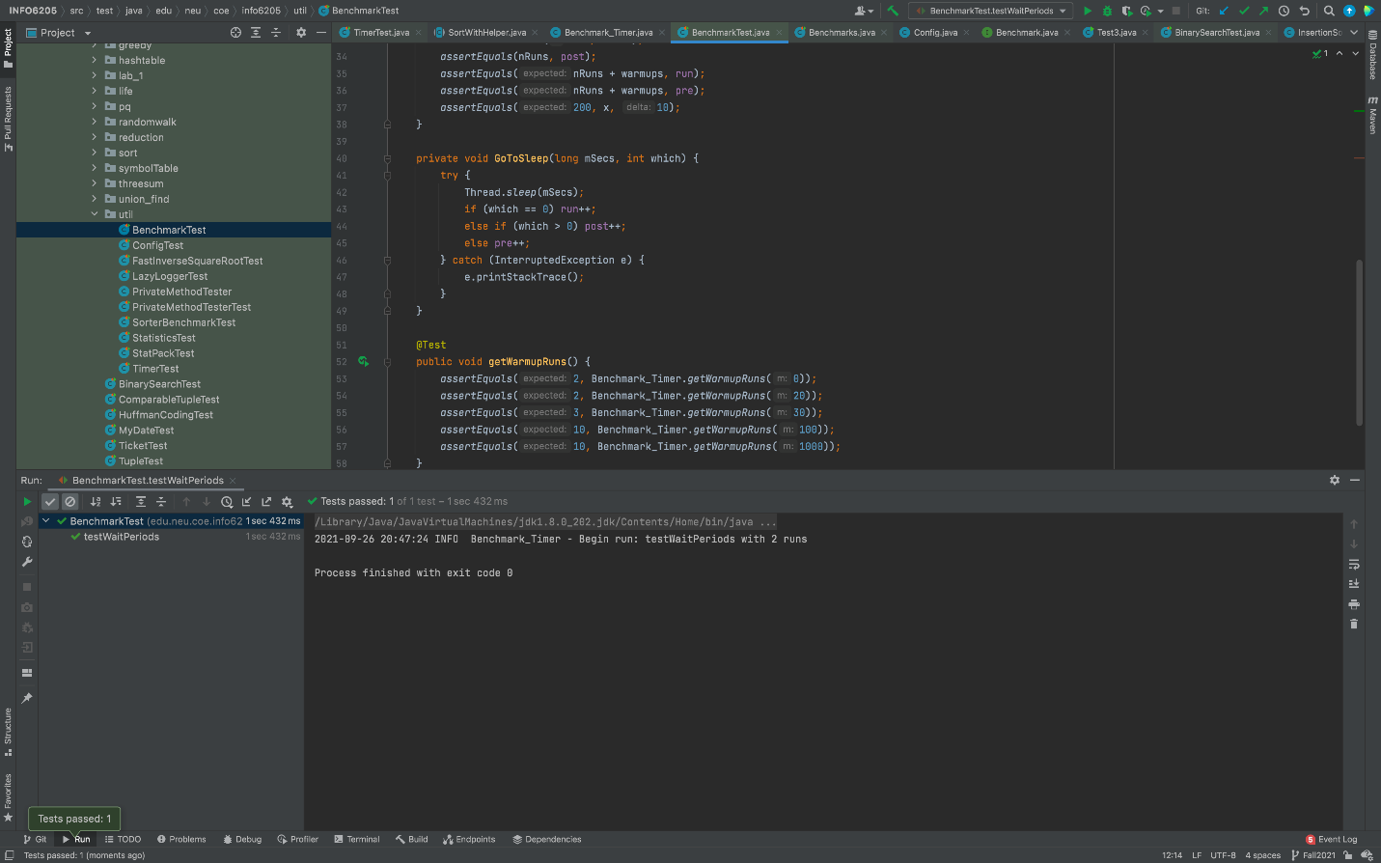

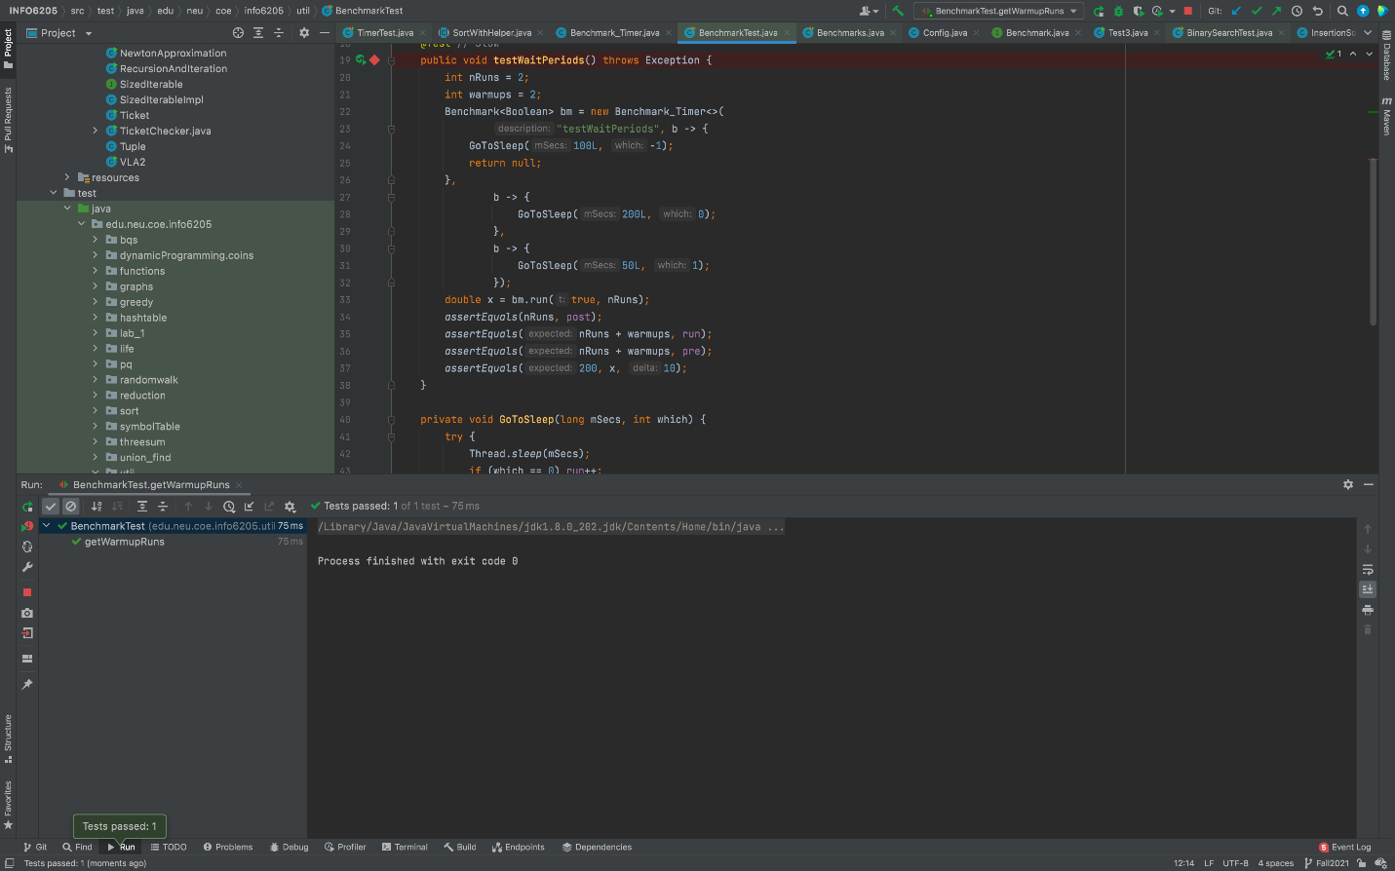

**Timer Test**

