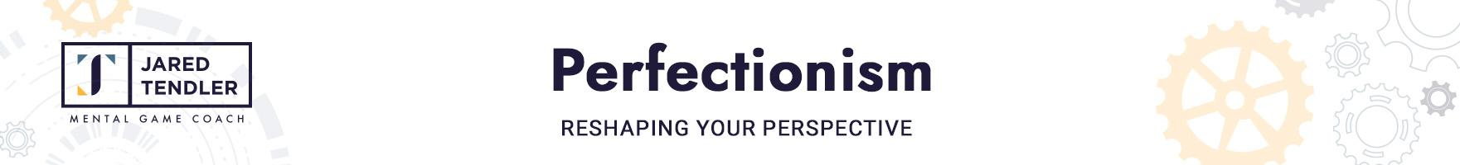

*Perfectionism drives motivation but damages confidence. To sustain high motivation while also allowing confidence to grow stronger, you must accurately assess your skills and accomplishments. The process below re-shapes your faulty perspective of your past performance and skills, and makes it more accurate going forward.**Complete this exercise for 5 to 10 minutes per day, or several times a day, as needed.*

| **For each of your professional accomplishments, both big and small, complete the following. (If you’re a perfectionist in life too, do this for your personal accomplishments as well.) Especially look for accomplishments that were underrecognized at the time. Also, beware of “yeah, but” thinking that diminishes the value of that accomplishment.** |
| --- |
| Describe the accomplishment: |
|  |
| **List and describe the key steps you took to achieve this accomplishment:** |
|  |
| **What difficulties did you encounter along the way and how did you get through them?** |
|  |
| **If you made mistakes, what lessons did you learn?** |
|  |

*Use additional space if you need it - don’t let the template limit you!*



| Describe the accomplishment: |
| --- |
|  |
| **List and describe the key steps you took to achieve this accomplishment:** |
|  |
| **What difficulties did you encounter along the way and how did you get through them?** |
|  |
| **If you made mistakes, what lessons did you learn?** |
|  |

*Use additional space if you need it - don’t let the template limit you!*



| List the skills you’ve acquired as a professional in your field. | | |
| --- | --- | --- |
| Hard/Tactical Skills | | Mental Skills |
| Skills you use to execute in your role, such as chart-reading, research abilities, etc. | | Skills that are not seen but allow you to perform well, such as patience or curiosity. |
| Transferable Skills | | Other |
| Skills learned in one role that may be useful in another, such as the ability to use Excel or communicate succinctly. | | Soft skills that are harder to measure and quantify, but matter, like interpersonal skills or creativity. |