**Module 38/1 :**

* DOM vs BOM
* Alert( )
* Confirm( )
* Prompt( )
* URL ( Uniform Resource Locate )
* Exploring URL

https://developer.mozilla.org/en-US/docs/Web/API/Location

* + href (Address)
  + Protocol
  + Hostname
    - Domain
    - Sub-domain
  + Port
  + Pathname
  + Search
  + Hash
* Location

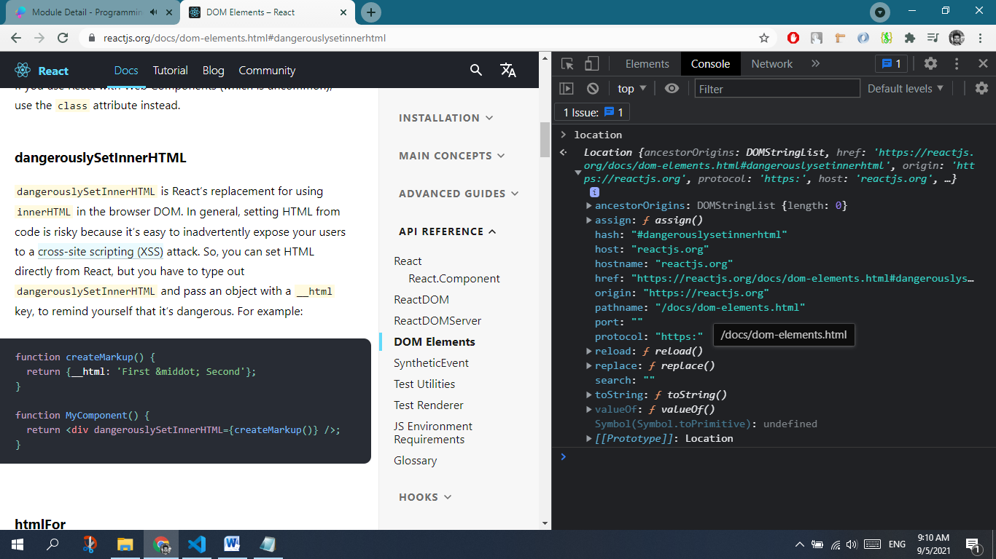

* location.reload ( Reload any page )
* location.assign ( Assign any href )
* location.href
* location.hash
* location.search ( Search query – Multiple search queries separated by & symbol, watch at **13:20** )
* Exploring History

https://developer.mozilla.org/en-US/docs/Web/API/History

* + history.length( )
  + history.back( ) - ( back < arrow )
  + history.forward( ) - (forward > arrow )
  + history.go( ( ) ,0, -1, 1, 4 ) - ( back & forth )
* Exploring Cookies
  + Session cookies
  + Permanent cookies
  + document.cookie
  + document.cookie.split(' ')
  + document.cookie.split(' ').map( c => console.log(c))
  + document.cookie.split(' ').map( c => console.log(c.split('=')))
  + document.cookie.split(' ').find(c=>c.includes('country'))
  + document.cookie.split(' ').find(c=>c.includes('country')).split('=')
  + Session Storage
  + Local Storage
    - localStorage.getItem('any-item')
    - localStorage.setItem('any-item')
    - localStorage.removeItem('any-item')
  + Major difference between these two
* Retrieve **Local Storage** value and display them
* Retrieve **Session Storage** vice versa
* Web API
* ContentEditable
  + document.body.contentEditable = true;
* Memory Sucker
  + Shif + Esc
  + Chrome://restart

**Interview Q/A**

*( interview question : compare between cookies & local & session storage )*