**Module 38.5 :**

Tasks 1,2,3 **- Resources**

* Anonymous function can have parameters too.
* setTimeout syntax is bit unique not same as expected
  + - setTimeout(function-name, time, arguments+…);
* Arrow ( ) Function without parameter

Tasks (4)

**http Cookies**

* + Pop-up notifications about cookies policies on websites
  + Website puts unique coded(id) cookies on user’s hard-drive
  + That cookie tracks the user’s overall visit session
  + Tracking users browsing activity
  + Remembering user Login details
  + Track website visitors count, how many users how many times have visited the website
  + Some special cookies are inter-connected with tech giants.

Tasks (5)

**Local Storage and Session Storage**

https://developer.mozilla.org/en-US/docs/Web/API/Window/sessionStorage

* + Both have same functionalities
  + Key-value pair syntax
  + Keys and values must be Json stingified
  + Both stores Multi- dimension object
* Local Storage
  + Local Storage never expires until you remove them.
* Session Storage
  + Session Storage will expire immediately after closing the browser tab.

Tasks (6)

**When does javascript act asynchronous ?**

Ans:

setTimeout,

setInterval ,

and fetch( )

these three are the asynchronous stuff of JS.

Tasks (7)

**How does javascript work in browsers ? and**

**Event Loop in Java Script ?**

<https://youtu.be/8aGhZQkoFbQ>

*at 12:15*

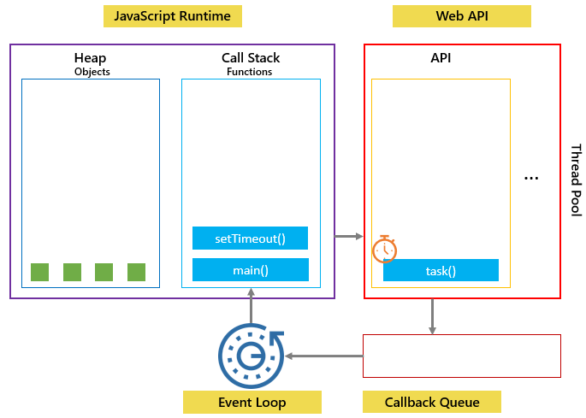

**Interview Q/A**

*( interview question : difference between grid & flexbox )*