**Original Manuscript ID:** Access-2022-06947

**Original Article Title: “** Overlapped Data Processing Scheme for Accelerating Inference Procedure in Machine Learning”

**To:** IEEE Access Editor

**Re:** Response to reviewers

Dear Editor,

Thank you for allowing a resubmission of our manuscript, with an opportunity to address the reviewers’ comments.

We are uploading (a) our point-by-point response to the comments (below) (response to reviewers), (b) an updated manuscript with yellow highlighting indicating changes (*Supplementary Material for Review*), and (c) a clean updated manuscript without highlights (*Main Manuscript).*

According to Editor's recommendation, we are also uploading the editing certificate (*Supplementary Material for Review*) that ensures language and grammar accuracy.

Best regards,

Donghyun Kang et al.

**Reviewer#1, Concern # 1: Does the paper contribute to the body of knowledge?: Yes, it does. But it is essential for the authors to showcase their novelty. As of now, the authors have implemented the ol.data and done subsequent analysis using this feature.Author response**

**Author action:** We updated the manuscript by ….



**Reviewer#1, Concern # 2:** **Is the paper technically sound?: Yes it is in terms go analysis using ol.data. I strongly suggest the authors to come up with their flowchart to showcase their methodology which particularly highlights the novelty.**

**Author response:**

**Author action:** We updated the manuscript by ….

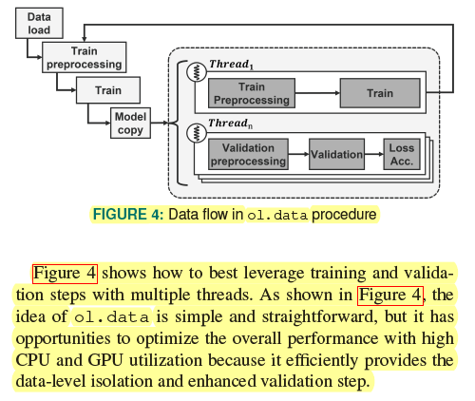



**Reviewer#1, Concern # 3:** **Is the subject matter presented in a comprehensive manner?: Can the authors summarise the findings of the literature review in tabulated form showcasing advantages and disadvantages of the existing techniques? I suggest the authors to incorporate the pseudocode for the overlapping process of training and validation.**

**Author response:**

**Author action:** We updated the manuscript by ….



**Reviewer#2, Concern # 1:** **The affiliations 1 and 2 are the same**

**Author response:**

**Author action:** We updated the manuscript by ….





**Reviewer#2, Concern # 2:** **What is “CNN” mentioned in Abstract?**

**Author response:**

**Author action:** We updated the manuscript by ….



**Reviewer#2, Concern # 3:** **The citations in “sufficiently utilize the hardware resources [1], [3], [17]–[22]” are improper; citing so many papers once is not professional.**

**Author response:**

**Author action:** We updated the manuscript by ….



**Reviewer#2, Concern # 4:** **When reviewing the related work, the sentence, “Ren et al. focused on GPU-CPU hybrid training technology that offloads data to reduce the amount of data movement to/from GPU [20]”, is improper. You can find the similar sentence in the following website that can help you how to review your work.**

**Author response:**

**Author action:** We updated the manuscript by ….



**Reviewer#2, Concern # 5:** **The “Kwon et al. introduced the prototype of the multi-FPGA acceleration for large-scale RNNs [21]” has the same problem with before;**

**Author response:**

**Author action:** We updated the manuscript by ….



**Reviewer#2, Concern # 6:** **Use “Fig. 1” or “Figure 1” instead of both.**

**Author response:**

**Author action:** We updated the manuscript by ….



**Reviewer#2, Concern # 7:** **The usage of “Fig. 2(a) and Fig. 2(b)” in “Unfortunately, as shown in Fig. 2(a) and Fig. 2(b)” is wrong**

**Author response:**

**Author action:** We updated the manuscript by ….



**Reviewer#2, Concern # 8:** **The usage of “Fig. 2(c) and Fig. 2(d)” in “Meanwhile, utilization of GPU shows better than that of CPU but reveals dramatic fluctuations (see Fig. 2(c) and Fig. 2(d))” is wrong**

**Author response:**

**Author action:** We updated the manuscript by ….



**Reviewer#2, Concern # 9:** **For “TABLE 1: Hardware and software environment”, use “TABLE I” instead of “TABLE 1” according to IEEE template**

**Author response:**

**Author action:** We updated the manuscript by ….



**Reviewer#2, Concern # 10:** **The usage of “Fig. 4 and Fig. 5” in “Fig. 4 and Fig. 5 illustrate how much ol.data and tf.data” is wrong**

**Author response:**

**Author action:** We updated the manuscript by ….

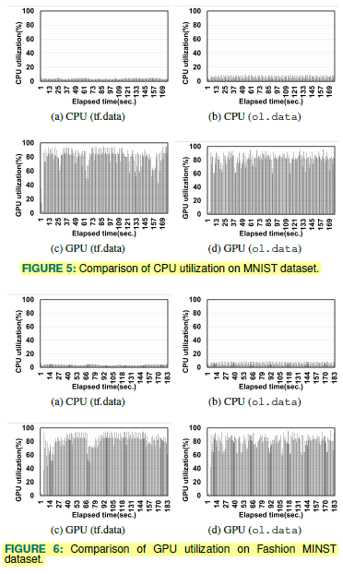





**Reviewer#2, Concern # 11:** **The “Fig. 8 and Fig. 9 show our empirical results” has the same problem with before**

**Author response:**

**Author action:** We updated the manuscript by ….

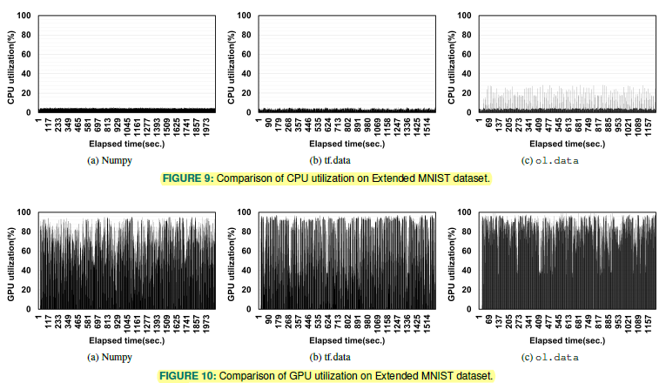





**Reviewer#2, Concern # 12:** **The “Fig. 10 and Fig. 11 present model loss and accuracy” has the same problem with before**

**Author response:**

**Author action:** We updated the manuscript by ….

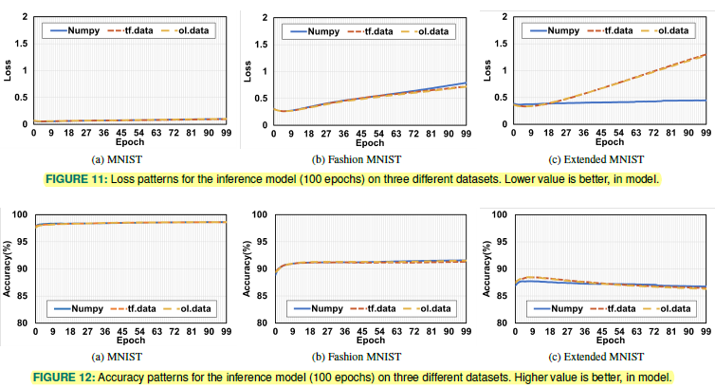



**Reviewer#2, Concern # 13:** **The sentence, “Ren et al. [21] also focus on reducing the amount of data movement between”, is wrong**

**Author response:**

**Author action:** We updated the manuscript by ….



**Reviewer#2, Concern # 14:** **“FlexLearn [17] proposes a flexible on-chip learning architecture that includes the specialized data paths and” has the same problem with before**

**Author response:**

**Author action:** We updated the manuscript by ….



**Reviewer#2, Concern # 15:** **Except the methods used in the paper, some of the most representative computational intelligence algorithms can be used to solve the problems, like monarch butterfly optimization (MBO), earthworm optimization algorithm (EWA), elephant herding optimization (EHO), moth search (MS) algorithm, Slime mould algorithm (SMA), hunger games search (HGS), Runge Kutta optimizer (RUN), colony predation algorithm (CPA), and Harris hawks optimization (HHO). These must be clearly pointed out in Section Conclusion.**

**Author response:**

**Author action:** We updated the manuscript by ….



**Reviewer#2, Concern # 16:** **The journal name in Ref. [8], “Advances in neural information processing systems”, is wrong. Remove the similar problems in the paper.**

**Author response:**

**Author action:** We updated the manuscript by ….



**Reviewer#2, Concern # 17:** **For Ref. [10], list all the authors instead of only listing the first author and using “et al.” to representing other authors.**

**Author response:**

**Author action:** We updated the manuscript by ….



**Reviewer#2, Concern # 18:** **The journal name in Ref. [24], “Proceedings of the national academy of sciences”, is wrong. Remove the similar problems in the paper.**

**Author response:**

**Author action:** We updated the manuscript by ….



***Note:*** *References suggested by reviewers should only be added if it is relevant to the article and makes it more complete. Excessive cases of recommending non-relevant articles should be reported to ieeeaccesseic@ieee.org*