MMA3001 Project - Automated Pork Packaging Quality Inspection

Introduction and Engineering Problem
Visual inspection is important in food-packaging quality control, but human inspection can be inconsistent and time-consuming. Defects such as poor seals and misplaced meat may affect product quality and require further inspection. Computer vision offers a way to identify visible defects in packaging images.
This project develops and evaluates a YOLO11 object detector for pork packaging. It predicts bounding boxes, confidence scores and four defect classes: loose-meat, packaging-error, twisted-meat and unsealed. Seven configurations were compared by varying network depth, width and learning rate. Validation results guided model selection, followed by held-out testing. The study is limited to Roboflow Dataset V1 and does not establish a production-ready Pass/Fail inspection system.

2. Dataset, Inputs and Outputs
The Roboflow Pork Rasher Error Packaging dataset (Version 1) contains annotated images of four defect classes: loose-meat, packaging-error, twisted-meat and unsealed. Dataset V1 was split into training, validation and test subsets as shown below.
Dataset subset | Number of images | Purpose
Training | 1944 | Model training
Validation | 120 | Hyperparameter comparison and model selection
Test | 80 | Final model evaluation

The validation set contained 155 annotated defects and the test set 99; some images contain multiple defects.
The input is a pork-packaging RGB image processed at an image size of 640 pixels. YOLO-format annotations supply each defect class and normalised bounding-box coordinates.
For each detection, the model outputs a predicted class, bounding-box position and confidence score, enabling defect localisation rather than whole-image classification alone.
All seven experiments used Dataset V1 for consistent comparison. Other available versions were not examined, so performance on different packaging images or production conditions remains unknown. The analysis assumes the ground-truth annotations are accurate.

3. Computational Method and Implementation
YOLO11 (You Only Look Once) was selected because it can identify both the type and location of packaging defects. Unlike whole-image classification, object detection predicts class-labelled bounding boxes that pinpoint suspected defects.
YOLO11 uses convolutional feature extraction and detection layers to predict defect classes and bounding boxes. The Ultralytics implementation provides configurable architectures, training and evaluation tools.
The solution was implemented in Python with Ultralytics and PyTorch in Visual Studio Code, using an NVIDIA GeForce RTX 3050 Laptop GPU. A YAML file defined the dataset splits and four defect classes.
An initial 10-epoch smoke test in src/train.py used pretrained YOLO11n weights to check the training workflow. The subsequent seven controlled experiments in src/run_architecture_experiments.py used random initialisation and trained from scratch, avoiding differences in pretrained-weight compatibility.
The seven experiments shared these training settings:
Training parameter | Setting
Dataset | Pork Rasher Error Packaging — Version 1
Training epochs | 30
Input image size | 640 pixels
Batch size | 2
Optimiser | AdamW
Random seed | 42
Weight initialisation | Random (training from scratch)
Hardware | NVIDIA RTX 3050 Laptop GPU

The baseline used depth 0.50, width 0.25 and learning rate 0.001. Depth scales repeated network blocks; width scales feature channels. Generated architecture YAML files varied these properties, while training arguments varied learning rate.
Each run saved its configuration, training history, validation metrics and best.pt checkpoint in a separate folder for reproducibility.

4. Verification and Validation Methodology
Verification checked that the implementation produced the intended architectures; validation measured predictions against labelled defects.

4.1 Verification of the Computational Implementation
Preview mode constructed all seven architectures and displayed their parameter counts. Changing width from 0.25 to 0.375 increased the baseline from about 2.59 million to 5.46 million parameters, while changing learning rate left model size unchanged.
Dataset class names and file paths were checked, and saved checkpoints were successfully loaded for validation. These practical checks do not replace formal automated software tests.

4.2 Validation Procedure
The training subset fitted model weights; the 120-image validation subset (155 defect instances) was used to compare configurations.
All seven runs used Dataset V1, 30 epochs, batch size 2, image size 640, AdamW and seed 42. Only specified architecture and learning-rate settings differed.
Performance was measured using:
- Precision: the proportion of predicted detections that are correct.
- Recall: the proportion of ground-truth defects successfully detected.
- mAP@50: mean Average Precision at bounding-box Intersection over Union (IoU) of 0.50.
- mAP@50–95: mean Average Precision averaged over IoU thresholds from 0.50 to 0.95.
mAP@50–95 was the primary selection metric, supported by precision, recall and model size. These measures assess object detection more directly than image-classification accuracy or RMSE.

4.3 Final Evaluation and Validation Limitations
After selecting the baseline using validation results, its saved best.pt checkpoint was evaluated once on the held-out test subset (80 images; 99 annotated defects).
Each configuration used one random seed; repeatability was therefore not measured. Rare defect classes and evaluation limited to Dataset V1 also restrict generalisation.

5. Hyperparameter Optimisation and Model Comparison

5.1 Experimental Design
Seven scratch-trained configurations tested network depth, width and initial learning rate against a common baseline. Table 3 reports the highest validation mAP@50–95 observed during each 30-epoch run.

5.2 Comparison of Experimental Results
Table 3. Architecture and hyperparameter comparison using peak validation mAP@50–95
Experiment | Depth | Width | Learning rate | Peak mAP@50–95
Baseline | 0.50 | 0.25 | 0.001 | 18.08%
Narrower | 0.50 | 0.1875 | 0.001 | 15.04%
Wider | 0.50 | 0.375 | 0.001 | 16.75%
Deeper | 1.00 | 0.25 | 0.001 | 16.03%
Lower learning rate | 0.50 | 0.25 | 0.0003 | 13.94%
Higher learning rate | 0.50 | 0.25 | 0.003 | 13.87%
Combined | 1.00 | 0.375 | 0.0003 | 16.00%

The baseline achieved the highest peak validation mAP@50–95 (18.08%). Increasing width or depth reduced peak performance to 16.75% and 16.03%, respectively; narrowing the network reduced it to 15.04% (Figure 1).
Learning rate 0.001 outperformed 0.0003 (13.94%) and 0.003 (13.87%) within the same 30-epoch budget. The combined depth, width and learning-rate change also failed to improve on the baseline (16.00%).
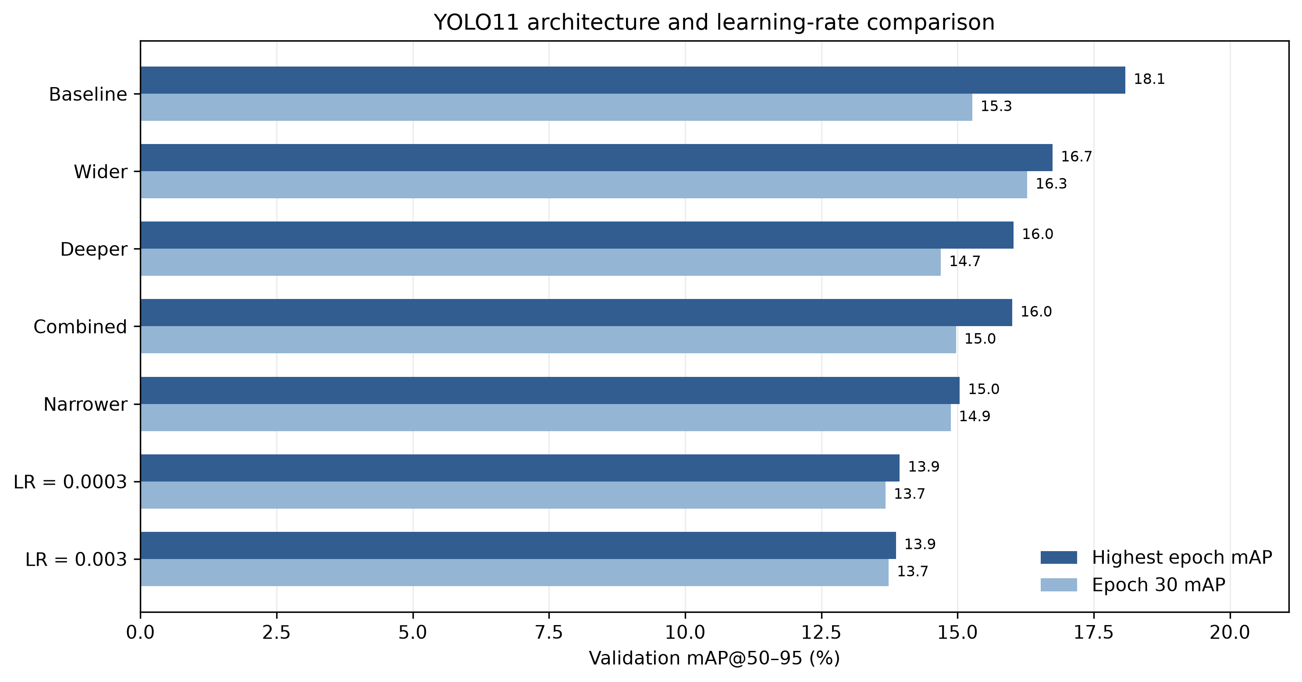
Figure 1: Comparison of peak and final-epoch validation mAP@50–95 across the seven YOLO11 experiments

5.3 Model Complexity and Computational Performance
Widening the baseline more than doubled its trainable parameters, from approximately 2.59 to 5.46 million; the deeper model contained about 3.31 million. Neither achieved higher peak validation mAP (Figure 2).
Training took about 38.1 minutes for the baseline, 36.7 minutes for the wider model, 47.1 minutes for the deeper model and 49.8 minutes for the combined configuration. Model size was not directly proportional to measured runtime.
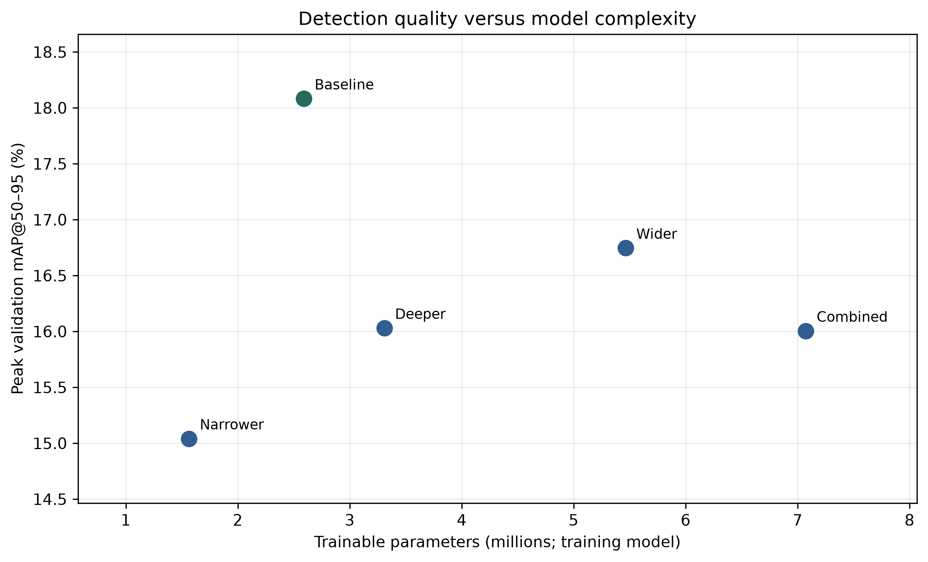
Figure 2: Model parameter count versus peak validation mAP@50–95

5.4 Learning Curves and Final Model Selection
The baseline peaked at epoch 28 (18.08% mAP@50–95), while the wider model peaked at epoch 29 (16.75%). At epoch 30, the wider model scored 16.28% versus 15.27% for the baseline (Figure 3).
Figure 3: Validation mAP@50–95 learning curves for the baseline and wider configurations
Re-evaluating the best.pt checkpoints gave 18.1% validation mAP@50–95 for the baseline and 16.8% for wider; wider precision was higher (65.9% versus 54.7%).
The baseline was selected for higher mAP, similar recall (33.6% versus 33.3%) and fewer parameters. Single-seed differences remain uncertain.

6. Final Model Evaluation and Results

6.1 Final Model Performance
The scratch-trained baseline (depth 0.50; width 0.25; learning rate 0.001) was evaluated on 80 held-out test images containing 99 defects, after model selection.
Table 4. Validation and final test performance of the selected baseline model
Performance metric | Validation | Final test
Precision | 54.7% | 71.8%
Recall | 33.6% | 33.1%
mAP@50 | 36.4% | 38.6%

Test mAP@50–95 was 15.9%, 2.2 percentage points below validation (18.1%). Test precision rose to 71.8%, while recall was similar at 33.1% (Table 4).

6.2 Performance Across Defect Categories
Table 5. Per-class detection performance on the final test dataset
Defect category | Test instances | Recall
Loose meat | 3 | 66.7%
Packaging error | 37 | 10.8%
Twisted meat | 7 | 0.0%
Unsealed | 52 | 54.9%

Performance varied substantially by defect class (Table 5). Unsealed packaging had the highest test mAP@50–95 at 37.2%.
Packaging-error recall was only 10.8% and twisted-meat recall 0.0%; these missed defects are particularly concerning for quality control. Loose-meat recall was 66.7% but was based on just three test instances (Figure 4).
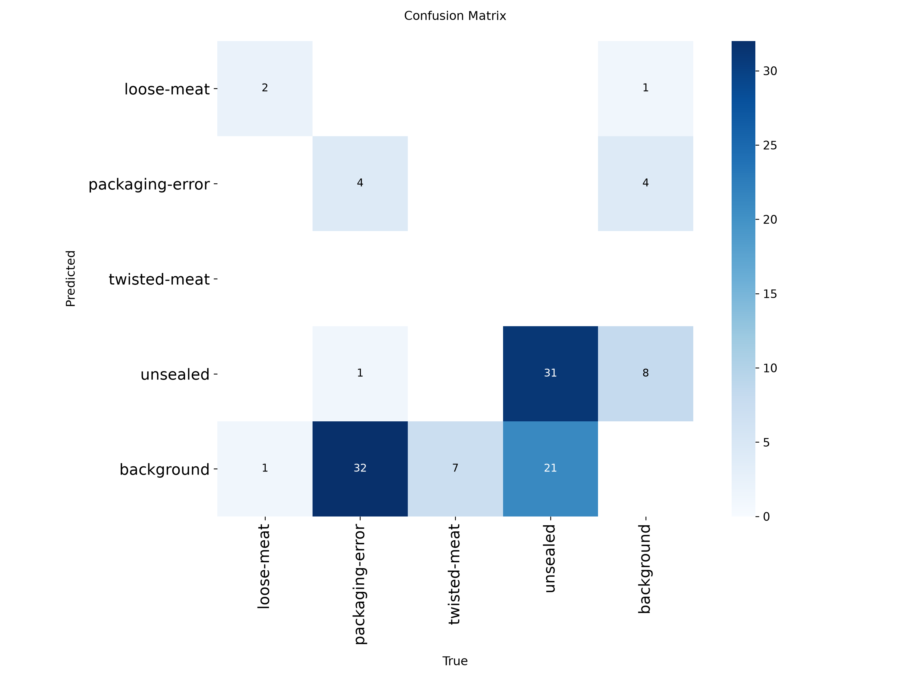
Figure 4: Confusion matrix of the selected YOLO11 baseline model on the held-out test dataset
The confusion matrix further illustrates missed defects, which aggregate precision and mAP can obscure.

6.3 Computational Performance
The fused baseline contained about 2.58 million parameters and required 6.4 GFLOPs. On the RTX 3050 Laptop GPU, inference averaged 7.4 ms per image, excluding preprocessing and postprocessing.
Although computationally compact, the model would require substantially better defect recall and realistic production testing before autonomous deployment.

7. Engineering Discussion, Limitations and Future Improvements

7.1 Engineering Interpretation
Increasing model width and depth did not improve peak validation mAP under the tested settings, despite adding parameters. The smaller baseline therefore offered the better observed performance–complexity trade-off.
Test recall of 33.1% shows that many defects were missed, especially packaging errors and twisted meat. This prevents reliable autonomous quality inspection.

7.2 Limitations of the Investigation
Only Roboflow Dataset V1 was evaluated; performance on other dataset versions or independent production images remains unknown.
Class-specific estimates are uncertain because the test set included only three loose-meat and seven twisted-meat instances.
All configurations were trained once with seed 42 for 30 epochs, so seed sensitivity and longer-training effects remain untested.
Metrics describe detected defect boxes, not complete Pass/Fail decisions. With only one background test image, the ability to accept defect-free packages is largely unverified.

7.3 Future Improvements
Further work should collect more representative and balanced annotations, particularly for packaging errors and twisted meat, and test robustness under real lighting and camera conditions.
Pretrained initialisation, longer training, additional random seeds and confidence-threshold calibration are promising experiments, but their benefits have not been established here.
A future Pass/Fail system would also require an explicit decision rule and separate image-level evaluation on both defective and defect-free packages.

8. AI Use and Critical Reflection
OpenAI ChatGPT substantially assisted with designing the YOLO11 architecture study, drafting experimental and plotting scripts, troubleshooting, interpreting metrics and drafting report text.
AI-generated code and advice were checked by previewing parameter counts, running all seven experiments, inspecting saved metrics, validating best.pt checkpoints and evaluating the selected model on held-out test images. Responsibility for checking results and choosing the final model remained with the student.
Early generic neural-network suggestions were not suitable for YOLO11 and needed adaptation. The difference between COCO-pretrained yolo11n.pt and the project-trained best.pt also required verification. These examples reinforced the need to check AI advice rather than accept it uncritically.

9. Conclusion
This project investigated the application of YOLO11 for detecting visible defects in pork packaging. Seven model configurations were evaluated by varying network depth, width and learning rate. The baseline model achieved the highest peak validation mAP@50–95 of 18.08% while requiring fewer parameters than the larger alternatives, demonstrating that increasing network complexity does not necessarily improve detection performance.
Final testing of the selected baseline model achieved an mAP@50–95 of 15.9% and recall of 33.1%. Although the model demonstrated the potential of automated defect detection, its limited recall across certain defect categories highlights the need for additional training data, further optimisation and more extensive validation before industrial deployment.

10. References
[1] G. Jocher and J. Qiu, Ultralytics YOLO11. Ultralytics, 2024. [Online]. Available: https://github.com/ultralytics/ultralytics
[2] Hello, "Pork Rasher Error (Packaging), Version 1," Roboflow Universe, n.d. [Online]. Available: https://universe.roboflow.com/hello-2aqe0/pork-rasher-error-packaging/dataset/1. [Accessed: Oct. 25, 2026].
[3] A. Paszke et al., "PyTorch: An Imperative Style, High-Performance Deep Learning Library," in Advances in Neural Information Processing Systems, vol. 32, 2019. [Online]. Available: https://arxiv.org/abs/1912.01703
[4] I. Loshchilov and F. Hutter, "Decoupled Weight Decay Regularization," in International Conference on Learning Representations (ICLR), 2019. [Online]. Available: https://openreview.net/forum?id=Bkg6RiCqY7
[5] Ultralytics, "YOLO Performance Metrics," Ultralytics Documentation, n.d. [Online]. Available: https://docs.ultralytics.com/guides/yolo-performance-metrics. [Accessed: Oct. 25, 2026].
[6] OpenAI, ChatGPT, AI language model, 2026. [Online]. Available: https://chatgpt.com/

