Referring {

<https://www.youtube.com/watch?v=8mAITcNt710>

}

For more {

<https://cs50.harvard.edu/x/2023/>

}

Computer science :

* computer science is problem solving by taking input and giving required output.
* To make things work with computer, certain methodical way and rules to follow ( programming lang and things )
* Computer speaking language – binary ( 1 & 0 )

Binary number system:

* Transistors turning on and off which manages the binary things
* In decimal system, each digit is power of 10 , likewise binary digits each is power of 2.
* At early stages, its common to have 8 bits to store numbers.
* At early stages, numbers were mapped to characters in order to make computer understand the alphabetical characters too.. so capital A is 65 and small a is 97 etc.. which is standardized and called as ASCII ( American Standard Code for Information Interchange) which also includes punctuations

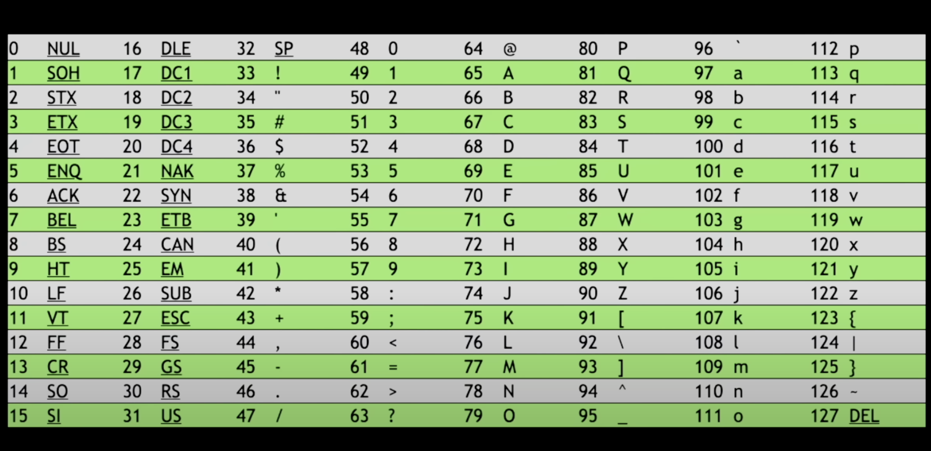

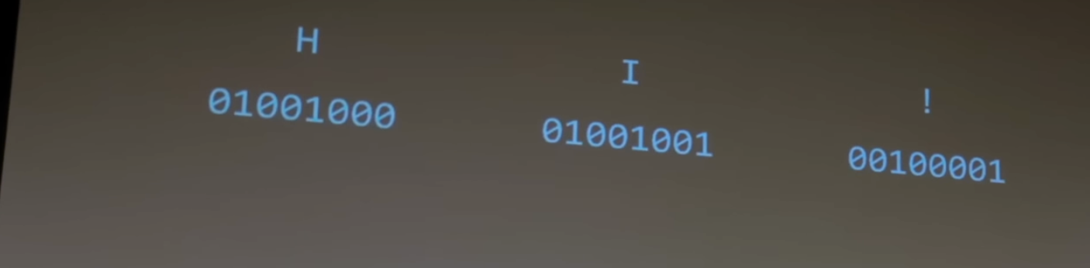

* So when you receive the pattern of 0’s and 1’s , ASCII characters got replaced..

* Now we will represent A as 65 , but how now we put 65 ? so how do I do math without numbers since we replaced numbers with characters. So by file extensions like indicators, they distinguish between things.. the context of this type of file will have only this type of contents.. so as programmer we have to give hint to the computer to interpreter this content as follows.. whether its number or character ..
* If you find these patterns of 0 and 1s in any format files ( email, text or file etc.. ) with standard length
* In our example, just to get HI! , 8+8+8 =24 bits used so 3 bytes.
* 256 possibilities for 8 bits , i.e 1 bytes, when files are bigger, bytes increases..  
  kilo bytes for thousand bytes, mega – millions , giga – billions, tera – trillions of bytes..
* ASCII only represents punctuations and English letters, but people want different languages and even reactions like emojis.. this new things were added with ASCII and made as Unicode ( super set ) which supports 8 bits for backward compact ability and will also use 16 bits ( 65k possibilities) and also even goes upto 32 bits ( 4billion possibilities )
* Unicode is standardized description of things used.. companies or people using them can interpreter in different manner, i.e same emoji representation will be slightly different interpretation in android vs ios.. sometimes it will be misconception by people, in some emojis gun looks like water gun..
* Basically people used only 7 bits first to map chars with numbers, then increased to 8 bits, then increased to 16 and now 24 bits..
* Color representation became quite different way, since in early days it was black and white, color was not a big thing.. but when colored display comes on, people started using color index to represent different colors and 16colors were total at that time, then things evolved and new RGB patter comes in which became the right choice to represent various colors on one go.

[…. Continue after 27mins ]