**Telerik Academy 2015 – 2016**

**JavaScript UI & DOM**

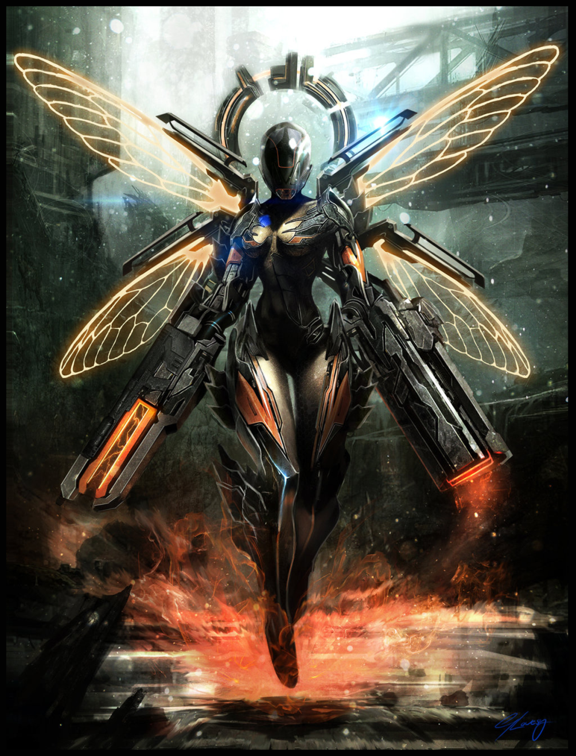

**Team – “Pisco Sour”**

**Project Members:**

1. Васил Динев (vassildinev)

2. Иван Колев (INKolev)

3. Петър Петров (eudaimonia)

4. Иван Иванов (zdzdz)

5. Константин Кондов (kskondov)

6.Марина Георгиева (marinag)

7. Димитър Янис (D.Yanis)

**Project Description:**

Dynamic and challenging classic shooter game with fun user experience.

Our hero – **“Lady Sour”**, is left on a deserted island where she finds herself surrounded with hostile alien snails **(Snailiens)**. Her main objective is – to survive. And while she’s trying, why not have some fun exterminating extraterrestrial life forms!?

**Controls (keyboard and mouse):**

**Key** – **“Q”** – Blink forward with **150** units of range in the current facing direction.

**Key** – **“W”** – Blink forward with **300** units of range in the current facing direction.

**Key** – **“E”** – Blink forward with **450** units of range in the current facing direction.

**Key** – **“A”** – Release a spray of **8 bullets** in all directions outwards the Hero.

**“On – Left – Mouse – Click”** – Shoot a **lightning** **ball** of condensed energy.

**“On – Mouse** – **Move“** – Change the **facing direction** according to cursor position.

**Used technologies:**

“JQuery”

“Require.JS”

“Create.JS”

“Kinetic.JS”

“Snap.SVG”

“HTML5 Canvas”

**GitHub Repository:**

[*https://github.com/JS-UI-And-DOM-Team-Pisco-Sour*](https://github.com/JS-UI-And-DOM-Team-Pisco-Sour)