  - LAB REPORT

Lab 7 - Python Testing
Student: Joey Sade | ID: 202305993 | Date: 8 November 2026

Objective
Test the Lab 5 Flask and SQLite user-management application with pytest. The graded requirements cover database creation, five database operations, and four individual-user API operations. HTTP tests verify both status codes and JSON data.

Implementation
The Lab 5 application was copied into the Lab 7 repository. The database is created when the application starts. A pytest fixture assigns a temporary SQLite database to each test so tests are repeatable and do not change the development database. A separate Python process verifies creation on the first import of the application.

Test coverage
Database: startup creation and schema; insert_user; get_users; get_user_by_id; update_user; delete_user.
API: GET /api/users; GET /api/users/<id>; POST /api/users/add; PUT /api/users/update; DELETE /api/users/delete/<id>.
Error behavior: missing users return 404; invalid creation or update data returns 400; repeat deletion returns 404.

Verification
Command: py -m pytest -v test_user_Joey_Sade.py
Result: 11 passed in 0.93 seconds on Python 3.12.6 (Windows). All required graded functions are represented, and API responses were checked against the expected JSON payloads.
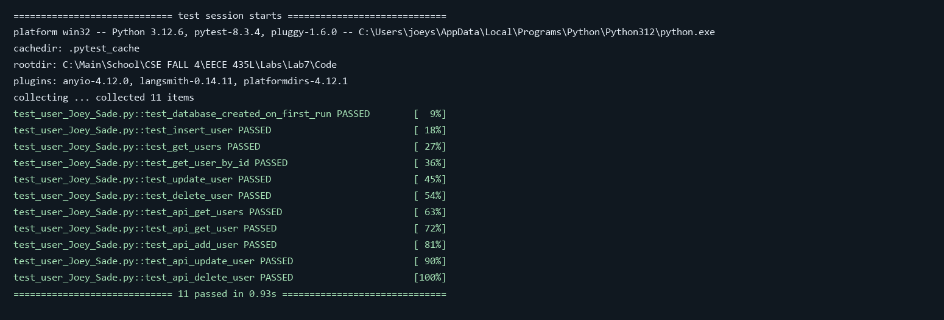
Figure 1. Successful pytest run for the Lab 7 test suite.

Conclusion
The Flask application and automated test suite meet the Lab 7 requirements. Tests pass with isolated databases, including the first-run database check and HTTP response checks.

