EECE 435L ? Lab 8 evidence
Joey Sade ? 202305993
Two Docker images were built and run locally. Version 1 serves the Lab 5 API on port 5000. Version 2 serves it on port 3000 and GET /api/get_users returned ["Joey Sade"] after inserting a sample user.

docker ps -a --filter name=lab8
Lists all containers, including stopped containers.

docker stop lab8-v2
Stops the named container. The returned name confirms the target.
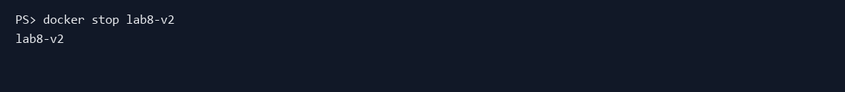

docker logs lab8-v2
Shows the container standard output and error, including server startup and API requests.
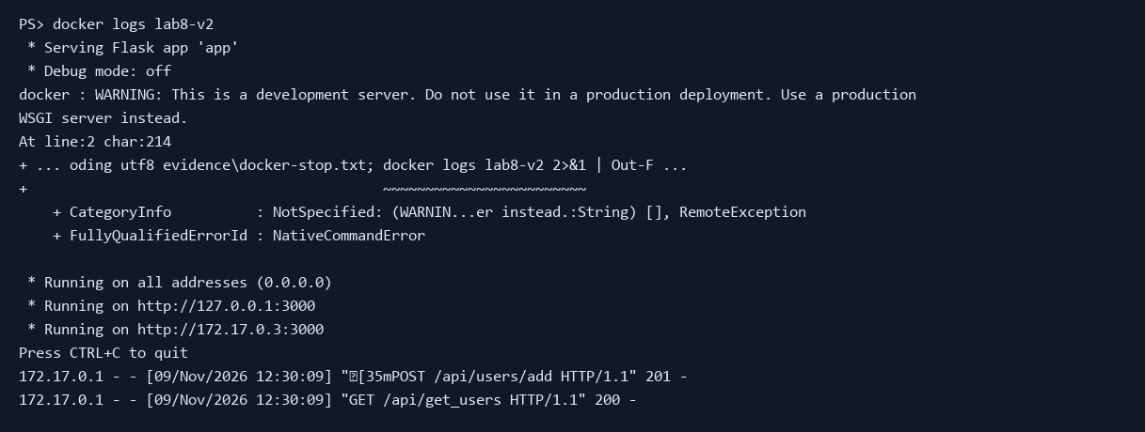

docker images js9872/lab8-joey_sade
Shows both image tags in the local Docker image list.


