Lab 8: Docker, containers, and images
EECE 435L Software Tools Lab | Joey Sade | ID 202305993
9 November 2026

Objective
Containerize the Lab 5 Flask user API, build two distinct images, run them on ports 5000 and 3000, add a GET endpoint that returns all user names, and document Docker commands and results.

Background
A Dockerfile specifies how an image is built. An image is the packaged application and runtime; a container is a running or stopped instance of that image. Port publishing maps a host port to the port on which the application listens inside the container. Each container in this lab uses its own SQLite database.

Implementation
Version | Image tag | Behavior
1 | js9872/lab8-joey_sade:0.0.1-RELEASE | Lab 5 user API; port 5000
2 | js9872/lab8-joey_sade:0.0.2-RELEASE | Lab 5 API plus GET /api/get_users; port 3000
Docker permits only one colon in an image reference. The handout?s ?0.0.1:RELEASE? notation was therefore encoded as the valid tag 0.0.1-RELEASE, and likewise for version 2. The namespace js9872 follows the repository owner.

Build and run procedure
docker build -f Dockerfile.v1 -t js9872/lab8-joey_sade:0.0.1-RELEASE .
docker build -f Dockerfile.v2 -t js9872/lab8-joey_sade:0.0.2-RELEASE .
docker run --name lab8-v1 -p 5000:5000 -d js9872/lab8-joey_sade:0.0.1-RELEASE
docker run --name lab8-v2 -p 3000:3000 -d js9872/lab8-joey_sade:0.0.2-RELEASE
Both builds completed successfully. Both containers ran on the specified ports. Version 1 returned HTTP 200 from GET /api/users. For version 2, POST /api/users/add created a sample user, and GET /api/get_users returned ["Joey Sade"]. The API selects the name column from SQLite in user ID order.

Activity 1: Docker commands

docker ps -a --filter name=lab8
The -a flag includes running and stopped containers. The filter limits this snapshot to the two lab containers. The output shows both lab8-v1 and lab8-v2.
Captured command output: docker ps -a --filter name=lab8

docker stop lab8-v2
Stops the named container and prints its name. Docker stop takes a container name or ID, not an image name.
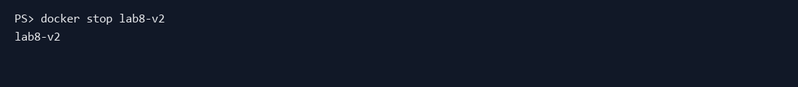
Captured command output: docker stop lab8-v2

docker logs lab8-v2
Prints standard output and error from the container. The captured Flask startup and HTTP request entries confirm the server ran and received requests.
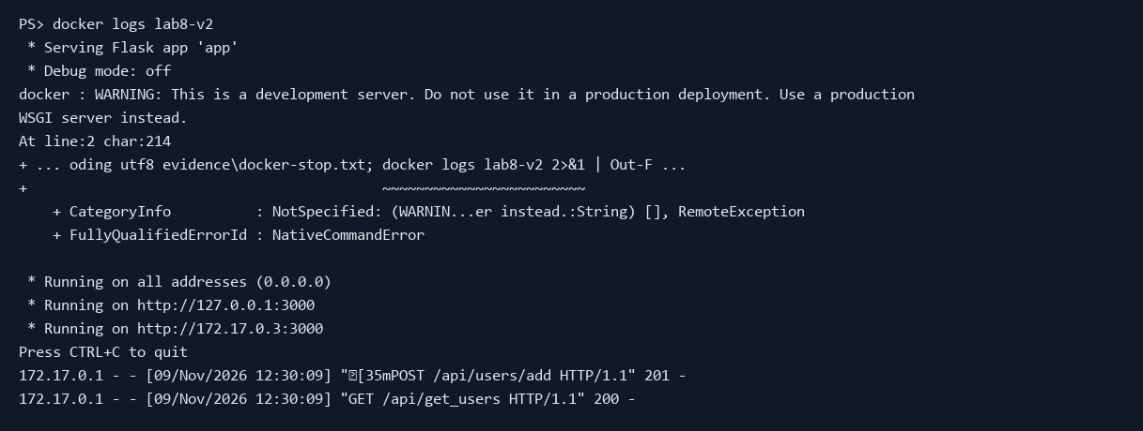
Captured command output: docker logs lab8-v2

Activity 2: two Docker images
Docker Desktop?s Images view shows both locally built image tags. Its Containers view shows the two named containers and their host-to-container port mappings after the stop commands. The stopped state is expected for the Activity 1 evidence.
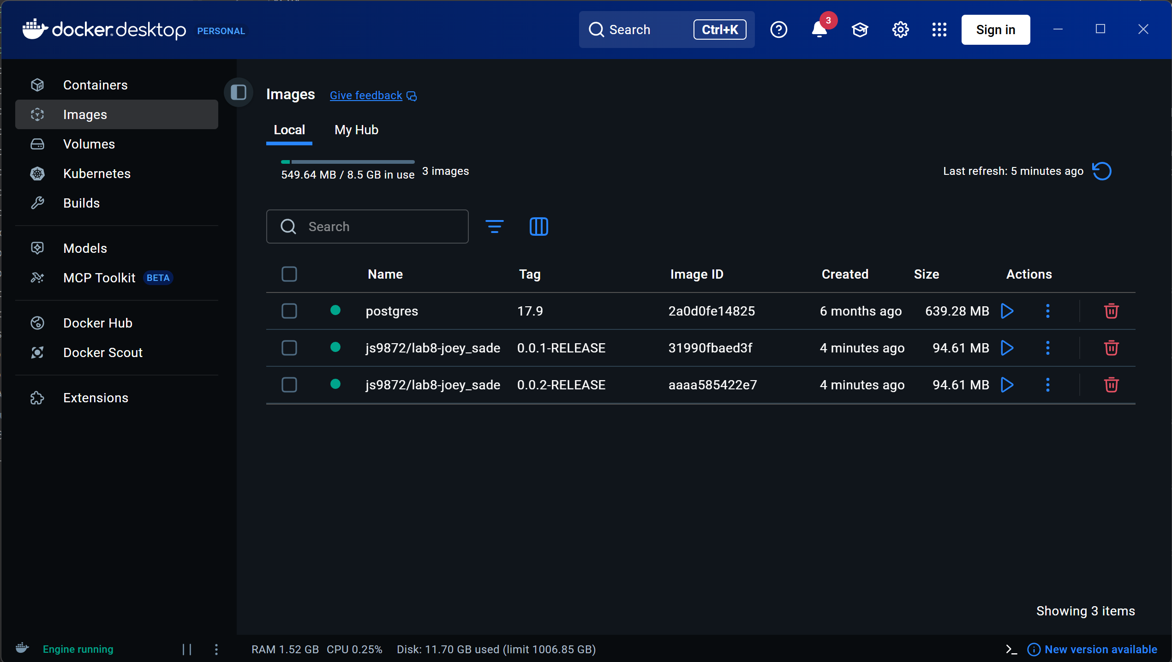
Docker Desktop Images view: version 1 and version 2 tags.
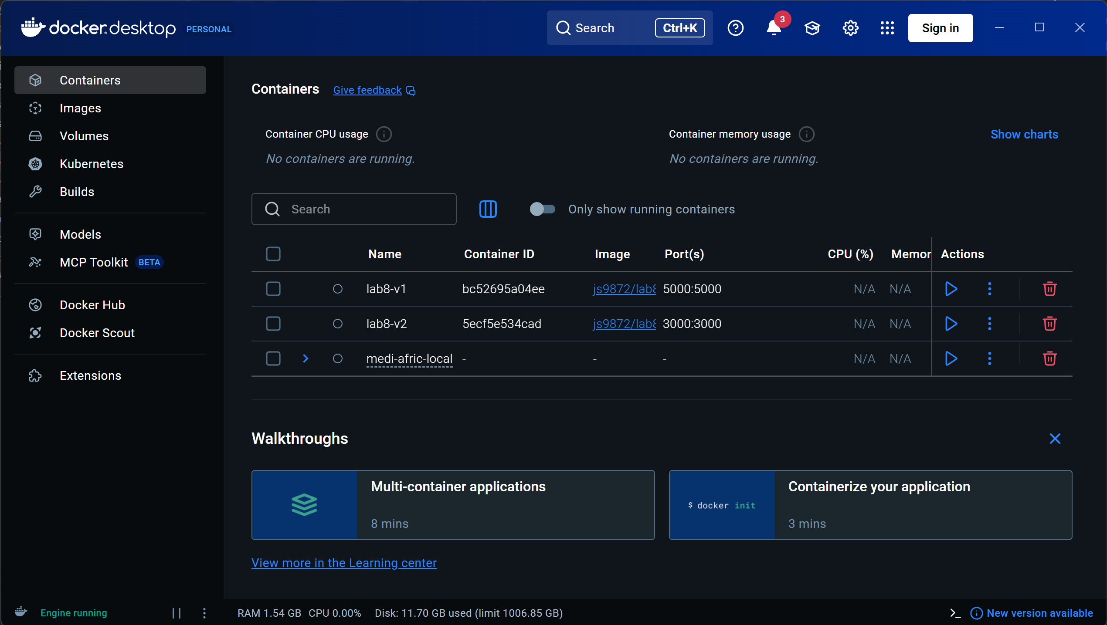
Docker Desktop Containers view: lab8-v1 on 5000:5000 and lab8-v2 on 3000:3000.
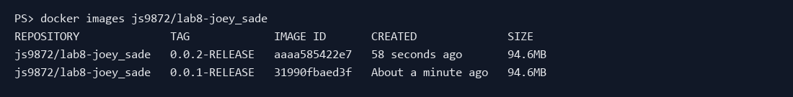
CLI image listing confirms both tags.

Verification and conclusion
The two image versions build and run locally. The first preserves the Lab 5 REST API on port 5000. The second adds the required name-list GET endpoint on port 3000; a sample insertion and retrieval confirmed the SQLite query. The command outputs and Docker Desktop captures document both graded activities. Source code, Dockerfiles, this report, and the evidence images are included in the submission ZIP.
Note: The AUB username was not present in the available project files, so the GitHub repository owner, js9872, was used as the image namespace.

