CHAPTER 1: Introduction

1.1 Project Summary

“HELLO PROVIDER” is the software that can be use by the customer for solve their daily accessed accessories, which caters large number of people. This software basically known as service provider. a managed service provider is third party software that provides the basic services to the customer.

1.2 Aim and Objectives of the project

The objective of the project is to achieve the goals listed below which will help user interact with the system and make maximum benefit out of it.

• Automatic theme changing

• Easy Management of client profile.

• Client can create wish list.

• Easy sorting of items as per user’s requirement

• Easy payment option

• Easy and accurate tracking of to-be-delivered product.

• Reduce Complexity

• Better options that markets

• Easily understandable website for end user

• Customer Satisfaction

• Easy registration and login

- Integration of PayPal.

1.3 Problem Specification and Scope

In the age of e commerce shopping, with the ever growing market of e -commerce site, our project strives to be different in terms the look and feel of the website.

In the beginning, we aim to connect the local business. i.e. we aim to provide services within a certain city.

1

The future scope implies expanding this site to other cities and states, include their regional festivals and provide their products to any part of the country.

The initial payment will be the “cash on delivery”, but in the future we will try to include other payment modes too.

Administrator:

• Can login as Administrator.

• Can enable notifications for user as per request.

• Can manage complain and feedback.

• Can manage products availability.

• Can generate reports.

- Can maintain the system and update the dates of festivals every year.

Customer:
• Can create codes.
• Can post comment and feedback.

1.4 TECHNOLOGY AND LITERATURERE VIEW

The technologies use to develop “HEY Provider!!!” are as follow:

- HTML

- CSS

- BOOTSTRAP

- ANGULAR

- JAVA

- SPRING BOOT

- MYSQL

2

- HTML:

Hyper Text Markup Language (HTML) is the main markup language for displaying web pages and other information that can be displayed in a web browser.HTML is written in the form of HTML enclosed elements consisting of tags in angle brackets(like <html>) within the webpage content.HTML tags mostly come in pairs like <h1> and </h1>. The first tag in the pair is called start tag and the second tag is called end tag.

Filename extension | .html, .htm
Internet media type | text/html
Type code | TEXT
Developed by | World Wide Web Consortium & WHATWG
Type of format | Markup language
Extended to | XHTML

Table 1.1: HTML table

The purpose of a web browser is to read HTML documents and compose them into visible or audible web pages. The browser does not display the HTML tags, but uses the tags to interpret the content of the page.

HTML elements form the building blocks of all websites. HTML allows images and objects to be embedded and can be used to create interactive forms. It provides a means to create structured documents by denoting structural semantics for text such as headings, paragraphs, lists, links, quotes and other items. It can embed scripts in languages such as JavaScript which affect the behaviour of HTML WebPages

- CSS

Cascading Style Sheets (CSS) is a style sheet language used for describing the presentation semantics (the look and formatting) of a document written in a markup language.

4

 |  | Filename extension | .css
 |  | Internet media type | text/css
 |  | Developed by | World Wide Web Consortium
 |  | Type of format | Style sheet language

Table 1.2: CSS table

CSS is designed primarily to enable the separation of document content (written in HTML or a similar markup language) from document presentation, including elements such as the layout, colors, and fonts. This separation can improve content accessibility, provide more flexibility and control in the specification of presentation characteristics, enable multiple pages to share formatting, and reduce complexity and repetition in the structural content (such as by allowing for table less web design). CSS can also allow the same markup page to be presented in different styles for different rendering methods, such as on-screen, in print, by voice (when read out by a speech-based browser or screen reader) and on Braille-based, tactile devices. It can also be used to allow the web page to display differently depending on the screen size or device on which it is being viewed.

While the author of a document typically links that document to a CSS style sheet, readers can use a different style sheet, perhaps one on their own computer, to override the one the author has specified.

CSS specifies a priority scheme to determine which style rules apply if more than one rule matches against a particular element. In this so-called cascade, priorities or weights are calculated and assigned to rules, so that the results are predictable.

Prior to CSS, nearly all of the presentational attributes of HTML documents were contained within the HTML markup; all font colors, background styles, element alignments, borders and sizes had to be explicitly described, often repeatedly, within the HTML. CSS allows authors to move much of that information to another file, the style sheet, resulting in considerably simpler HTML.

5

Headings (h1 elements), sub-headings (h2), sub-sub-headings (h3), etc., are defined structurally using HTML. In print and on the screen, choice of font, size, color and emphasis for these elements is presentational.

- BOOTSTRAP

Bootstrap is a free and open-source CSS framework directed at responsive, mobile-first front-end web development. It contains CSS and (optionally) JavaScript-based design templates for typography, forms, buttons, navigation and other interface components.
Bootstrap is the third-most-starred project on GitHub, with more than 131,000 stars, behind only freeCodeCamp (almost 300,000 stars) and marginally behind Vue.js framework.^{[2]} According to Alexa Rank, Bootstrap getbootstrap.com is in the top-2000 in US while vuejs.org is in top-7000 in US.

1.5 Materials/ Tools are Required
▪ Client side :- 

7

 | • Description of hardware required
 | • |  | Processor : 2.20 GHz
 |  |  | • | RAM : 8 GB
 |  |  | • | Hard Disk : 1 TB
 |  |  | • List of software required
 |  |  | • Operating System : Windows 7 , 8 or any compatible
 |  |  | • Browser : Chrome or any compatible browser
 | • |  | Server side :-
 |  |  | • |  | Hardware
 |  |  | • |  | Processor : 2.20 GHz
 |  |  | • |  | RAM : 8 GB
 |  |  | • |  | Hard disk : 1 TB
 |  |  | • | Software
 |  |  |  | • | Front End : PHP 5.3.8
 |  |  |  | • | Back End : MySQL 5.5.16
 |  | • Operating System : Windows XP or any compatible
 |  | • Web Server : Apache Server 2.2.21

8

CHAPTER 2: Project Management

2.1 Project planning and scheduling

Project planning is a part of project management, which relates to the use of schedules such as Gantt charts to plan and afterwards report progress within the project environment. Initially, the project scope is defined and the adapted methods for a completing the project was determined. Following the step are, the durations for the various tasks necessary to be a completed the work and listed and grouped in a work breakdown structures. The logical responsibility between tasks has been defined using an activity network diagram that enables identification of the analytical path. Float or slack time and the schedule can be calculated using the project management software. Then the necessary resources can be estimated and costs related to each activity can be allocated to every resource, providing the total project cost. At this stage, the project plan has been optimized to an achieve and the analytical balance between resource usage and project duration to accord with the project objectives. Once established and agreed, the plan becomes what is accepted as the baseline. Progress would be measured against the baseline of the whole life of the project. Analyzing progress compared from the baseline is known as earned value management.

- For a successful project, both good project management and good engineering are required. Lack of either one can result in to a project to failure. Without a proper plan or real monitoring and control of the project is possible.

- The basic goal of planning is to look the future, analyze the activities that need done the complete the project successfully and plan the scheduling and resources.

- Project planning is concerned with identifying and measuring the activities, milestones and deliverables produced by a project. Project management involved planning, monitoring, control of the people, process, and the events that occur as software evolves from a preliminary concept to an operational implemented. Software project management is an umbrella activity within software engineering.

- It begins when any technical activity is initially and continues throughout the definition, development, and support of computer software. People must be organized it effective teams, motivated to do high-quality software work, and coordinate to achieve effective communication. The Project must be in an organize manner that enables the software

9

team to success .A project management activity encircle measurement and metrics, estimation, risk analysis, schedules, tracking, and control. The objective of software project planning is to provide a framework that enables the manager to obtain reasonable estimates, cost, and scheduling. These estimates are made with a limit time frame at the beginning of a software project and should be updated frequently as the project progress.

2.1.1 Project Development Approach and Justification

- There are many project development approach are available like waterfall model, Iterative and Incremental model and Spiral model. But we Choose Spiral model for our project.

❖ Spiral Model:

• The spiral model is a software development process combine elements of both design and prototyping-in-stages, in an effort for combine advantages of a top-down and bottom-up concepts. Also known as the spiral lifecycle model, it is a systems
development method used in an information technology.

• This model of development combines the features of the prototype model and the waterfall model. The spiral model is intended for large, expensive and complicate
project.

• The spiral model has defined by Barry Boehm in his 1986 article "A Spiral Model of Software Development and Enhancement". This model was not first model to discuss
about the iterative development.

• The spiral model is a risk-driven process model generator that is used to guide with m multi stakeholder concurrent engineering of software intensive system it have two main different features one is cyclic approach for incrementally growing a system’s degree of defined and implemented while decreasing its degree of risk. The other is a set of ballast point milestones for ensure stakeholder commitment to achievable and mutually
satisfactory system solution.

- Risk Analysis: In the risk analysis phase, a process is undertaken to identify risk and alternate solution. A prototype is produced at the end of the risk analysis phase. If any risk is found during the risk analysis then alternate solutions are suggest and implement.

10

• Engineering Phase: In this phase software is a develop, along with a testing at the end

of the phase. Hence in this phase the development and testing is done.

- Evaluation phase: This phase allows the customer to evaluation the output of the project to date before the project continues to the next spiral.

❖ Steps : 

The steps in the spiral model iteration are as follow:-

• The system requirements are define in as much detail as possible. This usually involves interviewing a number of users representing all the external or internal users and other
asset of the existing system.

• A basic design is created for the new system. This phase is the most important part of "Spiral Model". In this phase the all possible back-up, which can help in developing a
cost effective project are analyze the strategies to use them are decide.

- This phase has been added specially in order to recognized and resolve all possible risks in the project development. If risks indicate any kind of ambiguity in requirements, prototyping can be used to proceed with the available data and find out possible solution in order to deal with the potential changes in the requirements.

❖ Advantages of Spiral model : 
• High amount of risk analyze hence, avoidance of Risk is amplify. • Good for large and mission-critical projects.

• Strong approval and documentation control.

• Additional Functionality can be added in future.

Software can produce early in the software life cycle.

❖ Disadvantages of Spiral model: 

• Can be an costly model to use.

• Risk analyze require highly specified expertise.

• Project’s success highly dependent on the risk analysis phase.

• Doesn’t work well for smaller project.

11

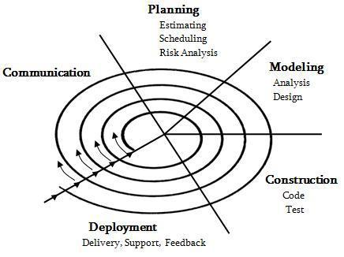

Fig 2.1: Spiral model

• A first prototype of the new system is constructing from the basic design. This is usually a scale-down system, and represents an approximated of the characteristics of the final
product.

• A second prototype is evolved by a fourfold procedure evaluated the first prototype in terms of its strength, weakness, and risk & defining the requirement of the second
prototype.

- 2.1.2 Project Plan:

12



 | Task Description |  |  | Time Taken |  | Year
 | Domain Understanding |  |  | July |  | 2016
 | Requirement gathering and analysis |  |  | August |  | 2016
 | Define Objectives |  |  | September |  | 2016
 | System Design |  |  | October |  | 2016
 | Partial documentation |  |  | November, December |  | 2016
 | Implementation |  |  | January, February, |  | 2017
 |  |  |  | March
 | Testing |  |  | April |  | 2017
 | Final Documentation |  |  | May |  | 2017

Table 2.1: Project plan

2.2 Risk Management

Risk management is an extremely important task in all projects and so it is in this project as well. Software is a difficult undertaking. So lots of things can go wrong. It is for this reason that being prepared understanding the risks and taking proactive measure to avoid or manage them is a key element of good Software Project Management.

Recognizing what can go wrong is the first step called Risk identification. Next each risk is analyzed to determine that it will occur and the damage that it will do if it does occur. Once this information is established, risks are ranked, by probability and impact. Finally a plan is developed to manage those risks with high probability.

13

2.2.1 Risk Identification:

Risk is an inevitable concept of software projects and it mainly concerns future happenings. We want to produce a well working system therefore we have to consider all the possible defects and unexpected conditions. First of all we have to define possible risks and develop a management style for each of them. After a deep investigation we identified the following possible risks of our project.

• The tasks that are planned in the schedule may overflow

• Some team members may not focus on the project deeply.

• A team member may leave the group.

• The team members may not be suitable for group work.

- The motivation of team members may not be sufficient.

2.2.2 Risk Analysis

For the risk management we select the most catastrophic risks of this list and we developed special several strategies in order to handle or block these unexpected situations. According to our risk table the most effective risks are as show below:

 | Risk |  |  |  | Probabilities |  |  |  | Effects
 | Website components which should be | reused |  |  | Moderate |  |  |  | Serious
 | contain defects limit their functionality
 | Change of requirements which require proposal |  |  |  | High |  |  |  | Serious
 | of major design rework. |  |  |  | Moderate |  |  |  | Serious
 | Scheduling slippage:
 | The time required for the development of website |  |  |  | High |  |  |  | Serious
 | is underestimated, so schedule slippage will occur
 | The size of website is underestimated |  |  |  | High |  |  |  | Tolerable
 | Power Failure |  |  |  | High |  |  |  | Tolerable

14

 | Inexperienced team member |  | Medium |  | Tolerable

Table 2.2: Risk type

2.2.3 Risk Planning

A risk plan is a list of all risks that threaten the project, along with a plan to mitigate some or all of those risks. Some people say that uncertainty is the enemy of planning. If there were no uncertainty, then every project plan would be accurate and every project would go off without a hitch. Unfortunately, real life intervenes, usually at the most inconvenient times. The risk plan is an insurance policy against uncertainty.

Into higher the mitigation response is the action plan to eliminate, reduce, or minimize the probability of a risk event occurring and or the impact of the project risk event should it occur. The output from the activity is a Risk Mitigation Plan that contains a set of actions directed at minimizing the potential occurrence or impacts of risks on a project and a Risk Contingency Plan to be activated. For low impact, low probability risks, a mitigation plan may not be prepared, rather these risk items will be monitored to ensure that they do not transpire or evolve risks.
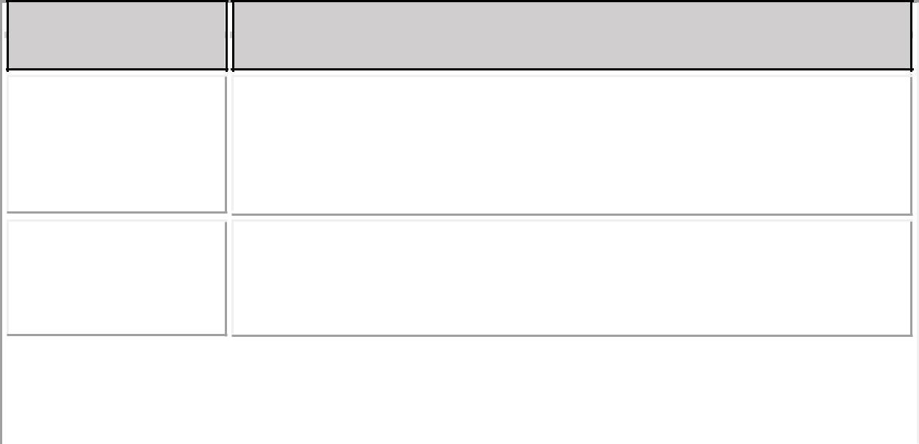

Risk

Requirement

Changes

Schedule risk

Plan

Derive traceability information to access requirements,

Change impact and maximize information hiding.

To reduce this risk, we are going to complete our project according to our schedule.

Performance |  | Investigate Database which can effectively process.

Table 2.3: Risk planning

15

CHAPTER: 3 SYSTEM REQUIREMENTS

System requirements study involves a clear and thorough understanding of the product to be developed with the view of removing all ambiguities from customer perception.

3.1 User Characteristics

There are two types of users in this application client and admin. Admin can manage application and database and also account of all the processes done in the system. client submit their requirement of product details, login , logout, do payment.

3.2 Hardware and Software Requirements


Requirements

Processors

RAM

Monitor

Hard disk

Requirements

Platform

Database

Tool

Server

Description

Pentium 4 or higher

256 MB or higher

800×600 or larger

40 GB or Above

Description

Windows XP/ or Higher with MS-office

PHPMyAdmin

Dreamweaver

Apache Server 2.2.21

16

Table 3.2: Software requirements

3.3 Constraint

- Hardware constraints:

We have used LAVAREL framework to build the application and for that Minimum 512 MB RAM is required with 800MB of Hard Disk Space with minimum 1 GHz processor. This is one time hardware requirement. Because after hosting the site, client does not need extra hardware specification.

- Design constraints:

To avoid duplication in the database we have used primary key as well as some times also used unique key. To establish relationship between columns of multiple tables, we have used foreign key constraints.

- Reliability:

This application must be reliable means it should not be crashed during the execution. We have cared properly no to crash the software. We have used unlimited bandwidth to give high performance in the heavy traffic on the application site.

- Availability:

We have considered all the basic requirements of the users before developing the site. So we have provided most of the features to be useful in the application, like submit requirements, updation in requirements, analysis of requirements, project management.

- Security:

Security is also a prime requirement of any application. For the security purpose we have used Login authentication before using any feature of the application. We have also encrypted the

17

Gujju Festival Team Id : 76050

password of the user in the database to make more secure database.

- Maintainability:

The application is online when we want to maintain anything we have to put site offline. The maintainability of site will be little bit hard but we have designed the application in a way that it will be easy to maintain the application.

18

CHAPTER 4: SYSTEM ANALYSIS

4.1 Study of Current Systems

To update any content or any part of site it requires using FTP and changing the content manually.

4.2 Problems and Weakness of Current System

Before the invention of an electronic commerce site or e-commerce website, there was the old fashioned shopping in which the customers used to visit the shop in person to buy their goods. It gave a very limited option to the user to choose in the present items. They had to pay whatever the merchants demanded. the didn't knew about the other markets' prices or ranges. the businessmen too were not able to expand their business beyond a certain area unless they have branches. The scope of the market was very limited.

4.3 Requirements of new System

The e-commerce websites that are already available have a very static kind of site theme.

They do not sell products are used in festivals except for clothes.

To bring creative in our project we have decided to create a website that would change its theme according to the festival.

The products that are necessary in festivals will be sold.

Users get wide range of products sitting at their home. Saves their time.

Vendors can do more business.

4.3.1 Functional Requirement

 | • | User can create account.
 | • | After that user can login and see the products available as per festival
 | • | Admin can approve request and track payment.
 | • | User can pay the amount on delivery
 | • | Easy payment using paypal integration
 | • | User can also return the products if they wish to.

4.3.2 Non-Functional Requirements

- Should work efficiently even on slow internet connections.

19

 | • Dynamic contents like success story are expected.
 | • | Secure Database.
 | • | Secure Payments.
 | • Communication between admin and client.
 | • Allow returning of products.
 | • Provide detailed sitemap.
 | • Provides customer support and feedback facility.
 | • | Customer satisfaction

4.3 Feasibility Study

A feasibility study is a preliminary study undertaken to determine and document a project's viability. The results of this study are used to make a decision whether to proceed with the project, or table it. If it indeed leads to a project being approved, it will - before the real work of the proposed Project starts - be used to ascertain the likelihood of the project's success. It is an analysis of possible alternative solutions to a problem and a recommendation on the best alternative.

Four types of project feasibility have been considered:

- Technical Feasibility

- Economic Feasibility

- Operational Feasibility
4.4.1. Technical Feasibility:

The following factors suffice for considering the given project as Technically Feasible.

• The system developed in PHP language which is well known and today we can easily

get the technical help of PHP language from the internet.

• The system development in PHP language is specified by client.

- We have used this technology and similar types of tools that can be useful to develop this system.
4.4.2. Economic Feasibility:

20

Economic feasibility is very important in development of the software for any company. Because it gives an idea, whether the project going to be developed can be completed at a cost affordable both by the client and developer. The availability of the required hardware and software used to develop our project makes it economically very feasible. Also the company is having all the other required resources needed for the project hence the project is feasible with respect to economy.

4.4.3 Operational Feasibility:

Proposed System is beneficial only if they are turned into Information Systems that will meet the organization’s operating requirements. This test of feasibility asks if the system will work when it is developed and deployed. Are there any major barriers to implementation? The following factors suffice for considering the given project as operational Feasible.

As the System is going to be developed at the place where it is going to be implemented, the track of the operations related to the software is constantly monitored by them and sufficient support is available.

21

CHAPTER 5: System Design
5.1 Function of System

Fig 5.1.1: Use case
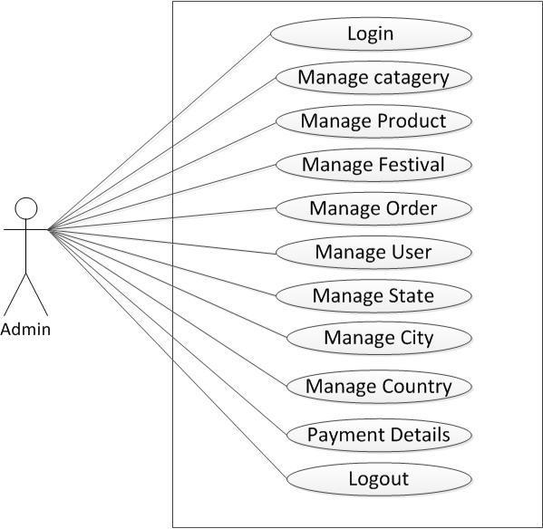

Use Case Diagram Of Admin
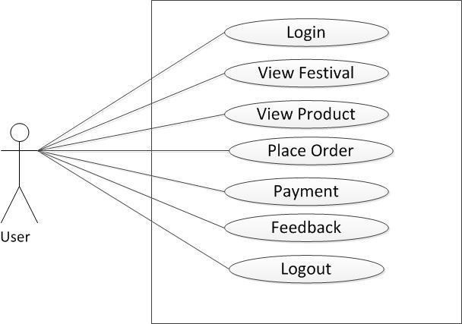

Use Case Diagram Of User

22

5.5.2 Data Flow Diagrams

5.5.2.1 Context Level
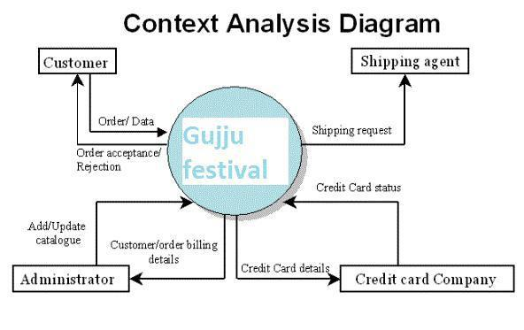

5.5.2.2 First Level
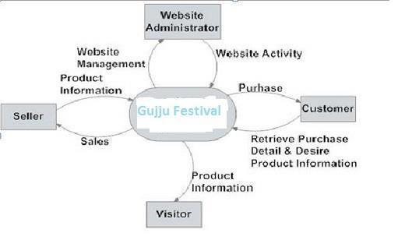

5.5.2.3 Second Level
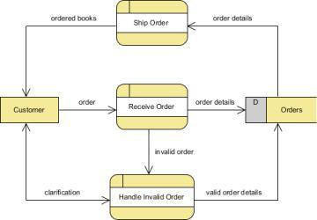

23

5.5.3 CLASS DIAGRAM
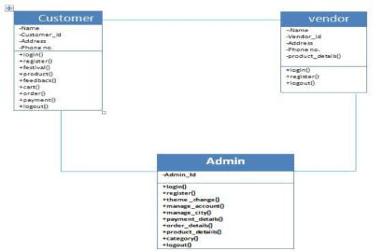

Fig 5.1.4: Activity Diagram
A. For admin
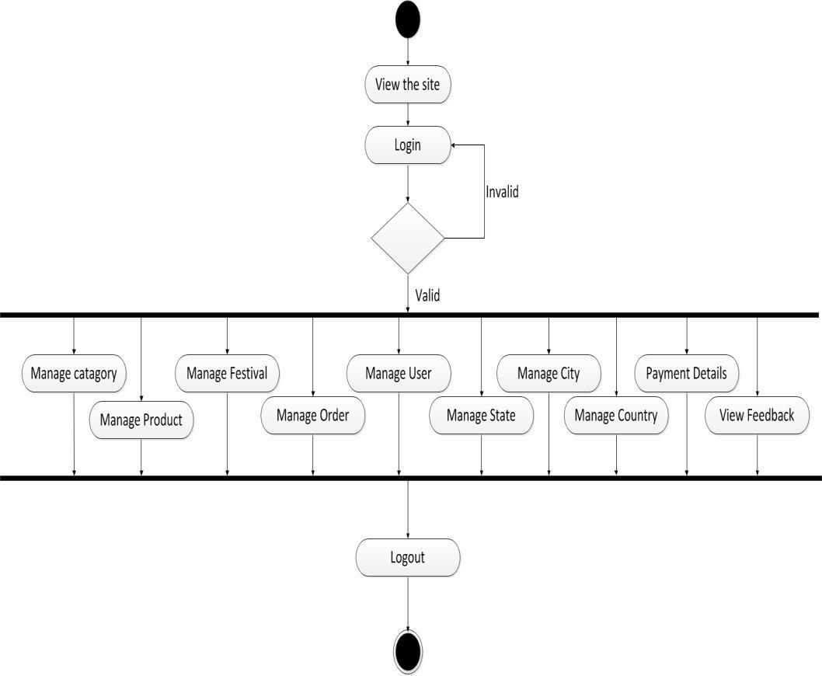

- For user

24

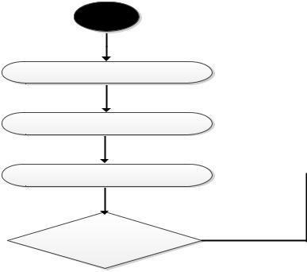

View the site

User

Have Register

Login

Invalid

Valid
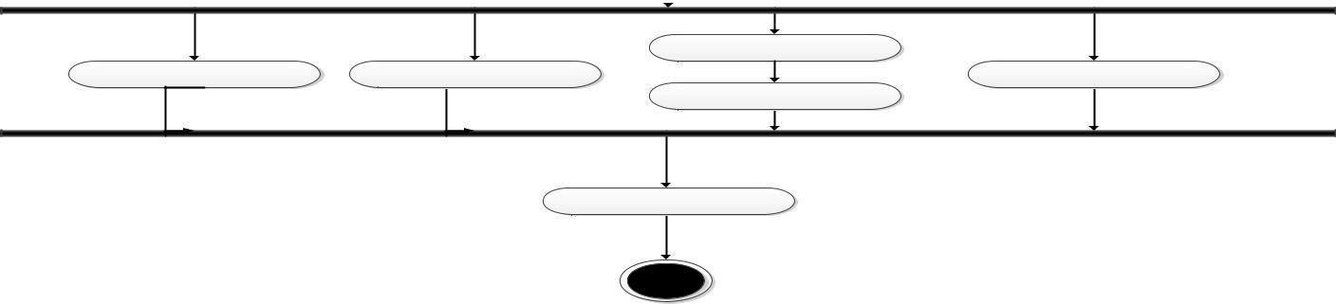

Place Order

View Festival View Product Feedback Payment

Logout

5.2 Data modelling
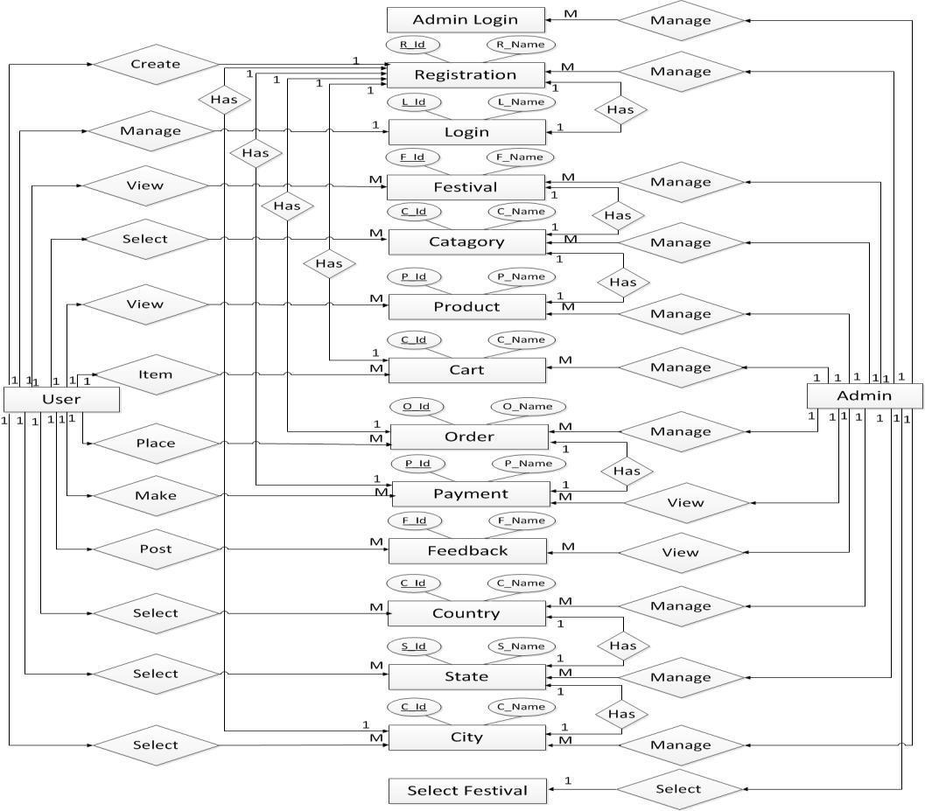

Fig 5.2.1: ER Diagram

25

.3 Data dictionary

- Table Name: - Admin Primary Key: - Admin_Id

Description: - The table is used for storing the Admin information
Sr no. | Field name | Data type | Size | Constraint | Description
1 | Admin Id | Int | 9 | Primary Key | Admin Id
2 | Username | Varchar | 255 | Unique Key | Admin
 |  |  |  | and not null | username
3 | Password | Varchar | 255 | Not null | Admin
 |  |  |  |  | password

- Table Name: - User Registration Primary Key: - Registration Id

Description: - The table is used for storing the User Registration details

Sr no. | Field Name | Data Type | Size | Constraint | Description
1 | Registration | Int | 9 | Primary Key | User
 | Id |  |  |  | Registration
 |  |  |  |  | Id
2 | Email Id | Varchar | 255 | Unique Key | User email Id
3 | Contact No | Varchar | 255 |  | User Contact
 |  |  |  |  | Id
4 | Password | Varchar | 255 |  | User
 |  |  |  |  | Password
5 | Address | Text |  |  | User’s
 |  |  |  |  | address
6 | Country Id | Int | 9 | Foreign Key | Country Id
7 | State Id | Int | 9 | Foreign Key | State Id
8 | City Id | Int | 9 | Foreign Key | City Id

- Table Name: - Login Primary Key: - Login Id
Description: - The table is used for storing the User Login details
Sr No. | Field Name | Data Type | Size | Constraint | Description
1 | Login Id | Int | 9 | Primary Key | User Login id
2 | Email Id | Varchar | 255 | Unique Key | User email id
3 | Password | Varchar | 255 |  | User
 |  |  |  |  | password
4) Table Name: - Country

26

Primary Key: - Country Id
Description: - The table is used for storing the Country details
Sr no. |  | Field Name |  | Data Type |  | Size |  |  |  | Constraint |  | Description
1 |  | Country Id |  | Int |  | 9 |  |  |  | Primary Key |  | Country Id
2 |  | Country |  | Varchar |  | 255 |  |  |  | Unique Key |  | Country name
 |  | Name
5) Table Name: - State
Primary Key: - State Id
Description: - The table is used for storing the State details
Sr no. |  | Field Name |  | Data Type | Size |  |  |  | Constraint |  | Description
1 |  | State Id |  | Int | 9 |  |  |  | Primary Key |  | State Id
2 |  | State Name |  | Varchar | 255 |  |  |  | Unique Key |  | State Name
3 |  | Country |  | Varchar | 255 |  |  |  | foreign Key |  | Country
 |  | Name |  |  |  |  |  |  |  |  | name
6) Table Name: - City
Primary Key: - City Id
Description: - The table is used for storing the City details
Sr no. |  | Field Name |  | Data Type |  | Size |  |  |  | Constraint |  | Description
1 |  | City Id |  | Int |  | 9 |  |  |  | Primary Key |  | City Id
2 |  | City Name |  | Varchar |  | 255 |  |  |  | Unique Key |  | City Name
3 |  | State Id |  | Varchar |  | 255 |  |  |  | Foreign Key |  | State Id

- Table Name: - Product Primary Key: - Product Id

Description: - The table is used for storing the Product details
Sr No. | Field Name | Data Type | Size | Constraint | Description
1 | Product Id | Int | 9 | Primary Key | Product Id
2 | Product code | Int | 9 | Unique Key | Product code
3 | Product name | Varchar | 255 |  | Product name
4 | Description | Text |  |  | Description
5 | Price | Int | 9 |  | Price
6 | Photo | Varchar | 255 |  | Photo
7 | Stock | Int | 9 |  | Stock
8 | Category Id | Int | 9 | Foreign Key | Category Id
9 | Sub category | Int | 9 | Foreign Key | Sub category
 | Id |  |  |  | Id
10 | Feedback Id | Int | 9 | Foreign Key | Feedback Id

- Table Name: - Contact Us Primary Key: - Contact Id

Description: - The table is used for storing the Contact details

27

Sr No. | Field Name | Data Type | Size | Constraint | Description
1 | Contact Id | Int | 9 | Primary Key | Contact Id
2 | Name | Varchar | 255 | Unique Key | Name
3 | Email Id | Varchar | 255 |  | Email Id
4 | Subject | Varchar | 255 |  | Subject
5 | Message | Text |  |  | Message

- Table Name: - Feedback Primary Key: - feedback Id

Description: - The table is used for storing the feedback details
Sr No. | Field Name | Data Type | Size | Constraint | Description
1 | Feedback Id | Int | 9 | Primary Key | Feedback Id
2 | Name | Varchar | 255 | Unique key | Name
3 | Email Id | Varchar | 255 |  | Email Id
4 | Subject | Varchar | 255 |  | Subject
5 | Message | Text |  |  | Message

- Table Name: - Cart Primary Key: - Cart Id

Description: - The table is used for storing the Cart details
Sr No. | Field Name | Data Type | Size | Constraint | Description
1 | Cart Id | Int | 9 | Primary Key | Cart Id
2 | Product Id | Int | 9 | Foreign Key | Product Id
3 | Login Id | Int | 9 | Foreign Key | Login Id
4 | Quantity | Int | 9 | Foreign Key | Quantity
5 | Price | Int | 9 | Foreign Key | Price
6 | Total | Int | 9 |  | Total

- Table Name: - Order Primary Key: - Order Id

Description: - The table is used for storing the Cart details
Sr No. | Field Name | Data Type | Size | Constraint | Description
1 | Order Id | Int | 9 | Primary Key | Order Id
2 | Login Id | Int | 9 | Unique Key | Login Id
3 | Total Amount | Int | 9 |  | Total Amount
4 | Order Date | Int | 9 |  | Order Date
5 | Product Item | Varchar | 255 |  | Product Item

28

12) Table Name: - Festival
Primary Key: - Festival Id
Description: - The table is used for storing the Festival details
Sr No. | Field Name | Data Type | Size | Constraint | Description
1 | Festival Id | Int | 9 | Primary Key | Festival id
2 | Festival name | Varchar | 255 | Unique Key | Festival name
13) Table Name: - Category
Primary Key: - Category Id
Description: - The table is used for storing the Category details
Sr No. | Field Name | Data Type | Size | Constraint | Description
1 | Category Id | Int | 9 | Primary Key | Category Id
2 | Name | Varchar | 255 | Unique Key | Category
 |  |  |  |  | Name
3 | Festival Id | Int | 9 | Foreign Key | Festival Id

- Table Name: - Subcategory Primary Key: - Subcategory Id

Description: - The table is used for storing the Subcategory details
Sr No. | Field Name | Data Type | Size | Constraint | Description
1 | Subcategory | Int | 9 | Primary Key | Subcategory
 | Id |  |  |  | Id
2 | Subcategory | Varchar | 255 | Unique Key | Subcategory
 | name |  |  |  | name
3 | Category Id | Int | 9 | Foreign Key | Category Id
4 | Festival Id | Int | 9 | Foreign Key | Festival Id

- Table Name: - Order Detail Primary Key: - Detail Id

Description: - The table is used for storing the Order details
Sr No. | Field Name | Data Type | Size | Constraint | Description
1 | Detail Id | Int | 9 | Primary Key | Detail Id
2 | Order Id | Int | 9 | Foreign Key | Order Id
3 | Product Id | Int | 9 | Foreign Key | Product Id
4 | Quantity | Int | 9 | Foreign Key | Quantity
5 | Price | Int | 9 |  | Price

- Table Name: - Slider Primary Key: - Slider Id

Description: - The table is used for storing the Slider details
Sr No. | Field Name | Data Type | Size | Constraint | Description

29

1 | Slider Id | Int | 9 | Primary Key | Slider Id
2 | Photo | Varchar | 255 | Unique Key | Photo
3 | Festival Id | Int | 9 | Foreign Key | Festival Id

- Table Name: - Background Primary Key: - Background Id

Description: - The table is used for storing the background details

Sr No. | Field Name | Data Type | Size | Constraint | Description
1 | Background | Int | 9 | Primary Key | Background
 | Id |  |  |  | Id
2 | Background | Int | 9 | Unique Key | Background
 | code |  |  |  | code

- Table Name: - Header Primary Key: - Header Id

Description: - The table is used for storing the Header details

Sr No. |  | Field Name |  |  | Data Type |  | Size |  | Constraint |  | Description
1 |  | Header Id |  |  | Int |  | 9 |  | Primary Key |  | Header Id
2 |  | Header Color |  |  | Varchar |  | 255 |  | Unique Key |  | Header Color
3 |  | Festival Id |  |  | Int |  | 9 |  | Foreign Key |  | Festival Id
19) Table Name: - Menu
Primary Key: - Menu Id
Description: - The table is used for storing the Menu details
Sr No. | Field Name |  |  | Data Type |  | Size |  | Constraint |  | Description
1 | Menu Id |  |  | Int |  | 9 |  | Primary Key |  | Menu Id
2 | Menu |  |  | Varchar |  | 255 |  | Unique Key |  | Menu Color
 | Color
20) Table Name: - Footer
Primary Key: - Footer Id
Description: - The table is used for storing the Footer details
Sr No. |  | Field Name |  |  | Data Type |  | Size |  | Constraint |  | Description
1 |  | Footer Id |  |  | Int |  | 9 |  | Primary Key |  | Footer Id
2 |  | Footer Color |  |  | Varchar |  | 255 |  | Unique Key |  | Footer Color
3 |  | Festival Id |  |  | Int |  | 9 |  | Foreign Key |  | Festival Id

- Table Name: - Product Directory

30

Gujju Festival |  |  |  |  | Team Id : 76050
Primary Key: - Product Directory Id
Description: - The table is used for storing the Product Directory details
Sr No. | Field Name | Data Type | Size | Constraint | Description
1 | Product | Int | 9 | Primary Key | Product
 | Directory Id |  |  |  | Directory Id
2 | Product | Int | 9 | Unique Key | Product
 | Directory |  |  |  | Directory
 | Color |  |  |  | Color
3 | Festival Id | Varchar | 255 | Foreign Key | Festival Id

- Table Name: - Social Media Primary Key: - Social Media Id

Description: - The table is used for storing the Social Media details

Sr No. | Field Name | Data Type | Size | Constraint | Description
1 | Social Media | Int | 9 | Primary Key | Social Media
 | Id |  |  |  | Id
2 | Festival Id | Int | 9 | Foreign Key | Festival Id
3 | Facebook | Varchar | 255 |  | Facebook
 | Icon |  |  |  | Icon
4 | Twitter Icon | Varchar | 255 |  | Twitter Icon
5 | Google+ Icon | Varchar | 255 |  | Google+ Icon

Appendix

Periodic Progress Reports (PPR)
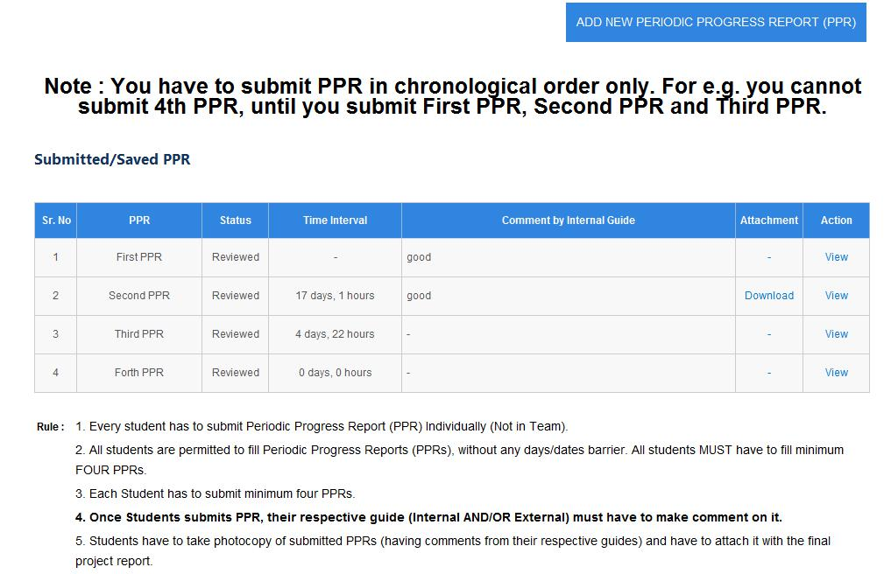

Patent search and Analysis Report (PSAR)

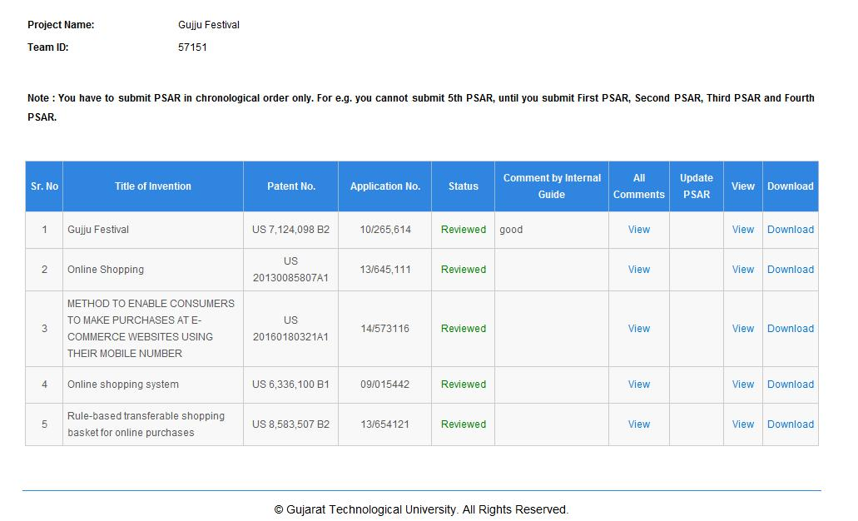

Design Engineering- Canvas Activity

1. Empathy Canvas
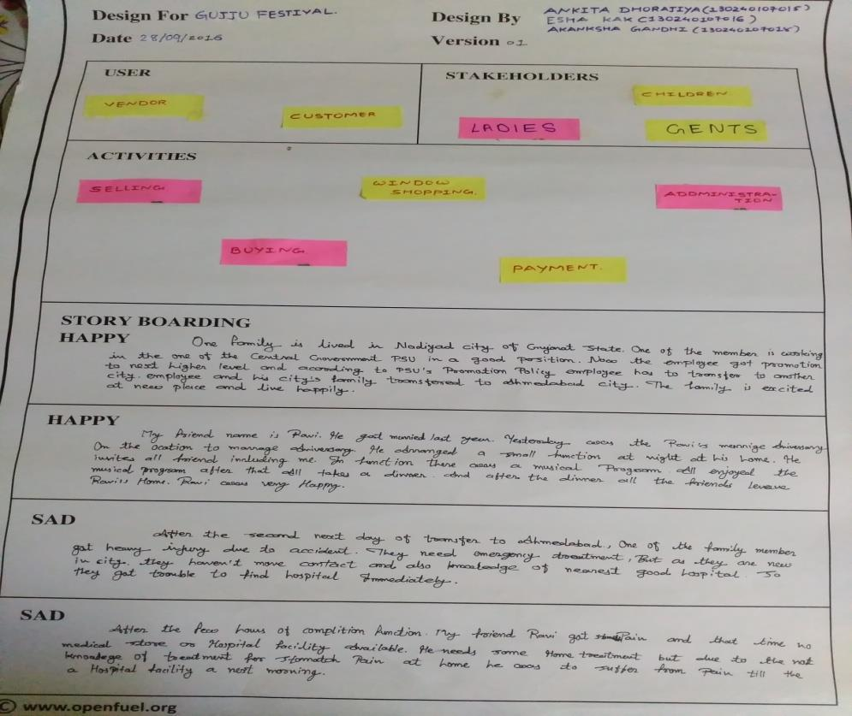

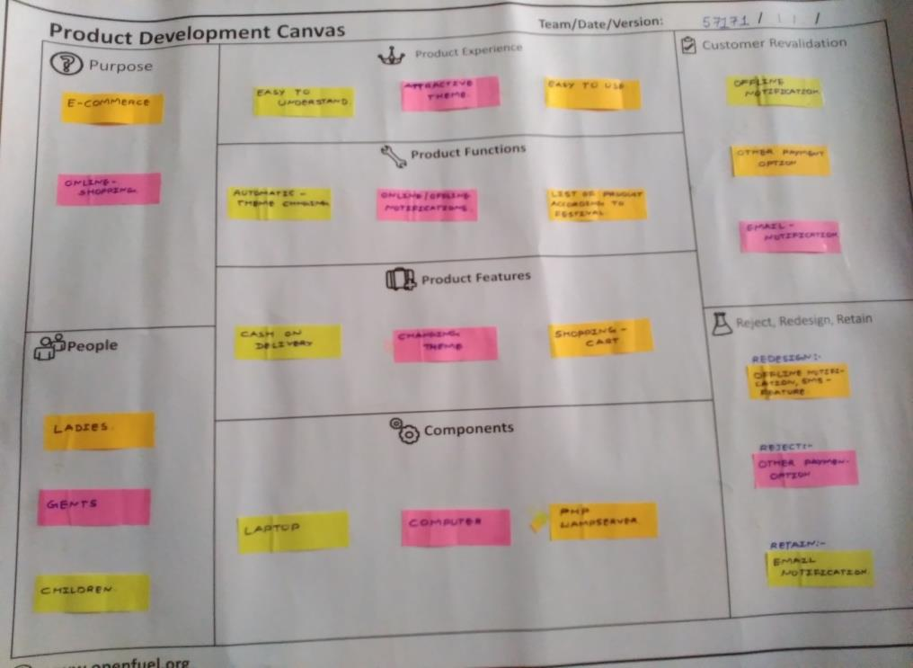
2. Product Development Canvas

3. Ideation Canvas
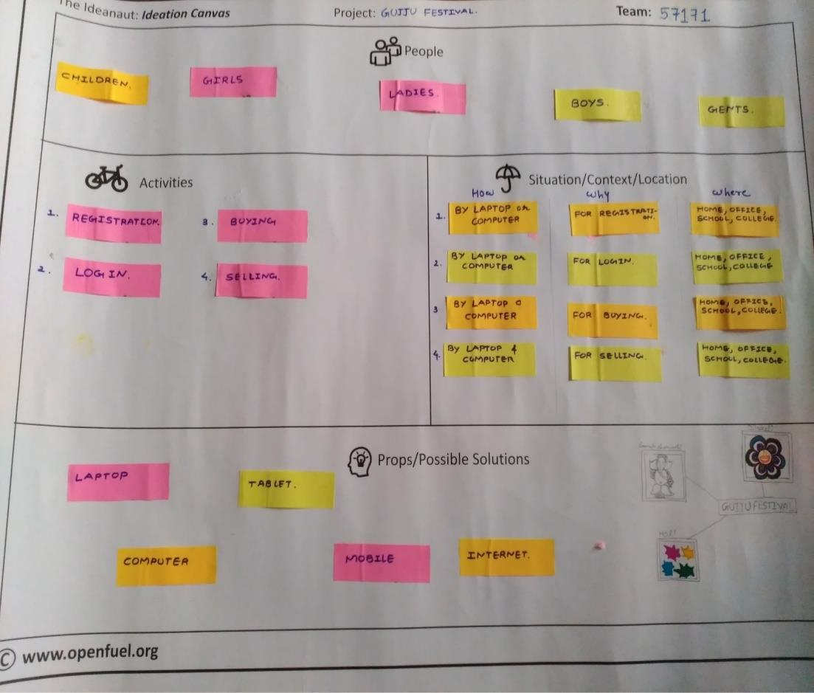

4. AEIOU Summary

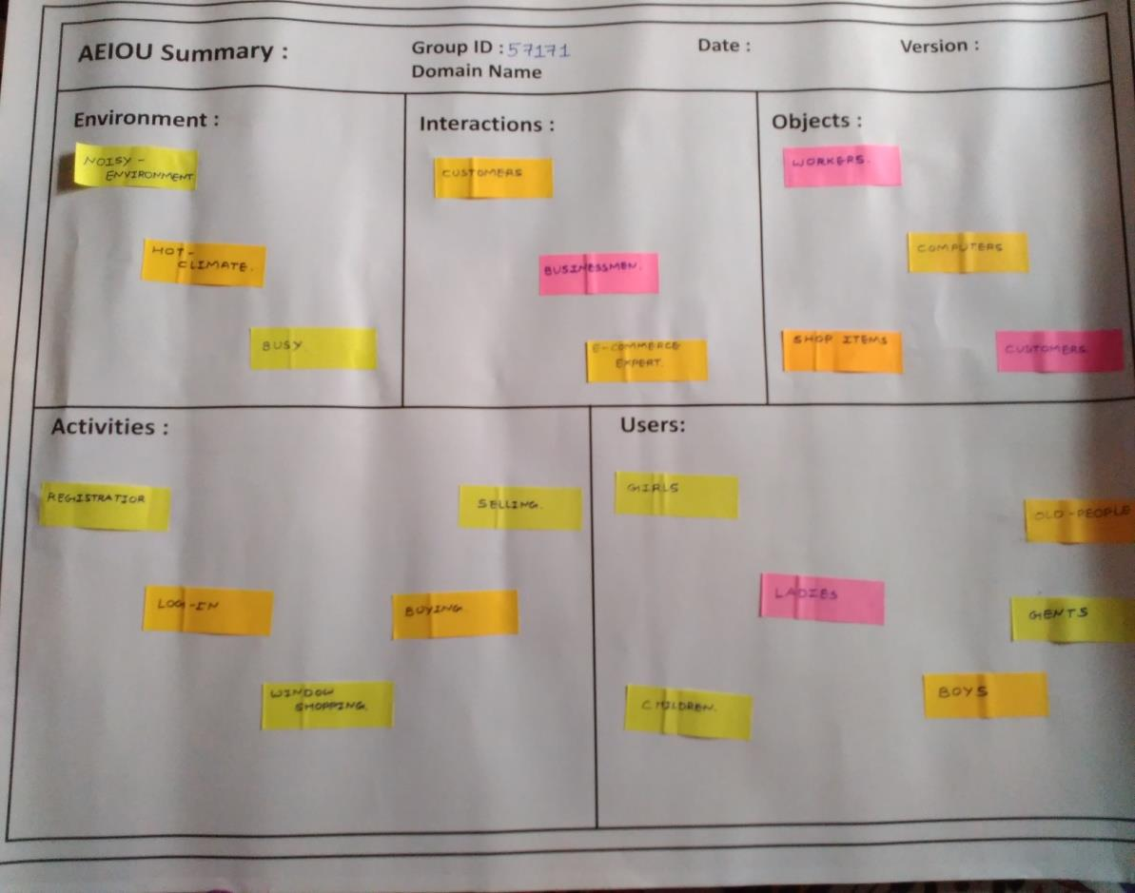

31

