Style Guide – GI. JOBs

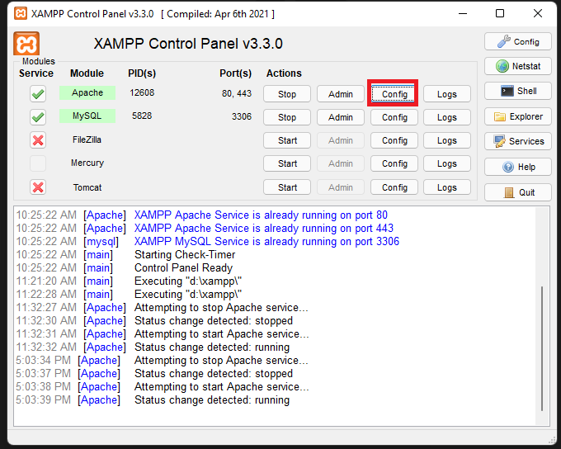**PLEASE NOTE:** You may not be able to use the default directory XAMPP due to the file structure. Below shows you the steps to fixing it.

1. Click “Config”

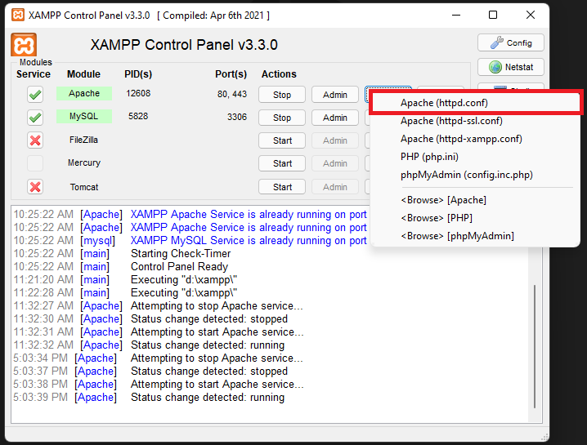

1. Click “Apache (httpd.conf)”
2. Search for ‘DocumentRoot’
3. Append “/Group Project” to BOTH directory

For example if your directory is “C:/xampp/htdocs”

You need to add the group projects to the end of the directory. “C:/xampp/htdocs/Group Project”.

Make sure you do this to both lines in the httpd.conf

1. Close and Open up xampp
2. 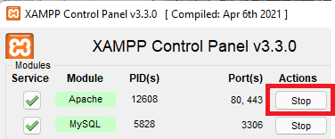Stop the Apache Server
3. Graphical user interface, text, application

   Description automatically generatedStart the Apache Server
4. Done!

**Company Name:** GI. JOBs

**Goods/Services:** Allow users to find job applications directly posted from businesses.

**Slogan:** Get your dream job with us

**Colour Scheme:**



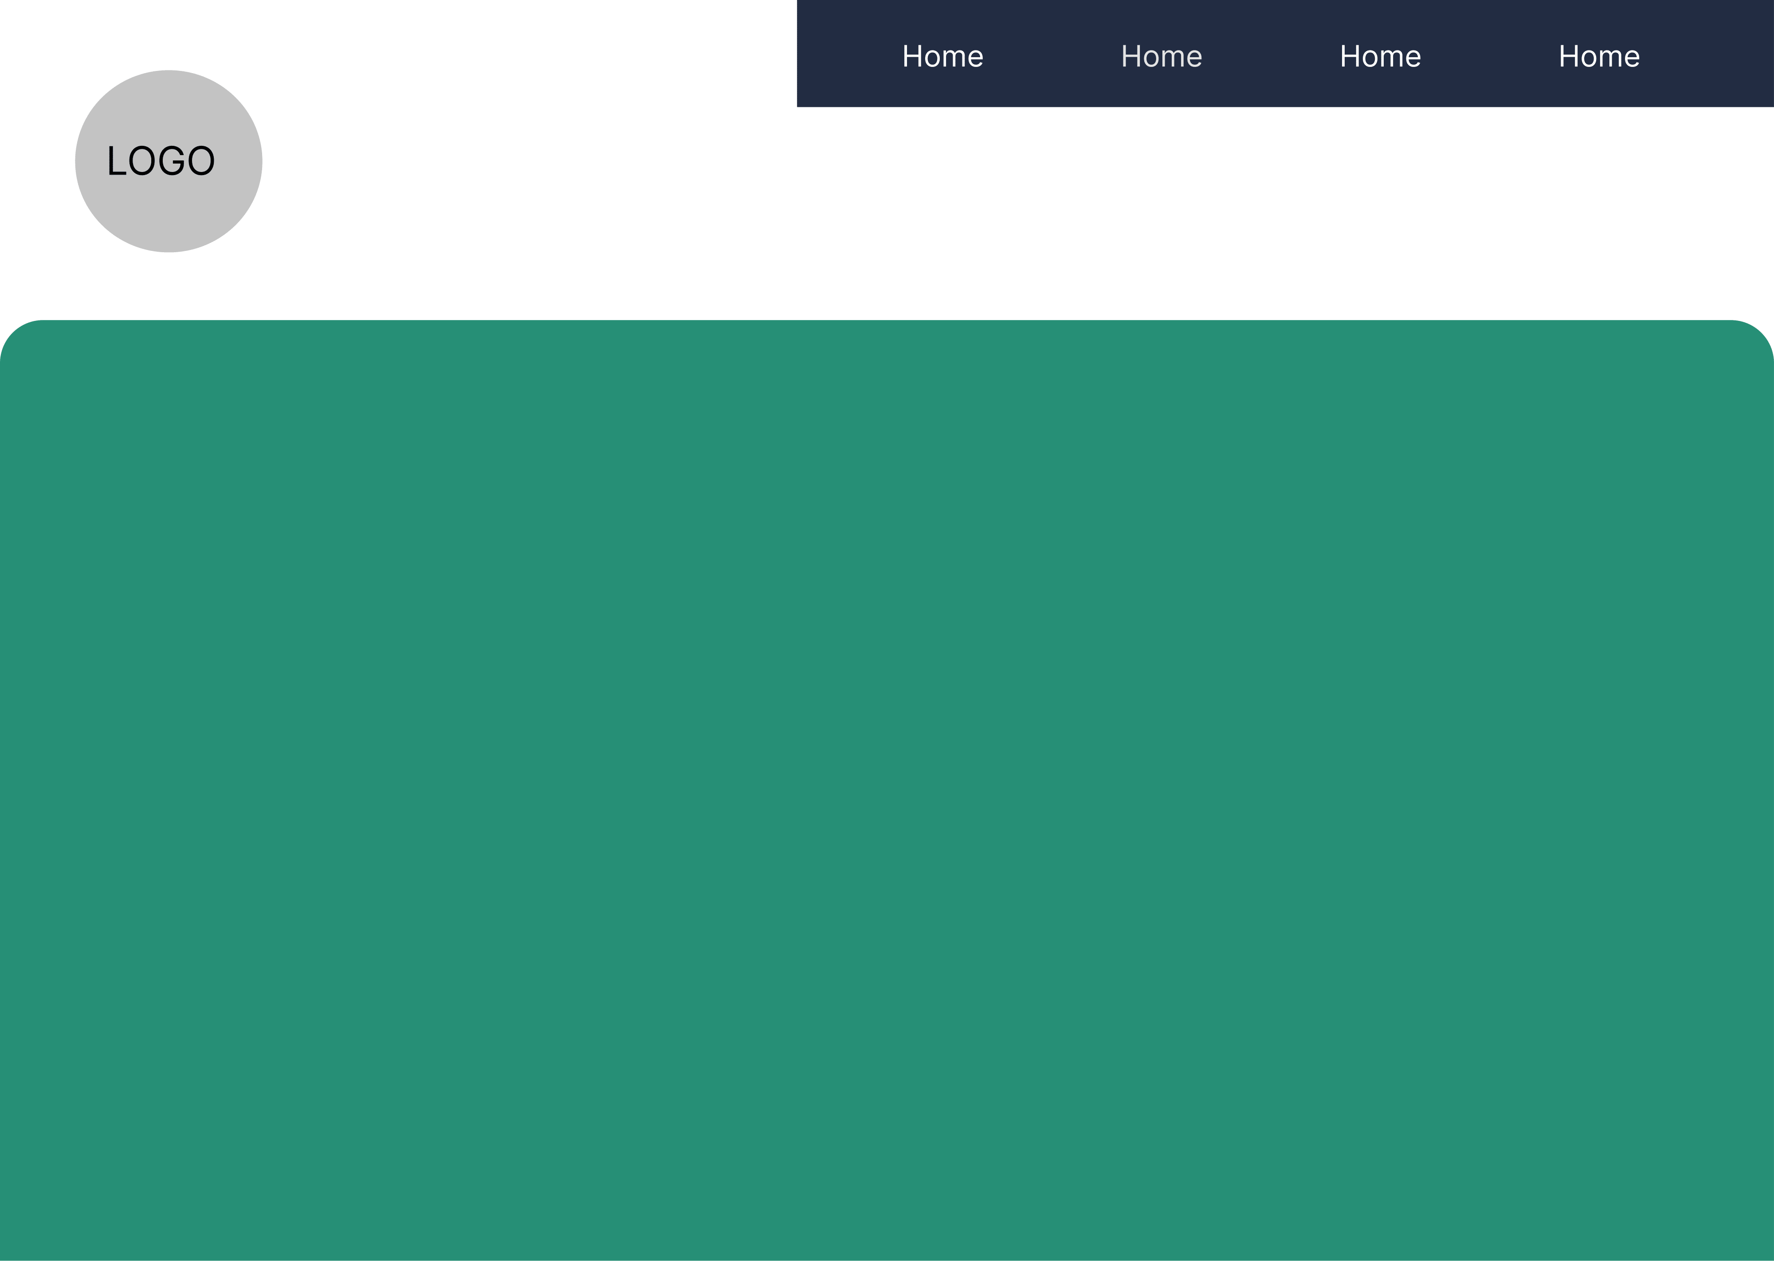Desktop/Mobile Mock-Up:

Folder Format:

* Group Project
  + database
    - connection.php
      * Attempt to connect to the database
      * Can’t? Then create the entire database and all its tables. Tables will only be created if they don’t exist.
    - db.php
      * Setup connection to database and prepare the data
      * printScreen function that is DEBUGGING ONLY. Will display any backend data to the front end
      * executeQuery() Run a query request
      * Self explanatory on the function name. Essentially all functions are SQL calls made into easy functions to be called.

selectAllUsers / selectAllCompany / selectOneUser / selectOneCompany / selectOneJob / createUser / createCompany / createJob / updateUser / updateCompany / updateJobs / deleteUser/ deleteCompany / deleteJob

* + - formError.php 🡪 Backend script that will error output to the front end
    - logout.php 🡪 Script called to logout the user or company
    - setup.php
      * Function when called will login a user
      * Register a user account
      * Register a company account
      * Backend login for either user or company
      * Backend places a job post request into the database
    - validate.php 🡪 Backend validation on any data coming from the front end
  + include
    - allowRegistered.php 🡪 If this user is not logged in the deny them
    - denyAll.php 🡪 If any user attempts to reach this site deny them
    - denyUsers.php 🡪 If the user isn’t a business then deny access to webpage
    - footer.php 🡪 All footer data can be linked using this file
    - header.php 🡪 All header data can be linked using this file
    - popup.php 🡪 Pop up message script. Used to display any message to any user
  + jobs
    - creation.php 🡪 Allows businesses to post a job posting to all users
    - dashboard.php 🡪 Displays all the current jobs in the database to both businesses and users
  + Starter
    - checkPassword.js 🡪 Checks to make sure the user or company has created a valid password
    - CSSReferences.css 🡪 All CSS styling is done through this file
    - FrontEndJS.js
      * On click the mobile drop down menu will display
      * User login front end validation
      * Company login front end validation
      * User registration front end validation
      * Company registration front end validation
      * “textarea” fields found in the company job posts that make it easier to drag the text box on a mobile device or on some browsers
      * Company job post front end validation
    - index.php 🡪 Main page of the program
    - login.php 🡪 Allow both businesses and users to login
    - newacc.php 🡪 Page for users to create an account
    - newcompanyacc.php 🡪 Page for businesses to create an account
    - template.php 🡪 Base template of the project website so its easier to create multiple pages.
  + path.php 🡪 Provides the program with a fixed path so then calls to different file paths are simpler to make
  + README.md 🡪 Brief description of the project
  + style-guide.docx 🡪 Document providing web map, design guide, and description of all elements for the project.