INSTRUCTOR NAME: ERSAN CAM
MARKS ALLOTTED: 100 (%70 back end + %30 Front End GUI)
WEIGHTING: 15%
Group Project

General Instructions :
You can use any Web based front end programming tool which can connect to our database in Lab or your own database
- Clean Coding, Interaction with Database (Connectivity, Login page etc ) , GUI features (Drop down menu , list box, Radio boxes etc if needed) and actual Presentation skills will be evaluated during presentation time.
- Expectation is that everyone in the team shares responsibility. If one person writes some stored procedure and the other one writes function , one or two can work on GUI same as in real life environment.
- Presentation will be on last day.
- Make power point presentation and do share with instructor in advance. Instructor will open presentation for you to present in front of class or you can plug your own laptop.
- If you want to use your own laptop , it is your responsibility to test connectivity of Projector otherwise do send all files and presentation to instructor and do DEMO from Instructor’s computer.

Marking guidelines
Back-end programming (Up to 70 points)

All the procedure ,function, triggers must be cleanly compiled with no errors. Tested on SQL Developer
You will be collecting points by doing successful Demo and test in front of Instructor and audience
2-Front end GUI effectiveness (0 up to30 pnts)
How user friendly is your GUI? Is it just basic & quickly written-basic but functional GUI or efficient and colorful/fancy GUI ?
Presentation skills (Eye contact with audience - Voice control - body gesture etc (Do some research on basic presentation skills )

Create a JL Book Sales application Menu like below or use your imagination to make more fancy. You are completely free to design any shape of form for the menus

Book Inventory Main Menu | Author Main Menu | Client Main Menu

Please Note that all the table names are under JL_XXXX Schema in our sample databases

Book register / Book removal / Book info Update/

Task1-1

Create a Procedure called sp_Book_register which accepts 8 parameters

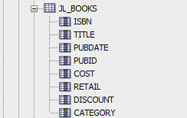

Once these values come as parameter then procedure BEGIN END should have simple INSERT statement

BEGIN
INSERT INTO jl_books ( col1, col2, col3, ….., col9 )
VALUES (par_isbn, par_title, par_pubdate,par_pubid, par_cost , …..)

COMMIT;
END;

TEST: You can test your procedure in SQL developer to make sure it works and insert new jl_books record to table

Task1-2 - GUI work
Create a Page (Form) for Book Register activities UNDER Book Main Menu

Book registration Form

ISBN : | Title: | Pubdate:

PubID: < It can be drop down> | Cost: | Retail price :

Discount:

Category :

Cancel
Register

In the form above you can see entry edit boxes such as phone or salary. They are simple edit boxes and when user enter these values they will be passed to sp_Book_register procedure.

Once you collect all this information from front end and user click on at the bottom, black border button called Hiring then send them all as INPUT parameter to your procedure and make sure Book is register by listing it at the bottom

Blue border box is for cancel option (optional)

Task 1-3
Under Book Main Menu , create a link to list and Update all or any one the Book record.
Make a form to list all Book records like excel grid format on the page and then let end user edit Category or Cost or Retail price information not any other info just any of these 3.
If any one of this info or all of these 3 info got change by end user then accept the new value and send to database as UPDATE COMMAND and replace old value with new one in Jl_books table.
Sample :
UPDATE JL_BOOKS SET cost= <new cost> , retail= <new retail> WHERE isbn = ISBN from the form selected -highlighted record line
Please note that This Update operation can be straight located in Front end application code or it can be stored procedure in Oracle DB and you call that store procedure from front end. Up to you
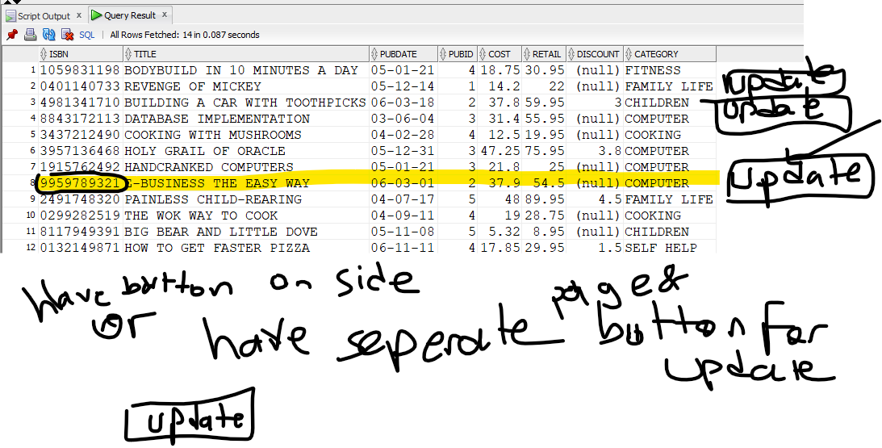

It is up to you to create a procedure for this or simply use front end GUI capability to do list of all staff and edit in place on the form. Either way is OK.
Below Tasks are options. Choose to do either Task 2 or Task 3
Task 2: AUTHOR related activities (AUTHOR menu)

Task 2-1 Author Register menu item

Under the AUTHOR MAIN menu create a link called Register Author

In this link or (page or form) idea is End user will enter Author
There will be one Edit boxes to accept Author details from end user

To do that, you use Stored

A ) create a procedure called sp_register_author (accept three parameters author ID , LNAME, FNAME )

JL_AUTHOR

Task 2-2 - Assign Author ID to BOOK
In this page (form) you will pick one ISBN and one Author ID (Preferably from Drop down menu if not just free entry) and register ISBN to a Author ID
-In each method please DO NOT FORGET TO ADD COMMIT; command after UPDATE command.
Please choose Book (ISBN)
2147428890

Please enter Author info for this book
W105

Assign(Click Button)

Task 3 – Customer Menu menu activities
Task 3.1 – Create a web Form to register new Customer
Similar to Task 1-2
Task 3.2 – Create a web Form to update Customer
Similar to Task 1-3

Allow change for to update Address or Region, State or email address. (all of them might be changed or only one info)
