**Supplementary data：**

**Table S1** Spearman correlations between βNTI of BS, RS or *phoD* bacterial communities and the changes of soil nutrients (based on Euclidean Distance).

|  |  |  |  |
| --- | --- | --- | --- |
|  | BS-βNTI | RS-βNTI | *phoD*-βNTI |
| AP | 0.59 | **-0.0006\*\*\*** | -0.62 |
| NH4N | 0.27 | 0.07 | -0.89 |
| NO3N | -0.66 | -0.72 | **-0.0001\*\*\*** |
| AK | -0.29 | -0.37 | 0.07 |
| pH | -0.11 | -0.14 | 0.063 |
| SOC | -0.44 | -0.32 | -0.07 |

**Table S2** Fit of the neutral model for the BS and RS and *phoD* bacterial communities in P Low-P and High-P fertilizer input treatments. *m* indicates the estimated migration rate; *R2* indicates the fit to the neutral model.

|  |  |  |  |  |  |  |
| --- | --- | --- | --- | --- | --- | --- |
| **Habitats** | **BS** | | **RS** | | ***phoD*** | |
| *m* | *R2* | *m* | *R2* | *m* | *R2* |
| Low-P | 1.510 | 0.693 | 1.565 | 0.713 | 0.129 | 0.654 |
| High-P | 1.523 | 0.702 | 1.569 | 0.709 | 0.184 | 0.693 |

**Table S3** The topological parameters of co-occurrence networks of bacterial and functional genes.

|  |  |  |  |  |  |  |  |
| --- | --- | --- | --- | --- | --- | --- | --- |
|  | Node | Edge | Average degree | Clustering coefficient | Average path length | Diameter | Graph density |
| Bacterial | 1180 | 199337 | 337 | 0.670 | 2.031 | 4.903 | 0.287 |
| Genes | 143 | 5935 | 83.00 | 0.893 | 1.585 | 3.513 | 0.585 |

**Table S4** The topological parameters of co-occurrence networks of BS, RS and *phoD*-bacterial communities.

|  |  |  |  |  |  |  |  |
| --- | --- | --- | --- | --- | --- | --- | --- |
|  | Node | Edge | Average degree | Clustering coefficient | Average path length | Diameter | Graph density |
| BS | 133 | 147 | 2.21 | 0.181 | 5.496 | 10.725 | 0.017 |
| RS | 196 | 454 | 4.63 | 0.351 | 4.251 | 9.850 | 0.024 |
| *phoD* | 64 | 56 | 1.75 | 0.256 | 3.293 | 6.618 | 0.028 |

**Table S5** The topological parameters of co-occurrence networks of functional genes from BS and RS bacteria communities.

|  |  |  |  |  |  |  |  |
| --- | --- | --- | --- | --- | --- | --- | --- |
|  | Node | Edge | Average degree | Clustering coefficient | Average path length | Diameter | Graph density |
| BS | 121 | 457 | 7.55 | 0.512 | 3.434 | 7.460 | 0.063 |
| RS | 141 | 1144 | 16.23 | 0.561 | 2.749 | 6.059 | 0.116 |

**Table S6** The mantel test between the bacteria and functional genes and soil properties in BS.

|  |  |  |  |  |
| --- | --- | --- | --- | --- |
|  | Environment | | r | *p* |
| Bacteria | | AP | -0.045 | 0.653 |
| Bacteria | | NH4N | -0.014 | 0.527 |
| Bacteria | | NO3N | 0.089 | 0.273 |
| Bacteria | | AK | -0.002 | 0.503 |
| Bacteria | | pH | 0.275 | **0.003\*\*** |
| Bacteria | | SOC | 0.334 | **0.002\*\*** |
| Bacteria | | Yield | 0.273 | **0.010\*** |
| Functional genes | | AP | -0.012 | 0.497 |
| Functional genes | | NH4N | -0.149 | 0.900 |
| Functional genes | | NO3N | 0.077 | 0.324 |
| Functional genes | | AK | 0.177 | **0.049\*** |
| Functional genes | | pH | 0.282 | **0.010\*** |
| Functional genes | | SOC | 0.388 | **0.001\*\*** |
| Functional genes | | Yield | 0.328 | **0.007\*\*** |

**Table7** The mantel test between the bacteria and functional genes and soil properties in the RS.

|  |  |  |  |  |
| --- | --- | --- | --- | --- |
|  | Environment | | r | *p* |
| Bacteria | | AP | 0.553 | **0.001\*\*** |
| Bacteria | | NH4N | -0.128 | 0.943 |
| Bacteria | | NO3N | 0.052 | 0.291 |
| Bacteria | | AK | 0.278 | **0.011\*** |
| Bacteria | | pH | -0.031 | 0.556 |
| Bacteria | | SOC | 0.057 | 0.255 |
| Bacteria | | Yield | 0.446 | **0.001\*\*** |
| Functional genes | | AP | 0.452 | **0.001\*\*** |
| Functional genes | | NH4N | 0.023 | 0.374 |
| Functional genes | | NO3N | -0.019 | 0.527 |
| Functional genes | | AK | 0.126 | 0.145 |
| Functional genes | | pH | -0.033 | 0.580 |
| Functional genes | | SOC | 0.146 | 0.111 |
| Functional genes | | Yield | 0.291 | **0.018\*** |

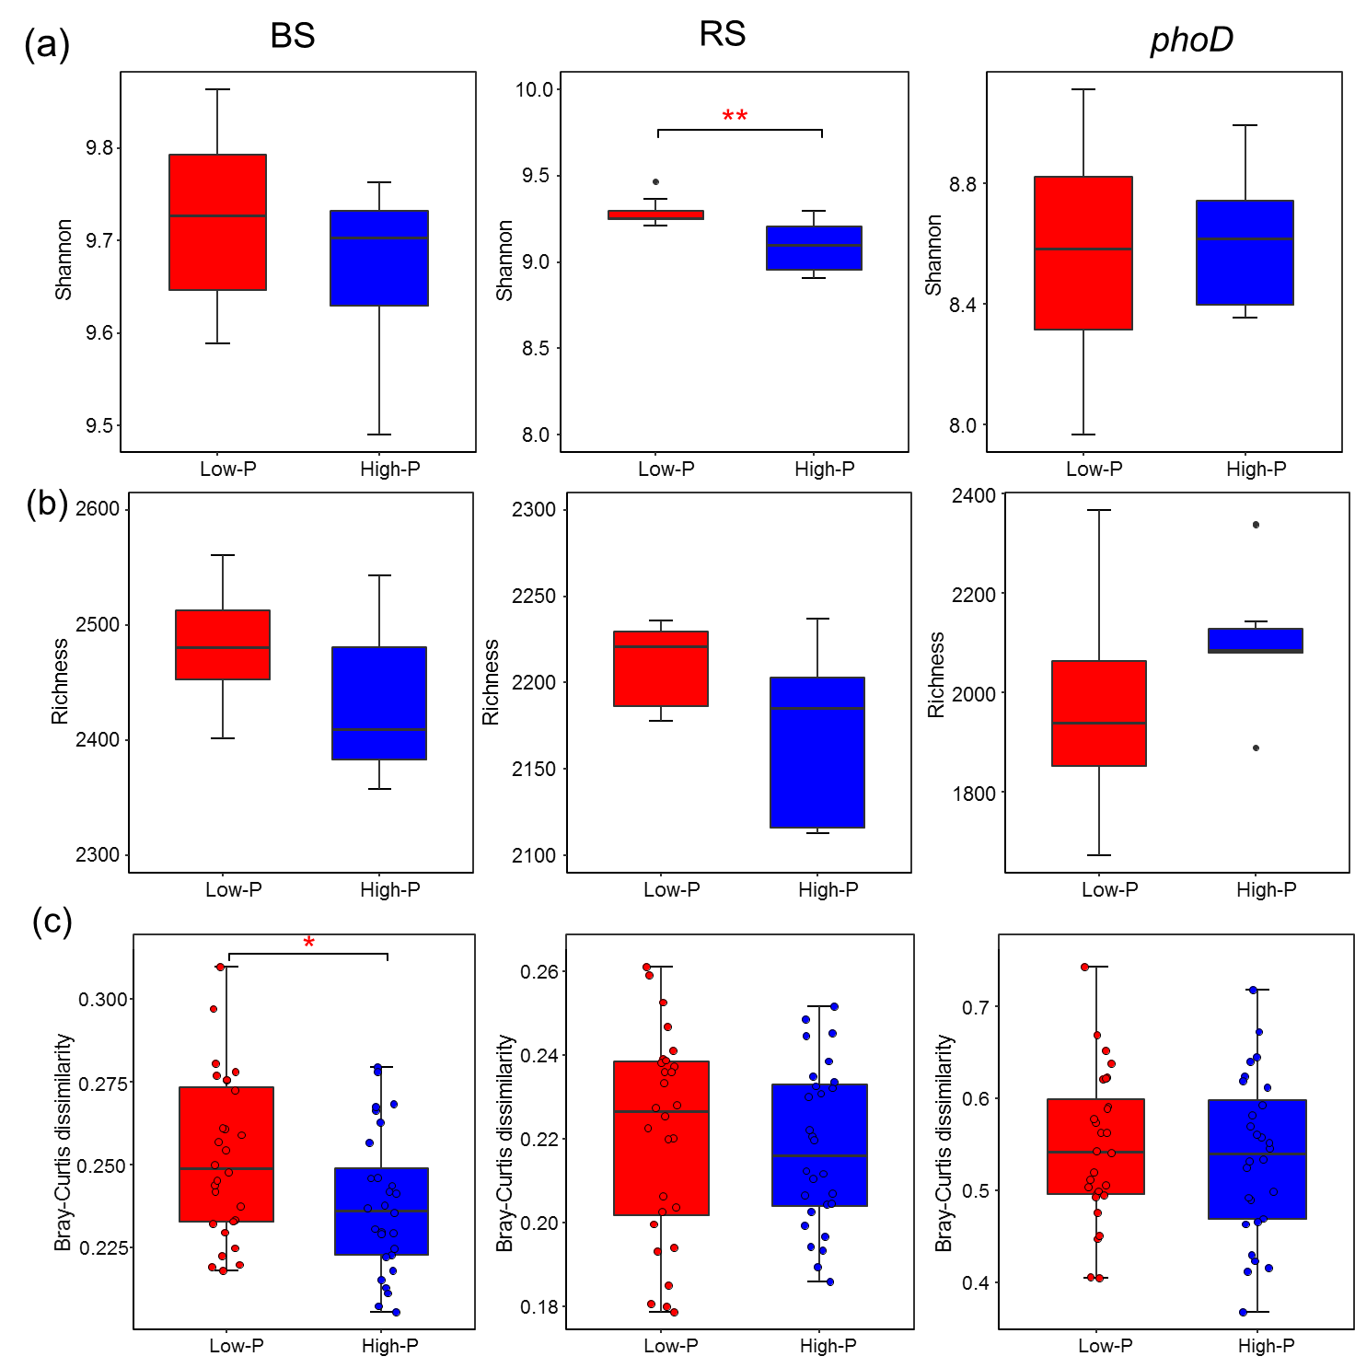

**Fig. S1** The composition and diversity of bulk soil (BS), rhizosphere soil (RS) and *phoD* bacterial communities with low-P and high-P fertilizer input treatments. (a) OTU Shannon, (b) richness, and (c) Bray–Curtis dissimilarity between low-P and high-P fertilizer input. * *p* < 0.05; ** *p* < 0.01; *** *p* < 0.001 for Kruskal–Wallis tests.

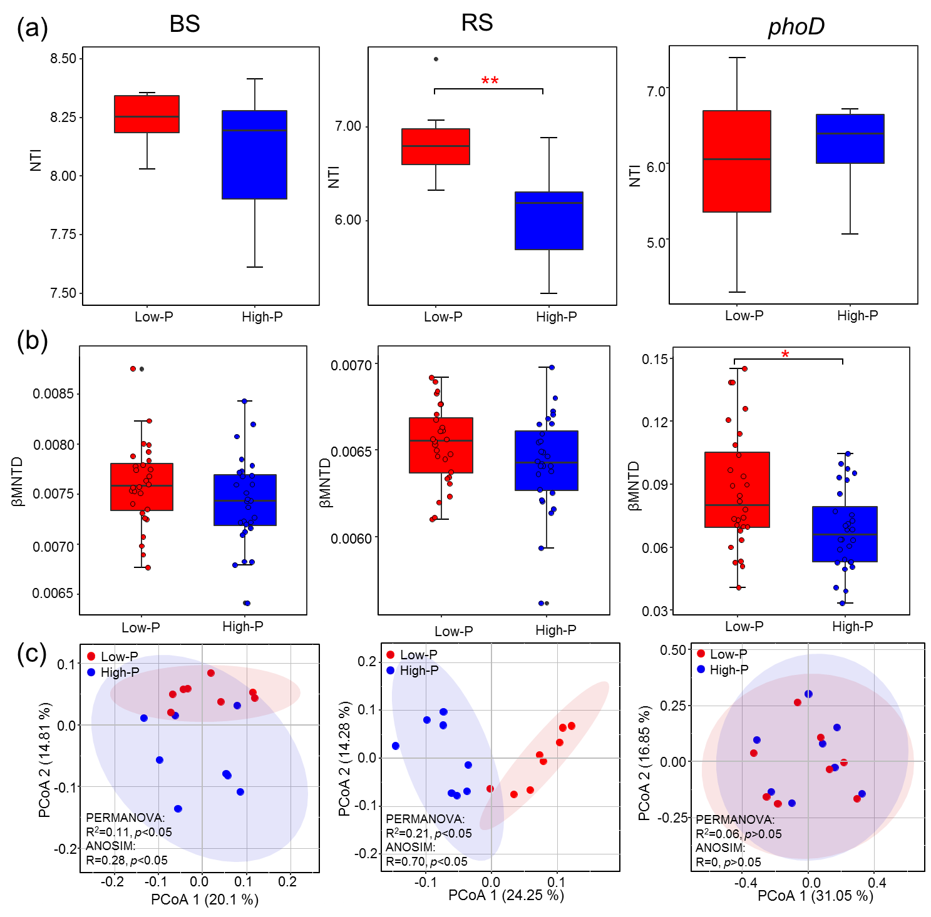

**Fig. S2** (a) NTI and (b) βMNTD indices of different bacterial communities with low-P and high-P fertilizer input. (c) PCoA plot based on Bray–Curtis distances depicting the distribution patterns of low-P and high-P fertilizer input. The PERMANOVA and ANOSIM tests were used to assess the significant differences between d low-P and high-P fertilizer input. *, *p* < 0.05; **, *p* < 0.01, ***, *p* < 0.001.

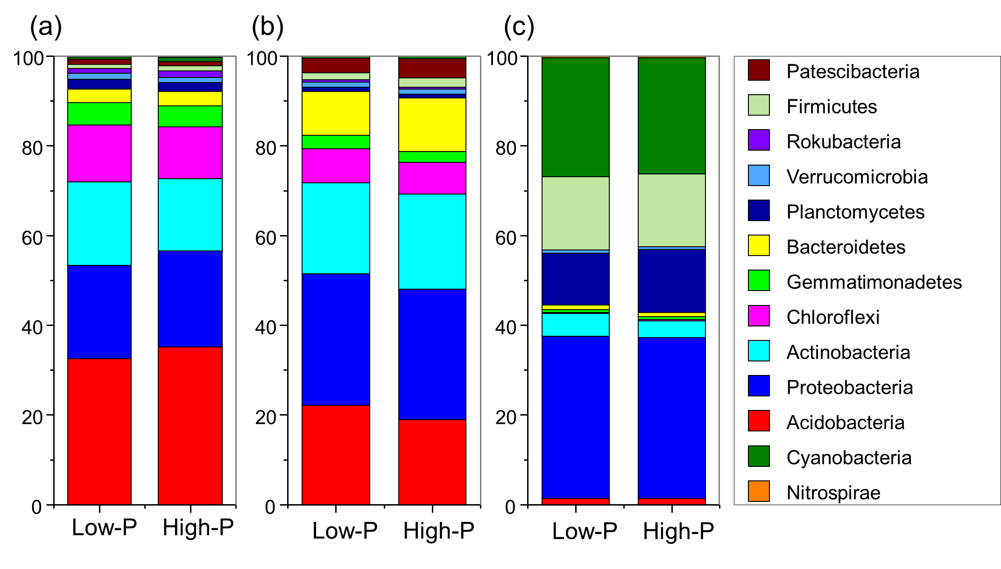

**Fig. S3** Taxonomic composition of (a) BS, (b) RS, and (c) *phoD* bacterial communities with low-P and high-P fertilizer input at the phylum level.

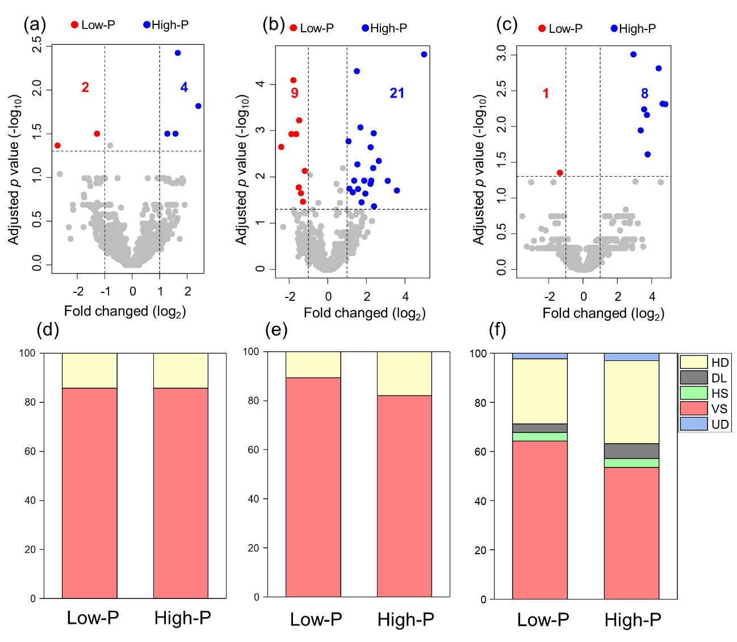

**Fig. S4** Enrichment and depletion of OTUs between low-P and high-P fertilizer input in (a) BS, (b) RS, and (c) *phoD* bacterial communities. The contribution of determinism and stochasticity on (d) BS, (e) RS, and (f) *phoD* bacterial communities’ assembly with low-P and high-P fertilizer input.

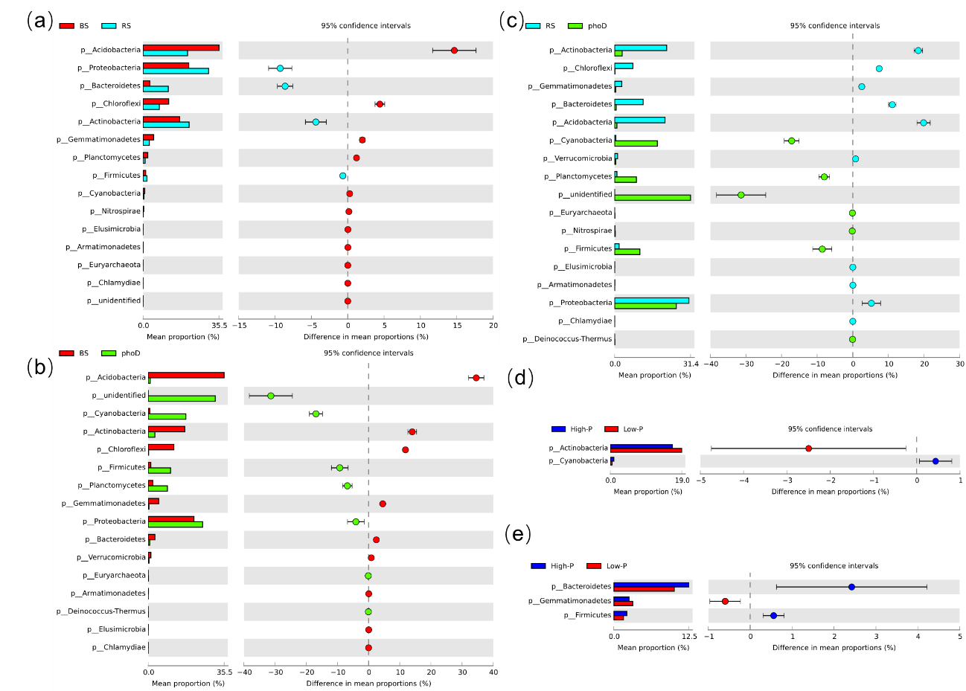

**Fig. S5** Variation analysis of the abundance of bacteria in different bacterial communities (a, b and c) and between low-P and high-P fertilizer input in (c) RS and (d) *phoD* bacterial communities.

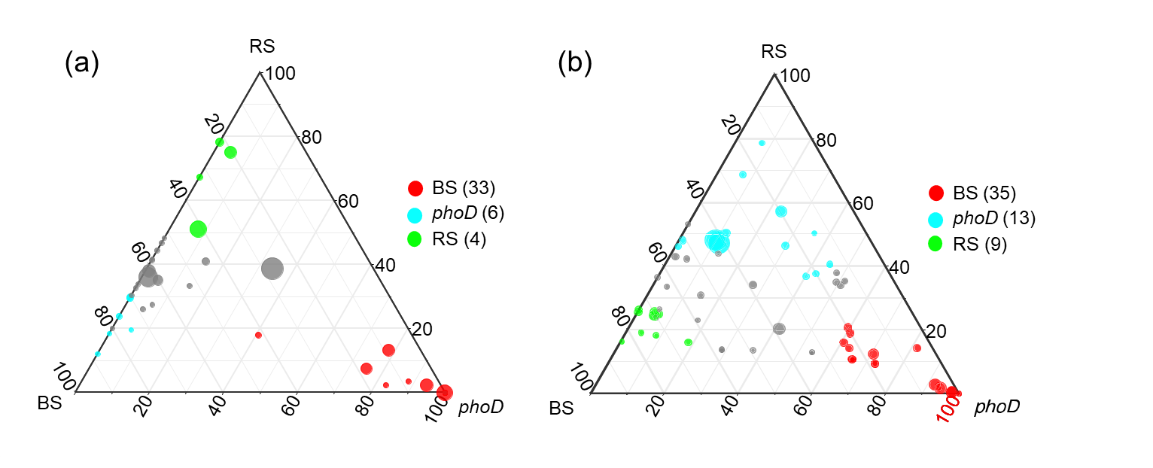

**Fig. S6** Ternary plots depicting the (a) bacterial at phylum level and (b) potential ecological functions significantly enriched in BS, RS and *phoD* bacterial communities. The size of each circle indicates the relative abundance. Different-colored dots show that function and bacteria are significantly higher in BS, RS, and *phoD* bacterial communities (*p* < 0.05), and the numbers in the parentheses denote the numbers of the differentiated functions and bacteria.

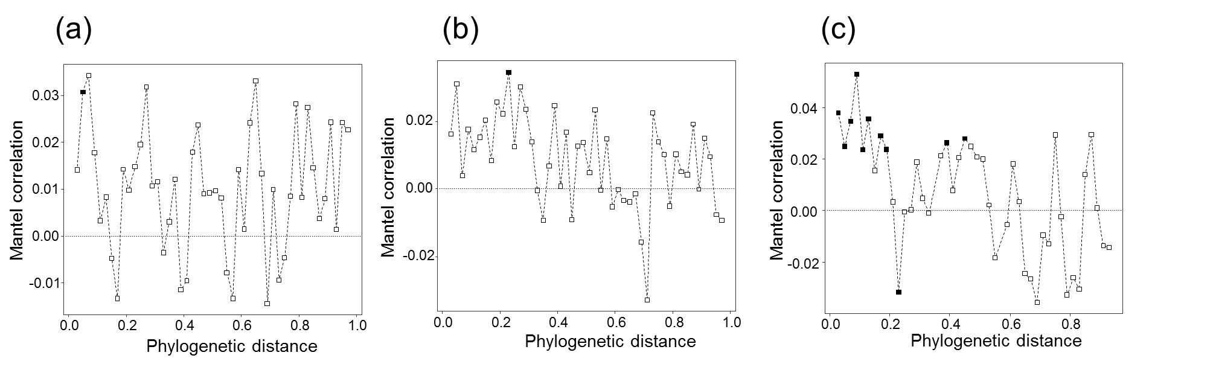

**Fig. S****7** Phylogenetic Mantel correlogram showing significant phylogenetic signal across short phylogenetic distances in (a) BS, (b) RS and (c) *phoD* bacterial communities. Solid and open symbols denote significant and nonsignificant correlations, respectively, relating between-OTU niche differences to between-OTU phylogenetic distances across a given phylogenetic distance.

**Fig. S****8** Random forest analysis showed the associations between βNTI of the (a) BS, (b) RS, and (c) *phoD* bacterial communities and the changes in environmental variables.

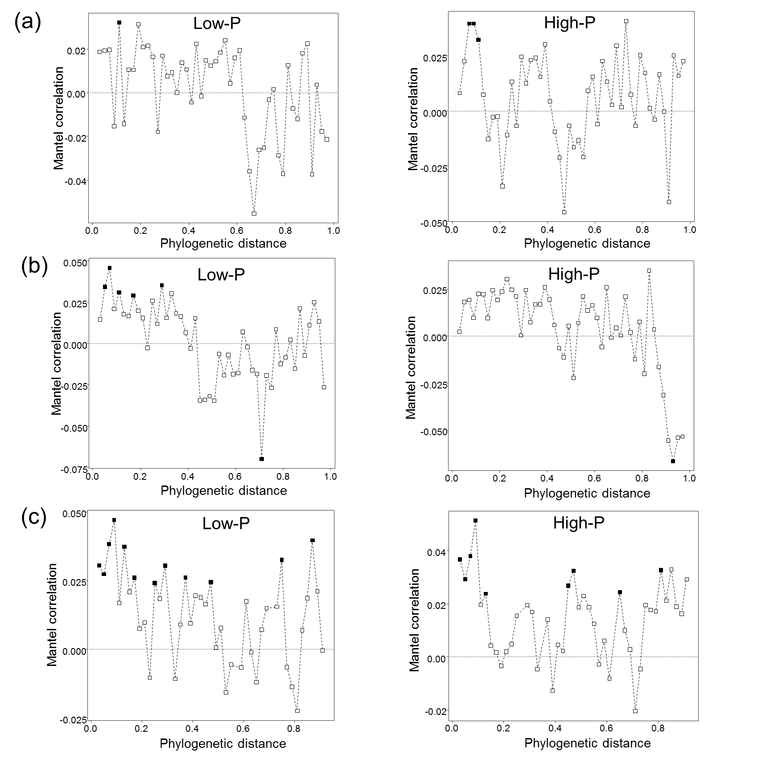

**Fig. S9** Phylogenetic Mantel correlogram showing significant phylogenetic signal across short phylogenetic distances in (a) BS, (b) RS, and (c) *phoD* bacterial communities with low-P and high-P fertilizer input. Solid and open symbols denote significant and nonsignificant correlations, respectively, relating between-OTU niche differences to between-OTU phylogenetic distances across a given phylogenetic distance.

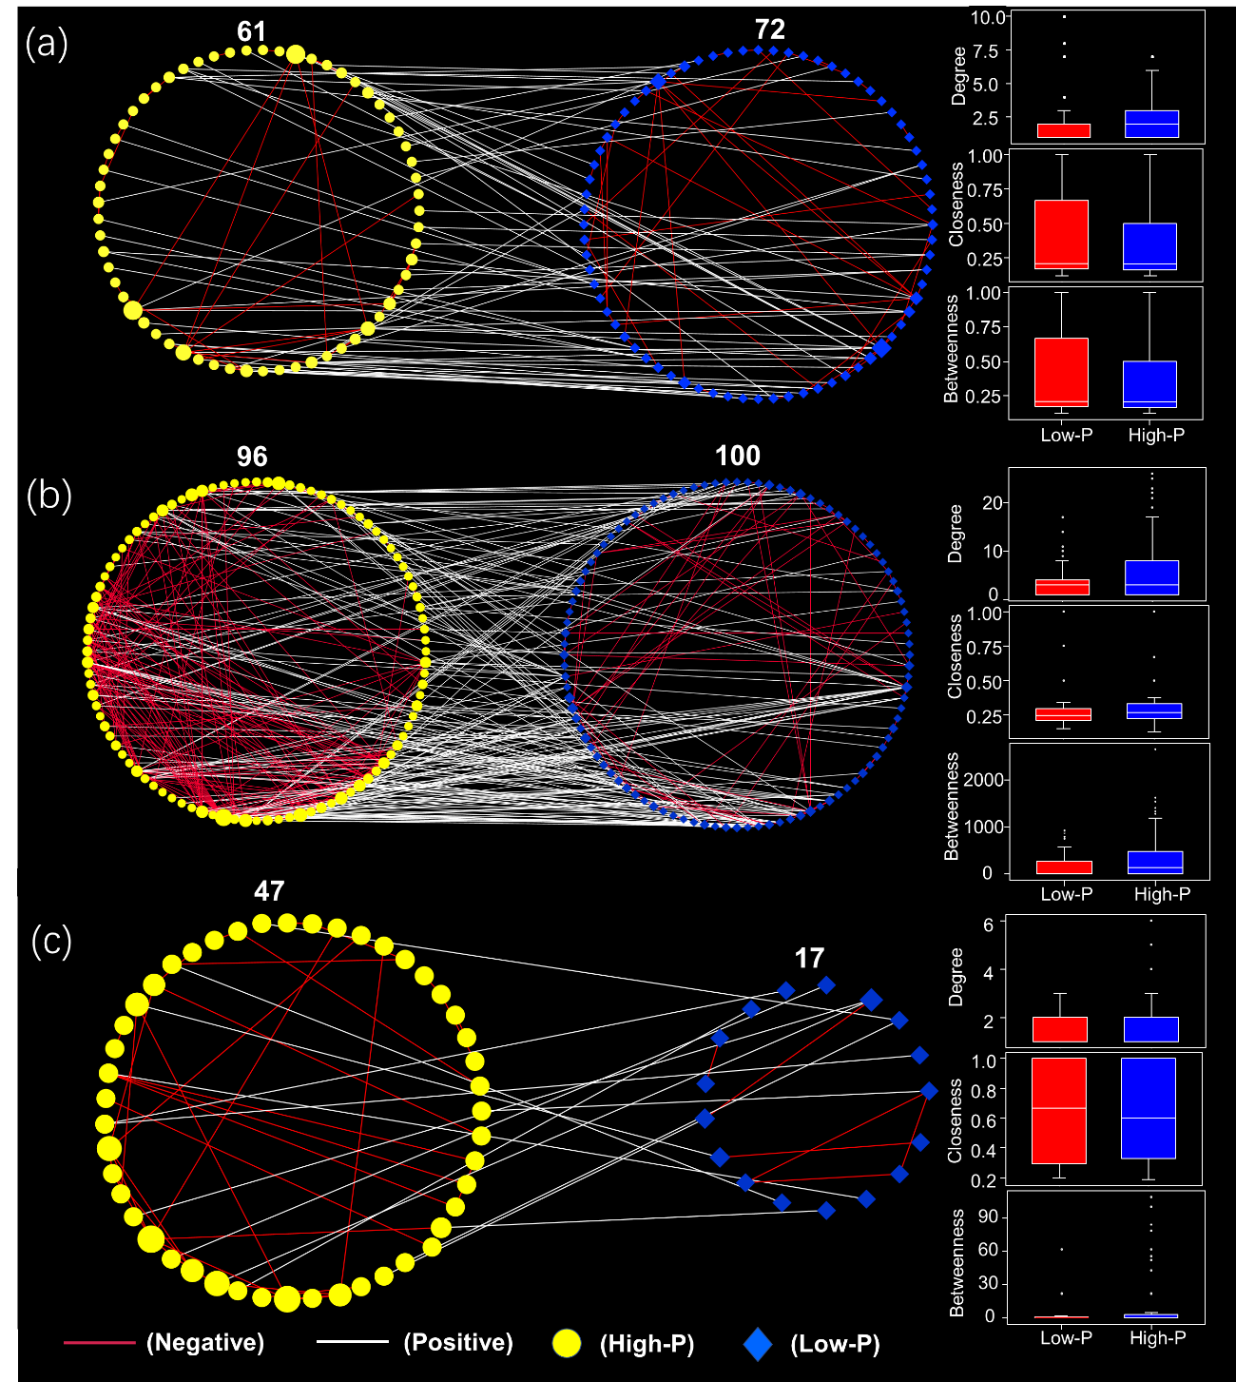

**Fig. S10** Metacommunity co-occurrence network of (a) BS, (b) RS, and (c) *phoD* bacterial communities with low-P and high-P fertilizer input. Each node represents a significantly enriched OTU in low-P and high-P fertilizer input, respectively. The basic topological properties of these networks are shown in Table S4.

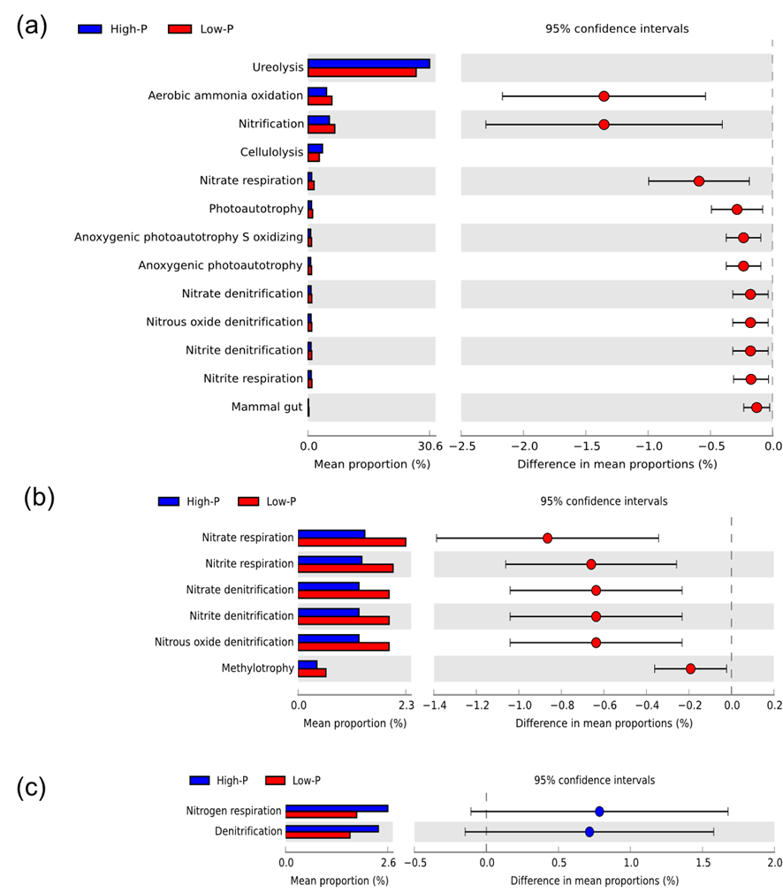

**Fig. S11** Variation analysis of the potential ecological functions of (a) BS, (b) RS, and (c) *phoD* bacterial communities with low-P and high-P fertilizer input based on FAPROTAX.

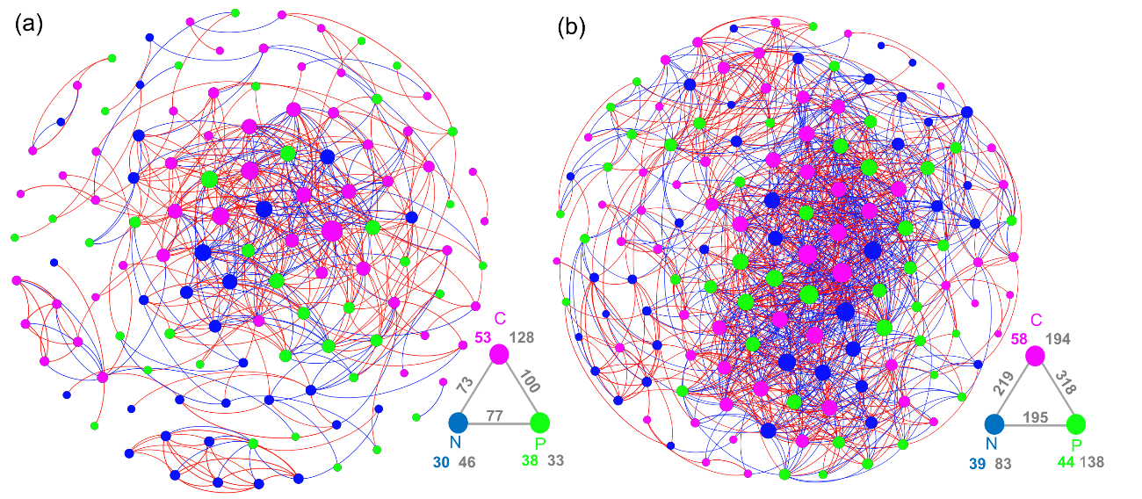

**Fig. S12** Occurrence network analysis showing genes involved in soil C, N, and P cycle under (a) BS and (B) RS bacterial communities. Nodes with pink, blue, and green colors represent soil C, N, and P genes. The colored line shows the correlation of the two nodes, with the red line for the positive relationship and the blue line for the negative relationship. The basic topological properties of these networks are shown in Table S6.

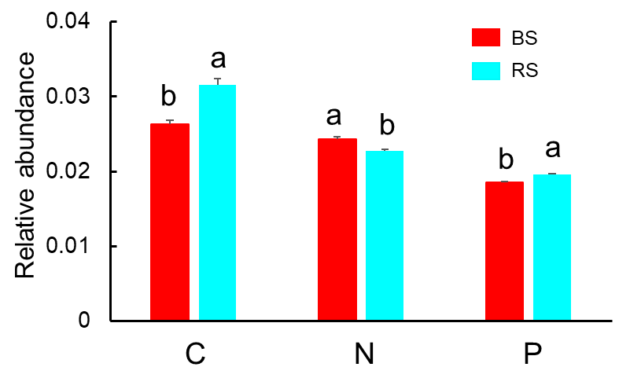

**Fig. S13** Difference in the relative abundance of soil C, N, and P cycle genes. Different letters in the same row mean a significant difference at *P* < 0.05 among the BS and RS bacterial communities (Duncan’s test).