**Lists of tables and figures:**

**Table S1**. **Summary of sequencing data from four long-term experimental sites.**

P0: no P fertilizer; P50: 50 kg P2O5 ha-1 year-1; P100: 100 kg P2O5 ha-1 year-1; P200: 200 kg P2O5 ha-1 year-1.

Please see the excel file (SM_Table S1.xlsx)

**Table S2**. **The KO number, COG numbers, function descriptions, gene name, and classification of the investigated genes related to the soil P cycle.** P0: no P fertilizer; P50: 50 kg P2O5 ha-1 year-1; P100: 100 kg P2O5 ha-1 year-1; P200: 200 kg P2O5 ha-1 year-1.

Please see the excel file (SM_Table S2.xlsx).

**Table S3**. **The soil biogeochemical properties in the four treatments.** *values are means (SD), Different letters in the same row mean significant difference at *P < 0.05* among the four treatments (Duncan’s test). P0: no P fertilizer; P50: 50 kg P2O5 ha-1 year-1; P100: 100 kg P2O5 ha-1 year-1; P200: 200 kg P2O5 ha-1 year-1. TP: total phosphorus; OP: Organic phosphorus; AP: available phosphorus; SOC: Soil organic carbon; DOC: dissolved organic carbon; NH4+-N: ammonium nitrogen; NO3--N: nitrate nitrogen; ALP: ALP activity.

Please see the excel file (SM_Table S3.xlsx).

**Table S4**. **The relative abundance of genera for bacteria.** (*) that follows the taxonomic name represents significant (*P* < 0.05) differences among the four treatments. P0 (without phosphate fertilizer), P50 (with a rate of 50 kg P2O5 ha−1 yr−1), P100 (with a rate of 100 kg P2O5 ha−1 yr−1), and P200 (with a rate of 200 kg P2O5 ha−1 yr−1).

Please see the excel file (SM_Table S4.xlsx).

**Table S5**. **The relative abundance of genera for fungi.** (*) that follows the taxonomic name represents significant (*P < 0.05*) differences among the four treatments. P0 (without phosphate fertilizer), P50 (with a rate of 50 kg P2O5 ha−1 yr−1), P100 (with a rate of 100 kg P2O5 ha−1 yr−1), and P200 (with a rate of 200 kg P2O5 ha−1 yr−1).

Please see the excel file (SM_Table S5.xlsx).

**Table S6**. **The relative abundance of genera for archaea.** (*) that follows the taxonomic name represents significant (*P* < 0.05) differences among the four treatments. P0 (without phosphate fertilizer), P50 (with a rate of 50 kg P2O5 ha−1 yr−1), P100 (with a rate of 100 kg P2O5 ha−1 yr−1), and P200 (with a rate of 200 kg P2O5 ha−1 yr−1).

Please see the excel file (SM_Table S6.xlsx).

**Table S7. The relative abundance of class for bacteria.** (*) that follows the taxonomic name represents significant (*P* < 0.05) differences among the four treatments. P0 (without phosphate fertilizer), P50 (with a rate of 50 kg P2O5 ha−1 yr−1), P100 (with a rate of 100 kg P2O5 ha−1 yr−1), and P200 (with a rate of 200 kg P2O5 ha−1 yr−1).

Please see the excel file (SM_Table S7.xlsx).

**Table S8 The relative abundance of class for fungi.** (*) that follows the taxonomic name represents significant (*P* < 0.05) differences among the four treatments. P0 (without phosphate fertilizer), P50 (with a rate of 50 kg P2O5 ha−1 yr−1), P100 (with a rate of 100 kg P2O5 ha−1 yr−1), and P200 (with a rate of 200 kg P2O5 ha−1 yr−1).

Please see the excel file (SM_Table S8.xlsx).

**Table S9 The relative abundance of class for archaea..** (*) that follows the taxonomic name represents significant (*P* < 0.05) differences among the four treatments. P0 (without phosphate fertilizer), P50 (with a rate of 50 kg P2O5 ha−1 yr−1), P100 (with a rate of 100 kg P2O5 ha−1 yr−1), and P200 (with a rate of 200 kg P2O5 ha−1 yr−1).

Please see the excel file (SM_Table S9.xlsx).

**Table S10**. **Basic topological properties of gene occurrence networks with the different treatments of P input.** P0 (without phosphate fertilizer), P50 (with a rate of 50 kg P2O5 ha−1 yr−1), P100 (with a rate of 100 kg P2O5 ha−1 yr−1), and P200 (with a rate of 200 kg P2O5 ha−1 yr−1).

Please see the excel file(SM_Table S10.xlsx).

**Table S11 Basic topological properties of PSMs occurrence networks with the different treatments of P input.** P0 (without phosphate fertilizer), P50 (with a rate of 50 kg P2O5 ha−1 yr−1), P100 (with a rate of 100 kg P2O5 ha−1 yr−1), and P200 (with a rate of 200 kg P2O5 ha−1 yr−1).

Please see the excel file(SM_Table S11.xlsx).

**Table S12 Basic topological properties of bacteria occurrence networks with the different treatments of P input.** P0 (without phosphate fertilizer), P50 (with a rate of 50 kg P2O5 ha−1 yr−1), P100 (with a rate of 100 kg P2O5 ha−1 yr−1), and P200 (with a rate of 200 kg P2O5 ha−1 yr−1).

(SM_Table S12.xlsx).

**Table S13 Basic topological properties of fungi occurrence networks with the different treatments of P input.** P0 (without phosphate fertilizer), P50 (with a rate of 50 kg P2O5 ha−1 yr−1), P100 (with a rate of 100 kg P2O5 ha−1 yr−1), and P200 (with a rate of 200 kg P2O5 ha−1 yr−1).

(SM_Table S13.xlsx).

**Table S14 Basic topological properties of aechaea occurrence networks with the different treatments of P input.** P0 (without phosphate fertilizer), P50 (with a rate of 50 kg P2O5 ha−1 yr−1), P100 (with a rate of 100 kg P2O5 ha−1 yr−1), and P200 (with a rate of 200 kg P2O5 ha−1 yr−1).

(SM_Table S14.xlsx).

**Table S15**. **The mantel test between the classified of soil P cycle genes and soil properties.**

Please see the excel file (SM_Table S15.xlsx).

**Table S16**. **The mantel test between the soil P cycle genes and soil properties (*P* <0.05).**

Please see the excel file (SM_Table S16.xlsx).

**Table S17. The mantel test between the PSMs and soil properties.**

Please see the excel file (SM_Table S17.xlsx).

**Table S18 Basic topological properties of functional co-occurrence network of PSMs and soil P cycle genes with the different treatments of P input.**

Please see the excel file (SM_Table S18.xlsx).

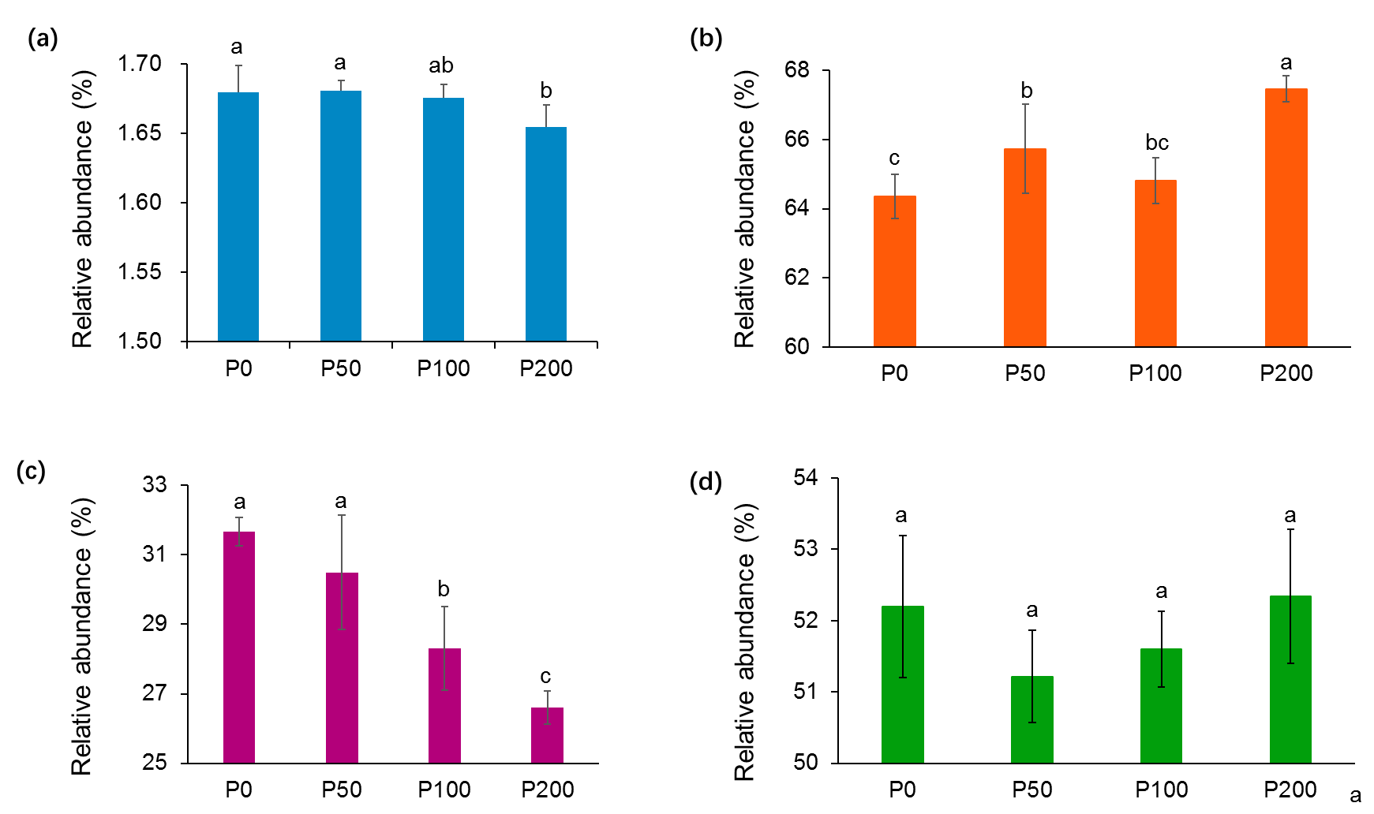

Fig. S1. Effects of long-term P input on the relative abundance of total soil (a) P cycle genes and PSMs ( b: bacteria, c: fungi, d: archaea). Different letters in the same row mean significant difference at *P* < 0.05 among the four treatments (Duncan’s test). P0 (without phosphate fertilizer), P50 (with a rate of 50 kg P2O5 ha−1 yr−1), P100 (with a rate of 100 kg P2O5 ha−1 yr−1), and P200 (with a rate of 200 kg P2O5 ha−1 yr−1).

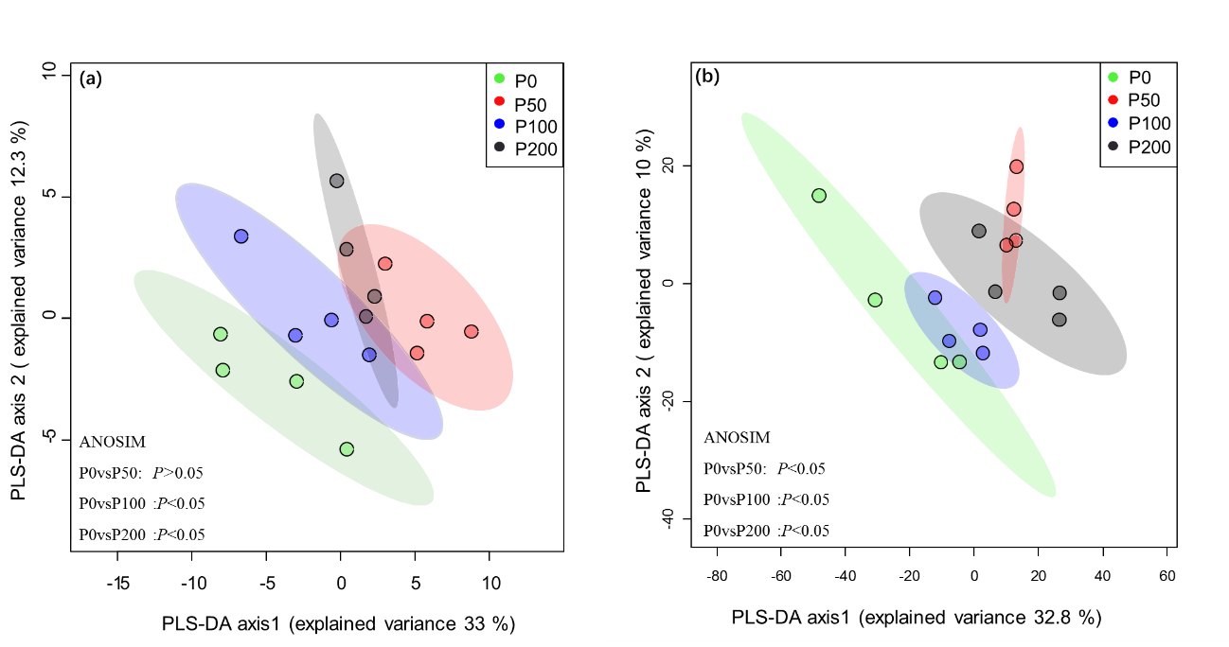

Fig. S2 Partial least-square discriminant analysis (PLS-DA) of (a) soil P cycle genes and (b) PSMs in the four treatments. ANOSIM were used to show the significant differences (*P* <0.05) in the soil P cycle genes and PSM compositions of the four treatments. Each colored dot represents a sample. P0 (without phosphate fertilizer), P50 (with a rate of 50 kg P2O5 ha−1 yr−1), P100 (with a rate of 100 kg P2O5 ha−1 yr−1), and P200 (with a rate of 200 kg P2O5 ha−1 yr−1).

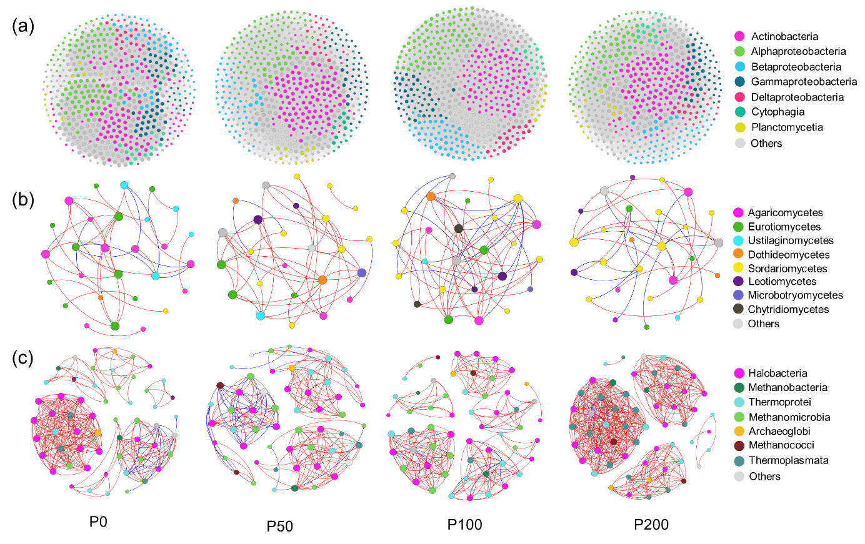

Fig. S3 Sub-networks for bacterial (a), fungi (b) and archaea (c). The node size indicates the strength of the connections with other nodes. Nodes with different colors represent the PSMs involved in different class level. The basic topological properties and their explanations of the four networks are shown in Table S7. P0 (without phosphate fertilizer), P50 (with a rate of 50 kg P2O5 ha−1 yr−1), P100 (with a rate of 100 kg P2O5 ha−1 yr−1), and P200 (with a rate of 200 kg P2O5 ha−1 yr−1).

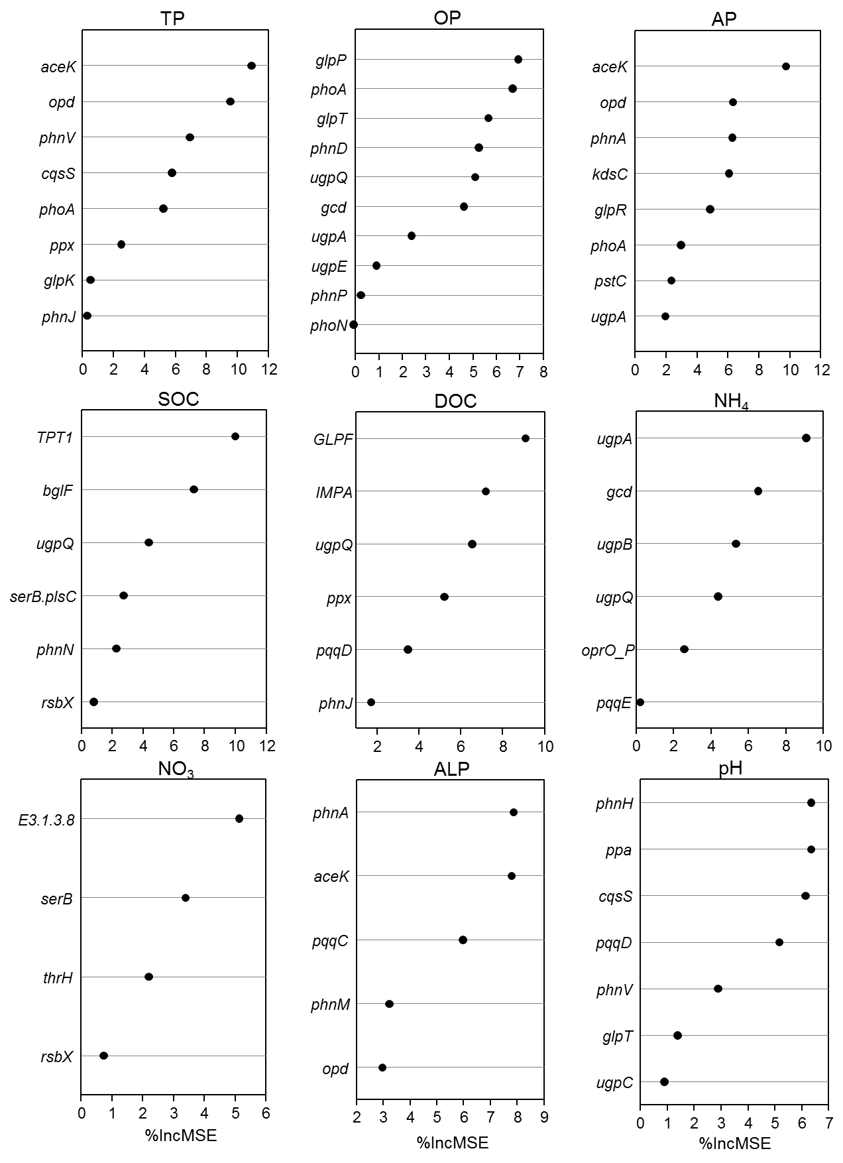

Fig. S4 Random forest analysis showed the associations between the soil P cycle genes and changes of environmental variables.

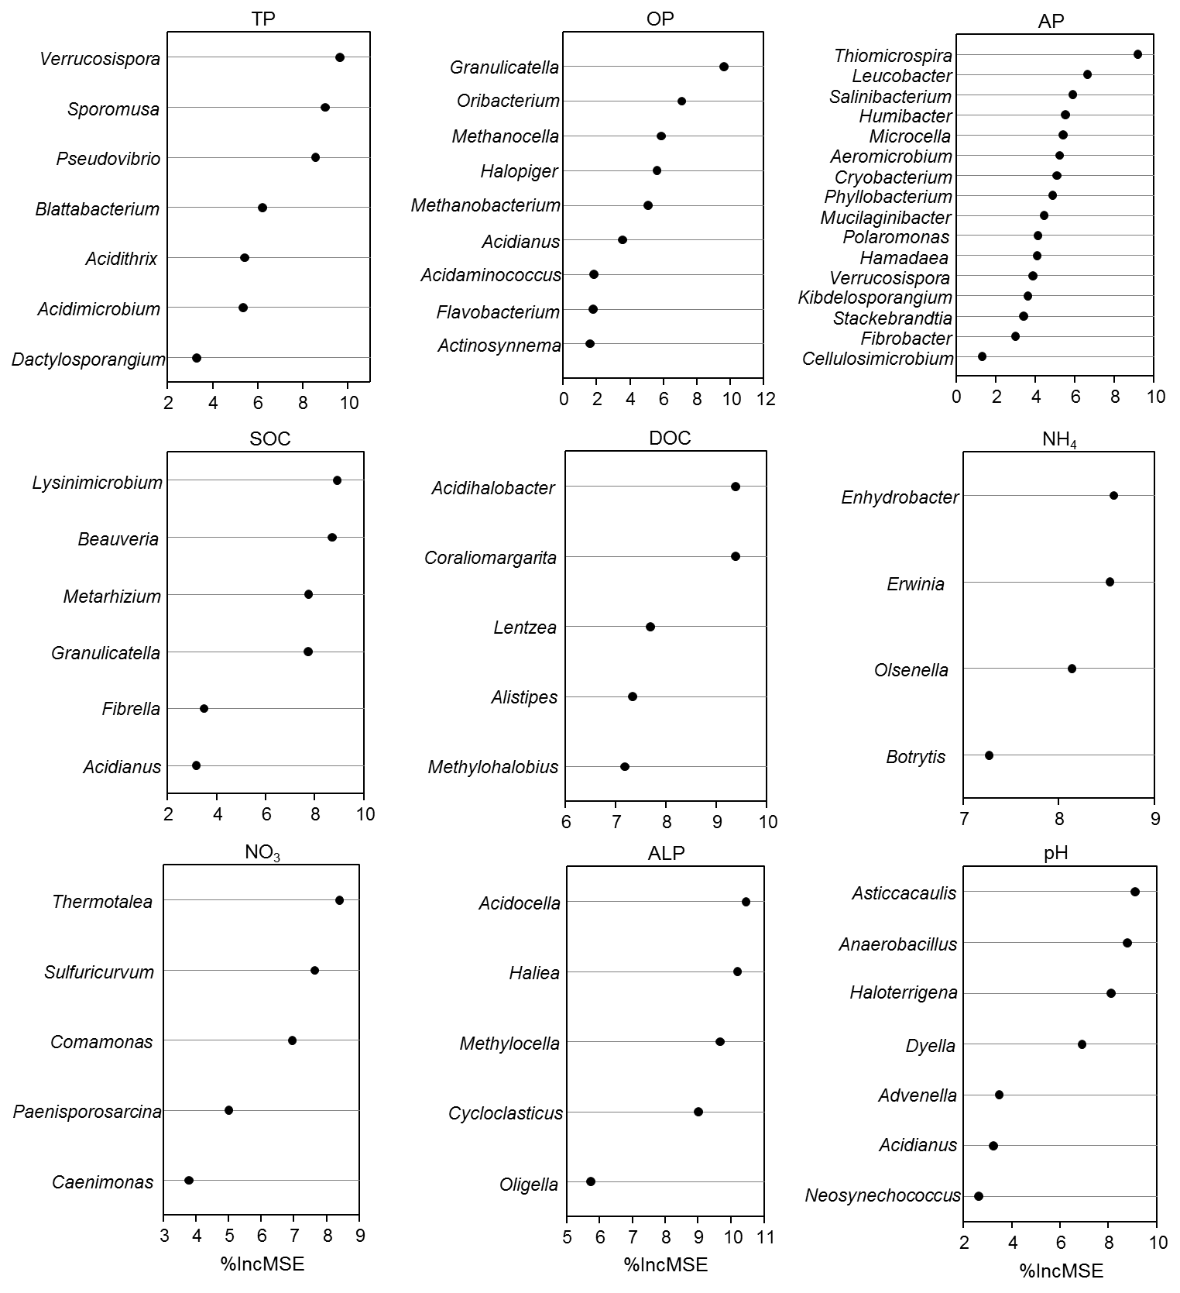

Fig. S5 Random forest analysis showed the associations between the PSMs and changes of environmental variables.

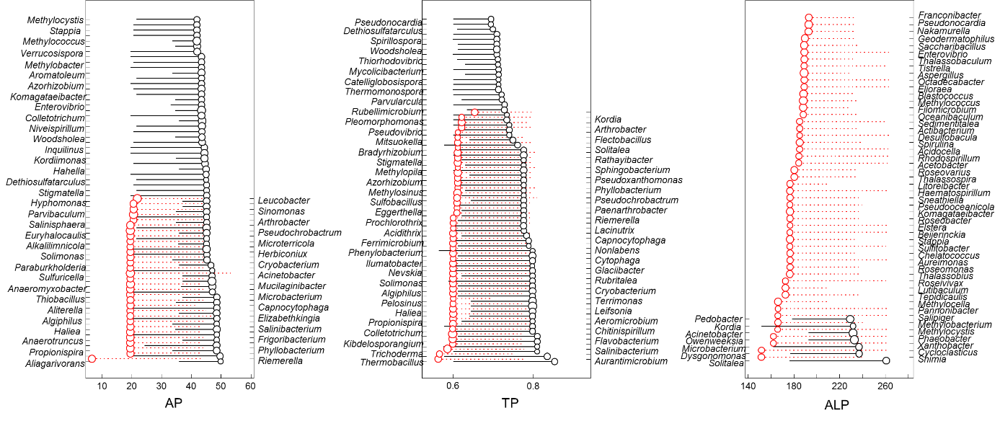

Fig. S6 Change of PSMs abundance concerning important environmental variables shown by threshold indicator taxa analyses (TITAN). Circles with red represent the genus increasing abundance and the circles with black represent the genus were declining abundance.