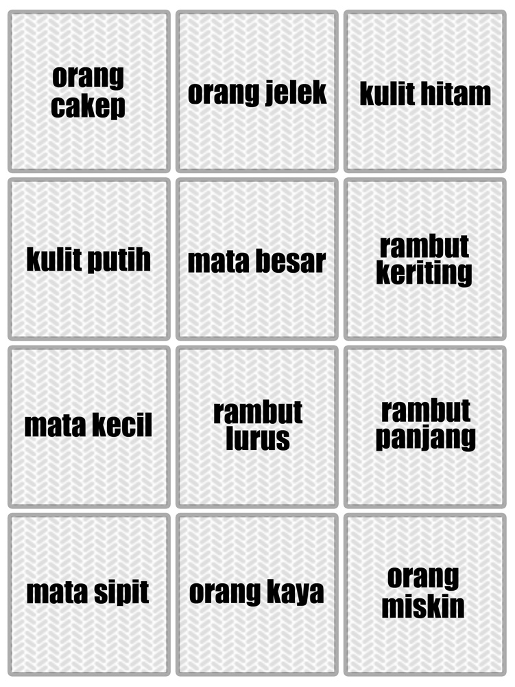
Kesabaran (Memory)

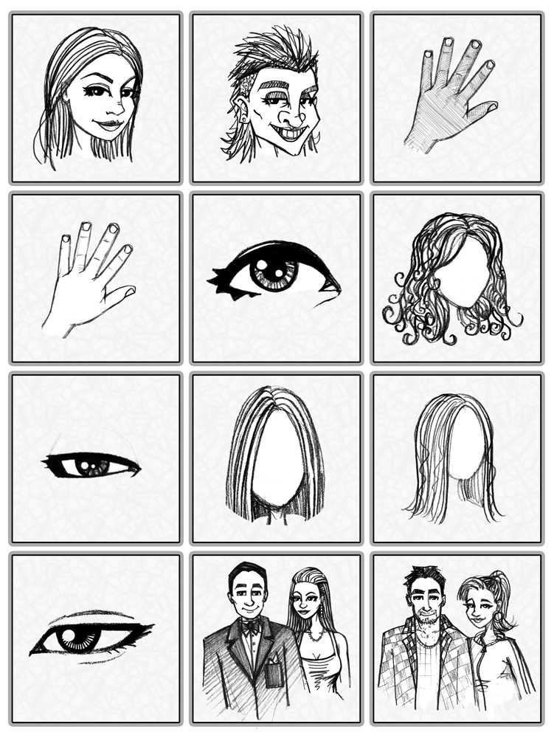  good-looking person | ugly person | black skin
white skin | big eye | curly hair
small eye | straight hair | long hair
slanted eye | rich people | poor people

