Tulislah!
Now use some of the language patterns demonstrated in creating descriptions to finish off Trish's blog entry about the following rooms.
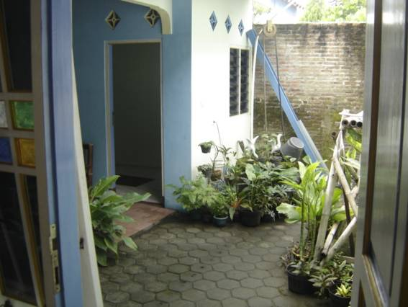
Reproduced with the permission of Wendy Young and Kees Vermey

Halaman

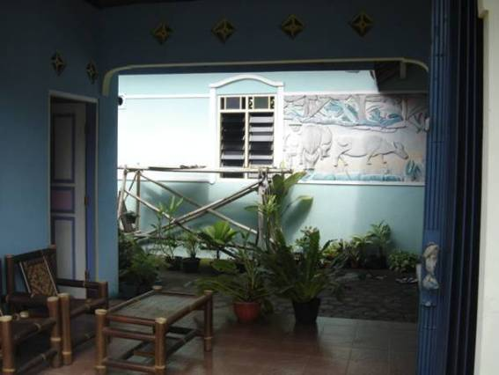
Reproduced with the permission of Wendy Young and Kees Vermey

Ruang duduk
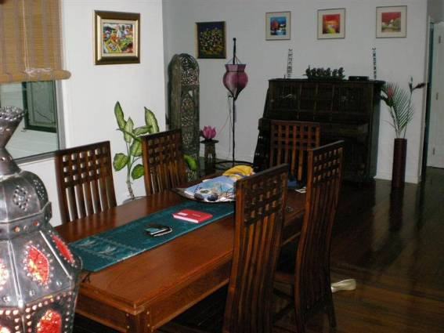
Reproduced with the permission of Piers Porter

Ruang makan

