Engage
Tugas 2
Bacalah secret code dong!
Wah, ada 3 SMS baru. Asyik … tapi … apa artinya? Tulislah pokok SMS, lalu balaskan. Write the main point of the message, then reply.
Listen to Audio CD – Track 3 for the voicemail.
When you have completed this activity, submit it to your teacher for assessment.
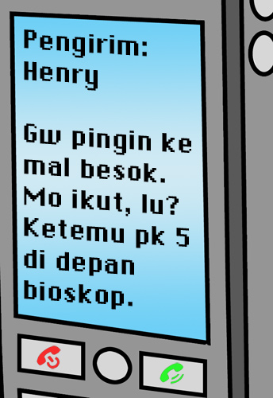 | Translation:
 | Reply:

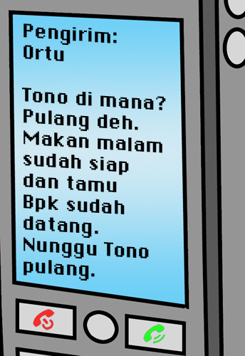 | Translation:
 | Reply:

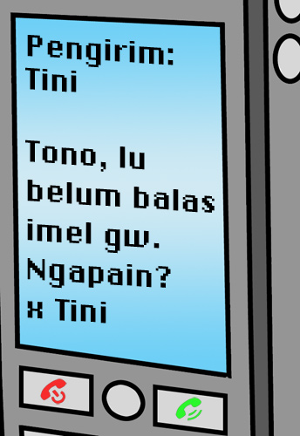 | Translation:
 | Reply:

