Tugas 7
Dengarkanlah orang² ini berbicara tentang rencananya untuk pulang mudik.
Listen to these people speak about their plans in Audio CD – Track 24. Find their destination.
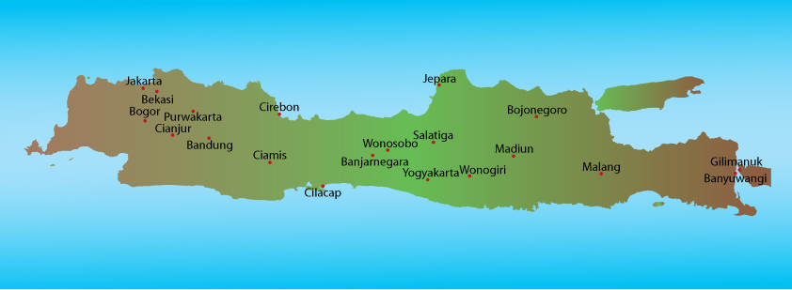

 | Destination
Tuti | Wonogiri
Mahmud | Banyuwangi
Heru | Bekasi
Vita | Cianjur
Brendon | Salatiga

