Tugas 5
2 |   ©2007 JupiterImages Corporation | 7 | 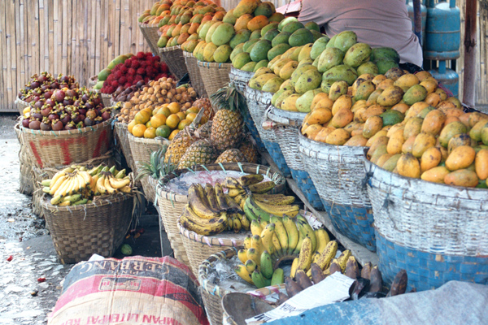  Reproduced with the permission of Katharina Popp
12 | 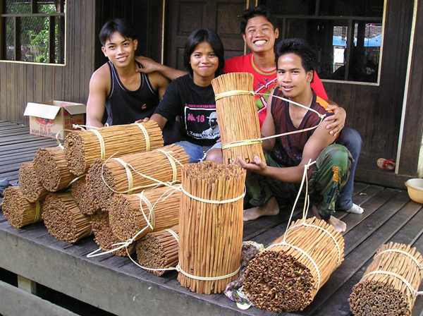  Reproduced with the permission of Jim and Robyn Nottingham | 3 | 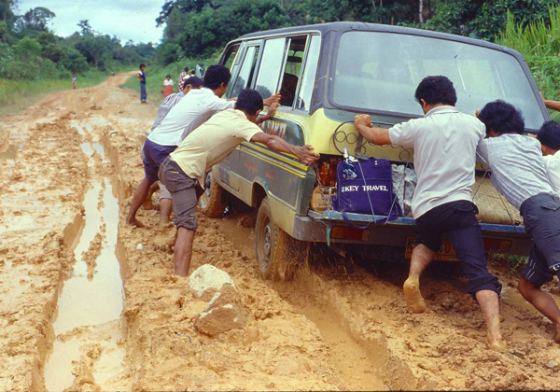  Reproduced with the permission of Jim and Robyn Nottingham
9 | 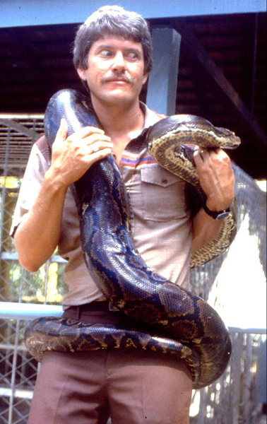  Reproduced with the permission of Jim and Robyn Nottingham | 5 |   Reproduced with the permission of Katharina Popp
4 | 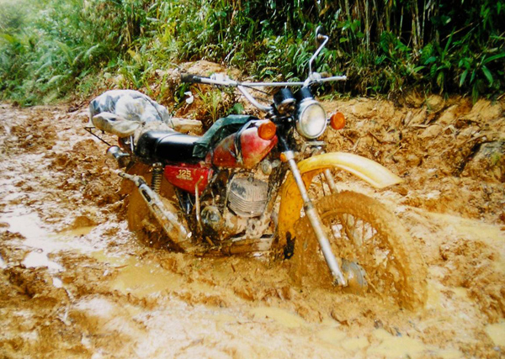  Reproduced with the permission of Jim and Robyn Nottingham | 11 | 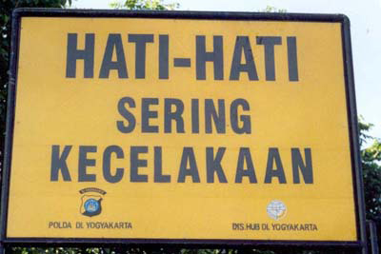  Reproduced with the permission of David Armstrong of www.foto-foto.com
8 | 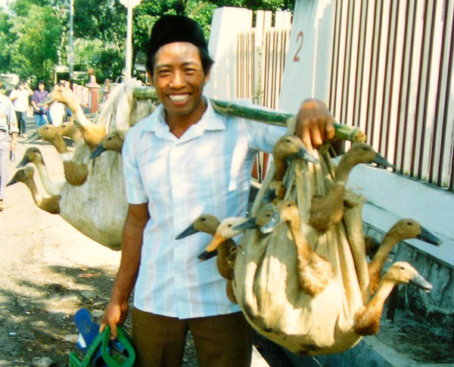  Reproduced with the permission of Jim and Robyn Nottingham | 10 | 
1 | 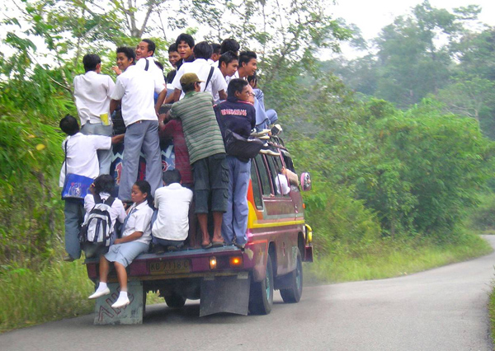  Reproduced with the permission of Jim and Robyn Nottingham | 6 | 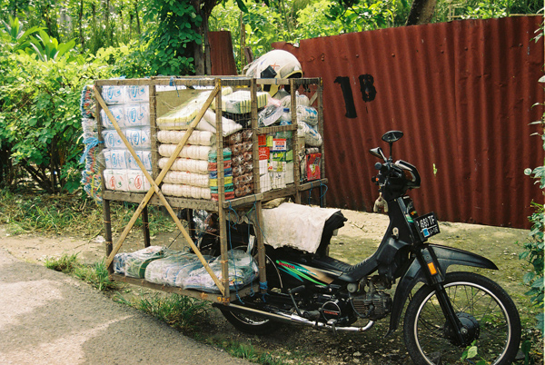  Reproduced with the permission of Gregory Grinham

