Tugas 7
Dengarkanlah orang² ini berbicara tentang rencananya untuk pulang mudik.
Listen to these people speak about their plans in Audio CD – Track 24. Find their Destination.

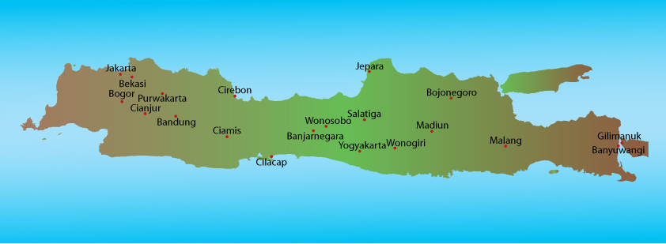

Destination
Tuti
Mahmud
Heru
Vita
Brendon

Click here to check answer.

