Tugas 5
Listen to Audio CD – Track 23, then put the order next to the following pictures in the sequence they were mentioned in the audio. For example, the second item mentioned in the audio was a computer.
2 |   ©2007 JupiterImages Corporation |  | 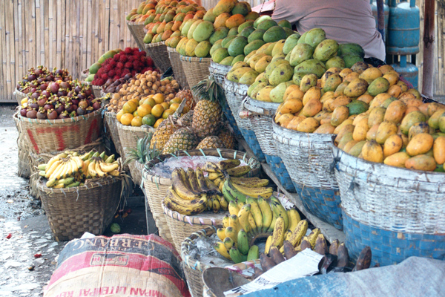  Reproduced with the permission of Katharina Popp
 |   Reproduced with the permission of Jim and Robyn Nottingham |  |   Reproduced with the permission of Jim and Robyn Nottingham
 | 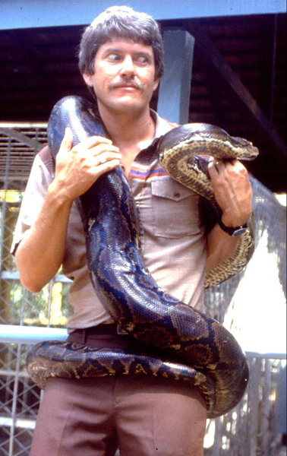  Reproduced with the permission of Jim and Robyn Nottingham |  |   Reproduced with the permission of Katharina Popp
 |   Reproduced with the permission of Jim and Robyn Nottingham |  |   Reproduced with the permission of David Armstrong of www.foto-foto.com
 | 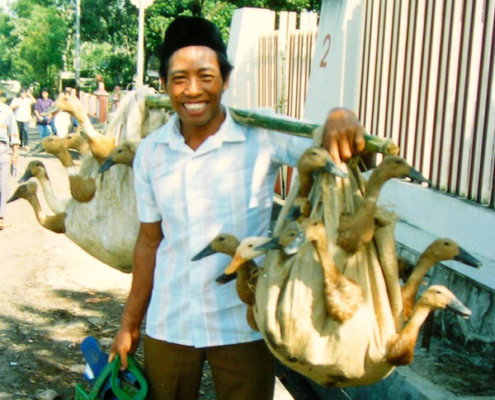  Reproduced with the permission of Jim and Robyn Nottingham |  | 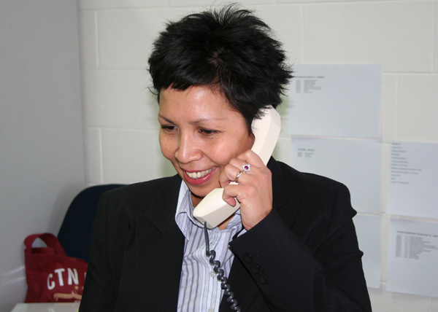
 | 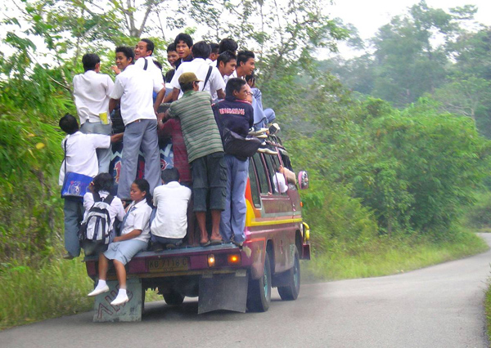  Reproduced with the permission of Jim and Robyn Nottingham |  | 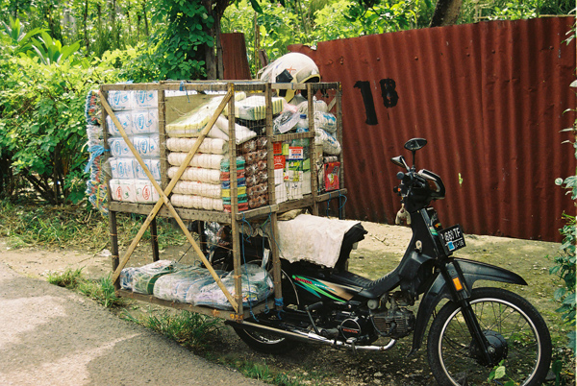  Reproduced with the permission of Gregory Grinham
Click here to check answer.

