Turisme

Engage 5

Cari informasi
Write the numbers of the shops onto the map provided, using the hotel as your reference point. Using a highlighter, trace the route Pak Nurhalim takes if he follows the concierge’s advice.
- RM Oleh-oleh
- Toko oleh-oleh
- Warung Kebab
- Apotik
- Bioskop
- Butik pakaian
- Restoran India

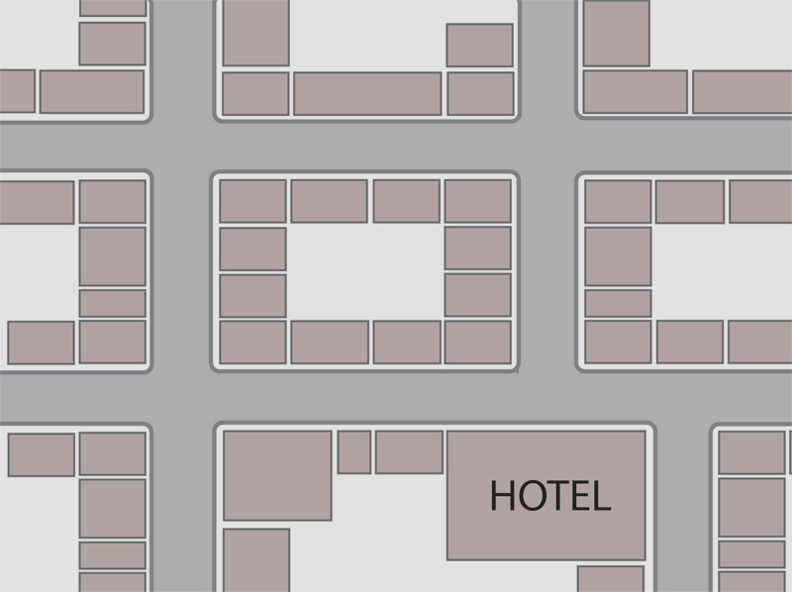

Click here to check answers.

