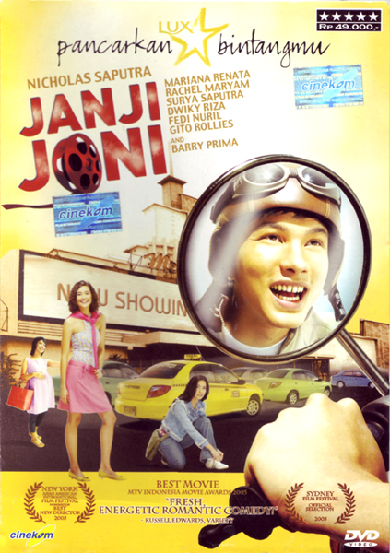
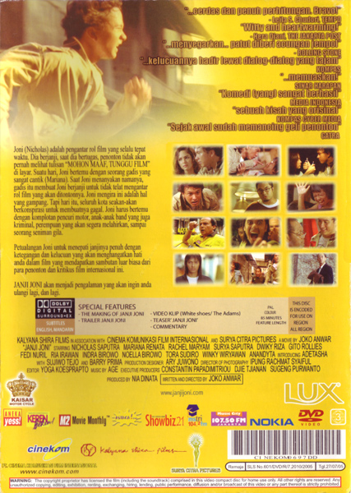
Reproduced with the permission of Kalyana Shira Films.
Gelar/Awards
Pengedar/distributor
Cewek cantik/love interest?
Foto aktor pokok
Film ini bertopik lalulintas
Simbol DVD
Judul/title
Film tentang film?
Nama bintang/star’s name
Harga/Price
Bintang/star-rating
Tanda dvd asli
Disponsori oleh Lux / sponsored by Lux

Sinopsis cerita

Direct address

Sponsor film

Informasi ttg resensi
Kode bar
Informasi film
Komentar kritikus film
Foto dari film
Sample – Reading the cover of a DVD
Text type  What sort of text is it? (what tells you this)  DVD cover of film Janji Joni  symbol for DVD  authentic copy | Audience  Who is the text for? (include how you know this)  Teens/adults (not a kids’ film – teenagers on cover)  Guys and girls – there are more girls on the cover so could be a chick-flick, but also motorbike and flight helmet so for guys as well, and main character looks like a guy. | Purpose  What is the purpose of the text? (eg to persuade/inform/entertain?)  To advertise the film (make people want to watch it)  Give information about the film
What other information can you gain straightaway? (eg from: title, subheadings, graphics, key words, cognates etc …)  Title: Janji Joni (Joni’s promise)  Cost: 49.000 rupiah  It’s won some awards.  Main character is a guy (Nicholas Saputra). | Predict  Before reading closely, what predictions or assumptions do you make about the text?  Film is about: a guy named Joni and 3 girls, and movies. Transport is important.  There’s a romance, maybe a love triangle; maybe his girlfriend is pregnant? | What do I need to know?  What do you need to find out? (eg key words to look up, questions to answer)  More about the plot  what the critics thought  Key words: cerdas, menyegarkan, memuaskan  pengantar  layar  gagal  komplotan  segera melahirkan  petualangan  mendapatkan sambutan

Persamaan dan perbedaan sampul DVD
Similarities and differences – DVD covers
example
Sponsorship NOT advertised on cover
Price usually not printed (up to individual shops)
Uses 1 language
Rating on front
Sponsorship advertised on cover
Price printed on cover
Uses 2 languages
Rating on back – not as clear
DVD Indonesia
DVD Australia
Comedies are popular
Large font title
Visually appealing
Images of main actors
Visual clues to theme/genre/plot
Includes rating
Info about extras
Kesimpulan (conclusions): Indonesian films are more multilingual, English being the main second language used. There is more sponsorship of Indonesian films. Both cultures have comedy as a genre.

