Elementi Culturali 1
Gli SMS 1
Carnevale in Italia 3
Città italiane 4
Aspetti di vita italiana aspects of Italian life 5

Elementi Culturali

Gli SMS
 | Reportage – I giovani e gli sms  In Italia circolano più di 36 milioni di cellulari e 89 ragazzi su cento (tra i 15 e i 24 anni) ha almeno un telefonino. Di questi l’83 per cento utilizza abitualmente l’SMS (in inglese Short Message Service) cioè, il sistema dei brevi messaggi.
This article is saying that 89 out of 100 young people between the age of 15-24 in Italia has at least one mobile phone. Of these, 83% use SMS regularly as a form of communication.

Some facts:
In Italia: 18 billion SMS messages, an average of 49 million a day.
In Australia: 4 billion SMS messages, an average of 294 messages per mobile phone.
Gli SMS is a craze that has hit Italy and the world! For young people it has replaced the phone as a way of interacting with friends and family.
I ragazzi all love to send SMS messages even though most of the messages sent have no real importance – in fact are inutili unnecessary!
The SMS craze is creating problems in schools where gli studenti students become distracted as they are busy sending and reading sms messages instead of being focused on their work in class. Lessons are often interrupted by the ringing of mobiles but the vast array of personalised ring tones are very creative!
The result is a new way of communicating using chat line style language and ‘emoticons’. (dall’ inglese emotion and icon).
Here are some of the most frequently used emoticons in italia.
Can you guess what they mean in inglese? Prova!
: -* bacio |  | :- D felice
[ ] baci e abbracci |  | : - v parlare
:- ( triste |  | : - 9 mi piace
: - ) sorridere, sorriso |  | : “ ( sto male

Tocca a te! Your turn!
I giovani young people/youth australiani Australian e gli SMS
How has the SMS craze affected young Australians?
Find out some facts and details about the use of SMS as a means of communication by i giovani young people in Australia.
La situazione the situation è simile similar in Australia?
Do some research on the Internet and write up your findings in this worksheet_gli_sms.

Carnevale in Italia
L’Italia con un clic!
È tempo di carnevale! It is carnival time | 
Carnevale in Italy is a winter festival celebrated with parades, masquerade balls and parties. Mischief and pranks are also common during the festival. As people say, A carnevale ogni scherzo vale! Anything goes at carnival!
Carnevale carnival is celebrated in Italy and many places around the world 40 days before Easter, a final party before Ash Wednesday and the restrictions of Lent. Although Carnevale is actually one date, in cities like Venice and Viareggio celebrations and festivities usually begin a few weeks before.
Il carnevale di Venezia the Venice Carnival: Carnevale da brividi thrilling
Il carnevale di Venezia the Venice Carnival is the most internationally known festival celebrated in Italy, as well as one of the oldest.
Maschere masks are an important part of carnevale and Venezia is the best city for traditional masks.
Andiamo a Venezia a vedere! Let’s go to Venice and have a look.
Vai al sito go to the site www.yahoo.it and cerca search for Carnevale di Venezia.
You will be amazed at how many sites exist! You may want to refine the search by putting in the year of the most recent festival.
Buon divertimento! Have fun!
Cosa hai scoperto? What did you discover?
Do some research on the Internet and write up your findings in this worksheet_carnevale.
Un consiglio A bit of advice
If you ever have the opportunity, make sure you visit Venezia at Carnevale time. It is a breathtaking experience! Un Carnevale da brividi! thrilling
Venezia ti aspetta! Venice is waiting for you!
To read about a personal experience of the Carnevale di Venezia, go to Extra – Una cartolina da Venezia. [Link back to parent window? A1.extra.htm?]
These are from the internet and give a good idea of the carnevale in Venice. Obviously cannot be used.
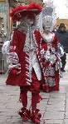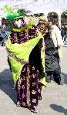

Città italiane
ITA 1A book 1 Graphic 59 incontri elementi culturali città italiane
Speak to Maria for clarification Gina will search LO in Indonisian and French
IS IT POSSIBLE TO HAVE A PICTURE GALLERY here of the 4 cities where the students come from eg Roma Firenze, Torino and Bologna.
Photos of these teenagers Roma, Firenze, Torino, Bologna
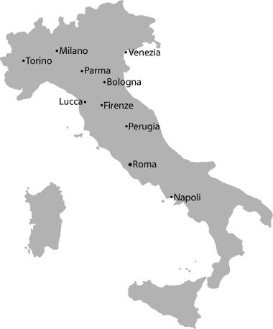
How can this be presented in a jazzy way??
I have SOME personal photos of Bologna and Roma
Can we access others off Photo shop?
L’Italia è bella! Italy is beautiful. È stupenda, vero? It’s stupendous, isn’t it?
To see more of these cities simply go on the Internet! There is a wealth of information and visual material.
L’Italia can come to you - l’Italia con un clic! Italy with a click!
Comincia begin, dai! come on Cosa aspetti? What are you waiting for?
Discover il fascino fascination d’Italia for yourself by begin your search at www.yahoo.it Buon viaggio! Have a good trip!

Aspetti di vita italiana aspects of Italian life
3 tabs to show 3 different aspects
Il bar | La gelateria | Guardare le vetrine
In Italy bar and il caffè are synonomous terms. All over Italy you will see these signs everywhere as coffee is an Italian passion!. I giovani young people often meet at il bar primarily for un caffè a coffee, una pasta a pastry or un panino a roll. The concept of an Italian bar is different to what you find in Australia. It is more like a café in Australia, the difference being that alcohol is available.  Even though alcohol is available there is no age limit for entry to the bar but people under 18 cannot be served alcoholic drinks.  However, i giovani go to il pub or la birreria pub if they want to drink alcohol. These are similar to the concept of the Australian pub. You need to be 18 years old to go to a pub, the same as in Australia.  To view some Italian bars visit the following siti web |  | Picture here

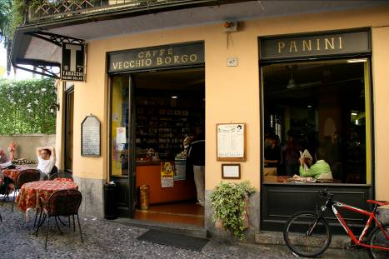

Il bar | La gelateria | Guardare le vetrine
Going to La gelateria is another integral aspect of the Italian way of life, especially in the summer period.  Having un gelato an icecream in Italy means going to la gelateria for an ice-cream cone and a choice of so many gusti deliziosi. delicious flavours.  Everyone loves il gelato – young or old. There is no age barrier! It is considered to be Italy’s most popular dessert.  For a virtual tour of two famous gelaterie in Italia explore the following siti web  Gelataria Gianni in the city of Bologna www.gelateriagianni.com  Giolitti in the city of Roma www.giolitti.it  Buon divertimento!have fun |  | Picture here
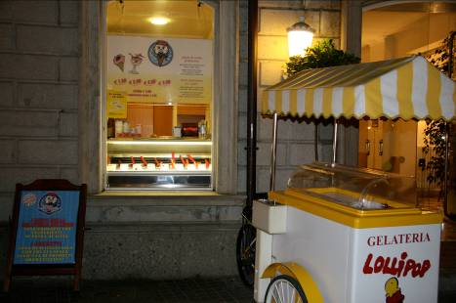

Il bar | La gelateria | Guardare le vetrine
Guardare le vetrine ! Window shopping! Che passione!  In Italia an important component of shopping is guardare le vetrine! Italians love going for a passeggiata in centro a walk in the city centre. Part of this ritual involves window shopping. You can’t blame them! Italian shop windows are so attractive and artistic!! Furthermore, when it comes to la moda fashion Italians are world leaders producing exquisite fashion.  Window shopping serves another purpose! In Italy when you go into a shop it is customary to ask for what you want rather than browse like in Australia. Having looked at le vetrine many times, they know exactly what they want. |  | Picture here
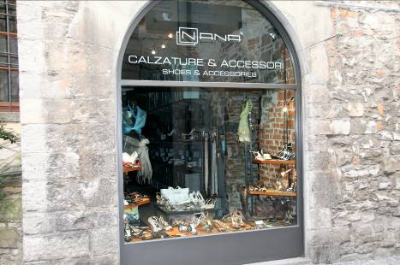

Some kind of title here…perhaps ‘Activity’ or ‘Let’s compare’….
Make a list of all the Italian influences that you can see in Australia/Perth. Focus especially on the areas that have been mentioned here – il bar, la gelataria, guardare le vetrine.

L’Italia in Australia
Text box
Text box
Text box
Text box
Text box
Non ci credo! I can’t believe it!
There are so many things that are italiani in Australia!

