Conosciamoci – Activity 4 De che tipo è?


Come sono queste persone? Cerca di immaginare!
Look at the pictures. What do you imagine the people to be like? Write a brief
description using sentences in the spaces provided.

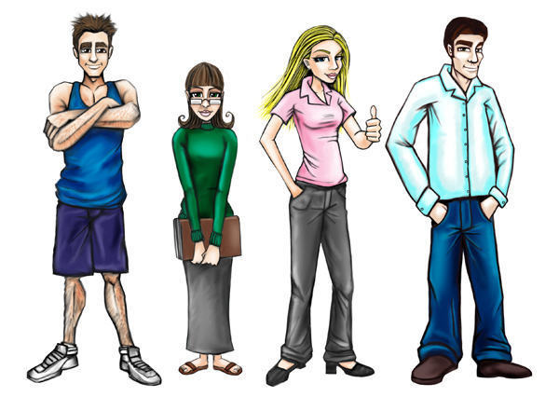
Character 1 | Character 2 | Character 3 | Character 4

Character 1
Character 2
Character 3
Character 4

