Musica e cinema! – Activity 2



Esercizio 2
In this activity you will be exposed to common termini (terms) that you will come across when doing a music search on Italian websites.
 | If you wish, you may explore www.yahoo.it and select musica to help you with the terms.
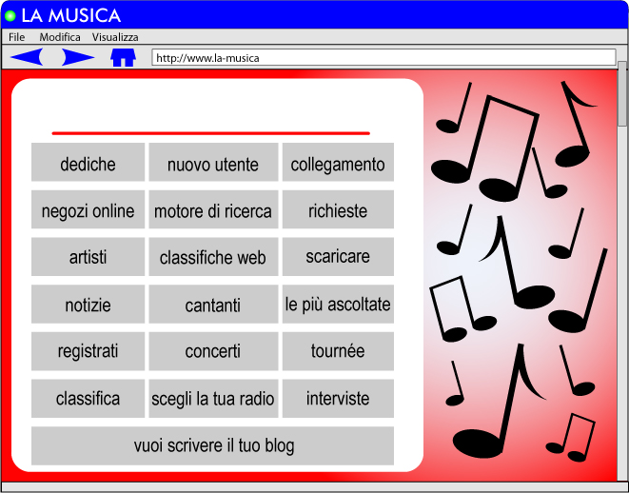
Select the correct termine from above for the following situations when doing an Italian Internet search on la musica.
You want to view the top ten charts.
You are a new user and would like to register.
You would like to request or dedicate a song to someone.
You would like to download some music.
You want to find out what the most listened to songs are.
You want to find out information about your favourite singer/group and/or listen to an interview.
You would like to buy the latest CD of your favourite group online.
You want to choose a radio station to listen to.
You want to try a new search engine.
You need to link to another site.
You want to find out the latest news in the music world.
You would like to write a blog.
You would like to go to a concert.

Now that you are familiar with the terms, go on to the Internet activity Extra: La musica in Italia. This will give you an excellent insight into the Italian world of music and you will be able to discover what your peers listen to in Italia.
Similar words in the two languages are not limited to the growing number of technological terms. Many words of a traditional nature also have many similarities.
Compare the following English word endings with the Italian word endings.
English | Italian
–ble (possible) | –bile (possbile)
–tion (creation) | –zione (creazione)
–ion (confusion) | –ione (confusione)
–ty (ability) | –tà (abilità)
–al (local) | –ale (locale)
–nce (violence) | –nza (violenza)
–ive (positive) | –ivo (positivo)
–ary (necessary) | –ario (necessario)
–ous (furious) | –oso (furioso)

Esercizio 3
Using the rules above, work out the Italian for these English words.
musical
information
incredible
identity
intelligence
creative
anniversary
famous
television
quantity

Esercizio 4
English words which end in –y usually change to –ia in Italian.
Work out the Italian for these English words.
allergy
biology
energy
industry
technology

Remember that these rules do not apply all the time.
Look through the material that you have covered so far in this unit. Find as many other words that follow these rules as you can. List them in the space provided.

Click on the button to check soluzioni.



Esercizio 2
You want to view the top ten charts.
classifica | classifiche web
You are a new user and would like to register.
nuovo utente | registrati
You would like to request or dedicate a song to someone.
dediche | richieste
You would like to download some music.
scaricare
You want to find out what the most listened to songs are.
le più ascoltate
You want to find out information about your favourite singer/group and/or listen to an interview.
artisti | cantanti | interviste
You would like to buy the latest CD of your favourite group online.
negozi online
You want to choose a radio station to listen to.
scegli la tua radio
You want to try a new search engine.
motore di ricerca
You need to link to another site.
collegamento
You want to find out the latest news in the music world.
notizie
You would like to write a blog.
vuoi scrivere il tuo blog
You would like to go to a concert.
tournée | concerti

Esercizio 3
musical | musicale
information | informazione
incredible | incredibile
identity | identità
intelligence | intelligenza
creative | creativo
anniversary | anniversario
famous | famoso
television | televisione
quantity | quantità

Esercizio 4
allergy | allergia
biology | biologia
energy | energia
industry | industria
technology | tecnologia

