Musica e cinema! – Activity 6 Voglia di cinema!



Esercizio 1 – Diary extract
Jot down in your diary the activities that you have planned so far for the holidays. This will make it easier to select a suitable time.
- Write the dates for the holiday week.
- Write the commitments that you have so far in Italian.
For example:
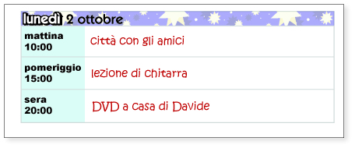
lunedì
Evviva! Incominciano le vacanze.

martedì
mercoledì
giovedì
venerdì
sabato
domenica

Esercizio 2 – Cosa danno al cinema?
Check to see which films are on at the cinema at the moment.
Use a relevant source to access this information.
Select a few that you are interested in seeing and write down the details.
Titolo  (Title) | Genere (di film)  (Genre) | Cast (attori)  (Actors) | Regista  (Director)
Prepare questions that you may ask/suggestions that you may make.
What details of the outing may the other person want to know?
What suggestions may the other person make?
Prepare possible responses to these questions in the space provided.

Appunti
Cosa chiedere (what to ask) | Come rispondere (how to reply)
Sei libero/a mercoledì pomeriggio?
When you are ready, make the phone call.
 | This is not a rehearsed, scripted role play. However, you can be very well prepared by being familiar with the appropriate language and expressions relevant to organising an outing to the cinema.

