Una dieta sana – Activity 10 Voglia di pizza!

Pizza al taglio in Italy
What is pizza al taglio?

Where did the concept begin?

How is it different from normal pizza?

Is it popular in Italy?

When is it eaten?

Delizioso café
When did it open?

Why did Raffaele decide to open a pizza al taglio instead of a normal pizzeria?

Is the concept of pizza al taglio popular in Perth?

Raffaele’s success as a pizza maker
Where did he learn to make pizza?

Why are his pizzas so good?

What type of oven are the pizzas cooked in at Delizioso Café?

Name some of the awards that he has won.

Does he have a favourite pizza which he makes for competitions?

The following is Delizioso’s Café pizza al taglio menu. Are you tempted?
La pizza è veramente strepitosa! Ci devi andare!!
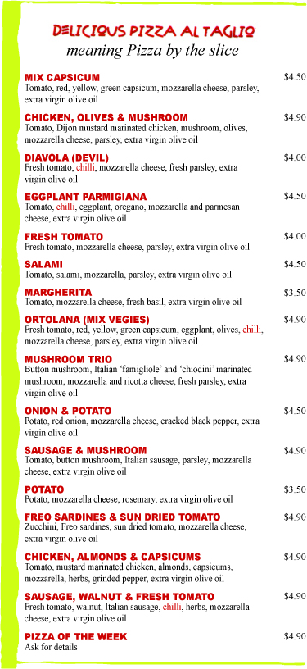

Vuoi fare la pizza?
Pizza margherita.
Ingredienti
Condimenti (toppings)

Preparazione
1.
2.
3.
4.
5.
6.

