Una dieta sana – Activity 7 I pasti di Matteo in Italia
Differences in eating habits |  | 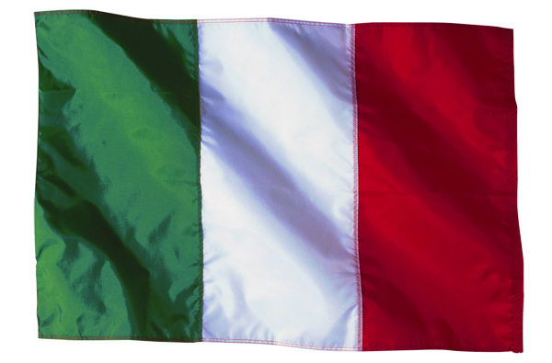  Matteo | 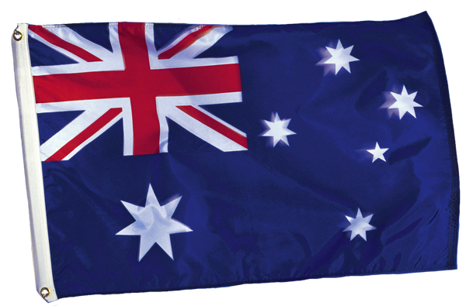  Tu
Mealtimes | lunch
Mealtimes | dinner
What does the meal consist of? | breakfast
What does the meal consist of? | lunch
What does the meal consist of? | dinner
What does the meal consist of? | snack
Where are meals eaten? | breakfast
Where are meals eaten? | lunch
Where are meals eaten? | dinner
Where are meals eaten? | snack
How does Matteo answer this question? Write your answer in English.
Matteo, quali sono le differenze tra consumare il cibo in Italia e in Australia?
Click on the button to check soluzioni.

Tocca a te!
Imagine that you are on exchange in Italy. You have been asked to speak to a class on the topic of meals and eating habits in Australia. You have now experienced Italian meals and are in a position to make a comparison and be aware of some of the differences.
What can you say?
Vuoi fare bella figura? (Do you want to make a good impression?) Prepare yourself well for this interaction.
Begin by looking at the different meals.
What is generally eaten for the various meals? Jot down your answers in italiano.
Appunti
Colazione
Pranzo
Cena
Spuntini

 | To show your understanding of the differences between the meals in Italy and Australia, try and highlight these differences. For example: In Australia faccio una colazione abbondante. Di solito mangio cereali, yogurt e un frutto e bevo un succo di frutta. In Italia invece …
The Italian students will want to ask you questions. Be prepared for possible questions. You need to be flexible! Listen again to the questions that la Prof asks Matteo to get an idea of possible questions and make a list of possible questions and responses below:
Domande | Le tue risposte


Differences in eating habits |  | Matteo | Tu
Mealtimes | lunch | 1:45pm
Mealtimes | dinner | usually 8pm.  in summer about 9.30pm
What does the meal consist of? | breakfast | cappuccino, two pastries, a roll and a hot drink
What does the meal consist of? | lunch | pasta, meat, vegetables, fruit
What does the meal consist of? | dinner | pasta and a main course  ice-cream or fruit as dessert
What does the meal consist of? | snack | usually does not have snacks – sometimes pizza al taglio (by the slice).
Where are meals eaten? | breakfast | cappuccino at home  has the rest of his breakfast at the café
Where are meals eaten? | lunch | at home because school finishes at 1.00pm
Where are meals eaten? | dinner | at home
Where are meals eaten? | snack | in a pizza al taglio
How does Matteo answer this question? Write your answer in English.
Matteo, quali sono le differenze tra consumare il cibo in Italia e in Australia? |  | Italians are more selective and attentive/careful about food.  They are more traditional and fussy.  Food is very important. | They are less rigid, more open to new ideas and different cuisines.

