Benvenuti al nuovo corso d’italiano online!
Learning another language is a cultural experience. It opens new doors and expands your outlook on life. In today’s global world, knowledge of a foreign language can paly an important role in providing opportunities for employment overseas.
Modern technology makes language learning lots of fun. The Internet is changing the way language is learnt. Chat, email, forums, virtual tours, accessing authentic material are just some of the ways in which language can be used. Language is dynamic, authentic and immediate.
You will be working primarily online. If you don’t have Internet access use the course materials from the eLearning CD-ROM.

How to navigate around the course
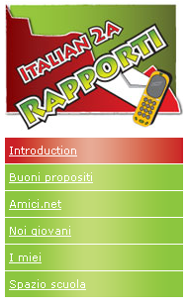 | There are five main topics in Unit 2A. These are entitled:  - Buoni propositi  - Amici.net  - Noi giovani  - I miei  - Spazio scuola  Each topic contains four sections:  Introduce (I) – provides an overview of the topic.  Discover (D) – provides the resources to help you work through the attività in the Engage section.  Engage (E) – provides you with a range of tasks to practise the language in a variety of contexts.  Apply (A) – gives you an opportunity to apply your skills and knowledge.

Click on I, D, E & A on the top right hand corner to navigate between these four sections.
Navigate around the course to get a feel for how things work. Enjoy!

Signposts
Throughout the course signposts are used to explain the type of activity you will be doing and to give you extra information.
 | Writing activity |  |  | Come si dice  (Vocabulary)
 | Listening and Responding activity |  |  | Elementi linguistici  (Linguistic elements)
 | Viewing, Reading and Responding activity |  |  | Elementi culturali  Culture elements
 | Spoken interaction |  |  | Rifletta un po  (Reflection)
 | Esercizi linguistici  (Language practice) |  |  | Attenzione!  (Attention)
 | Internet activity |  |  |  | Listen to the audio

