L’estate Gianluca Grignani
Depending on the result of your search, watch the video clip/listen to or read the words of the song.
Listen to/read the words several times to help you understand the content of the song.
- Identify words and expressions that are related to the summer theme, ie il sole. Use the explosion chart to write the words/expressions.
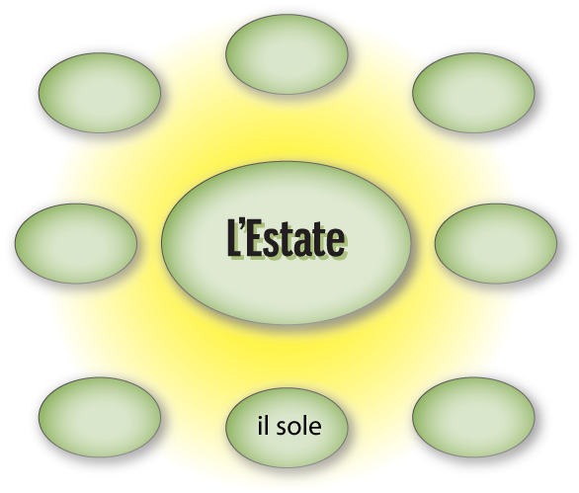
- Which characteristics of L’estate is the singer expressing in the song?

- Which ones do you think relate specifically to the Italian summer scene? For example il traffico.

