Rapporti commerciali
- Complete the following fact sheet about trade relationships between Australia and Italy. Write your answers in English.
Exports  Australia → Italia  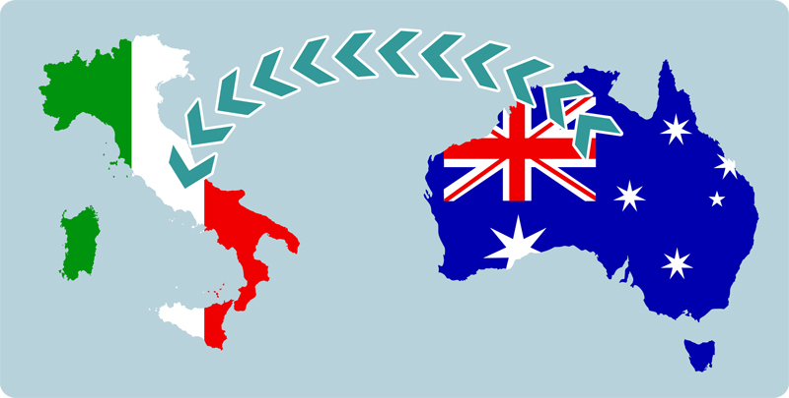 | Value of exports | Key industries | Growth industries
Exports  Italia → Australia  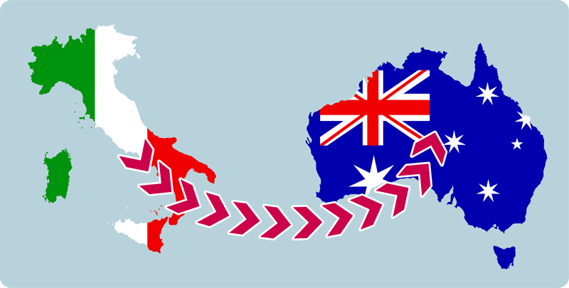 | Value of exports | Key industries | Growth industries
- Make notes on i punti interessanti e quelli che ti hanno colpito in regard to the nature of the trade relationship between Italy and Australia. You may choose to do this in English or Italian.
Appunti

