Riflessione
Reflect on your learning experience.
Rank yourself, by using the scale below, according to how you think you are achieving:
 |  | 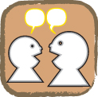 |  | 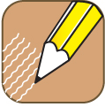
nessun problema

sto migliorando

me la cavo

ho bisogno di molta pratica
★
Answer the following questions in English.
In what area are you doing well?
In what area do you need to practise?
What area(s) are you finding difficult?
Make a note of three things that you wish to build on.
1.
2.
3.
What do you have to do to accomplish the three things that you have listed?

