**Explaining Dylan Bundy’s 2020 Dominance and 2021 Struggles**

*By Jerry Scott Sheehan*

In 2020 Dylan Bundy had a career year pitching to a 3.06 xERA with a 27% Strikeout rate and 6.4% walk rate - all career bests. Almost every statistic pointed to 2020 being his best season as shown in Table 1 below. It appeared that the once highly touted fourth overall draft pick had finally tapped back into the potential he showed before Tommy John surgery in 2013 delayed his stardom. But in 2021, these same statistics are now almost all career worst. In the analysis below I look into what changed between 2019, 2020, and 2021, and how Bundy can get back on track.

**Table 1: Statistics by Season**

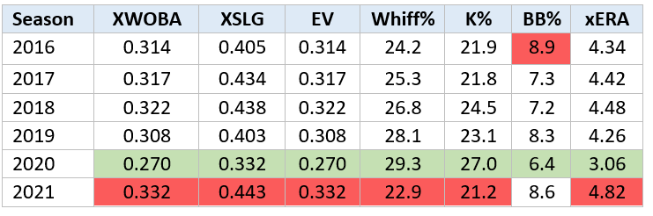

*Note: The red highlighting notes the worst year for each respective category while green represents the best*

One change Bundy makes each year is his pitch mix. Bundy added a slider in 2017 and since has used a five-pitch mix. His usage of each of these pitches are outlined in Graphic 1 below.

**Graphic 1: Bundy Pitch % by Season**

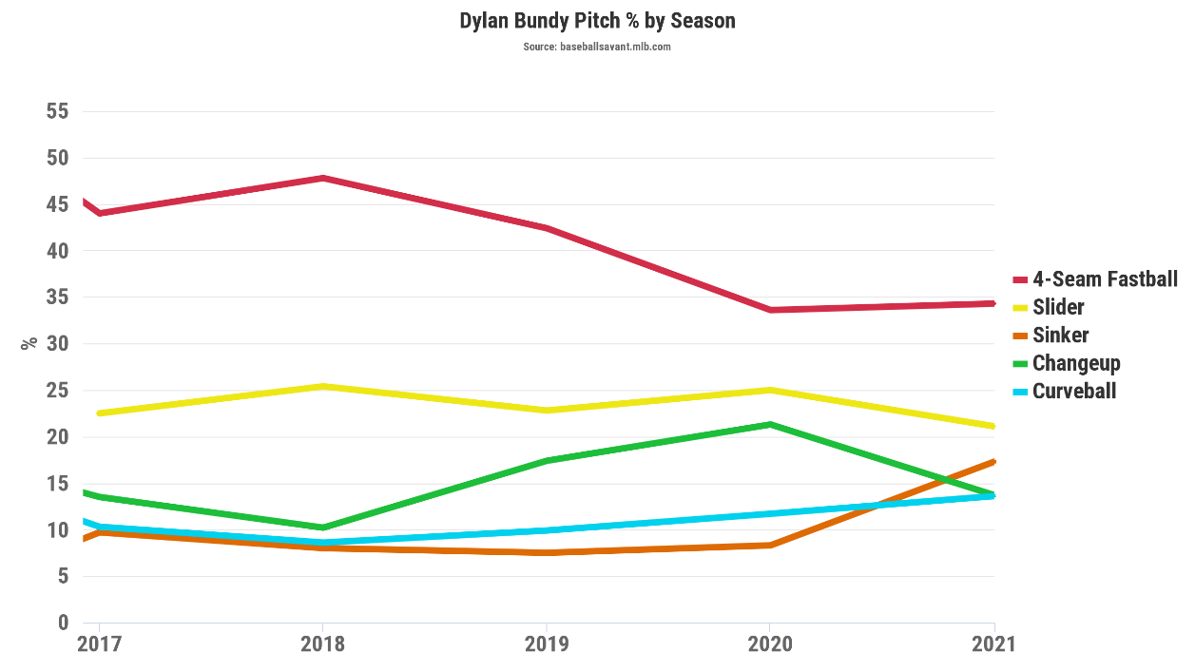

As you can see from Graphic 1, Bundy has relied less on his four-seamer ever since 2018 when he threw it nearly half the time. Table 2 below highlights these percentages for 2019 and 2020 showing his four-seam usage dropped down to only 33.6% in 2020.

**Table 2: Bundy Pitch Usage 2019 vs 2020**

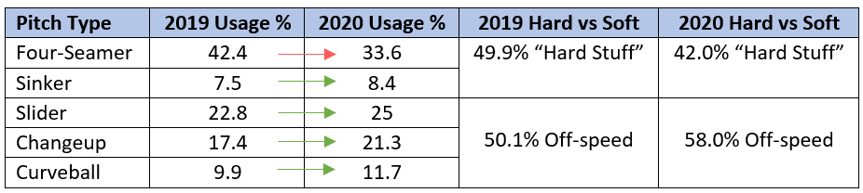

*Note: The red arrow highlights a decrease in usage while the green arrows indicate increases*

By cutting down his four-seam usage Bundy was able to rely more on his off-speed pitches which tended to perform better than his four-seam or sinker. Looking in Table 3 below, which breaks up each of the 2019 statistics from Table 1 by pitch type, his four-seam or sinker (his only pitches thrown over 90 mph) were his worst performing pitches in nearly every category.

**Table 3: 2019 Statistics by Pitch Type**

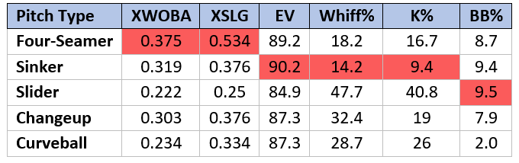

*Note: The red cells highlight the worst performing pitch in each category*

The success of each pitch carried over similarly into 2020 as Bundy continued to dominate hitters with his off-speed pitches while his four-seam and sinker were again his worst performing pitches as shown in Table 4. Since Bundy threw his off-speed pitches more than ever before, his overall numbers were better than they’ve ever been.

**Table 4: 2020 Statistics by Pitch Type**

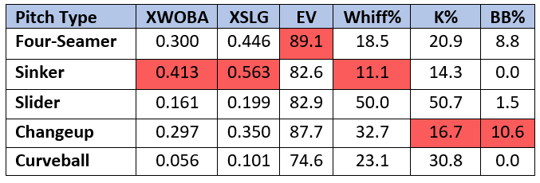

*Note: The red cells highlight the worst performing pitch in each category*

Coming off his 2020 success there were high standards for Bundy this season, but he hasn’t lived up to them. In 2021 his numbers have been the worst of career, as discussed earlier. Looking at his pitch usage in Table 5, in 2021 Bundy has continued to use his four-seamer at around the same rate as 2020 but is relying heavily on his sinker and less on his change-up. As a result, he’s using his hard stuff nearly 10% more than he did in 2020.

**Table 5: Bundy Pitch Usage 2020 vs 2021**

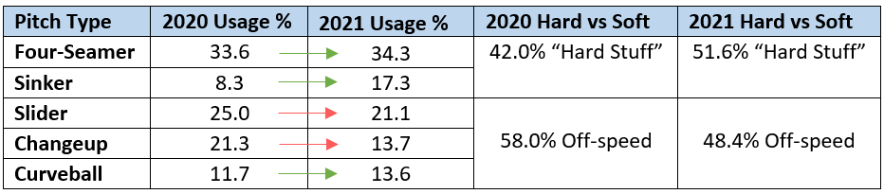

*Note: The red arrows highlight a decrease in usage while the green indicate an increase*

Again, it’s held true that his sinker and four-seamer have been less effective in 2021, and he is now throwing them even more combined than in 2019. These pitches have contributed to more hits, less strikeouts, and more walks as shown in Table 6.

**Table 6: 2021 Statistics by Pitch Type**

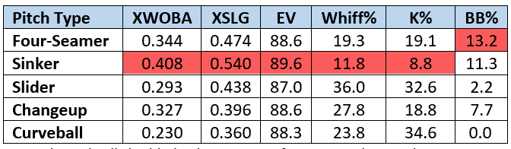

*Note: The red cells highlight the worst performing pitch in each category*

Increasing the usage of his sinker most likely is a contributing factor of Bundy’s 2021 struggles. But when digging into the numbers further we can see that even though he hasn’t increased how often he used his four-seam much, he’s changed when he used it. In 2020 Bundy started throwing more first pitch curveballs as shown in Graphic 2 below. By not relying on his four-seamer so often he not only was throwing a more effective pitch with the curveball but was throwing off a hitters timing by mixing up speeds. His four-seam averaged over 90 mph while his curveball averaged only 73.5 mph. This meant a player couldn’t just sit on his four-seamer as easily as they could in 2019 when he was throwing it around 55% of the time on his first pitch.

So far in 2021 Bundy is continuing to use his four-seamer at a similar overall rate to 2020 but he’s reverted to throwing mostly hard stuff to start hitters off. He’s increased his combined four-seamer and sinker usage back over 50% in both 0-0 and 0-1 counts. This has led to a 0.645 slugging percentage in 0-0 counts and 0.789 in 0-1 counts, as opposed to a 0.267 and 0.500 respectively in 2020 as shown in Graphic 3. Given that hitters are making solid contact early and not whiffing as often, since his four-seamer only has 19.3% and his sinker a 11.8% whiff rate, Bundy isn’t working deep into counts that favor him and therefore can’t get to his big wipeout slider to finish off batters.

**Graphic 2: Pitch Selection by Count**

**2019 (left) 2020 (middle) 2021 (right)**

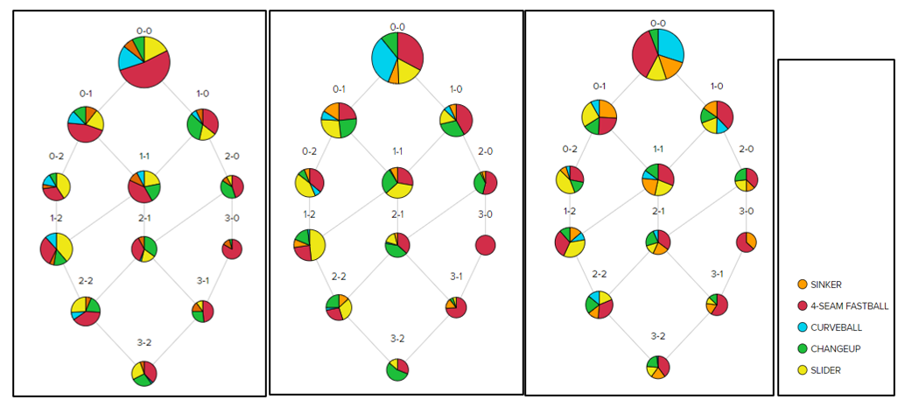

**Graphic 3: Opponents Slugging Percentage by Count**

**2019 (left), 2020 (middle), 2021 (right)**

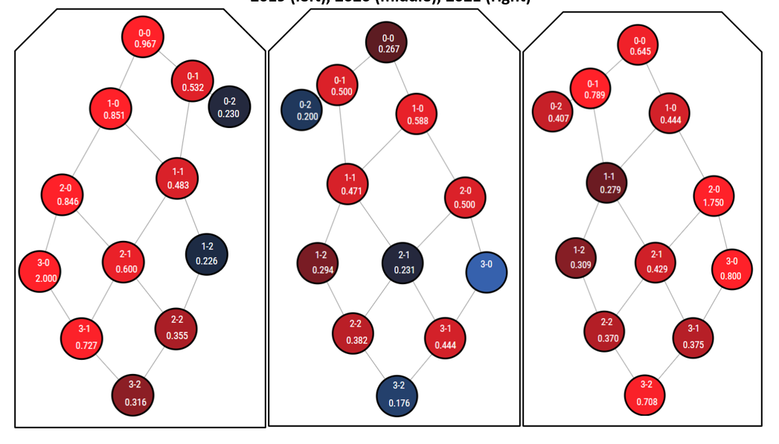

*Note: the numbers at the top of each circle display the count. The number at the bottom is the opponents slugging percentage during that count. The darker the blue is, the lower the slugging percentage. The darker the red is, the higher the slugging percentage.*

Looking at Graphic 2 and 3 above, Bundy is more successful not only when he is using his off-speed pitches, but when he varies his pitch usage in each count, so that a hitter isn’t as likely to guess what’s coming. Although Bundy has factored in his sinker more often this year, it hasn’t done much to throw hitters off when he throws it in fastball heavy counts because his four-seamer and sinker are very similar pitches. Looking at Graphic 4 below his four-seamer and sinker were thrown at the same speed this year while varying only slightly in horizontal and vertical break. Without much difference in the movement or speed of the pitches, hitters are more likely to hit a sinker when guessing four-seamer or vice versa compared to any other pitch. This means even though he may be varying pitches by using his sinker more frequently, he isn’t throwing off hitters the way he does when switching in off-speed pitches.

**Graphic 4: Bundy Pitch Speed and Break**

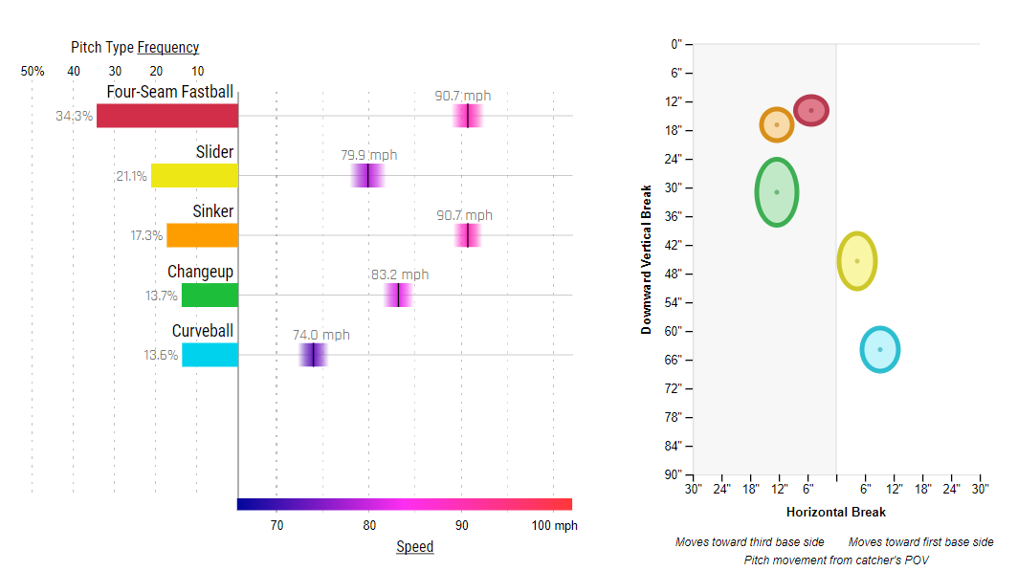

Overall, it seems there are two changes Bundy can make to improve moving forward and regain his 2020 form:

1. **Rely more on his off-speed**. Throwing his four-seamer at a similar rate to 2020 and 2021 seems to be a good way of mixing it in, without relying on it too heavily. But Bundy shouldn’t be trying to throw his sinker more if it means replacing his off-speed pitches. His best option would be to drop his pitch mix usage rate back to his 2020 percentages.
2. **Mix up when he uses his pitches**. In certain counts Bundy makes himself too predictable. In 2019 Bundy relied heavily on first pitch four-seamers throwing them over 50% of the time. By not varying speeds enough hitters were able to sit four-seamer and more often than not be right. By varying his pitch mix more in 2020 he dropped his opponents slugging percentage significantly. In 2021 Bundy has become more predictable again by throwing either four-seamers or sinkers a majority of the time early in at bats and when behind in the count. Bundy needs to switch up his pitch usage within the same count to keep hitters guessing on every pitch.