UI Mock for the attendant call system

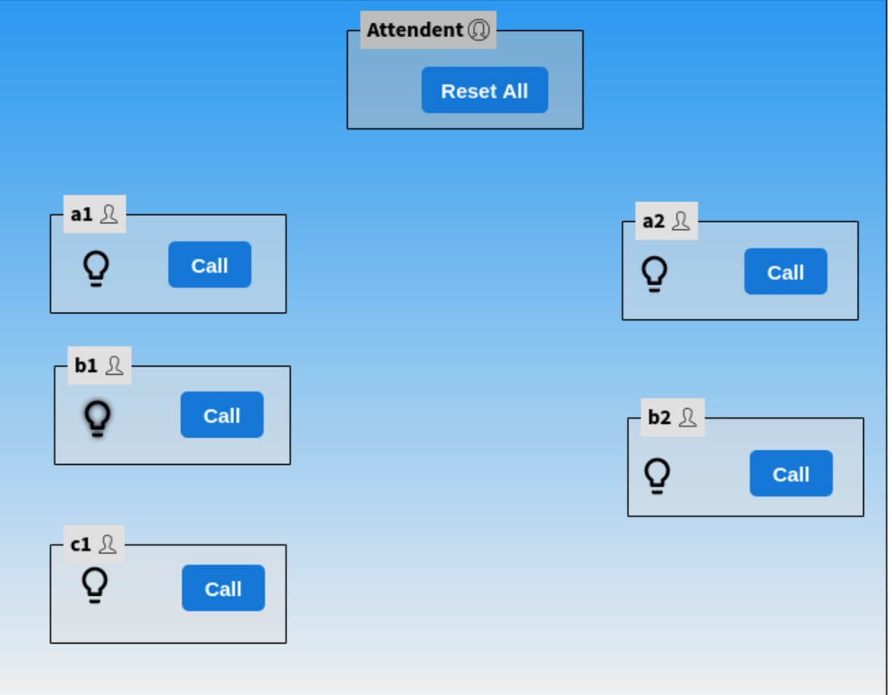

Initial State:-

Snapshots of the results:-

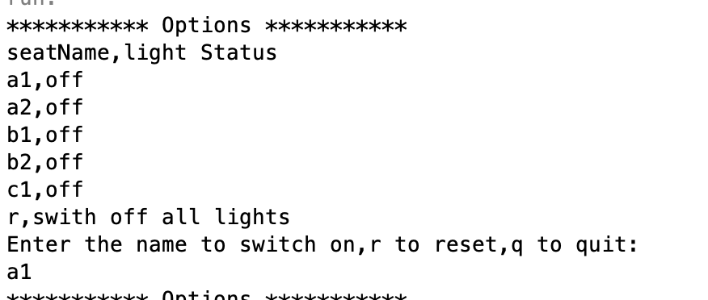

Intially all lights are switched off and the user presses ‘a1’

2

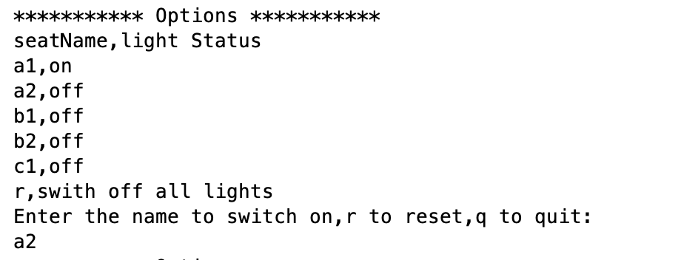

As we can see that a1 Is switched on and the user presses a2

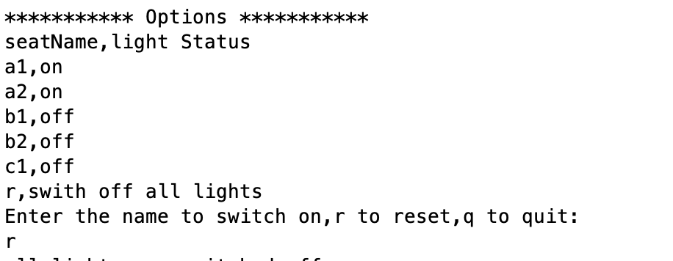

Now a1,a2 is switched on. And the attender presses ‘r’. This will switch off all the lights.

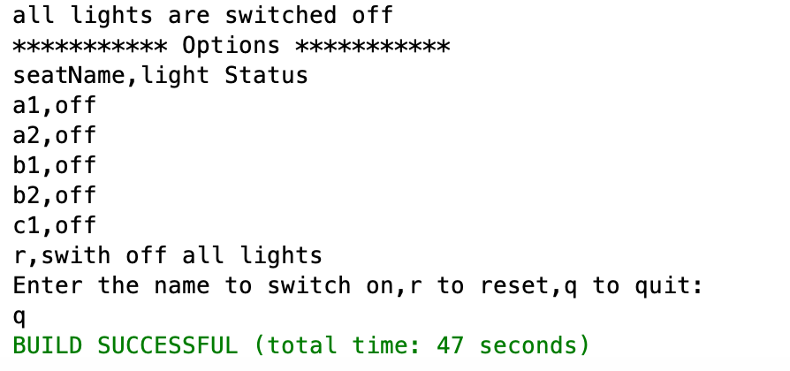

All lights will be switched off now and the user presses q to quit the application.