## ARELLANO UNIVERSITY

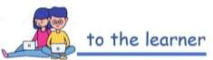

**Elementary Department**

**Dynamic Learning Program in SCIENCE 6**

1st Quarter Activity Sheet #1.5

**Topic : Lesson 1.5: DIGESTIVE SYSTEM Date:**

**Objectives:** After learning this D.L.P , the students will be able to:

1. Identify each organ in the Digestive System.
2. Explain how each organ work together for our Digestive System to function well.

Hello dedicated learner! How are you today? I am hoping that you are safe and healthy at home. Enjoy learning our lesson about the Digestive System!

Directions: Search the given words in the word hunt puzzle. Encircle the letters to complete the word.

## DIGESTIVE SYSTEM WORD HUNT

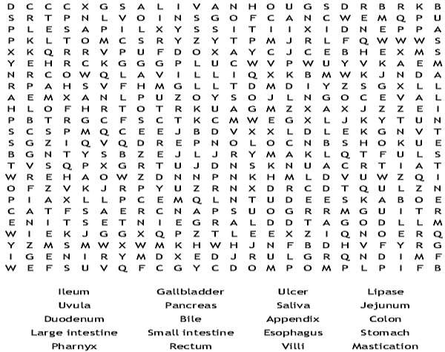

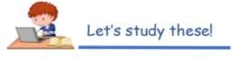

**CONCEPT NOTE 1.5: THE DIGESTIVE SYSTEM**

* **Digestion** – process of breaking down the food into simpler substances. This process is carried out by the Digestive System.
* **Mechanical Digestion** – breaking down of food into smaller pieces. As food is digested, it is mechanically broken down. It undergoes chemical process that covert it into small nutrient molecules. Mechanical digestion happens when food is chewed in the mouth, when food passes through the esophagus, and the churning action in the stomach.
* **Chemical Digestion**-the conversion of food nutrients-carbohydrates, proteins, and fats-into smaller substances. Food is chemically broken down when fluids produced by the digestive organs act on it. These fluids are *digestive juices*, contains substances called *enzymes*, which cause specific chemical change on food.

## Parts of the Digestive System:

The two organs involve in digestion are classified into two groups – *alimentary canal* and

*accessory organs* of digestion.

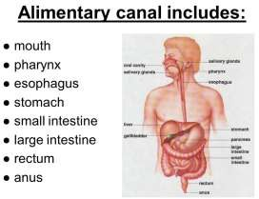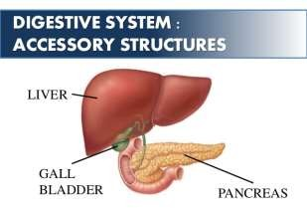

# Alimentary canal has the length of approximately 9 meters when organs are extended.

Food enters the accessory organs. These organs secrete enzymes that chemically break down and digest food.

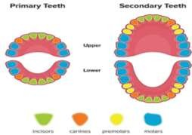

## PARTS OF THE DIGESTIVE SYSTEM

Milk teeth

Permanent teeth

* 1. **Mouth-** Digestion starts the moment you put food in your mouth. Teeth breakdown food into smaller pieces. A normal adult has 32 permanent teeth. Children have mostly milk teeth. Before you reach the age 12, most of your teeth will be replaces by permanent teeth.

Your teeth differ in shape. Each type of teeth has a specific job to do.

* **Incisors**- are the eight front teeth (4 upper, 4 lower). They have sharp edges for cutting food into pieces.
* **Canines** – are four sharp teeth next to the incisors (2 upper; 2 lower). You use these canines to tear meat.
* **Molars**- are four or five pairs of big, strong teeth at the back of your mouth. They have flattish tops and are use for grinding the food. The fifth pair of molar is the wisdom teeth. These are the last teeth to grow, but sometimes they never appear.
* **Premolars**- are the four pairs of teeth (2 upper; 2 lower part) in front of molars.

While your food break into smaller pieces, these pieces are moistened by **saliva**, which is produced by the salivary glands. Saliva contains enzyme called ***ptyalin*** that breaks down starch into sugar. The breaking of starch into sugar is an example of chemical digestion.

## Esophagus/Gullet

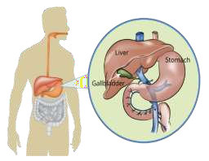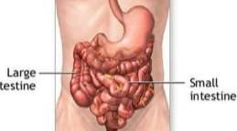

After food is being chewed, and moistened by saliva, it is now ready to be swallowed. This chewed food is called **bolus**. When you swallow, your tongue pushes the bolus down to your throat. The bolus passes through the **esophagus or gullet**, a long muscular tube that connects the mouth and the stomach. The muscular contraction of the esophagus, called **peristalsis**, pushes the food down to the stomach.

## Stomach

The **stomach** is a bag-like organ that holds and digest food. On the walls of the stomach are the gastric glands, which produces gastric juices. The stomach churns and mixes the food and the gastric juices thoroughly. This action turns food into a soup-like mixture called ***chyme***. The food must be in this

form so it can pass through the small intestine.

## Pancreas, Gallbladder and Liver

The food coming from the stomach is a partially digested food. As it slowly enters the small intestine, the pancreas, and gall bladder produces their digestive juices into the small intestine.

The pancreas and the gall bladder are organs found just bellow the liver. The **pancreas** produces pancreatic juice, which neutralizes the acid in chyme. It also breaks down large molecules into smaller ones. The **liver** produces a yellow greenish liquid called bile, which is stored temporarily in the gallbladder. This substance helps break down fats in chyme.

## Small Intestine

The **small intestine** is where complete digestion and absorption of nutrients happen. It is about 4 to 7m long and 2.5 cm wide. This long tube coils around and fits inside the abdomen.

The small intestines secrete digestive juices from its walls. The enzymes in these juices are responsible for digesting complex food substances into simpler form. These digestive juices together with pancreatic juices together with pancreatic juice and bile from the gallbladder complete the digestive process.

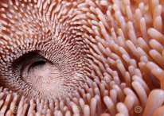

villi

Food is simply digested when the all nutrients are converted into the simplest substances-the carbohydrates to glucose, the proteins to amino acids, and the fats to fatty acids. Only glucose, amino acids, and fatty acids can pass through the walls of the small intestine and are absorbed by the blood.

How does absorption happen?

The internal surface of the small intestine is lined with millions of small fingerlike structures called ***villi***. Molecules of digested food, which are small, pass through the cells lining each villus and into the blood vessel inside it.

The blood carries these molecules of digested food to the different cells all throughout the body. In the cells, the digested food is converted into energy.

## Large Intestine

Not all substance in the food that you eat can be broken down by your digestive system. Fibers in fruits, vegetables, and grains are highly indigestible. From the small intestine, they are collected in the

large intestine together with some dead cells, bacteria, a little digestive juice, and some water. These materials form ***feces***.

The ***feces or waste material*** is stored in the rectal cavity. From there, it moves to the rectum before it leaves the body. The process of eliminating undigested food and other waste materials through the anus is called ***defecation***. In the large intestine, water is absorbed by the body through its walls. If much water is absorbed, the feces becomes hard and solid.

## THE DIGESTIVE PROCESS

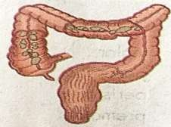

In the large intestine, water is absorbed and undigested food is stored temporarily until It is eliminated through the anus.

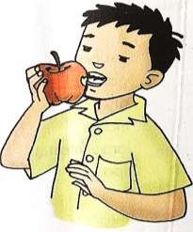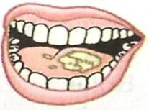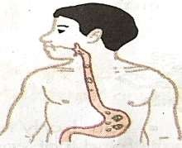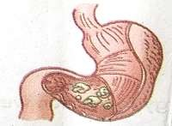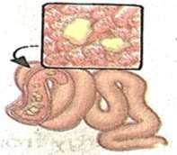

In the mouth, food is broken down into smaller pieces.

In the small intestine, food is completely digested and is absorbed through the villi.