Arellano University

Jose Rizal High School

Gov. Pascual Ave. Malabon City

Tel/ Fax # 921-27-44

PACUCOA ACCREDITED: LEVEL II

SY: 2021 – 2022

Name:_________________________________________ Score:__________________________

Grade and Section:_______________________________ Teacher: ________________________

GRADE 9 ENGLISH

I.CONTENT: Lesson #17: Part 3: Vocabulary in Communication Skill

A vocabulary, usually developed with age, serves as a useful and fundamental tool for communication and acquiring knowledge.

Four types of vocabulary:

1. Listening vocabulary refers to the words we need to know to understand what we hear.
2. Speaking vocabulary consists of the words we use when we speak.
3. Reading vocabulary refers to the words we need to know to understand what we read.
4. Writing vocabulary consists of the words we use in writing.

II. OBJECTIVE:

1. Acquire new vocabulary identified from the assigned text.

III. ASSESSMENT: Activity # 17:

Word Search Puzzle

Look for the word you will see in the puzzle. Write down the word in each number provided for.

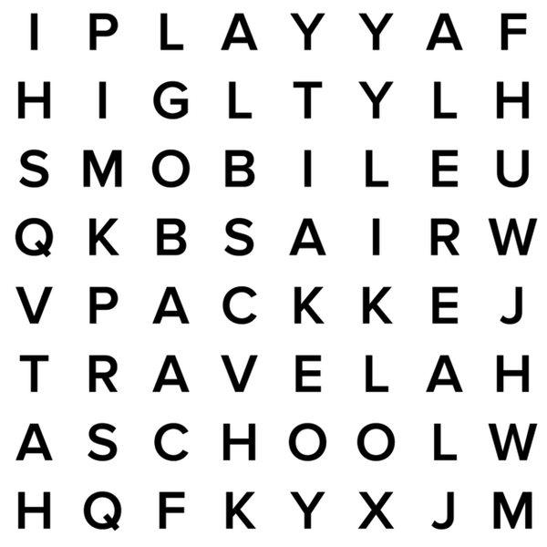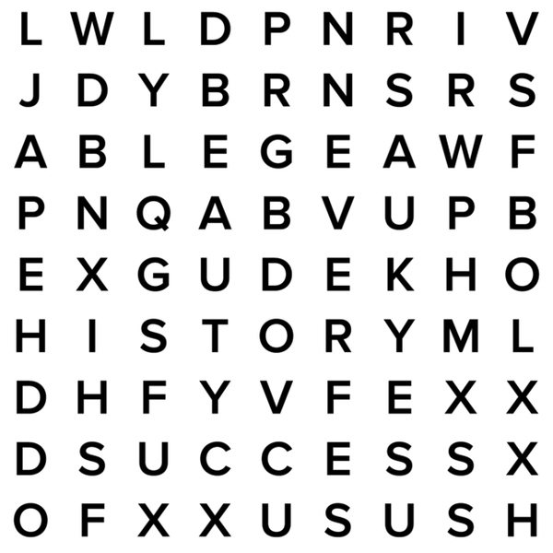

1. _____________________ 6. _____________________
2. _____________________ 7. _____________________
3. _____________________ 8. _____________________
4. _____________________ 9. _____________________
5. _____________________ 10. _____________________

IV. REFERENCE: <https://www.readingrockets.org/teaching/reading-basics/vocabulary>

V.GENERALIZATION:

Vocabulary is an important aspect of language and communication skills.

VI.INSTITUTIONAL CORE VALUES: Competence