**Development of Web-based Productivity System in Arellano University – Jose Rizal Campus**

**Joshua P. Sotto**

Arellano University-Jose Rizal Campus Gov. Pascual Malabon City

joshuasottoelyen@gmai.com

**Cleyre C. Catada**

Arellano University-Jose Rizal Campus Gov. Pascual Malabon City

ccleyrecatada@gmail.com

**Joanna Francesca G. Tolentino**

Arellano University-Jose Rizal Campus Gov. Pascual Malabon City

joannagellado1873@gmail.com

**ABSTRACT**

With the growing prevalence of online and blended learning in the modern post-pandemic educational curriculum, the ramifications posed by online distractions has ever been more rampant than ever. This leads to procrastination and decreased levels of productivity within students. Efficiently application features productivity and anti-procrastination tools which helps in combating these adverse effects. It can also aid in boosting student productivity. It offers task organizers, scheduling tools, and focus mode. It is developed using JavaScript, Nuxt.js, Veutify, and MongoDB as frameworks, languages, and database management programs. Additionally, it uses Visual Studio Code as text editor for the code and Postman as API Testing. Using these various software technology, the researchers are able to formulate a web-based productivity application which academically helps student navigate learning in the digital age.

**Keywords**

Coronavirus Pandemic, Online Learning, Asynchronous learning, physical distraction

1. **INTRODUCTION**

The Coronavirus pandemic has changed the landscape of learning in the modern times. Online Learning is introduced in order for students to learn lessons, in addition to doing and submitting their activities when face-to-face classes are not available (UNESCO Office Santiago and Regional Bureau for Education in Latin America and the Caribbean, 2020). Blended Learning is then utilized in order to integrate both face-to-face and online learning to use the benefits of both learning styles for optimized learning (What Is Blended Learning? Examples & More, n.d.).

Both of these are effective tools for combating quarantine struggles and allowing students to continue their education even when face-to-face classes are unavailable. According to Guatam in 2020, online learning has become an essential tool for students to continue learning even when they cannot physically attend classes.

However, these methods can also lead to distractions and limitations in academic productivity. Students are learning on an environment different from the traditional academic learning which has been used from the very conception of academic curriculum. Students are experiencing new challenges such as online distractions, and self-supervision struggles partnered with time management issues (National University, 2021) that can lead to procrastination of their activities, especially during online and asynchronous activities where they are required to supervise their own selves at their own home, which is filled with distractions, in comparison to the traditional classroom, which is designed for students to be able to focus on their academic related activities only, and are constantly supervised by a professional to guide them.

Because of this, the researchers have created the Web-Based Productivity Application System which will help give the students the environment which supports focus. It also provides an anti-procrastination feature that supervises their activity and prevents them from giving in to online distractions. It uses programs such as Portman, Visual Studio Code, Node.js and MongoDB to provide these features on a user-friendly and visually appealing interface.

**1.2 Objective of the study**

This study aims to create a system that enhances student productivity and prevents distractions. The software features calming background images and sounds, productivity tools like focus sessions, to-do lists, and media cards. It also allows task management, schedule setting, and performance reporting. The system is developed using Postman, Visual Studio Code, Node.js, and MongoDB. The software will be tested and improved using ISO 25010 criteria and performance criteria.

**1.3 Scope and Limitations of the Study**

The study focused on designing, creating, testing, improving, and evaluating a Web-Based Productivity Application for college students at Arellano University – Jose Rizal Campus. The application offers customizable audio and visual backgrounds, color themes, volume mixing, and a Media Section for watching visuals and instructional videos. It also features an anti-procrastinating alarm function, which alerts users when they have been inactive for a certain period. The system also includes a Text Editor for text input, image addition, and file saving. However, the study only targeted college students, limiting its device compatibility to desktop platforms and mobile devices.

**2 METHODOLOGY**

**2.1 Project Design**

The researchers used Developmental Research to create the application. This method focuses in making new instruments that will either improve the equipment currently used, or solve the issues that the current equipment possesses.

**2.1.1 System Architecture**

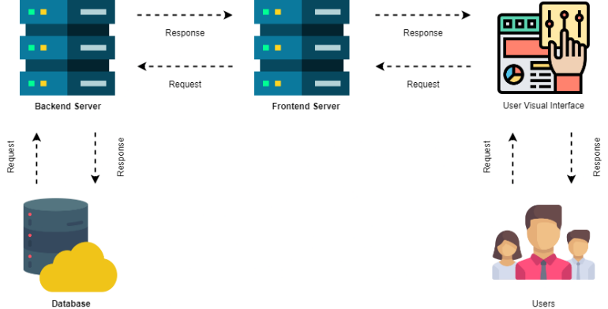

**Figure 1: System Architecture**

Figure 1 illustrates a system architecture consisting of two web servers, two visual interfaces, users, and a database. The backend server secures, stores, deletes, updates, and retrieves data, while the frontend server handles user interface and requests. The database stores data, while users are the application's users.

**2.1.2 Use Case Diagram**

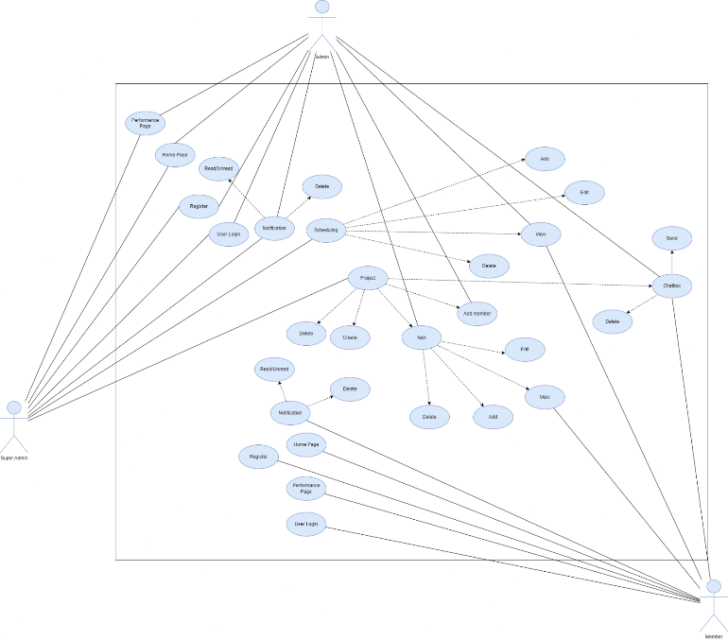

**Figure 2: Use Case Diagram**

Figure 2 illustrates a use case diagram with three actors: admin, super admin, and member. The super admin has full access to schedule and project, while the admin can login, register, track progress, add members, view schedules, and view tasks. The member has login, registration, progress tracking, and project chat box capabilities.

**2.1.3 Use Case Diagram**

Figure 3 outlines the user's process of using the application, which includes logging in, scheduling appointments and tasks, tracking progress, using productivity tools, collaborating with others, and analyzing results and performance through activity reports.

**2.2 Project Development**

**2.2.1 Entity Relationship Diagram**

Figure 4 displays an entity relationship diagram with sixteen entities: user, session, schedule, tag, guide, notification, preference, theme, sound, time spent, project, task, note, message, member, and section. Each entity has its own theme, notification, sound, tag, project, member, message, task, section, notes, and assignee.

**2.2.2 Flowchart Home page**

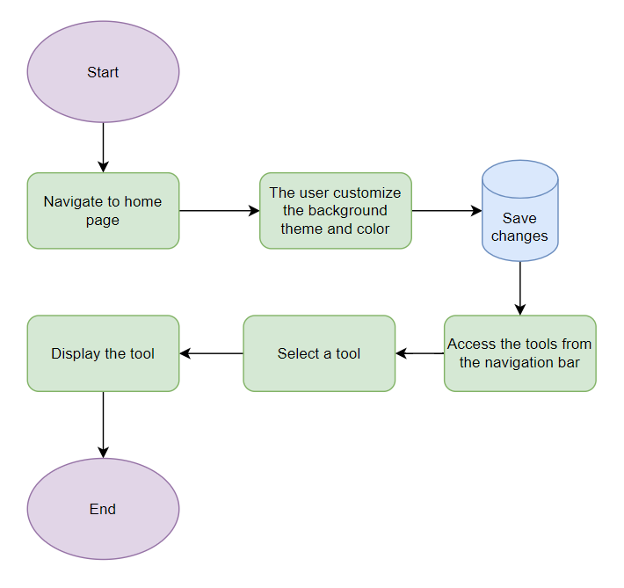

**Figure 6: Home page flowchart**

Figure 6 illustrates user interaction with the home page, allowing them to customize background and color, save changes, and access various tools from the navigation bar, which appear on the screen for use.

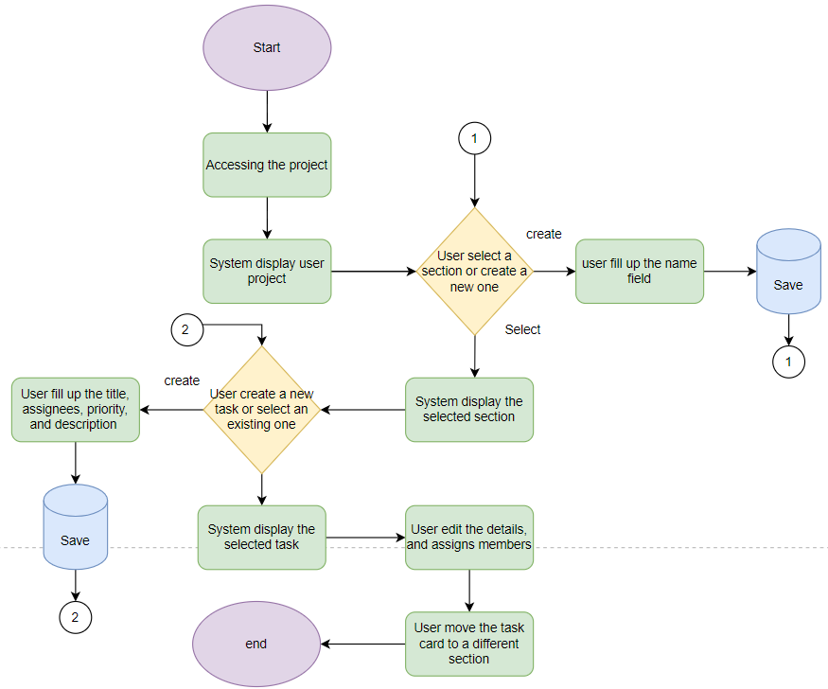

Figure 7 displays the project page where users access project details, select sections, create tasks, edit task details, assign members, and move tasks between sections for efficient management. Users can also create new sections and edit tasks for better organization.

**3. RESULTS AND DISCUSSION**

The Efficiently web productivity system offers a user-friendly design and tools to help students improve their productivity. It provides a relaxing space for focus, easy task management, schedule planning, and reports statistics. The system also includes real-time communication, collaboration tools, and time management techniques like Pomodoro and media cards. The system was developed using Javascript, Nuxtjs, and Vuetify, with Nuxtjs for efficient frontend development and Vuetify for a rich user experience. MongoDB is used for data storage, simplifying the SQL base database and ensuring faster retrieval and security.

**3.1 Project Structure**

The system consists of two main user components: guest and authenticated. The guest component includes features, pricing, testimonials, and FAQ, while the authenticated component includes home, projects, schedules, and statistics.

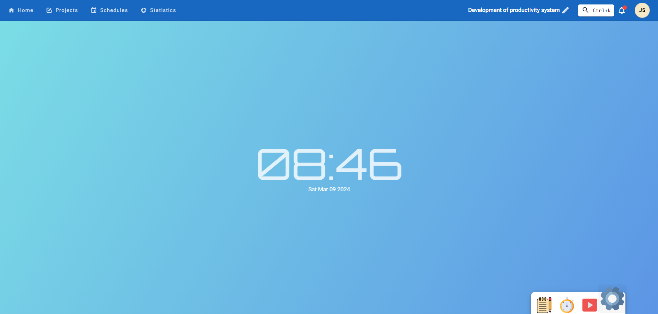

**Figure 12: Home Page**

The figure 12 show the home page of authenticated user, where the page gives user a relaxing background and customizable colors and theme.

**3.1 Capabilities and Limitation**

The system offers various capabilities, including a relaxing home page with customizable backgrounds, a task management page with customizable sections and tasks, a schedule for students, progress reports, notifications, productivity tools like notepads and media cards, easy login via Google accounts, and compatibility with various browsers. However, it has limitations such as a desktop-only interface, inability to detect malicious media, lack of dashboard and timeline support, internet connection access, limited customization options for themes and relaxation features, and alarm features only detecting user activity when the application is currently in use.

**3.2 Summary of the evaluation results**

The system's evaluation results, based on survey questionnaires, show an overall satisfaction rate of 4.6 out of 4.6. Usability is the highest satisfaction rate, followed by Functional Suitability at 4.64. Performance Efficiency is the lowest, followed by Reliability at 4.53. Security is rated "Very Good" for confidentiality, integrity, accountability, authenticity. Usability is rated "Excellent" for operability, user interface aesthetics, learnability, error protection, performance efficiency, and functional suitability.

**4. Summary Of Findings, Conclusions,**

**And Recommendations**

**4.1 Summary and Findings**

Researchers tested and evaluated the Efficiently application, revealing its functional quality and user-friendly design. The application offers a relaxing online environment, manages tasks, and displays detailed productivity and progress reports. The system architecture uses JavaScript for frontend and backend development, Nuxr.js for frontend development, Veutify for user-friendly interface, and MongoDB for secure data storage. The system received an average score of "Excellent" with an average of 4.57, demonstrating its ability to assess student message contributions. The application's effective system architecture ensures excellent software quality and user-friendliness, with detailed progress reports and a secure data storage system.

**4.2 Conclusion**

The Efficiently app was developed to provide users with calming background visuals and auditory sounds, tools for productivity, task management, and schedule management. It also allows collaboration, invites attendees, alarms upcoming schedules, and monitors performance. The app was created using Postman, Visual Studio Code, Node.js, and MongoDB, and deployed using hosting providers like Netflify and Render. The system was tested for functionality and accuracy, and received an "excellent" rating from evaluators, proving its effectiveness in helping users improve their productivity

**4.3 Recommendation**

The summary recommends enhancing the productivity application's user interface to support mobile devices, integrating a scanner for potential malicious files and images, optimizing the background for faster display, and improving the performance report for more entertainment. These recommendations aim to enhance user experience and overall productivity.

**Reference**

U.S. BUREAU OF LABOR STATISTICS. (n.d.). What is Productivity? : U.S. Bureau of Labor Statistics. Www.bls.gov. https://www.bls.gov/k12/productivity-101/content/what-is-productivity/home.htm

Perry, E. (2023, March 23). What is productivity? A complete guide for improving yours. Www.betterup.com. https://www.betterup.com/blog/what-is-productivity

Kenton, W. (2024, March 2). Productivity. Investopedia. https://www.investopedia.com/terms/p/productivity.asp

Simplilearn. (2022, April 1). What is Productivity? How to Define and Measure It? | Simplilearn. Simplilearn.com. https://www.simplilearn.com/what-is-productivity-and-how-to-define-and-measure-it-article