VOLTRIKE

A Capstone Project Proposal Presented to the Faculty of the College of Information Technology
University of Negros Occidental – Recoletos

In Partial Fulfillment

of the Requirements for the Degree Bachelor of Science in Information Technology

by

Jose Vincent Bayoguing III Denro S. Maban

2026

LIST OF FIGURES
- VolTrike General Features 13
- VolTrike Application Decomposition Chart 29

LIST OF TABLES
- Comparative Matrix of Related Systems 4
- Hardware Requirements 17
- Software Requirements 18
- Passenger Account Registration 31
- User Account Login 32
- Password Recovery 33
- Driver Registration and TODA Approval 35
- Ride Request and Booking 39
- Real-Time GPS Tracking 42
- Route Compliance and Validation 45
- Fare Calculation and Cash Settlement 48
- Admin and TODA Operations 50

TABLE OF CONTENTS
LIST OF FIGURES i
LIST OF TABLES ii
CHAPTER
- INTRODUCTION 1
  - Purpose 2
    - Driver Safety and Legality 2
    - Modernizing the Local Commute 3
    - Fair Pricing and Transparency 3
  - Technical Review of Related Systems 3
    - Connectivity 3
    - Target Users 4
    - Ride Information 4
    - Safety Features 4
    - Regulatory Compliance 4
  - Project Scope 7
    - Design Mobile and Web Application using Essential TNVS Features 8
    - Adopt Geofencing System and Route Compliance 8
    - Combine Multi-Criteria Decision-Making for Match Optimization 9
    - Facilitate Change to a Clean Climate by Electric Mobility 9
    - Assure Accessibility of Target Populations 10
    - Geographic Scope and Strategy Deployment 10

    - Project Deliverables 11
- SYSTEM SPECIFICATION 12
  - Product Perspective and General Features 12
    - Booking and Ride Matching 13
    - Geofencing and Compliance of Route 14
    - Real-Time Location Tracking and Navigation 14
    - Standardized Fare Calculation and Transparency 15
    - Driver Verification and Credential Management 15
    - Administration, Safety, and Operational Reporting 16
  - Operating Environment 16
    - Hardware Requirements 17
    - Software Requirements 18
  - Design and Implementation Constraints 18
    - Optimization of Budget Devices and Scalability 20
    - Boundary Complexity and the Regulatory Rules of a Municipality 20
    - Dependences on Third party services 21
  - Assumptions and Dependencies 21
    - Assumptions 21
      - Sufficient Driving Engagement and Revenue Rewards 22
      - Smartphone Penetration and Driving Digital Literacy 23
      - Regulatory Stability and Cooperation with Local Government 23
    - Dependencies 23
      - Third Party Mapping and Geolocation Services 24
      - Cash Payment and Settlement 24

      - Firebase and Google Cloud Infrastructure 25
      - Cells and Net Cellular Network and Internet Network 25
      - Regulatory Cooperation of Local Government Unit 25
- PRODUCT FEATURES 27
  - Product Decomposition 27
  - Product Functionalities 29
    - User Account Management 29
      - Description and Priority 30
      - Stimulus/Response Sequence 30
      - Functional Requirements 34
    - Driver Registration and TODA Approval 34
      - Description and Priority 34
      - Stimulus/Response Sequence 34
      - Functional Requirements 35
    - Ride Request and Booking 37
      - Description and Priority 37
      - Stimulus/Response Sequence 38
      - Functional Requirements 40
    - GPS Tracking and Map Display in Real Time 41
      - Description and Priority 41
      - Stimulus/Response Sequence 41
      - Functional Requirements 43
    - Geofence and Route Compliance 43
      - Description and Priority 44
      - Stimulus/Response Sequence 44
      - Functional Requirements 46
    - Fare Calculation, Cash Payment, and Settlement 47
      - Description and Priority 47

      - Stimulus/Response Sequence 47
      - Functional Requirements 49
    - Administrative Operations and Access Control 49
      - Description and Priority 49
      - Stimulus/Response Sequence 49
      - Functional Requirements 50
VI. PROJECT MANAGEMENT 53
  - Hardware Recommendations 53
  - Software Recommendations 54
  - User Classification 54
    - Passenger Users 55
    - Drivers of E-Trikes 55
  - Product Feasibility Assessment 56
    - Marketing 56
    - Management 57
    - Economic 57
    - Production 58
  - Time Management 58
  - Communication, Coordination, and Team Composition 59
    - Communication 59
    - Coordination 60
    - Team Composition 60
      - Project Lead and Systems Developer 60
      - UI/UX Designer and Quality Assurance Head 61
GLOSSARY 62
APPENDIX 67
- PERT Table 67
- PERT Diagram 68
- Team Logo 70

- VolTrike Logo 69
REFERENCES 71
CURRICULUM VITAE 73

CHAPTER I INTRODUCTION

Navigating the streets of Bacolod City remains a daily struggle for many residents, especially when trying to reach the inner sections of local barangays. While the main way are busy, the last-mile journey the major transport stop and a person’s doorstep often lacks transportation options. Major transport modes like jeepneys and taxis rarely venture into these interior roads or residential areas where people actually live. This gap often forces commuters to depend on informal options like "trisikads", unregistered motorbikes or sometimes just walk from a distance, which can be unpredictable in terms of both safety and pricing. However, the rise of electric trikes or e-trikes offers a cleaner, more modern solution that could finally bring some order to these neighborhood routes. By integrating technology into these e-trike services, Bacolod has a real chance to formalize local transport, making daily commutes more reliable and efficient for every Bacolodnons.
This proposed project supports United Nations Sustainable Development Goal (UN-SDG) 13 by organizing short-distance transport around electric tricycles. E-trikes produce no tailpipe emissions during operation, although their total environmental effect still depends on electricity generation, vehicle production, and local operating conditions. VolTrike will support cleaner and more organized mobility through digital booking, transparent fares, and route-policy controls without claiming a measured emissions reduction that the application does not calculate [ADB2022] [UN2025].

Voltrike proposes the development of a barangay-based e-trike ride-hailing platform designed specifically for Bacolod City, utilizing geo-fencing technology to ensure compliance with local road regulations. The system will enable residents to book registered and verified e-trike drivers for short trips within designated areas, providing a convenient and eco-friendly alternative transportation. By combining digital innovation with electric mobility, the project aims to improve daily commuting experiences, support local livelihoods, and contribute to a cleaner and more sustainable urban environment.

  - Purpose

This proposal aims to build a structured e-trike [LTO2024] transportation network within Bacolod's barangays, connecting residential areas to major transit hubs for more accessible daily travel. It replaces the uncertainty of informal transport with a reliable, technology-enabled system that ensures passenger safety, legal compliance, and convenience through organized routes, digital booking, and real-time tracking. By strengthening first- and last-mile connectivity, the system supports the city's vision of a smarter, more sustainable urban mobility network.
    - Drivers Safety and Legality

One of the biggest headaches for e-trike drivers in the main road is accidentally wandering onto main highways where they are not allowed by law. This proposal integrates geofencing technology that acts as a virtual boundary. It alerts drivers if they are approaching restricted main roads, to ensure they stay within designated zones and avoid heavy fines or impounding.

    - Modernizing the Local Commute

This proposal aims to modernize the traditional pedicab and motor-tricycle transportation system by introducing electric tricycles equipped with smart technology. Through VolTrike, the project seeks to provide a quieter, more comfortable, and environmentally friendly mode of transportation while improving the commuting experience for drivers and passengers. In addition, the system promotes sustainable transportation practices, contributing to a safer, and more efficient public transport service.
    - Fair Pricing and Transparency

The proposal will put an end to the special trip haggling that often leads to overcharge or confusion. By using digital fare calculations, the price is set and transparent from the moment you book. This protects passengers from being overcharged just because it is raining or late at night, while ensuring drivers earn a stable, honest wage without the need for an argument.

  - Technical review of Related Systems

This technical review examines several transportation and ride-hailing platforms that serve commuters dependent on tricycle-based, last-mile travel. VolTrike is compared against Pedi App (Bohol) [PSI2025], Grab Philippines [GH2012], and Joyride [WMT2019] to determine how each contributes to safer, more reliable, and more accessible transport for passengers and drivers within the Philippine setting. The platforms under review share a common set of capabilities, including ride booking, live location tracking, fare and trip-detail display, driver credential verification, and adherence to transport regulations. This comparison examines each system's connectivity, ease of

use for different users, range of functionalities, quality of ride information, business model, and target user base, in order to surface where each platform excels and where it falls short. The findings offer a foundation for strengthening VolTrike's own design, especially its regulatory-compliance controls and transparent configurable fares, so it can better meet the needs of e-trike drivers and passengers in Bacolod City and similar communities.

Criteria/System Name | Pedi App (Bohol) | Grab Philippines | Joyride | VolTrike System
Connectivity | Mobile app-based booking with GPS tracking | Mobile and web-based platforms | Mobile with GPS | Mobile with GPS tracking, geofencing integration
Target Users | Available in Bohol province | Available nationwide in major cities | Available in selected Areas | Designed for all e-trike drivers and passengers in Bacolod City
Ride Information | Driver name and photo, vehicle details, fare estimate, estimated arrival time, ratings | Driver details, vehicle details, real-time location, fare breakdown, estimated time of arrival | Fare estimate, driver profile, route tracking, trip receipt | Driver information real-time location, approved route display, driver ratings, estimated trip time
Safety Features | Driver license verification passenger-driver phone masking | Driver identity verification, vehicle inspection, insurance requirements, emergency button, trip sharing, 24/7 support | GPS  monitoring, SOS feature, driver verification | Driver/TODA verification, live tracking, SOS/reporting, ratings, trip history, and route-policy controls
Regulatory Compliance | Drivers must have existing public transportation licenses; operates within LGU-approved areas | LTFRB  accreditation complies with national regulations | Operates under Philippine transportation regulations | Configurable TODA coverage and route restrictions with scoped administrative review
Table 1. Comparative Matrix of Related Systems

    - Connectivity

The effectiveness of a ride-hailing platform depends on how its passenger, driver, and backend components exchange trusted data. VolTrike will use Flutter mobile applications for passengers and drivers, together with a separate web portal for administrators. The system will require an active data connection for booking, dispatch, tracking, and protected transactions. When connectivity is interrupted, the application will present clear retry or reconnect states; it will not be described as a complete offline service.
    - Target Users

Knowing who the beneficiary of any system is relevant in the design. Platforms of tricycles cater to tricycle drivers and passengers within their localities-tourists and locals. Grab Philippines focuses on car and motorcycle drivers as well as urban commuters all over the country that value speed and convenience. The conventional e-trikes will cater to drivers who receive livelihood income and local commuters who will require affordable transport. VolTrike will serve e-trike drivers who desire quality income and business efficiency, passengers who demand cost-effective transport means over short distances, Tricycle Operators and Drivers Associations (TODA) organizations who control the

activities of tricycles in the locality, and local government offices which want to enforce sustainable transport policies.
    - Ride Information

Before and during a ride, VolTrike will present the verified driver name and photo, assigned TODA, vehicle information, fare estimate, rating information, route, and expected arrival details that are available for the booking. Live driver movement will be shown during active ride states. Battery percentage will not be presented as a verified passenger-facing or dispatch factor because it is not part of the implemented data model.
    - Safety Features

Safety features offered by Pedi, Grab Philippines, JoyRide, and VolTrike. While the existing platforms provide essential safety measures such as driver verification, GPS tracking, emergency support, and identity verification, their features are designed for general ride-hailing services. In contrast, VolTrike enhances safety by integrating geofencing to prevent illegal routes, a mutual rating system, trip history, and emergency contact integration, offering a more secure and regulated transportation experience specifically for electric tricycle drivers and passengers.

    - Regulatory Compliance

Regulatory compliance measures implemented by Pedi, Grab PH, JoyRide, and VolTrike. While the existing platforms comply with transportation regulations through driver licensing, LTFRB accreditation, and adherence to national policies, their compliance largely depends on drivers following established rules. VolTrike incorporates geofencing technology to proactively enforce regulatory compliance by preventing entry into restricted or illegal routes, helping drivers comply with road regulations while promoting safer and more efficient electric tricycle operations.

  - Project scope
VolTrike will provide a Flutter-based passenger and driver platform for electric-tricycle transport in Bacolod City, supported by a role-aware web administration portal. Passengers will register and request rides; drivers will submit personal, TODA, vehicle, and document information for review; TODA Administrators will manage only their assigned organization; and the System Administrator will manage platform-wide policies, restrictions, and quality controls. The scope covers booking, server-ranked dispatch, GPS tracking, fare calculation, cash settlement, reports, ratings, safety records, and route/service-area controls.

    - Design Mobile and Web Applications using Essential TNVS Features

VolTrike will provide Flutter mobile interfaces tailored to passengers and drivers and a React web portal for administration. Passengers will search for destinations, review a trusted fare and route preview, submit a booking, track an assigned driver, communicate during an active ride, and view history, receipts, and ratings. Approved drivers will manage availability, receive ranked offers, progress through the ride lifecycle, and review earnings and violations. Administrative functions will remain in the web portal rather than the mobile app, with platform-wide and TODA-scoped access enforced separately.
    - Adopt Geofencing System Route Compliance

The platform will use configurable TODA coverage polygons and developer-managed route-restriction polygons or corridors. Pickup and destination points will be classified against the approved service areas, while route-policy checks will identify prohibited endpoints or restricted crossings. Visible warnings and blocking decisions will follow the configured policy. Requests to avoid highways will be sent to the routing provider, but this preference will be described as advisory because the provider may not honor it in every route.

TODA Administrators will request or maintain coverage information for their organization, while the System Administrator will review coverage requests and manage platform route restrictions. The system will give passengers and drivers concise reasons when a location or route cannot be accepted. It will not promise automatic alternative destinations or universal prevention of every road violation.
    - Combine Multi-Criteria Decision-Making for Match Optimization

VolTrike will use server-side ranked dispatch rather than passenger selection of nearby drivers. Eligible drivers will be ordered using service and TODA priority, 100-meter distance bands, daily award counts for fairness, smoothed reliability, smoothed quality or rating, exact distance, and deterministic tie-breakers. Battery level is not an implemented factor. Booking acceptance will be claimed atomically by the backend so that one driver is assigned to a request.
    - Facilitate Change to a Clean Climate by Electric Mobility

VolTrike will support SDG 13 by organizing the use of electric tricycles and improving the visibility of routes, demand, and completed rides. The proposal will describe e-trikes as having zero tailpipe emissions during operation, while avoiding unsupported claims that the application computes kilograms of carbon dioxide saved for every trip.

Trip and operational data may support future sustainability studies when an approved methodology and reliable baseline data are available. Climate calculations and aggregate emissions reports are outside the currently implemented scope.
    - Assure Accessibility of Target Populations

Accessibility decisions will focus on readable high-contrast interfaces, simple task flows, bounded background work, compact PSGC lookup data, cached policy data, debounced search, and image preparation that can use a native Rust path with a Dart fallback. Exact APK-size, memory, battery, and performance guarantees will be stated only when supported by a reproducible test on a named device and build.
    - Geographic Scope and Strategy Deployment.
Initial validation will focus on Bacolod City and participating TODAs. Planned pilot activities may examine usability, booking completion, network behavior, driver and passenger feedback, and policy configuration. Expansion to other locations will remain future work and will require new local coverage, fare, registration, and regulatory review rather than being presented as a guaranteed deployment.

    - Project Deliverables

VolTrike will have fully working Android applications to passengers and drivers that are tested on representative budget smart devices; a web application that will deliver administrative dashboard and public information; operate geofencing implementation with demarcation of boundaries around the pilot area; cloud-based back-end infrastructure supporting all applications; documentation on the technical architecture and API specifications; user documentation to include passenger and driver manual, training videos, and user support procedures; and a detailed pilot evaluation report that gives usage metrics, driver income analysis, passenger satisfaction metrics, technical performance analysis, and scaling recommendations.

This chapter has laid the base of VolTrike by defining the necessity of an intensified e-trikes operation in the Philippines, examining the current platforms to determine the severe gaps, and ensuring that there is a clear scope of development. VolTrike will fill the gap between the established ride-hailing technology and demands of the electric tricycle, developing digital infrastructure that will enhance the livelihood of drivers, convenience of passengers, and climate outcomes simultaneously. The implementation has a realistic roadmap given by the identified project scope and deliverables.

CHAPTER II
SYSTEM SPECIFICATION

VolTrike is a Transport Network Vehicle Service application which is mobile based specifically to electric trikes in Bacolod City. This chapter offers an elaborate technical description of the system, the product perspective, the essential functionalities, the operating environment, design constraint, and assumptions. Specifications bridge the technical basis that allows VolTrike to deal with the existing operational inefficiencies in existing e-trike operations and guarantee reliability, scalability, and accessibility amongst drivers with budget smartphones in locations with poor connectivity. This chapter provides technical requirements and parameters of implementation that make sure that the work on development is aimed at providing a system that is technically correct and operational within the e-trike transport ecosystem.

  - Product Perspective and General Features

VolTrike is composed of integrated passenger, driver, administrative, and backend functions. The Flutter/Dart mobile app serves passengers and drivers; the React/TypeScript portal serves both administrator roles. Firebase and Node.js Cloud Functions remain the trusted data and mutation layer. A private Go compute/read service can assist route/fare quotations and dispatch-candidate reads when its feature flags are enabled, while Rust accelerates selected Android image tasks and optional geometry, PSGC, and navigation workloads with Dart fallbacks [FLUTTER2026] [FIREBASE2026] [REACT2026] [GO2026] [RUST2026].

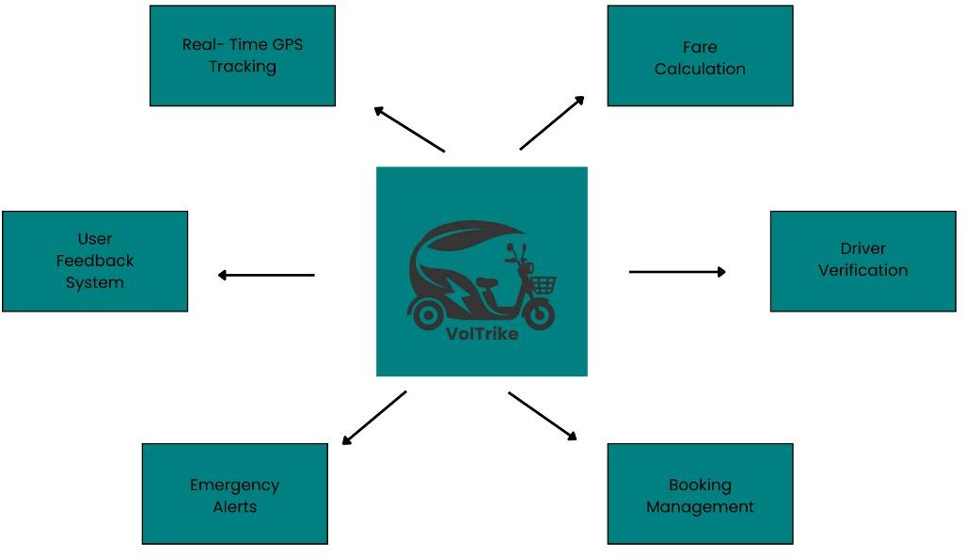
Figure 1. Voltrike General Features

    - Booking and Ride Matching
On-demand booking will allow a passenger to select pickup and destination locations, review a trusted route and fare preview, and submit a request. Cloud Functions will create the booking and rank eligible drivers using service/TODA priority, distance bands, daily award counts, reliability, quality, and exact distance. Offers may be accepted or declined, and the backend will atomically assign the first valid acceptance. This approach provides fairer dispatch without using battery percentage or passenger-side manual driver selection.

    - Geofencing and Compliance of Route

Geofencing will classify pickup and destination points against approved TODA coverage polygons and will apply configured route-restriction polygons or corridors. The system may block invalid endpoints or restricted crossings and may warn drivers about monitored corridors. Highway avoidance supplied to the routing provider is advisory, while local and server policy checks provide the enforceable booking decision. Fine amounts, impoundment outcomes, and alternative-route guarantees will not be stated without an authoritative current source and verified system behavior.
    - Real-Time Location Tracking and Navigation

During active operations, driver coordinates will be written to Firebase Realtime Database and observed by authorized ride participants. The passenger map will display the assigned driver's current or last trusted position, while Google routing and navigation services provide route and guidance information. The design will use bounded updates and reconnect handling instead of promising a universal fixed refresh interval.

Live-location exchange will be limited to the data and ride states required for operations. Network loss will produce an explicit reconnect or unavailable state; the proposal will not claim that booking or navigation remains fully functional offline.
    - Standardized Fare Calculation and Transparency

The fare system will use a versioned configuration containing a base fare, included distance, stepped distance charge, additional-passenger charge, baggage charge, and outside-TODA surcharge. The backend will recompute and snapshot the trusted fare when a booking is created. The implemented payment lifecycle is cash-based, with passenger confirmation, driver receipt acknowledgment, commission and net-earnings snapshots, receipts, and settlement-dispute support. GCash, Maya, PayMongo, Xendit, and card processing are future integrations rather than current functions.
    - Driver Verification and Credential Management

Driver registration will collect personal and contact information, an official PSGC-based address, an active TODA selection, vehicle details, legal consent, and seven images: profile photo, driver's-license front and back, government ID, Official Receipt, Certificate of Registration, and vehicle photo. These uploads are VolTrike/TODA verification requirements; the document will not present every upload as a universal legal requirement without an authoritative source [LTO2024] [PSA2026].

The application will validate required fields and prepare images through crop, resize, compression, and resource-limit checks. It does not perform optical character recognition or query an LGU/LTO database. A driver application will remain pending, offline, and unavailable until the assigned TODA reviews the evidence, records verified license details, verifies the vehicle, and approves the account.
    - Administration, Safety, and Operational Reporting

The shared web portal will provide role-aware operational views. The System Administrator will manage platform-wide TODAs, fare policy, route restrictions, coverage review, operations, reports, safety incidents, and violations. A TODA Administrator will review drivers and view rides, live drivers, commission, ratings, reports, safety incidents, violations, and coverage requests only for the assigned TODA. The mobile applications will also support ride reports, SOS records, chat, and ride-scoped voice communication; external emergency dispatch will remain outside the current implementation.

  - Operating Environment

VolTrike will operate across Flutter passenger and driver clients, a React web administration portal, Firebase managed services, Node.js Cloud Functions, Google mobile mapping and navigation services, and Mapbox-based administrative map editing. Client hardware and mobile-network conditions may vary, so target devices must be validated through named device tests instead of relying on unverified universal RAM or APK-size thresholds.

The platform requires network access for protected booking, dispatch, tracking, and settlement operations. Graceful retry states, bounded caches, and optimized local processing will reduce avoidable work, but the system will not be described as offline-first. Backend scaling and availability will depend on Firebase/Google Cloud configuration, monitoring, quotas, security rules, and operational support.
    - Hardware Requirements:

Hardware requirements are crucial to ensure that the VolTrike mobile application functions smoothly during both the development and deployment phases. The tools used in the development process have been carefully considered, and the following minimum hardware specifications are recommended.

Component | Development | Implementation (Mobile)
Processor | Modern x64 CPU suitable for Flutter/Android builds | Android device with 64-bit CPU, GPS, camera, and mobile data
RAM | 8 GB or more recommended for development | Target-device requirement to be confirmed by named-device testing
Storage | At least 20 GB free for SDKs and build artifacts | Sufficient free space for the app, cache, and evidence uploads
GPU | Dedicated GPU not required | Google Play Services and supported mobile graphics
Display | 1366 x 768 or higher recommended | Readable phone display supported by the final test matrix
Battery | Not applicable | Adequate for GPS/navigation; external power recommended for drivers
Table 2. Hardware Requirements

    - Software Requirements

VolTrike will be developed with Visual Studio Code and Android Studio where appropriate. The passenger and driver application uses Flutter with Dart, Riverpod, and GoRouter. The administrator portal uses React, TypeScript, and Vite. Firebase Authentication, Cloud Firestore, Realtime Database, Storage, Cloud Messaging, and Node.js Cloud Functions provide managed backend services. Google Maps Platform supports mobile places, routes, roads, geocoding, and navigation, while Mapbox GL JS supports web-based coverage and restriction editing. A private Go service provides rollout-controlled quote and dispatch read/compute paths behind Cloud Functions. Rust modules support Android registration-image preparation and optional geometry, PSGC, and navigation acceleration, always with the implemented Dart fallback or rollout mode [FLUTTER2026] [FIREBASE2026] [GMAPS2026] [MAPBOX2026] [REACT2026] [GO2026] [RUST2026].

Component | Software Tool / Technology
Development Tools | Visual Studio Code, Android Studio, Flutter SDK, Dart, Gradle, Git
Mobile Application | Flutter with Dart, Riverpod, and GoRouter
Backend and Data | Firebase Authentication, Firestore, Realtime Database, Storage, Node.js Cloud Functions, and a private Go compute/read service behind Functions
Maps and Geolocation | Google Maps Platform/Navigation for mobile; Mapbox GL JS for the admin portal
Notifications | Firebase Cloud Messaging and local notifications
Web Administration | React, TypeScript, and Vite with role-aware Firebase access
Native and Compute Optimization | Go for rollout-controlled server quote/candidate reads; Rust through Flutter Rust Bridge for Android image preparation and optional geometry, PSGC, and navigation with Dart fallbacks
Table 3. Software Requirements

  - Design and Implementation Constraints

The development and implementation of VolTrike are carried out within a range of technical, regulatory, and operational limitations that influence the system's architecture, functionality, and feature prioritization. These constraints affect decisions regarding software design, hardware integration, compliance with transportation regulations, and the allocation of development resources throughout the project. Recognizing these limitations enables realistic project planning, effective risk management, and proper expectation setting among stakeholders regarding the system's capabilities, performance, and implementation timeline.

    - Optimization of Budget Devices and Scalability.

Support for budget and mid-range devices will be addressed through measurable implementation choices rather than fixed, unsupported requirements. The mobile app uses compact PSGC indexing, bounded caches, search debouncing, controlled background work, image processing outside the UI isolate, and Rust-native paths with Dart fallbacks. The private Go service can cache policy reads and move selected route/fare and dispatch-read computation behind Cloud Functions when enabled. Performance claims will identify the test device, build mode, workload, rollout mode, and recorded benchmark; real-device and service-load testing will remain necessary.
    - Boundary Complexity and the Regulatory Rules of a City.

Every municipality that has a jurisdiction to operate tricycles comes up with its unique rules that outline the scope of operation, the routes that should be used, the fare structure, and licensing guidelines. VolTrike will have to cater to this regulatory heterogeneity by having flexible systems of boundary definition that can admit different geographic zone definitions to different municipalities but without necessarily having different versions of the application. The limitation demands tight cooperation between local government units and TODA organizations in the deployment as needed to determine the correct boundary definitions, which introduces time and complexity in the first rollouts in the city. Adaptation of the boundaries through a change in regulations needs to be coordinated with the regulatory authorities and the deployment of the updated

configurations quick, which brings about operational dependencies between VolTrike and the government entities, which are not under its direct control.
    - Dependences on Third party services.

VolTrike depends on Firebase managed services, Google Maps Platform, Mapbox for the web administration map, mobile data networks, and notification/email infrastructure. A service disruption may affect sign-in, booking, dispatch, tracking, route calculation, or administrator operations. The design will use clear error, retry, reconnect, and cached-policy behavior where safe, while acknowledging that protected transactions cannot continue when their authoritative backend is unavailable. No AWS, offline-map, or payment-gateway fallback will be claimed in the current design.

  - Assumptions and Dependencies

The project assumes that passengers, drivers, and administrators have compatible devices, sufficient connectivity for online operations, and access to the external services configured for the platform. It also depends on participating TODAs and local stakeholders supplying correct coverage, driver-review, and policy information. These conditions will be validated during staged testing and any future pilot rather than treated as guaranteed market outcomes.

    - Assumptions

The design and development of VolTrike is premised on a few underlying assumptions regarding the environment of operation, the behavior of the users, and the market. These assumptions ought to be tested on pilot operations and modified according to the real conditions observed. The system presupposes that adequate e-trike drivers and passengers will be enthusiastic about the platform to establish the viable marketplace economics in which the income gains by drivers will motivate the drivers to join the platform and the convenience of passengers will be a motivating factor to use the e-trikes. In the absence of critical mass in both categories of users, network effects that enable the value of platforms to increase do not take place.
      - Sufficient Driving Engagement and Revenue Rewards.

Driver participation is expected to depend on the usefulness, fairness, and reliability of booking opportunities and on the clarity of commissions and net earnings. No fixed daily-income threshold will be assumed. A future pilot may compare platform-assisted earnings and operating effort with the driver's prior workflow using consented, appropriately scoped data.

      - Smartphone Penetration and Driving Digital Literacy.

The platform assumes that target users have access to compatible Android devices and can complete guided mobile tasks. The registration flow, validation messages, review screens, and high-contrast controls are intended to reduce onboarding difficulty. Any additional training, printed guide, or support channel will be treated as a deployment decision rather than an already completed deliverable.
      - Regulatory Stability and Cooperation with Local Government.

The system presupposes that the e-trikes regulations at the municipal level are not going to change much, and the local government agencies will be sscooperative with the platform deployment by checking the boundaries and regulatory assistance. Negative regulatory developments or resistance on local governments may severely restrict the growth of platforms. The system presupposes that TODA organizations will collaborate with the platform as an official way of structuring the hitherto informal operations instead of perceiving the platform as a threat to their traditional dominance.
    - Dependencies

VolTrike will rely on numerous external elements, services and states outside of the direct control of the platform, which determine functionality and performance. Such

dependencies need to be managed and carefully followed during the project lifecycle to avoid disruptions as they may occur unexpectedly.

      - Third Party Mapping and Geolocation Services.

Google Maps Platform will supply places, routes, roads, geocoding, and mobile navigation functions used by the implementation. Availability, quota, credential security, pricing, and provider behavior remain external dependencies. The route service will request appropriate preferences and will present failures clearly; OpenStreetMap will not be described as an implemented fallback.
      - Cash Payment and Settlement

The implemented ride-payment process uses cash. After the ride reaches payment confirmation, the passenger confirms payment and the driver acknowledges receipt before completion. The trusted booking stores fare, commission, driver net earnings, receipt, and settlement status snapshots. Digital-wallet and external-gateway integrations may be evaluated later but are not dependencies of the current release.

      - Firebase and Google Cloud Infrastructure

Authentication, durable records, live location data, evidence files, notifications, and protected operations rely on configured Firebase services and the associated Google Cloud project. Their availability, quotas, security rules, secrets, indexes, monitoring, and deployment configuration directly affect the platform. Firebase reduces infrastructure management but does not remove the need for security review, backups, incident response, and release maintenance.
      - Cells and Net Cellular Network and Internet Network.

Cellular network connectivity is necessary in driver and passenger applications. The platform relies on the ability of telecommunications providers to keep their networks active, to have sufficient signal strength in their service zones, and sufficient data rates of the networks to support application functionality. Peak hours are times that can cause network congestion which reduces performance. Poor signal in peripheral locations is a direct restriction of the geographical coverage of the platform.
      - Regulatory Cooperation of Local Government Unit.

The operation of the platform will rely on the local government units passing positive regulatory directions on the operation of the e-trikes, setting clear boundaries, and avoiding the restrictive policies that confined the operation of platforms. The platform relies on the municipal governments that possess stable regulations as opposed to abrupt prohibition or significant restrictions. Negative regulatory developments that ban the use of e-trikes in some lucrative cities may significantly decrease the viability of the platform.

This chapter specified VolTrike's implemented design basis: Flutter/Dart mobile clients, a React/TypeScript administrator portal, Firebase managed services, Google and Mapbox mapping components, server-authoritative booking and fare operations, driver/TODA verification, live tracking, route and service-area policy, cash settlement, and scoped safety/administrative functions. It also identified device, connectivity, provider, and regulatory dependencies. Unsupported carbon calculations, OCR, digital wallets, offline maps, and universal performance figures have been excluded from the current implementation scope.

CHAPTER III PRODUCT FEATURES

This chapter presents the principal product features of VolTrike across the Flutter passenger and driver application, the shared React web administration portal, Firebase and Node.js trusted backend operations, the rollout-controlled private Go compute service, and Rust-assisted Android workloads. The design combines role-aware accounts, driver verification, ride booking and dispatch, GPS tracking, route and service-area compliance, fare and cash settlement, and administrative safety controls.
VolTrike supports the intent of SDG 13 by organizing electric-tricycle operations and making short-distance travel data more visible. Because e-trikes have no tailpipe emissions during operation, their organized use may support cleaner local mobility; however, the application does not calculate avoided emissions. Future climate analysis would require an approved baseline and methodology separate from the booking system.

  - Product Decomposition

Figure 2 presents five user-facing subsystems: User Account Management, Ride Request and Booking, Real-Time GPS Tracking and Map Display, Route Compliance and Geofence Validation, and Fare Calculation and Settlement.

Driver/TODA verification and role-aware administration operate as cross-cutting controls across those subsystems. Cloud Functions authorize sensitive booking, dispatch, fare, settlement, reporting, and administrative changes. The private Go service is called only behind Cloud Functions for enabled quote or candidate-read paths; it does not accept direct mobile or admin traffic. Rust is used inside the Android client for registration-image preparation and optional geometry, PSGC, and navigation acceleration. Firestore, Realtime Database, and Storage retain distinct data responsibilities.
User Account Management covers passenger registration, driver application and TODA review, email verification, login, password recovery, and role-specific access. Ride Request and Booking validates trusted route, coverage, and fare inputs before server-ranked driver offers. GPS Tracking uses Realtime Database for current driver location. Route Compliance separates TODA service-area polygons from developer-managed restriction polygons or corridors. Fare Calculation applies a versioned backend policy and supports cash confirmation, receipt acknowledgment, commissions, and ratings. The shared web portal gives the System Administrator platform-wide access and each TODA Administrator only its assigned scope.
This decomposition keeps user-facing functions understandable while preserving server authority and role boundaries. Additional payment methods, climate calculations, or new deployment areas can be evaluated later without being presented as current features.

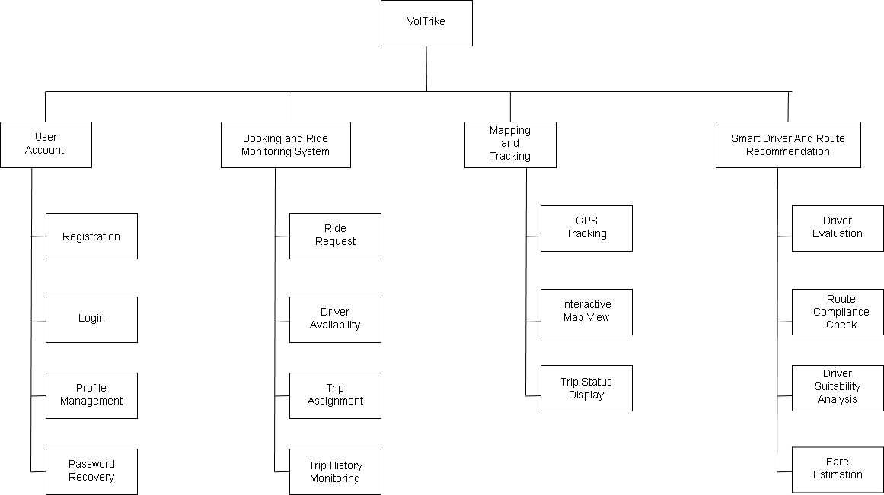
Figure 2. Voltrike Application Decomposition Chart

  - Product Functionalities

Each major capability is described through its purpose and priority, stimulus-response behavior, functional requirements, and the existing seven-part function-table format. The activity flows use implementation-backed roles, states, alternate paths, and exceptions.
    - User Account Management

This subsystem allows passengers, driver applicants, approved drivers, TODA Administrators, and the System Administrator to access only the functions permitted for their role. Firebase Authentication manages email/password credentials and verification, while Firestore stores permitted profile and application data.

A consistent account and approval layer is required before booking, tracking, settlement, driver review, or administrative operations can be performed.
      - Description and Priority

User Account Management covers passenger self-registration, email verification, email/password login, password recovery, and role-aware access. Public registration never offers a System Administrator role, and every authenticated account must still pass its active, verification, and authorization checks before entering a permitted interface.
      - Stimulus/Response Sequence

Tables 4, 5, and 6 describe passenger registration, user login, and password recovery. Together they show validation, Firebase Authentication, permitted profile access, role/status checks, generic recovery responses, and safe handling of unavailable authentication or email services.

Function Name | Passenger Account Registration
Function Description | Creates a passenger account from name, phone, email, password confirmation, and accepted Terms and Privacy Policy.
Precondition | User has the VolTrike mobile app, an active internet connection, and access to a valid email address.
Post Condition | Firebase Authentication account and permitted passenger profile are created; a verification email is sent before normal access.
Activity Flow
User |  | VolTrike | Database
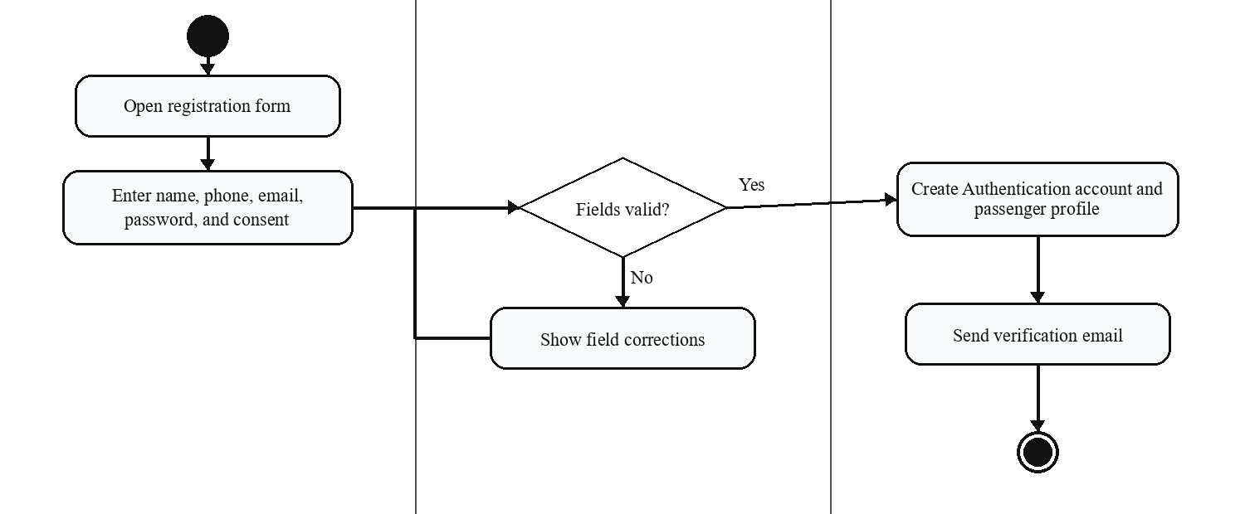
Alternate Flow | If validation fails or the email is already registered, show a concise field/account error and keep the entered form data for correction.
Exception | If account creation, profile creation, or email delivery fails, show a safe error and prevent a partially authorized session.
Table 4. Passenger Account Registration

Table 5 shows email/password login. Firebase Authentication verifies the credentials and email state, after which the application or web portal applies the account role, active status, driver approval status, and administrator scope before opening the correct interface.
Function Name | User Account Login
Function Description | Authenticates an existing user through verified email/password credentials and applies the role and account-status gate before access.
Precondition | The user has an existing VolTrike account, an active connection, and access to the mobile application or shared web portal.
Post Condition | An active, permitted user is directed to the passenger, approved-driver, TODA Administrator, or System Administrator interface allowed by the account.
Activity Flow
User |  | VolTrike | Firebase Authentication / Data
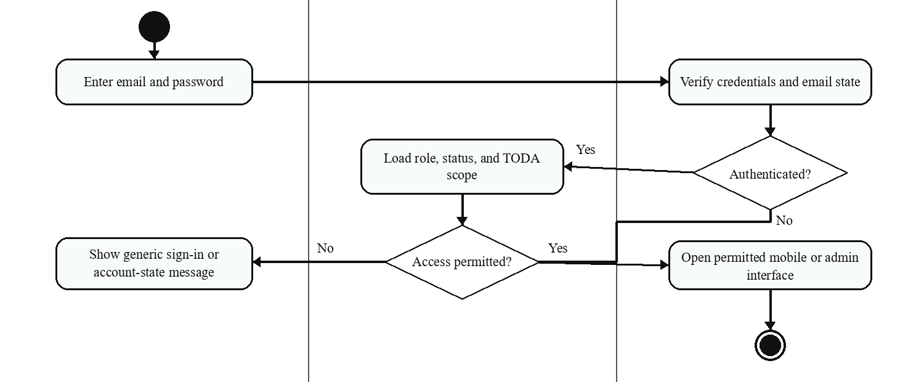
Alternate Flow | If credentials or account state are not accepted, show a generic sign-in message and allow retry or password recovery without exposing protected account details.
Exception | If authentication or profile services are unavailable, show a temporary-unavailable message, grant no protected session, and allow a safe retry.
Table 5. User Account Login

Table 6 shows password recovery. The user submits an email address and Firebase Authentication handles the reset request. The interface displays a generic completion or error message without exposing whether another person's account exists.
Function Name | Password Recovery
Function Description | Requests a Firebase Authentication password-reset email without disclosing whether another person's account exists.
Precondition | The user can open the recovery interface, enter an email address, and access the associated email service if a reset message is issued.
Post Condition | Firebase accepts the reset request and the interface shows a generic completion response; the user may set a new password through the secure email link.
Activity Flow
User |  | VolTrike | Firebase Authentication / Email
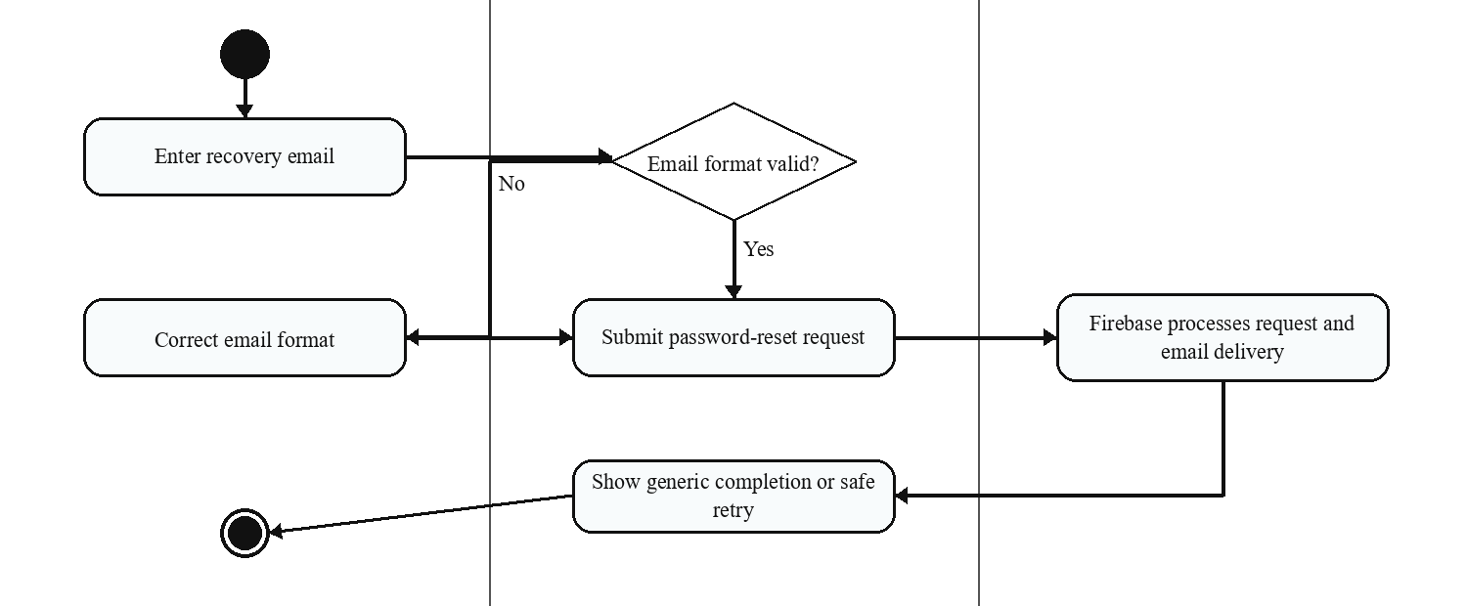
Alternate Flow | A syntactically invalid email is corrected in the form; a valid request always receives a generic response that does not confirm account existence.
Exception | If Firebase or email delivery cannot complete the request, show a safe retry message without exposing account-registration information.
Table 6. Password Recovery

      - Functional Requirements

User Account Management provides passenger registration, driver application and approval gating, email verification, login, password recovery, permitted profile access, and administrator role/scope enforcement.
        - Enable passenger self-registration and the separate five-step driver application, including validation, evidence upload, review/edit, and legal consent.
        - Authenticate users with Firebase Authentication and apply active, verified, driver-status, and administrator-scope checks before access.
        - To have a system to recover passwords by sending a secure reset message to the registered email address.
        - Store only permitted user, passenger, driver, TODA application, and role metadata in Firestore; never store passwords in Firestore.
        - Enforce protected access through Firebase claims, Firestore/Realtime Database/Storage rules, and server-side Cloud Function checks.
    - Driver Registration and TODA Approval
The driver-onboarding module collects the identity, address, TODA, vehicle, evidence-image, review, and legal-consent information required for a driver application. Submission creates a pending record; it does not grant permission to go online or receive bookings.
      - Description and Priority
Driver registration is a high-priority trust and safety function. The five-step Flutter flow validates personal and PSGC address data, active TODA selection, vehicle details, seven required evidence images, final review/edit, and legal consent. On supported Android devices, registration images use the Rust preparation path automatically with a Dart-isolate fallback; optional Rust PSGC lookup remains rollout-controlled. The assigned TODA Administrator reviews the evidence and records the required verification decision within the role's permitted scope.
      - Stimulus/Response Sequence
Table 7 shows the applicant completing the guided flow, the application validating fields and preparing evidence through the supported Rust-or-Dart path, Firebase creating a pending/offline/unavailable driver application, and the assigned TODA Administrator approving or declining it after verification. Invalid fields, failed preparation/upload, unavailable TODA data, or authorization failures stop the submission or review safely.
Function Name | Driver Registration and TODA Approval
Function Description | Collects personal, PSGC address, TODA, vehicle, evidence-image, review, and legal-consent data for scoped TODA verification; supported Android image preparation uses Rust with a Dart fallback.
Precondition | Applicant is at least 18, has a valid email, selects an active TODA, and can provide every required field and image.
Post Condition | A pending, offline, unavailable driver application is created; approval requires TODA review, verified license metadata, and vehicle verification.
Activity Flow
Driver Applicant |  | VolTrike | TODA Admin / Firebase
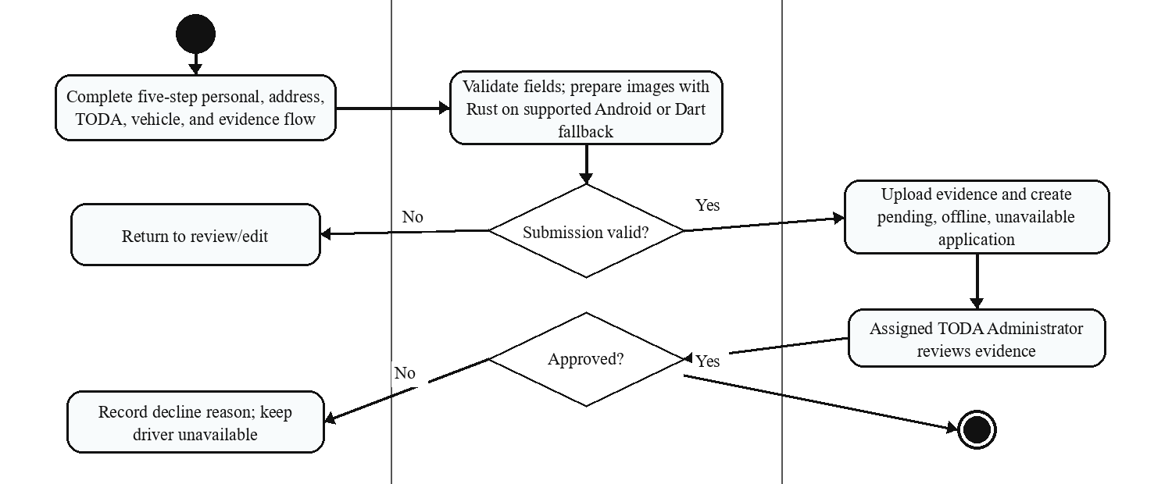
Alternate Flow | The applicant may move back to edit a section before submission; the reviewer may decline with a reason and require correction outside the active-driver flow.
Exception | Missing/invalid fields, failed image preparation/upload, unavailable TODA data, or backend authorization failure prevents submission or review.
Table 7. Driver Registration and TODA Approval
      - Functional Requirements
Driver Registration and TODA Approval must preserve application completeness, evidence integrity, role scope, and approval gating before any driver can participate in dispatch or rides.
        - Collect and validate personal, PSGC address, TODA, vehicle, review, and legal-consent data through the guided five-step registration flow.
        - Require the seven implemented evidence images and prepare each image through the supported native-first path with a Dart fallback before upload.
        - Create the driver application as pending, offline, and unavailable; registration alone must not activate driver operations.
        - Limit TODA review to the assigned organization and require the permitted license metadata, vehicle verification, approval, or documented decline decision.
        - Permit online availability, driver offers, and ride operations only after the account and driver application satisfy active, verified, approved, and authorization checks.

    - Ride Request and Booking

The ride-request module manages the passenger flow from trusted pickup/destination and fare preview through backend booking creation and driver assignment. The interactive map, coverage classification, route restrictions, fare policy, and server-ranked dispatch are evaluated before an offer can become an assigned ride.
      - Description and Priority

The passenger selects pickup and destination locations and reviews the trusted route and fare preview. On confirmation, a Cloud Function validates account, location, coverage, route policy, and fare inputs, creates a `pending` booking, and offers it to eligible ranked drivers. A valid acceptance atomically changes the booking to `driverAssigned`.
This is the core passenger-driver connection function. It reduces uncertainty through a trusted lifecycle and transparent fare while avoiding unsupported claims that the system measures fuel or emissions savings.

      - Stimulus/Response Sequence

Table 8 shows trusted booking creation, ranked driver offers, atomic acceptance, assignment, timeout/decline handling, and service-area or route-policy exceptions. Cloud Functions remains authoritative. When the configured rollout flag is enabled, it may request a signed route/fare quote or dispatch-candidate read from the private Go service before validating and applying the protected booking operation.

Function Name | Request and Booking
Function Description | Allows a passenger to select pickup and destination, review trusted route/fare information, and submit a Firebase-authoritative request; the private Go quote/read path is used only when enabled.
Precondition | Passenger is authenticated and active, location permission is available, pickup is supported, and the route/coverage policy can be evaluated in Bacolod City.
Post Condition | A pending booking and ranked offers are created; the first valid driver acceptance changes the status to driverAssigned and tracking begins.
Activity Flow
Passenger |  | VolTrike | Cloud Functions / Driver
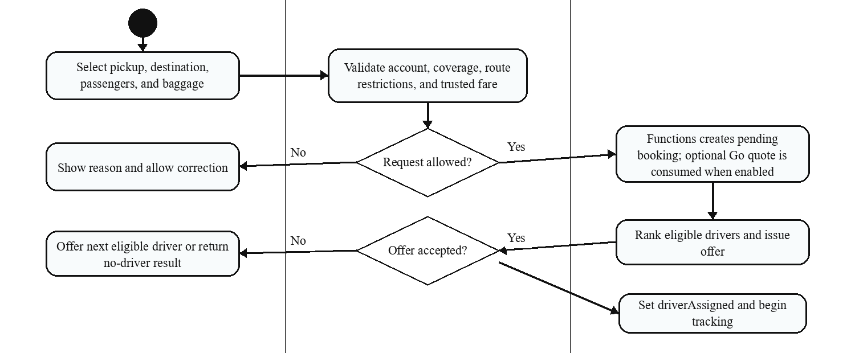
Alternate Flow | If an offer is declined or expires, the backend may continue with eligible ranked drivers. If no driver accepts, return a no-driver result and allow retry.
Exception | Reject booking creation when account, pickup coverage, destination/route policy, fare validation, or the authoritative backend check fails.
Table 8. Ride Request and Booking

      - Functional Requirements

The module keeps booking and status mutations server-authoritative in Firebase Functions even when rollout-controlled Go quote or candidate-read assistance is used. The ride lifecycle proceeds through pending, driverAssigned, driverArriving, passengerOnBoard, paymentConfirmation, and completed, with cancellation allowed only in permitted pre-onboard states.
        - Provide destination search and map selection for pickup and destination, subject to location permission and trusted route validation.
        - Reject a pickup outside configured service coverage or a route/end point blocked by an active restriction; handle permitted cross-TODA destinations according to policy and surcharge configuration.
        - Compute and display a trusted route, estimated distance/time, fare breakdown, and applicable advisory before confirmation.
        - Create bookings and all sensitive lifecycle transitions through Cloud Functions, with fare, route, participant, TODA, vehicle, and timestamp snapshots.
        - Rank eligible drivers on the server, send bounded offers, and atomically assign the first valid acceptance or finish with a no-driver result.
        - Notify authorized participants of request, assignment, arrival, onboard, payment, completion, and valid cancellation events.

    - GPS Tracking and Map Display in Real Time

The GPS tracking feature uses the driver's device location and Firebase Realtime Database to provide current driver position to authorized ride participants. Firestore stores durable booking and route records; it is not presented as the live driver-location channel. Google route/navigation services support map and guidance displays.
      - Description and Priority

After assignment, the driver app publishes authorized location updates while the driver approaches, carries, and completes the ride. The passenger listens for the assigned driver's current location and the interface updates the marker and available route or arrival information according to booking state. On supported Android devices, the optional Rust navigation path can validate and smooth GPS samples and calculate route progress; rollout modes and the Dart fallback prevent this optimization from becoming a universal dependency.
      - Stimulus/Response Sequence

Table 9 shows permission and location capture, optional Rust-assisted sample processing, secure Realtime Database transmission, passenger listening, map updates, and weak-signal or connectivity feedback. No universal five-, ten-, or fifteen-second guarantee is stated.

Function Name | Real-Time GPS Tracking
Function Description | Publishes an authorized driver's current location to Realtime Database and displays it during operational ride states; optional Rust navigation processing keeps a Dart fallback.
Precondition | An approved driver is online or has an active assigned booking, required location permission is granted, and the participant is authorized.
Post Condition | The passenger map displays the current or last trusted driver location and available route/arrival information with stale or reconnect feedback when needed.
Activity Flow
Driver / Passenger |  | VolTrike | Realtime Database / Maps
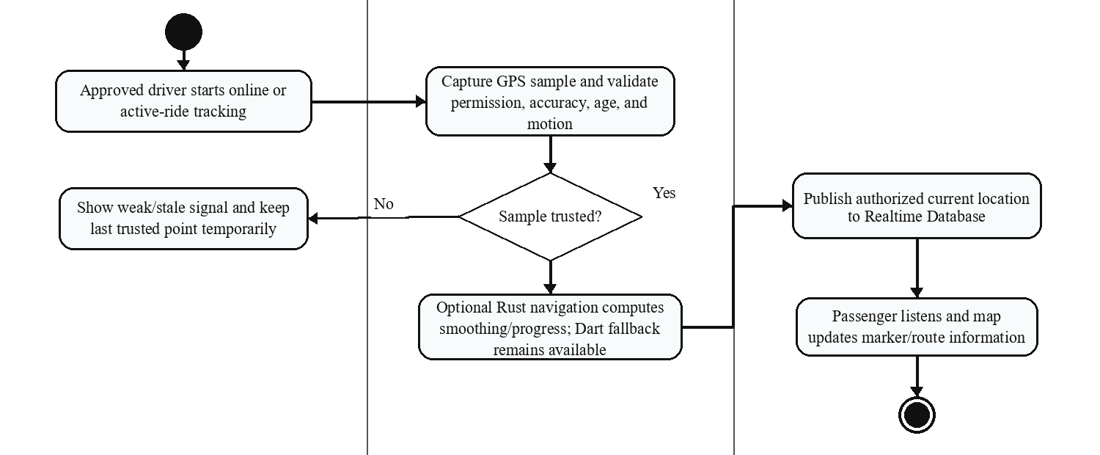
Alternate Flow | If GPS is weak, keep the last trusted location temporarily and show an explicit weak-signal or stale-location state.
Exception | If network or authorization fails, stop unauthorized updates/listening, show reconnect or unavailable feedback, and preserve safe ride-state handling.
Table 9. Real-Time GPS Tracking

      - Functional Requirements

This module is a safety and transparency layer for active rides. It uses bounded current-location data and trusted booking/route context without claiming that every coordinate is stored as a permanent route history or used to calculate avoided carbon emissions.
        - Start and stop ride-related tracking according to approved driver availability and booking lifecycle states, and remove or expire live presence according to policy.
        - Capture driver location at the configured cadence and transmit only the data required by authorized operations.
        - Display current or last trusted driver location smoothly on the passenger map, with an explicit stale, weak-signal, or reconnect state when necessary.
        - Display route and arrival information available from the configured Google services without promising a fixed recalculation interval.
        - Retain the durable booking route and the trusted location snapshots required for operations, safety, reports, or violations; do not claim an unimplemented full route-history archive.
        - Handle temporary GPS or network loss with clear feedback, bounded retry, and safe state transitions.

    - Geofence and Route Compliance

The route-compliance module distinguishes approved TODA coverage polygons from developer-managed restriction polygons and corridors. Coverage classifies pickup and destination relationships, while restriction checks can block prohibited endpoints or crossings and can produce driver warnings or violation cases.
      - Description and Priority

Approved TODA service areas are stored as latitude/longitude polygons. The system classifies requests as pickup outside, same TODA, or cross-boundary and applies configured booking/fare policy. Active route restrictions are evaluated separately as polygons or corridors. Cloud Functions performs the authoritative decision, while the Go service and Rust geometry path may assist enabled compute/read work under their rollout controls. The term intercountry trip is not used for this Bacolod City service design.
      - Stimulus/Response Sequence

Table 10 shows coverage and restriction validation: load active policy, classify pickup/destination with point-in-polygon logic, evaluate route intersections or corridors, then allow, surcharge, warn, or reject according to the authoritative policy. The diagram distinguishes Cloud Functions authority from optional Go server computation and Rust client acceleration. Missing or invalid policy data produces a safe error rather than manual approval of a live trip.
Function Name | Route Compliance and Geofence Validation
Function Description | Validates coverage and active endpoint, polygon, corridor, and route-intersection restrictions, with Cloud Functions authority and rollout-controlled Go/Rust assistance.
Precondition | Trusted pickup/destination coordinates, approved TODA coverage polygons, active route restrictions, and route-service results are available.
Post Condition | An allowed request continues to trusted fare and booking; a blocked or unsupported request returns a concise reason and permits location correction.
Activity Flow
Passenger |  | VolTrike | Firebase / Route Services
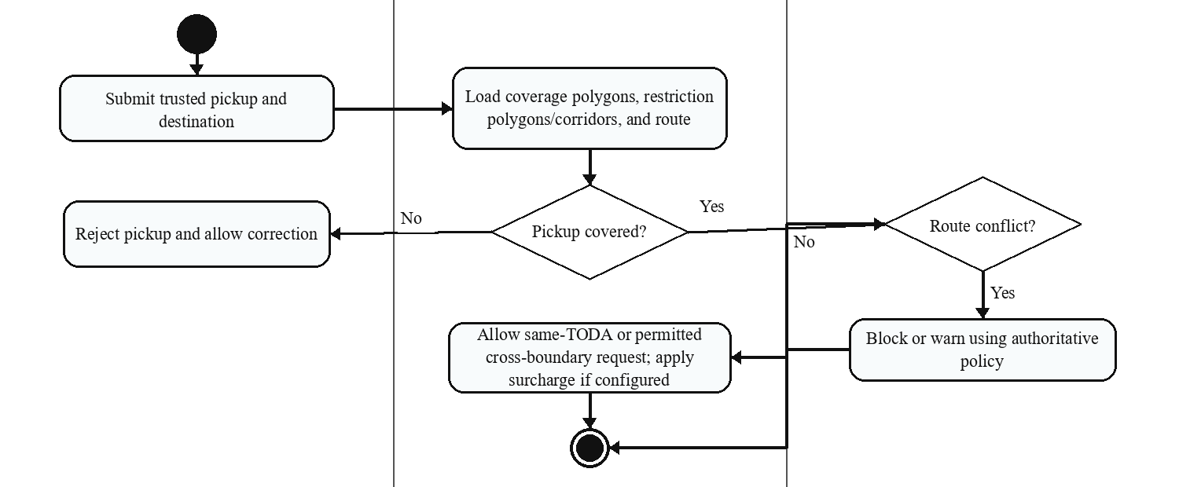
Alternate Flow | A permitted cross-TODA destination continues under the configured boundary and surcharge policy; a blocked location may be replaced by the passenger.
Exception | Missing, invalid, unauthorized, or unavailable coverage/restriction data stops booking creation and returns a safe configuration or service error.
Table 10. Route Compliance and Validation

      - Functional Requirements

This module supports operational compliance by validating configured service areas and restrictions before booking and by monitoring relevant driver-route conditions. It does not claim that geofencing alone proves legal compliance or prevents every possible violation.
        - Allow TODA Administrators to request or maintain their coverage polygons and allow the System Administrator to review coverage and manage platform route restrictions.
        - Check pickup/destination coverage and active route restrictions before the trusted fare is accepted and the booking is created.
        - Show concise feedback for blocked locations or routes and identify the configured reason where available.
        - Monitor configured driver restriction conditions and create scoped warning or violation records when the implemented policy requires it.
        - Use coverage, restriction, and violation results for operational review; climate analysis remains future research.

    - Fare Calculation, Cash Payment, and Settlement

The fare module provides a transparent quote using a versioned, administrator-configurable policy. The current policy contains a base fare, included distance, stepped distance charge, additional-passenger charge, baggage charge, and outside-TODA surcharge. The cash lifecycle continues through payment confirmation, driver acknowledgment, receipt, commission, and settlement records.
      - Description and Priority

After route and coverage validation, the system calculates fare components, records a trusted snapshot at booking creation, and displays the breakdown before confirmation. Cloud Functions recomputes and validates the fare instead of trusting the client. If Go quote mode is enabled, the private service may calculate the Google Routes-based quote and issue a short-lived encrypted token that Cloud Functions consumes and validates.
      - Stimulus/Response Sequence

Table 11 shows route/coverage input, loading the current fare policy, calculating and rounding fare components, displaying the preview, snapshotting the trusted booking fare, and completing the later cash-confirmation and receipt process. The flow identifies the optional Go quote path without presenting it as the authority for settlement or ride-state changes.

Function Name | Fare Calculation and Cash Settlement
Function Description | Calculates a trusted fare from a versioned policy and supports cash confirmation, driver acknowledgment, receipt, commission, and settlement; an enabled Go quote is consumed by Cloud Functions.
Precondition | Trusted route distance, coverage classification, passenger/baggage options, and the active fare configuration are available.
Post Condition | Passenger receives a fare breakdown before confirmation; booking stores an authoritative fare snapshot and later cash-settlement fields.
Activity Flow
Passenger / Driver |  | VolTrike / Cloud Functions | Fare / Settlement Records
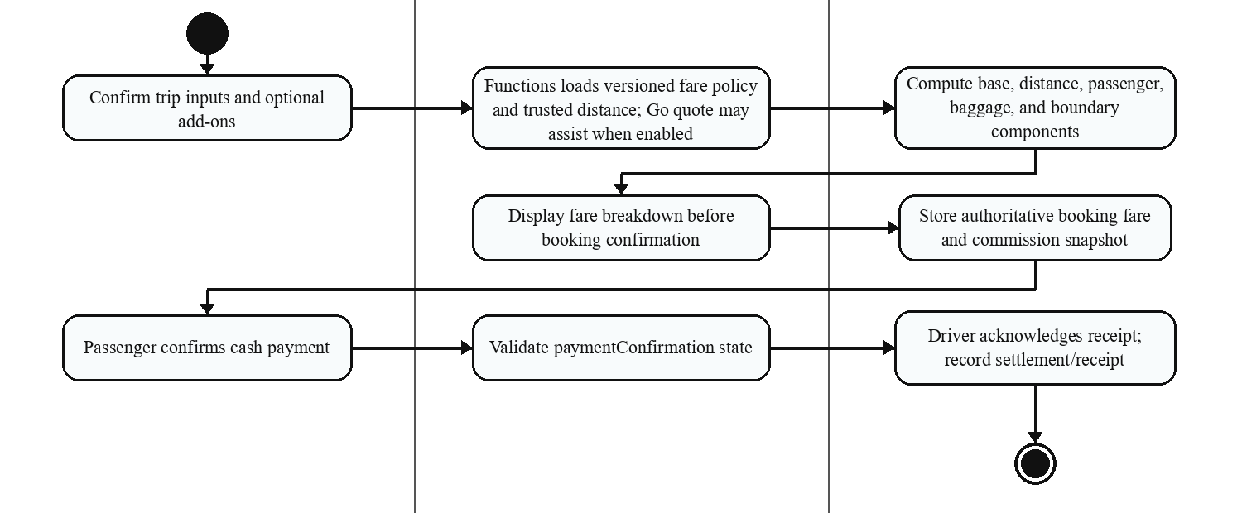
Alternate Flow | If an optional component does not apply, calculate from the remaining configured components. Versioned defaults may be used only through the trusted policy.
Exception | Reject or retry when trusted route, fare configuration, backend recomputation, or settlement-state validation fails.
Table 11. Fare Calculation and Cash Settlement

      - Functional Requirements

This module standardizes pricing through one trusted versioned policy and preserves the exact fare and commission inputs used for a booking. It supports passenger transparency and driver settlement without claiming digital-wallet processing.
        - Maintain a versioned fare configuration that authorized administrators can update without recalculating completed rides.
        - Classify the pickup and destination coverage relationship for any configured outside-TODA surcharge.
        - Calculate the base, stepped distance, additional-passenger, baggage, and applicable boundary components using centavo-safe rounding.
        - Present the fare total and major components before passenger confirmation.
        - Snapshot the authoritative fare policy and result at booking creation; only approved backend transitions may change settlement fields.
        - Create the cash confirmation, driver acknowledgment, receipt, commission, net-earnings, and dispute records required after the ride.
    - Administrative Operations and Access Control
System and TODA Administrators use one web portal, while Firebase claims, security rules, and Cloud Functions preserve platform-wide and TODA-scoped authority.
      - Description and Priority
Administrative operations are high priority because driver approval, TODA onboarding, fare policy, coverage, route restrictions, reports, safety records, violations, ratings, settlements, and platform configuration require trusted role and scope enforcement. The interface is shared, but System Administrator and TODA Administrator authority remains distinct.
      - Stimulus/Response Sequence
Table 12 shows an administrator signing in, opening only permitted pages, submitting a review or configuration action, and the shared portal forwarding the protected request. Firebase claims, profile status, and TODA assignment are checked before the backend accepts and records the action.
Function Name | Admin and TODA Operations
Function Description | Provides role-aware review, monitoring, fare, coverage, restriction, report, safety, violation, rating, and settlement functions in one portal.
Precondition | Administrator is authenticated, active, email-verified where required, and has matching Firebase claims/profile scope.
Post Condition | Only authorized platform-wide or assigned-TODA data and actions are displayed and accepted; protected mutations are audit-scoped by the backend.
Activity Flow
Administrator |  | Shared Web Portal | Firebase / Cloud Functions
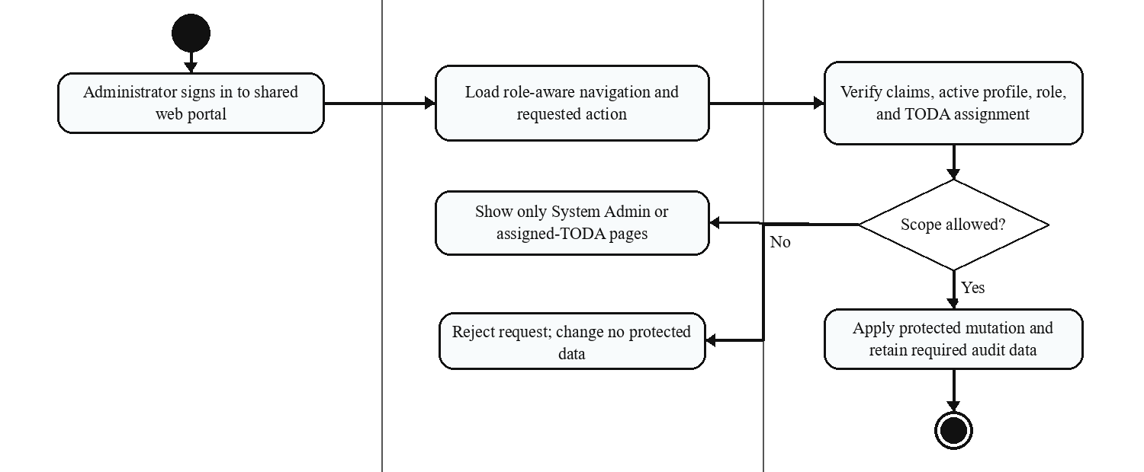
Alternate Flow | A TODA Administrator sees only assigned-TODA pages and data; the System Administrator sees platform-wide configuration and review functions.
Exception | Claim/profile mismatch, inactive account, missing TODA assignment, or insufficient role returns an access error and performs no protected mutation.
Table 12. Admin and TODA Operations
      - Functional Requirements
Administrative Operations and Access Control must apply the same authorization decision in navigation, data queries, security rules, and protected backend mutations.
        - Provide one shared React/TypeScript portal with role-aware navigation for System Administrators and TODA Administrators.
        - Validate authentication, active status, Firebase claims, profile role, and TODA assignment before displaying protected data or accepting a mutation.
        - Restrict TODA Administrators to the drivers, applications, live operations, commissions, ratings, reports, safety incidents, violations, and settlements of their assigned TODA.
        - Reserve platform-wide TODA onboarding, fare policy, coverage approval, route restrictions, operational quality, protected configuration, and cross-TODA oversight for the System Administrator.
        - Reject claim/profile mismatches or insufficient scope without changing protected data, and retain the result or audit information required by the implemented operation.

Chapter III described how account and approval gates, Firebase-authoritative booking states, ranked dispatch, Realtime Database location tracking, coverage and route restrictions, fare snapshots, cash settlement, and scoped administration work together. It also identifies the private Go compute/read service and Rust-assisted Android paths as controlled optimizations with explicit authority boundaries and fallbacks. The design supports organized electric-tricycle operations in Bacolod City without unsupported fuel, carbon-calculation, offline, or digital-payment claims.

CHAPTER VI PROJECT MANAGEMENT

This chapter demonstrates the way VolTrike project is to be planned, supported, and maintained after its technical design based on the requirements and strategies that allow the application to operate with high reliability in the real environment. It describes the suggested hardware and software requirements to run smoothly, types of users and details of their need, and considerations of implementing VolTrike in real urban communities. Besides this, timelines, communication practices, coordination mechanisms, and team roles which guided the development process and will further influence future maintenance and enhancements have been discussed in this chapter which will ensure the project is realistic, manageable and aligned to its SDG 13 oriented focus.

  - Hardware Recommendations

VolTrike will target Android devices with GPS, camera access, Google Play Services, and a stable mobile-data connection. Because exact processor, RAM, storage, and battery needs depend on the build and workload, minimum specifications will be confirmed on named test devices. Drivers should use a safe phone mount and suitable power source for extended GPS/navigation use.

The server side will use Firebase and the associated Google Cloud project. Managed services can scale with configuration and quota planning, but the team must still maintain security rules, indexes, secrets, monitoring, backup/retention decisions, and release procedures.

  - Software Recommendations

The mobile application will be maintained with Flutter, Dart, Riverpod, GoRouter, Android/Gradle tools, Firebase, and Google Maps Platform SDKs. The web portal will use React, TypeScript, Vite, Firebase, and Mapbox GL JS. Node.js Cloud Functions remain authoritative for protected operations. The Go service must be deployed privately, authenticated service-to-service, monitored, and enabled only through tested quote/dispatch feature flags. Rust and Flutter Rust Bridge must retain API-version checks, supported Android builds, controlled rollout modes, and Dart fallbacks. Supported versions and device requirements will come from the final build and test matrix [REACT2026] [GO2026] [RUST2026].

  - User Classification

VolTrike has four operational user classifications: Passenger, Driver Applicant/Approved Driver, TODA Administrator, and System Administrator. Passengers and drivers use the Flutter mobile application. Both administrator roles use one React web portal, but their authority remains separate and is enforced by Firebase claims, rules, and Cloud Functions.

Passengers and approved drivers participate in rides. TODA Administrators review drivers and monitor only their assigned TODA. The System Administrator reviews TODA onboarding and manages platform-wide fares, coverage approvals, route restrictions, quality controls, reports, safety incidents, and violations.
    - Passenger Users

Passenger users include residents, students, and workers making short trips in Bacolod City. The application will provide destination search, trusted fare and route previews, ride requests, assigned-driver tracking, communication, safety/reporting, cash confirmation, receipts, history, and ratings through guided mobile interfaces.
    - Drivers of E-Trikes

Drivers are electric-tricycle operators who submit a five-step application and remain unavailable until TODA approval. Approved drivers can manage availability, receive server-ranked offers, progress through the ride lifecycle, communicate with the passenger, confirm cash receipt, and review earnings, ratings, reports, and violations within their role.
    - TODA Administrator
A TODA Administrator uses the shared web portal to review assigned driver applications and manage only the organization's drivers, rides, live operations, commission, ratings, reports, safety incidents, violations, and coverage requests.
    - System Administrator
The System Administrator has platform-wide responsibility for TODA onboarding review, fare configuration, coverage approval, route restrictions, operational quality, reports, safety incidents, violations, and protected account actions. This role remains distinct from TODA administration.

  - Product Feasibility Assessment

VolTrike feasibility will be evaluated across user adoption, organizational support, operating cost, technical maintenance, and staged deployment. The proposal will not assume that the prototype prevents accidents or guarantees revenue. Feasibility will instead depend on verified system behavior, participant feedback, policy fit, and the ability of partner TODAs and administrators to maintain accurate data.
    - Marketing
Future introduction activities may involve participating TODAs, barangay or city stakeholders, schools, and workplaces. Any pilot orientation, printed material, or public communication will be planned and documented when approved; it will not be described as already completed.

    - Management

Deployment and maintenance will require coordinated release planning, monitoring, incident handling, security-rule review, backup/retention decisions, policy updates, and user-support procedures. Firebase reduces physical infrastructure work but does not eliminate technical operations. Google Play release will remain a planned distribution option until a signed production build and store release are completed.

    - Economic

Economic feasibility will initially be evaluated through actual hosting, mapping, notification, support, and maintenance costs together with agreed TODA commission and settlement behavior. Per-booking fees, subscriptions, preferred visibility, and external partnerships are future business options, not implemented features or committed revenue sources.

Any later use of aggregated trip patterns for funded planning or research will require appropriate consent, access controls, and an approved purpose.

    - Production

The team will maintain one version-controlled codebase and a repeatable release checklist covering automated tests, environment configuration, security rules, Android signing, admin builds, backend deployment, and rollback preparation. Play Store or assisted installation will occur only after production signing, approval, and pilot readiness are confirmed.

  - Time Management

The staged plan covers requirements, design, implementation, integration, documentation, and validation. Completed automated tests may be reported with exact suite and result evidence; manual two-device, GPS, network, usability, security-rule, production-signing, and pilot checks will remain planned until records are available.

Final evaluation will distinguish verified unit, widget, policy, native, integration, and benchmark results from planned field or usability testing. A functional claim will be included only when it can be traced to a reproducible test, build, screenshot, or approved evaluation record.

  - Communication, Coordination, and Team Composition

During the process of developing VolTrike, the project team focused on proper communication, organization, and roles to handle the workload in a realistic way considered the work of two people. The frequent check-in and joint task lists were used to monitor the progress and make sure that the design, the implementation, and the documentation proceeded in parallel with the minimum number of bottlenecks. Subsections below outline the tools and strategies to ensure collaboration and the specific roles of each of the team members.

    - Communication

The communication in the team is based on instant messaging, mostly using Facebook Messenger, and, if necessary, voice or video calls to gather around design choices, fix bugs, and coordinate timelines. Documents, diagrams and design assets are organized on shared cloud storage (i.e. Google Drive) so that both members can always open the very latest version of files. The formal updates are captured in brief progress notes which summarize the work done, the work being done and any blockers such that despite a different schedule the team still has a shared perception of project status.

    - Coordination

Coordination of tasks is also an informal and regular kind of workflow where bigger milestones like the completion of a feature or chapter is subdivided into smaller and well-defined tasks. One member can be engaged in the backend and integration work and the other in interface design and documentation but during testing and review one member can take the other to identify errors through the other lenses. Weekly checkpoints against a basic Gantt-like timeline are used to check progress and address risks (such as delays, technical issues, etc.) by re-prioritizing non-critical tasks or consulting advisers or by eliminating features without undermining the essential research goals.
    - Team Composition

The VolTrike team from Team TraceLogy is composed of two individuals whose functions are complimentary as they touch upon the technical as well as the user-experience aspects of the project. Instead of placing highly specialized roles, roles are shared in which every member is involved in the analysis, implementation, and documentation although he/she has a main area of focus.
      - Project Lead and Systems Developer.

The Project Lead and Systems Developer will handle general system architecture, database schema development, and the development of core application logic, such as user authentication, reservation workflows, GPS positioning, geofence verification and calculation of fares. This position is also in charge of integration with Firebase and mapping APIs, code structure, and version control, as well as making sure that technical decisions do not contradict the project goals and constraints established in previous chapters.

      - UI/UX designer and Quality assurance head.

The UI/UX Designer and Quality Assurance Lead is geared towards the design of the mobile interface, the development of screen flows that will fit into the activity diagrams, and the fact that the application should be easy to use by both passengers and drivers who have different digital abilities. Such a position will design visual resources like VolTrike logo and icons, construct microcopy on buttons and prompts, and test functionality and usability to ensure every feature acts as it should, and to document problems and recommend improvements to make it more understandable, user-friendly, and willing to use.

This chapter defined the hardware and software environment, four user classifications, staged feasibility and deployment considerations, and the team's coordination responsibilities. It positions VolTrike as a Flutter mobile and React web system with Firebase authority, a private rollout-controlled Go compute/read service, and Rust-assisted Android optimization. Production rollout still requires technical, security, policy, device, service-load, and user validation.

GLOSSARY

- BARANGAY

The smallest administrative unit in the Philippines, which represents a village, district or ward in the city. In VolTrike, service zones are also determined by the barangays within which e-trikes are permitted to service under the local government control.
- CLIMATE ACTION

United Nations Sustainable Development Goal 13 calls for urgent action on climate change. VolTrike supports its intent by organizing electric-tricycle mobility and operational data; it does not currently calculate avoided emissions.
- E-TRIKE (ELECTRIC TRICYCLE)
An electrically powered three-wheel vehicle used for short-range transport. It produces zero tailpipe emissions during operation, while its full environmental effect depends on electricity generation, manufacturing, maintenance, and end-of-life handling.
- FIREBASE

A Google application-development platform that provides managed services such as Authentication, Cloud Firestore, Realtime Database, Cloud Storage, Cloud Messaging, Hosting, and Cloud Functions. Firebase is not described as an open-source architecture.
- FIRESTORE

A flexible NoSQL document database used by VolTrike for durable user profiles, applications, bookings, fare-policy snapshots, coverage/restriction records, reports, ratings, settlements, and administrative data. Firebase Authentication, not Firestore, manages passwords and authentication credentials.

- GEOFENCE / GEOFENCING

A virtual geographic boundary represented in VolTrike by latitude/longitude polygons. TODA coverage polygons classify pickup and destination relationships; route-restriction polygons or corridors are separate policy objects used for blocking, warning, or monitoring decisions.
- GOOGLE MAPS API

Google Maps Platform services used for place search, route calculation, roads, geocoding, and mobile navigation. The implementation requests route preferences but does not guarantee that the provider will honor every avoidance preference.
- GPS (GLOBAL POSITIONING SYSTEM)

A satellite positioning system that gives positioning and time of any point anywhere on the earth. VolTrike is based on GPS to monitor the positions of drivers in real time and estimate the expected arrival time, as well as ensure adherence to geofenced areas of services.
- LTFRB (LAND TRANSPORTATION FRANCHISING AND REGULATORY BOARD)

The Philippine agency responsible for regulating public land transportation services within its legal mandate. VolTrike must not be described as an LTFRB-accredited or managed service unless formal authority is obtained; local e-trike/TODA operation may also depend on LGU rules.
- MULTI-CRITERIA DECISION-MAKING (MCDM)

A ranking approach that evaluates more than one factor. VolTrike dispatch uses service/TODA priority, distance bands, daily award counts, smoothed reliability, smoothed quality, exact distance, and deterministic tie-breakers. Battery charge is not an implemented factor.

- POINT-IN-POLYGON ALGORITHM

The computational geometry method that is used to establish a GPS location within or outside a given polygon boundary. VolTrike utilizes this algorithm to ensure that pickup and destination points do not exceed permitted geofenced services.
- REAL-TIME GPS TRACKING

The authorized transmission and display of a driver's current position during operational and ride states. VolTrike uses Firebase Realtime Database for current driver-location updates and presents weak-signal or reconnect feedback without promising one fixed universal interval.
- RIDE-HAILING
A transportation service model in which the customers demand to be driven in a mobile-based application and are then paired with local drivers. VolTrike uses ride-hailing technology uniquely to the electric tricycles to digitalize the informal street-hailing.
- SDG 13 (SUSTAINABLE DEVELOPMENT GOAL 13)

A United Nations goal calling for urgent action to combat climate change and its impacts. VolTrike supports cleaner local mobility through organized electric-tricycle operations but does not claim a measured emissions reduction without an approved methodology.
- TNVS (TRANSPORT NETWORK VEHICLE SERVICE)

A technology-enabled transport-service model that matches passengers and drivers through a digital platform. VolTrike uses this model for its proposal; the term does not by itself establish regulatory accreditation or franchise status.

- TODA (TRICYCLE OPERATORS AND DRIVERS ASSOCIATION)

A local association of tricycle operators and drivers. In VolTrike, a TODA Administrator reviews assigned driver applications and manages only the organization's authorized operational scope.
- FLUTTER
Google's UI toolkit used to build the VolTrike passenger and driver mobile application from one Dart codebase.
- DART
The programming language used by the VolTrike Flutter mobile application.
GO (PROGRAMMING LANGUAGE)
A compiled language used by VolTrike's private compute/read service behind Firebase Functions. The service can compute trusted route/fare quotes, cache policy reads, issue short-lived encrypted quote tokens, and read dispatch candidates when its rollout flags are enabled; it does not replace Firebase Functions as the authority for booking and ride-state changes.
RUST (PROGRAMMING LANGUAGE)
A memory-safe systems language used through Flutter Rust Bridge for Android registration-image preparation and optional geometry, compact PSGC, and navigation work. VolTrike keeps Dart fallbacks and controlled off, shadow, or on rollout modes for the optional native paths.
- FIREBASE REALTIME DATABASE
The Firebase database used for current driver location and presence data that authorized ride participants observe in near real time.
- BOOKING STATUS
A controlled ride state. VolTrike uses pending, driverAssigned, driverArriving, passengerOnBoard, paymentConfirmation, completed, and permitted cancellation states.
- TODA ADMINISTRATOR
An administrator limited to the assigned TODA's drivers and operational records in the shared web portal.
- SYSTEM ADMINISTRATOR
The platform-wide administrator responsible for TODA review, fares, coverage approvals, route restrictions, quality controls, and cross-platform operational oversight.
- VOLTRIKE

A Flutter/Dart passenger and driver application, React/TypeScript web administration portal, and Firebase backend designed for electric-tricycle booking and operations in Bacolod City. Core functions include role-aware onboarding, dispatch, tracking, route/service-area policy, fare and cash settlement, reports, ratings, and safety records.
- ZONE-BASED FARE

A configurable pricing policy that combines a base fare, included distance, additional distance increments, optional passenger and baggage charges, and a configured outside-TODA component. VolTrike stores the policy version and an authoritative fare breakdown with each booking; it does not rely on an unsupported fixed zone-to-zone matrix.

APPENDIX A

PERT Table
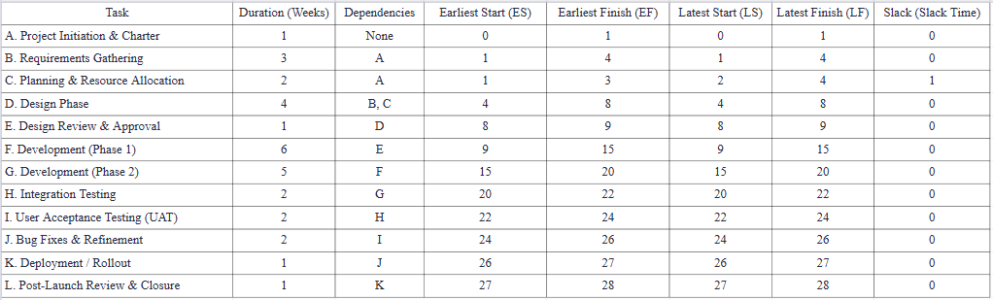

APPENDIX B

PERT Diagram
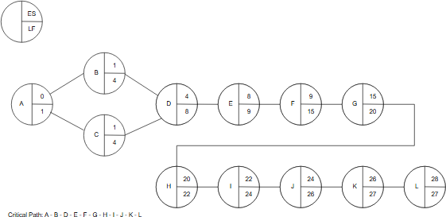

APPENDIX D

Application Logo



The VolTrike application logo has a stylized etrike image in eco-friendly form in a dark cyan that is placed against an identical background and the wordmark is displayed in Poppins, a clean and modern sans-serif and reflects the objective of the app to be the one that is easy to access and learn. The curvilinear canopy and forward tilt of the car suggest movement and motion, and the combined lightning-bolt design suggests dynamism, velocity and the future-oriented nature of the project toward less energy-consuming and electric short-range transit targeting users to ride eco friendly ebikes and etrikes and supporting drivers of those. The three-color, muted color scheme makes the mark behind-the-scenes and easy to remember on small mobile displays, and the dark cyan and rounded typography is meant to convey a sense of trustworthiness, serenity and digital chic into urban barangays to the passengers and drivers.

APPENDIX C

Team Logo


The logo of the team still features the magnifying glass around a circuit-like component, which is, however, understood today as a representation of VolTrike being a company dedicated to intelligent, data-driven mobility instead of charging infrastructure alone. The magnifying glass symbolizes the close inspection, scrutiny, and never-ending adjustment of ways and processes whereas the internal circuitry reminds the algorithms and cloud computing that drives the characteristics of booking, GPS tracking, and geofence authentication. The turquoise and soft grey-turquoise palette is reminiscent of clean, technology-enhanced transportation and stable underlying infrastructure and the use of clean, modern, sans-serif typeface also underlines the integrity of the team to clarity, ease of use, and climate-conscious innovation to the everyday commuter.

REFERENCES
[ADB2022] Asian Development Bank. (2022). Philippines: Market transformation through the introduction of energy-efficient electric vehicles. https://www.adb.org/documents/philippines-market-transformation-through-introduction-energy-efficient-electric-0. Relevance to VolTrike: This evaluation identifies adoption, governance, and implementation risks in a Philippine e-trike program, so VolTrike uses it as cautionary context rather than proof that e-trike projects automatically succeed.
[ADB2025] Asian Development Bank. (2025, January 27). ADB, Ayala sign $100 million financing deal to support electric mobility in the Philippines. https://www.adb.org/news/adb-ayala-sign-100-million-financing-deal-support-electric-mobility-philippines. Relevance to VolTrike: The report establishes current national momentum and infrastructure investment around electric mobility; it does not indicate that ADB funds or endorses VolTrike.
[CT2025] Climate Tracker Asia Team. (2025, January 20). Wheels of change: Electrifying Philippine transport. https://climatetracker.asia/wheels-of-change-electrifying-philippine-transport/. Relevance to VolTrike: The fact sheet supports the proposal's environmental and transport-transition background, while VolTrike avoids claiming a measured emissions reduction without a separate approved methodology.
[DOE2023] Department of Energy Philippines. (2023). Comprehensive Roadmap for the Electric Vehicle Industry. https://legacy.doe.gov.ph/sites/default/files/pdf/energy_efficiency/CREVI-2023_Updated.pdf. Relevance to VolTrike: The national roadmap provides policy and industry context for planning an e-trike platform, but it is not an operating permit or local deployment approval.
[GMA2025] GMA Integrated News. (2025, December 18). LTFRB OKs fixed pick-up fare for ride-hailing services during holiday rush. https://www.gmanetwork.com/news/topstories/nation/970049/ltfrb-oks-fixed-pick-up-fare-for-ride-hailing-services-during-holiday-rush/story/. Relevance to VolTrike: The report shows that fare rules can change, supporting VolTrike's versioned and administrator-controlled fare configuration; TNVS rules are not represented as automatically governing local e-trike fares.
[GH2012] Grab Philippines. (n.d.). Grab transport services. https://www.grab.com/ph/transport/. Relevance to VolTrike: Grab is a functional benchmark for upfront pricing, driver assignment, tracking, and trip information; VolTrike has no affiliation with Grab and adapts only general ride-hailing concepts to TODA-scoped e-trike operations.
[IEOM2024] Agno, J. M. S., Castillo, A. M. O., Franco, J., & Ong, N. R. (2024). Assessment of ride-hailing apps using customer satisfaction framework for University of Santo Tomas engineering students. IEOM Society International. https://ieomsociety.org/proceedings/2024bogota/244.pdf. Relevance to VolTrike: The study highlights service quality, reliability, system attributes, and professionalism as adoption factors, informing VolTrike's emphasis on clear workflows and trustworthy ride information without treating a Manila student sample as Bacolod-specific validation.
[IN2025] Cabalza, D. (2025, February 17). LTFRB open to reviewing matrix for ride services. Philippine Daily Inquirer. https://newsinfo.inquirer.net/2035271/ltfrb-open-to-reviewing-matrix-for-ride-services. Relevance to VolTrike: The article illustrates the need to balance driver earnings, affordability, transparency, and cancellations; VolTrike therefore stores a versioned fare policy instead of presenting one proposal-era amount as permanent law.
[LTO2024] Land Transportation Office. (2024, April 17). Memorandum Circular No. VDM-2024-2637: Guidelines in the registration of all types of light electric vehicles. https://lto.gov.ph/wp-content/uploads/2024/05/MC_VDM-2024-2637.pdf. Relevance to VolTrike: The circular provides national vehicle-classification and registration context for reviewing driver and vehicle evidence, while VolTrike does not replace LTO registration or verification.
[NDC2024] Government of the Philippines. (2024). Implementation plan for the Republic of the Philippines Nationally Determined Contribution 2020-2030. https://niccdies.climate.gov.ph/files/documents/The%20Philippines-%20NDC%20Implementation%20Plan%20-%20072024.pdf. Relevance to VolTrike: The plan supports the proposal's national climate-policy context; VolTrike does not report official NDC progress or quantified mitigation outcomes.
[PN2024] Guadalquiver, N. (2024, May 24). Bacolod City to issue temporary permits for e-bikes, e-trikes. Philippine News Agency. https://www.pna.gov.ph/articles/1225506. Relevance to VolTrike: This Bacolod-specific report supports TODA/barangay accreditation, permit review, and route-restriction considerations; it does not prove that VolTrike itself is licensed, endorsed, or deployed by the city.
[PSI2025] Pedi App. (n.d.). Pedi App: Affordable rides and ticket booking in Bohol. https://pedi.ph/. Relevance to VolTrike: Pedi provides a Philippine local-mobility benchmark for app-based tricycle/motorcycle booking and driver participation; VolTrike remains an independent Bacolod-focused proposal.
[SC2017] Balaria, F. E., Pascual, M. P., Santos, M. D., Ortiz, A. F., Gabriel, A. G., & Mangahas, T. L. S. (2017). Sustainability of e-trike as alternative mode of public transportation system: The case of Cabanatuan City, Philippines. Open Journal of Civil Engineering, 7, 362-377. https://doi.org/10.4236/ojce.2017.73025. Relevance to VolTrike: The study supplies Philippine stakeholder and sustainability context, including cost and adoption concerns, but its Cabanatuan findings are not treated as direct evidence of Bacolod feasibility.
[STATISTA2025] Statista. (2025, March 27). Share of carbon dioxide emissions from the transportation sector in the Philippines. https://www.statista.com/statistics/1084702/philippines-share-co2-emissions-transportation-sector/. Relevance to VolTrike: The dataset is used only for national background on transport emissions; VolTrike does not calculate or claim verified emissions savings.
[UN2025] United Nations. (n.d.). Goal 13: Climate action. https://www.un.org/sustainabledevelopment/climate-change/. Relevance to VolTrike: SDG 13 frames the proposal's sustainability objective, but it is not evidence that the application has already produced a measurable climate impact.
[WMT2019] JoyRide Philippines. (n.d.). JoyRide PH mobility services. https://joyride.com.ph/. Relevance to VolTrike: JoyRide is a Philippine benchmark for on-demand booking, driver networks, quotations, and service communication; VolTrike has no affiliation with JoyRide and retains TODA-specific e-trike controls.
[FLUTTER2026] Flutter. (2026). Flutter documentation. https://docs.flutter.dev/. Relevance to VolTrike: Flutter with Dart implements the passenger and driver Android application from one mobile codebase.
[FIREBASE2026] Google. (2026). Firebase documentation. https://firebase.google.com/docs. Relevance to VolTrike: Firebase Authentication, Cloud Firestore, Realtime Database, Cloud Storage, Cloud Messaging, and Cloud Functions provide identity, durable records, current location, evidence files, notifications, and trusted backend operations.
[GMAPS2026] Google. (2026). Google Maps Platform documentation. https://developers.google.com/maps/documentation. Relevance to VolTrike: Google services support place search, geocoding, route computation, road-aware processing, and Android navigation displays, subject to provider availability and configured policy checks.
[MAPBOX2026] Mapbox. (2026). Mapbox GL JS documentation. https://docs.mapbox.com/mapbox-gl-js/. Relevance to VolTrike: Mapbox GL JS renders operational, coverage, and route-restriction maps in the React web administration portal; it is not the passenger/driver mobile framework.
[PSA2026] Philippine Statistics Authority. (2026). Philippine Standard Geographic Code. https://psa.gov.ph/classification/psgc. Relevance to VolTrike: PSGC-based province, city/municipality, and barangay data supports consistent registration addresses and the compact client lookup index.
[BACOLOD2023] City Government of Bacolod. (2023). Business Permits and Licensing Office citizen's charter. https://bacolodcity.gov.ph/wp-content/uploads/2023/04/BPLO.pdf. Relevance to VolTrike: The charter provides limited local administrative and documentary context; it does not show that VolTrike has obtained a permit, franchise, endorsement, or city deployment approval.
[REACT2026] React Team. (2026). React documentation. https://react.dev/. Relevance to VolTrike: React with TypeScript and Vite implements the single role-aware web portal used by both System Administrators and TODA Administrators, whose permissions remain separate.
[GO2026] The Go Authors. (2026). Documentation: The Go programming language. https://go.dev/doc/. Relevance to VolTrike: Go implements a private compute/read service behind Firebase Functions for cached fare and policy reads, Google Routes quote computation, encrypted short-lived quote tokens, and dispatch-candidate reads; feature flags control rollout and Firebase Functions remains authoritative for protected state changes.
[RUST2026] The Rust Project Developers. (2026). The Rust programming language book. https://doc.rust-lang.org/stable/book/. Relevance to VolTrike: Rust is connected to Flutter through a native bridge for Android registration-image preparation and optional geometry, PSGC, and navigation acceleration, with off/shadow/on rollout controls and Dart fallbacks where implemented.

CURRICULUM VITAE


Name : JOSE VINCENT BAYOGUING III
ORCID : 0009-0005-3818-0945
Program of Study : Bachelor of Science in Information Technology Date of Birth : July 11, 2002
Contact Details : joseiiibayoguing@gmail.com Areas of Interest : Front- End Developer, DevOps


Name : DENRO S. MABAN
ORCID : 0009-0007-5648-6088
Program of Study : Bachelor of Science in Information Technology Date of Birth : January 4, 2003
Contact Details : denmaban04@gmail.com
Areas of Interest : Front-End Developer, Back-End Developer

