Adaptive Feature Fusion Networks for Origin-Destination Passenger Flow Prediction in Metro Systems
In modern areas many peoples are preferring Metro Rails to travel from one place to another as its cheap and fastest way of reaching to destination. Huge demand leading to degradation in services and to overcome from this issue author of this paper employing Adaptive Feature Fusion Network (AFFN) algorithm to predict passenger flow between source and destination.
Based on predicted flow Metro management can take required steps to manage passenger flow which can lead to enhancing services quality and customers satisfaction level will also be enhanced.
In propose algorithm author utilizing adaptively fuse spatial dependencies from multiple knowledge-based graphs and even hidden correlations between stations and then accurately capture the periodic patterns of passenger flows based on the auto-learned impact from external factors. To deal with the incompleteness and sparsity of OD (origin to destination) matrices, AFFN can extend to multi-task AFFN to predict the inflow and outflow of each station as a side-task to further improve OD prediction accuracy.
Propose paper employing graph based Convolution neural network whose implementation are describing in below points
- An Enhanced Multi-Graph Convolution Gated Recurrent Unit (EMGC-GRU) is designed to exhaustively capture spatial correlations predefined in multiple knowledge based graphs and auto-learned hidden attention-based correlations between stations within GRUs.
- An external factor-based attention module is proposed to collaboratively integrate periodic data flow with attention weights learned from external factors to improve the prediction accuracy.
- An asymmetric multi-task Adaptive Feature Fusion Network (AFFN) to mutually predict OD flow and IO flow with a task-shared IO encoder and a task-shared external factor-based attention further improve OD prediction accuracy.
Author trained above GRU based CNN algorithm using Real world Metro dataset which is not publish on internet so we used Metro Passenger Traffic flow dataset from KAGGLE repository and this dataset contains Routes and Environment and weather conditions details.
In below screen displaying dataset details
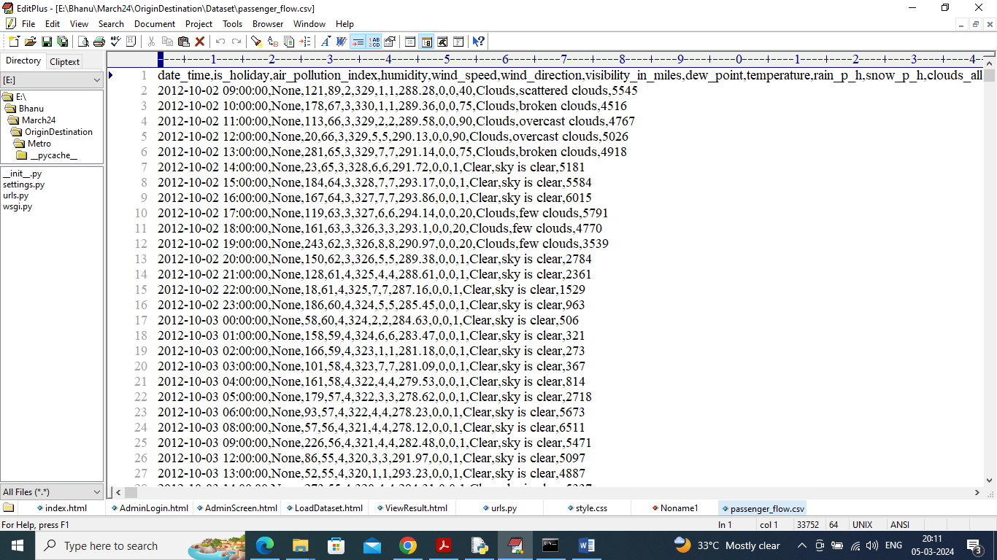
In above dataset first row contains dataset column names and remaining rows contains dataset values and in last column can see ‘Passenger Flow’ Rate. Each row represents one route from origin to destination.
In propose work author evaluating algorithm performance in terms of MAP (mean absolute error) and RMSE (root mean square error). MAP and RMSE refers to difference between true values and predicted values so the lower the difference the better is the algorithm.
Extension Concept
In propose work author has utilized GRU (gated recurrent unit) which is an old RNN algorithm so as extension we modified propose algorithm using LSTM layer. LSTM is more advance than GRU and can help in reducing prediction error.
To implement this project we have designed following modules
- User login: user can login to system using username and password as admin
- Load & Process Dataset: using this module user can upload dataset to application and then normalise and split dataset into train and test part
- Existing MLP: using this module we can run existing algorithm to predict passenger flow and then calculate RMSE and MAP using true and predicted values
- Propose AFFN (EMGC-GRU): using this module we can run propose convolution graph based GRU algorithm to predict passenger flow and then calculate RMSE and MAP using true and predicted values
- Extension AFFN (EMGC-LSTM: using this module we can run propose convolution graph based LSTM algorithm to predict passenger flow and then calculate RMSE and MAP using true and predicted values
- Graphs: will plot RMSE and MAP comparison graph between all algorithms and then display true and predicted passenger flow values
SCREEN SHOTS
We have coded this DJANGO web framework so double click on run.bat file to start web server and get below page
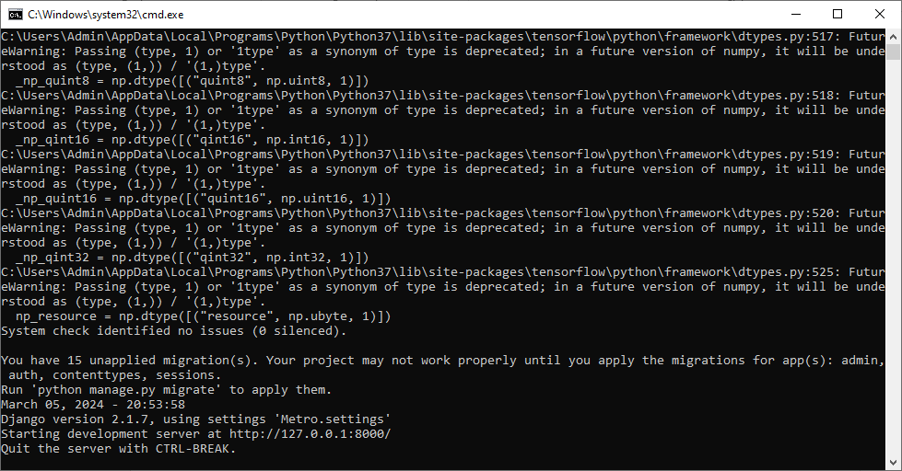
In above screen python web server started and now open browser and enter URL as http://127.0.0.1:8000/index.html and press enter key to get below page
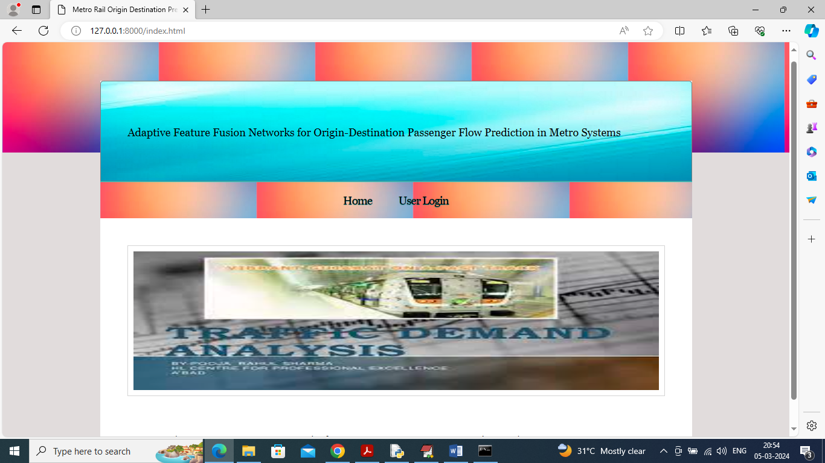
In above screen click on ‘User Login’ link to get below page
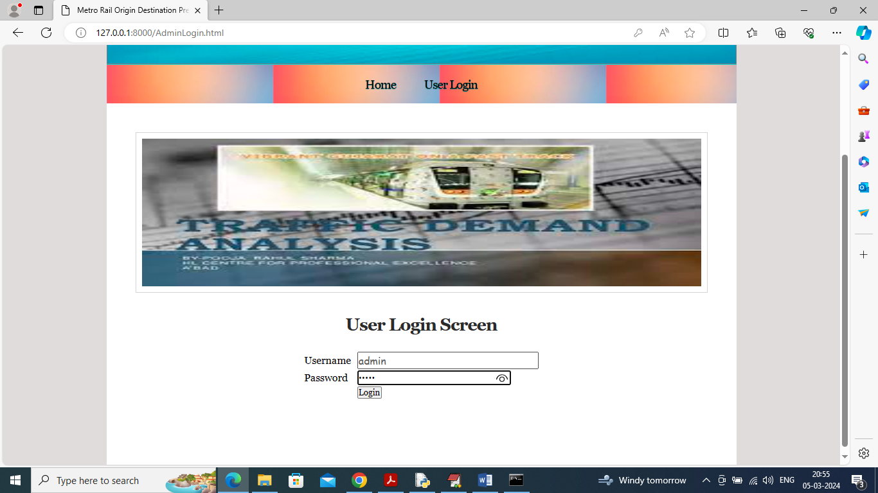
In above screen user is login and after login will get below page
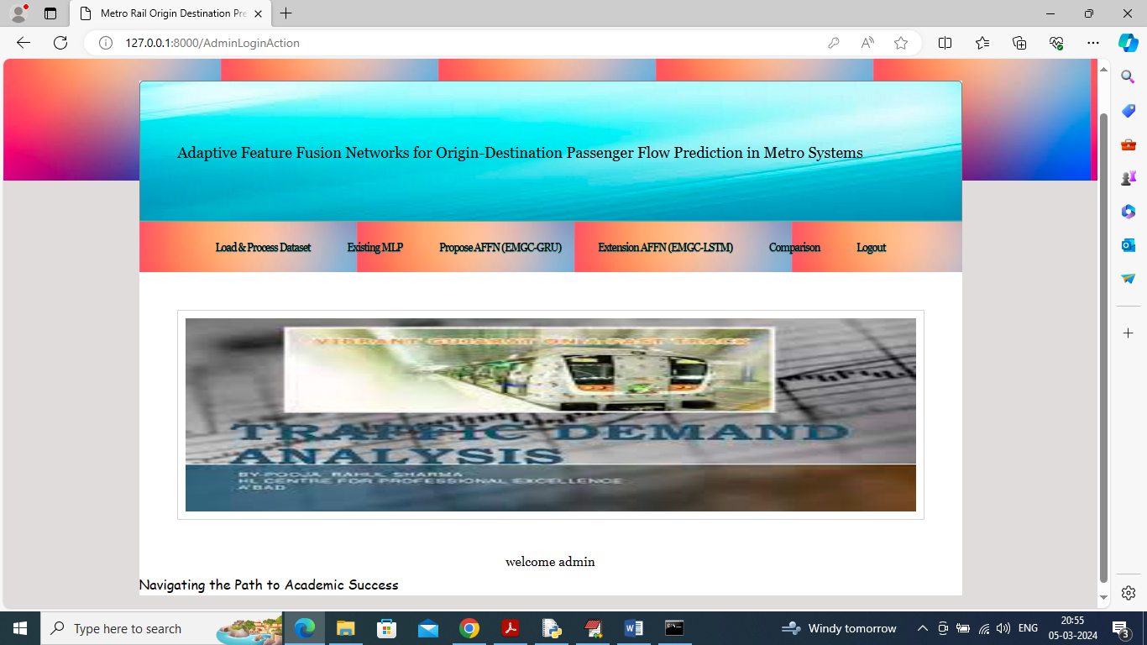
In above screen click on ‘Load Process Dataset’ link to get below page
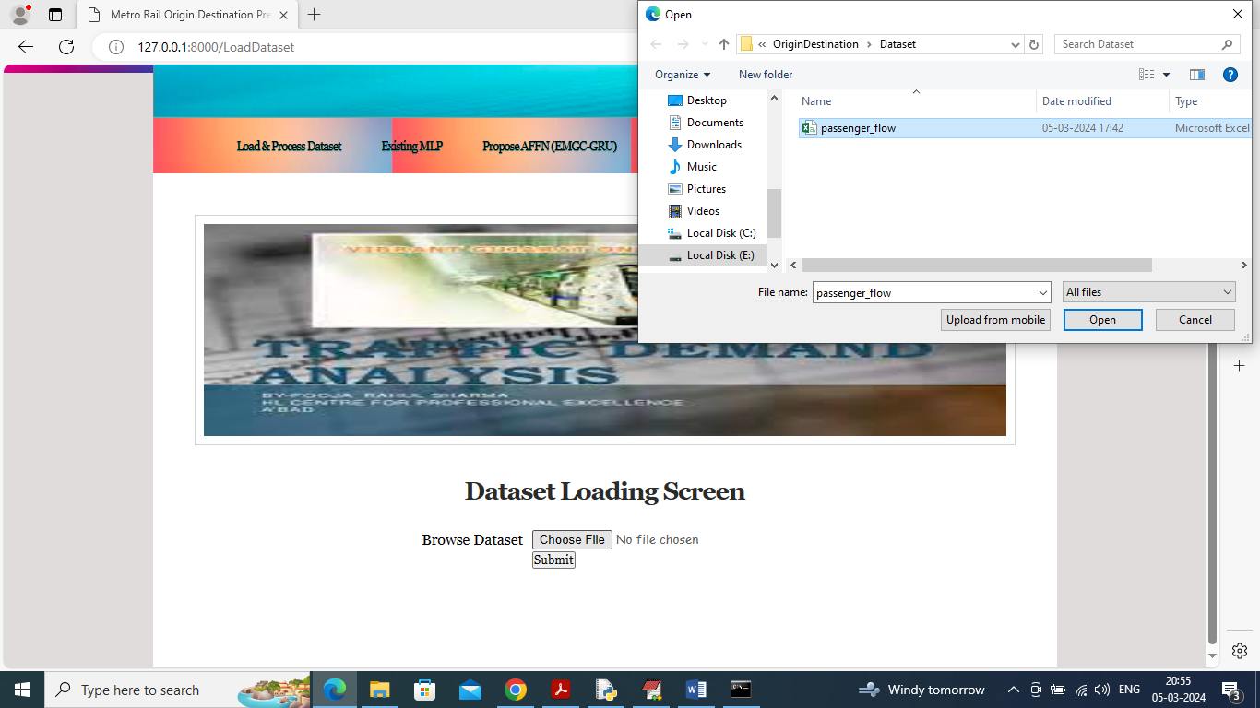
In above screen selecting and uploading dataset and then click on ‘Open’ button to load dataset and get below page
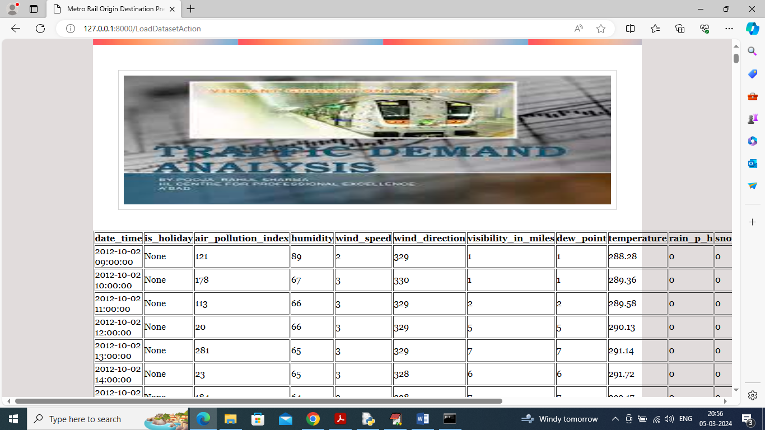
In above screen dataset loaded and now click on ‘Train Existing MLP’ link to train existing algorithm and get below page
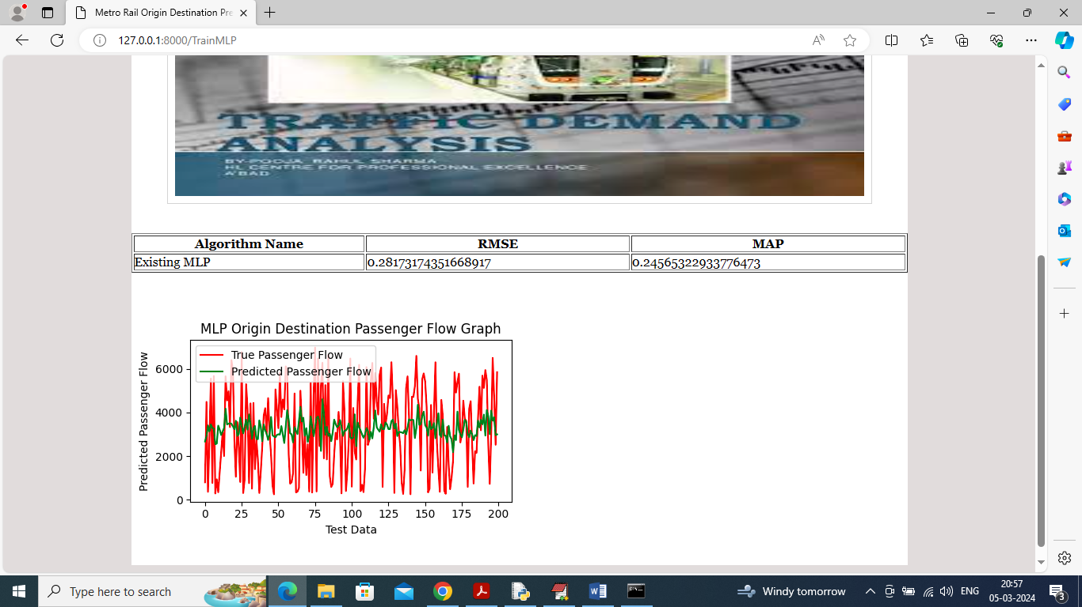
In above screen MLP existing algorithm training completed and can see RMSE and MAP values and in prediction graph x-axis represents Test data number and y-axis represents passenger flow and then red line represents True passenger flow and green line represents MLP predicted passenger flow and can see huge gap between both lines so we can say MLP is not accurate and now click on ‘Propose AFFN (EMGC-GRU)’ link to train propose algorithm and get below page
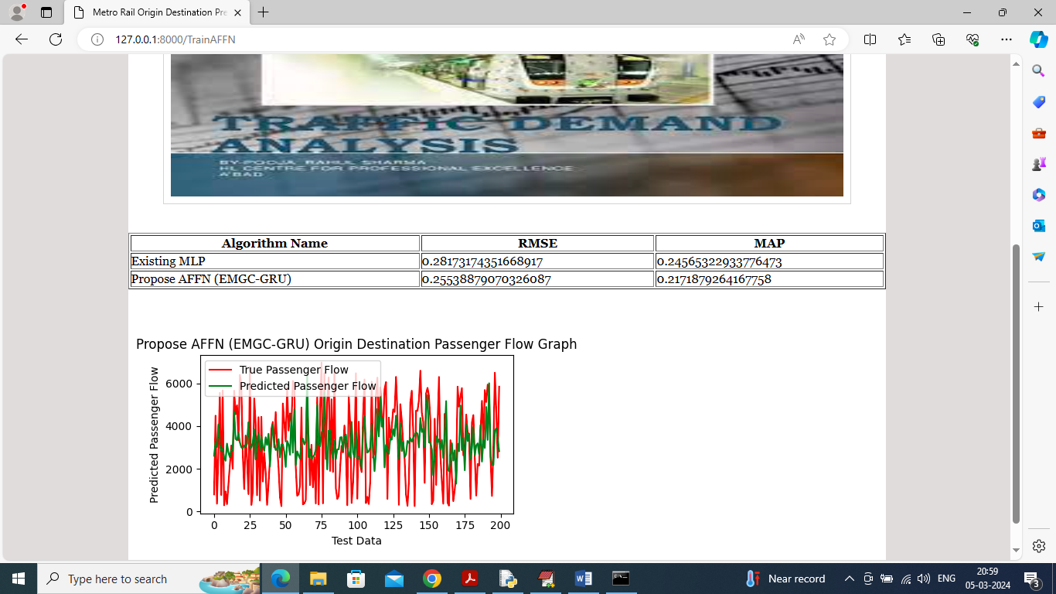
In above screen can see propose algorithm MAP and RMSE values which is lesser than existing algorithm and can see green and red line is overlapping with little gaps and now click on ‘Extension AFFN (EMGC-LSTM)’ link to train extension LSTM algorithm and get below page
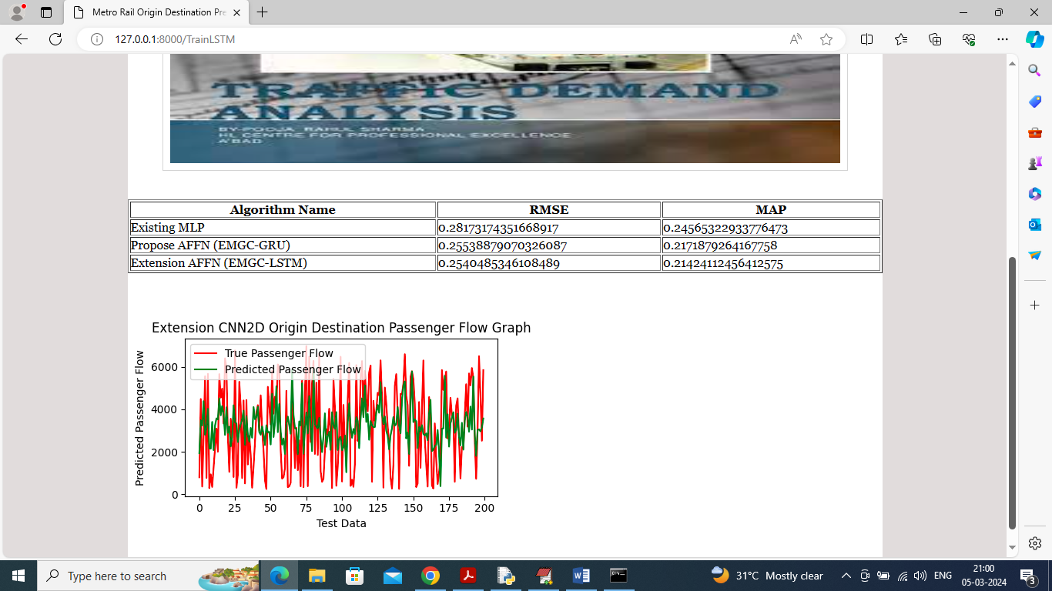
In above screen in all 3 algorithms can see extension AFNN with LSTM got less MAP and RMSE values and can see little less gap in green and red lines and now click on ‘Comparison Graph’ link to get below graph
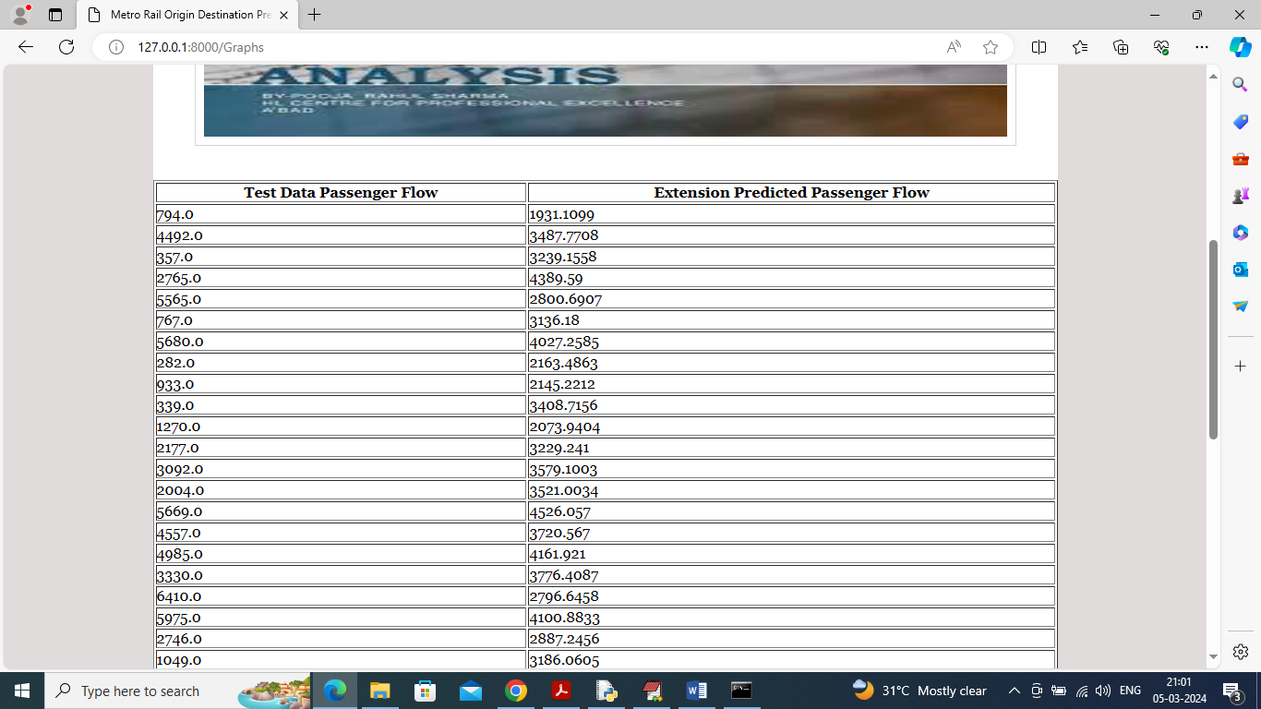
In above screen first column contains True passenger flow and second column contains extension passenger flow and can see some predictions are very close and now scroll down above page to view below graph
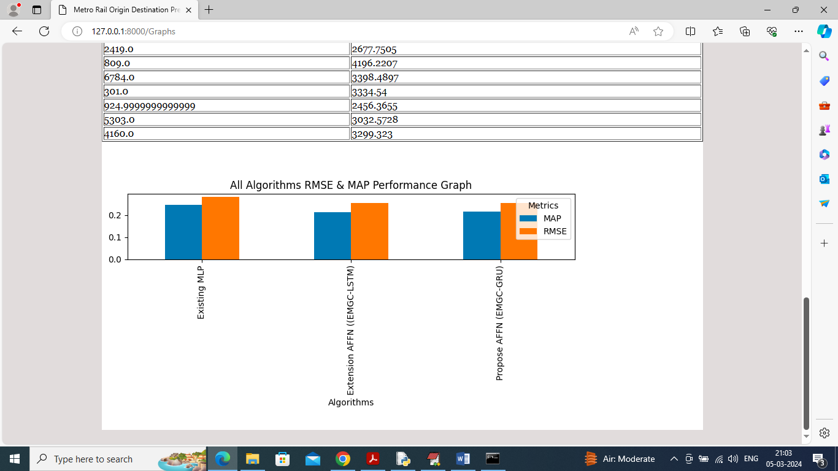
In above graph x-axis represents algorithm names and y-axis represents MAP and RMSE value in different colour bars and in all algorithms extension got less MAP and RMSE values so extension is better than all algorithms

