The Orange Pi Zero2 is based on the Allwinner H616 SoC (system on a chip), it can be purchased with either 512MB or 1GB of DDR3 Random Access Memory, costs around £25 for the 1GB version and has performance similar, if not better, to the Raspberry Pi 3.

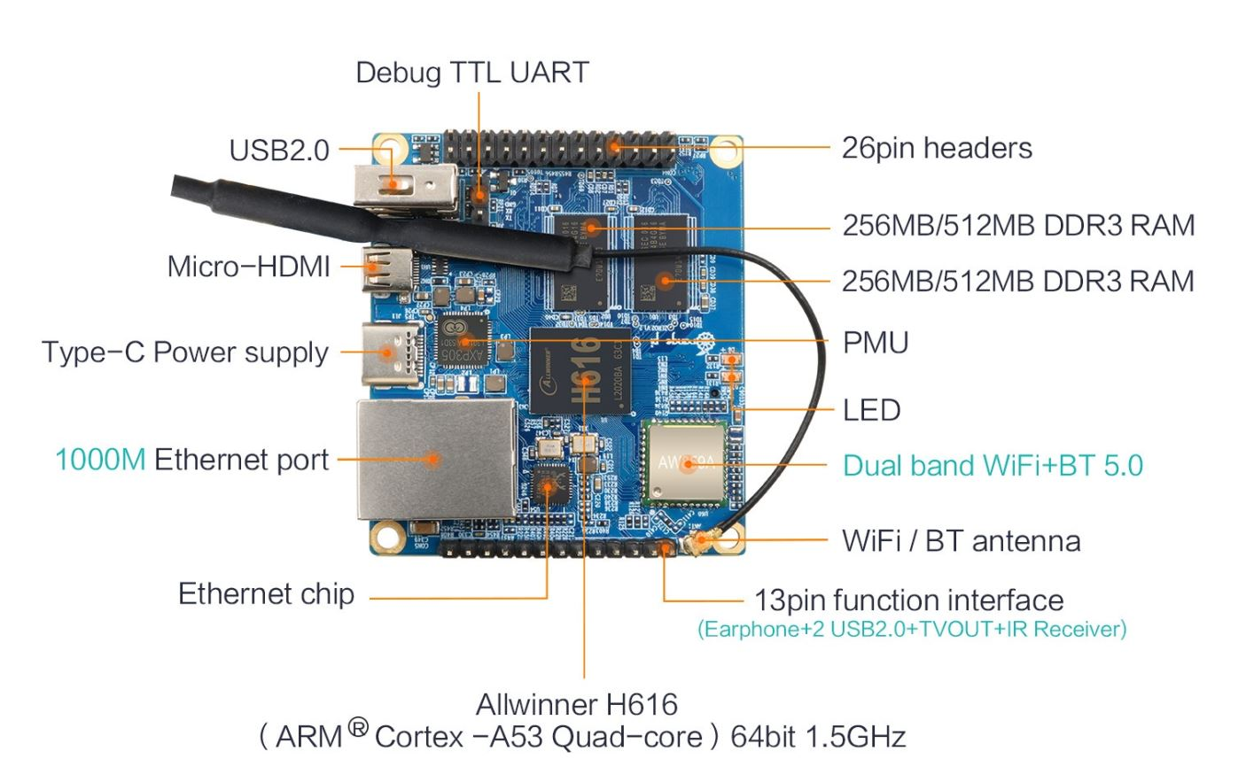

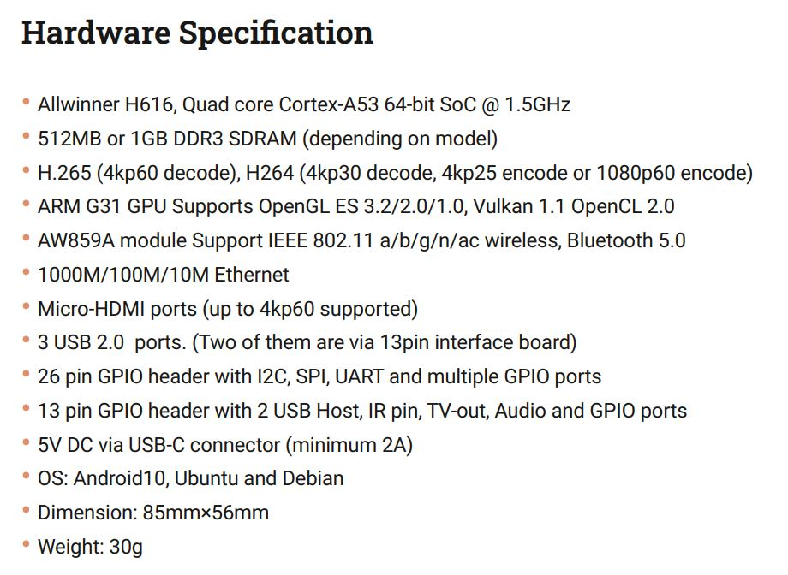

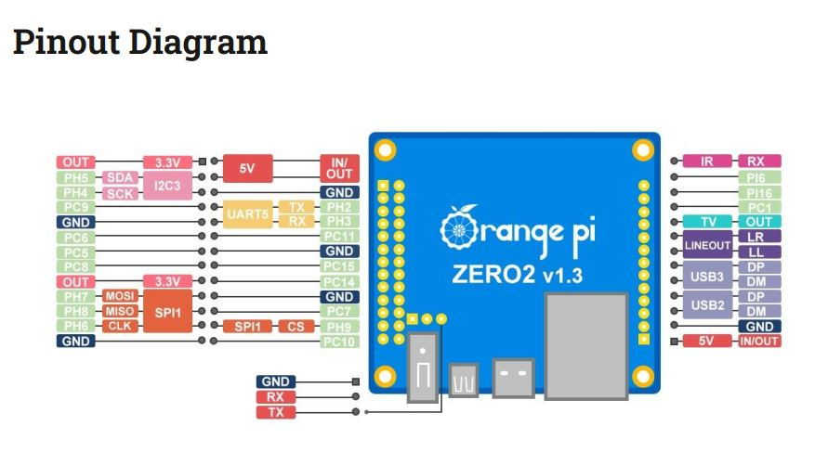

At this point in time there is no working Armbian release, but MaxAir has been installed on the Orange Pi Zero 2 Debian Buster release.

The main difference between this board (and a number of other Orange Pi boards) is that the main Input/Output interface is presented on a 26pin header, which is rotated 180°as far as pin numbering is concerned when compared to the Raspberry Pi’s 40pin I/O connector. Pins 1-26 of the Orange Pi Zero 2 board I/O connector correspond to pins 1-26 of the Raspberry Pi boards 40pin I/O connector. The result is that the Orange Pi Zero 2 has less available GPIO pins, when compared to the Raspberry Pi. Not taking in to account the UART5, I2C3 and SPI1 interface pins, the available GPIO pins are 7, 11, 12, 13, 15, 16, 18, 22 and 26 ie a total of nine. An additional four GPIO pins are available on the 13pin header, these are pins 10, 11, 12 and 13. The MaxAir numbering scheme used is that pins 1-26 identify pins on the 26pin header, while pins27-39 pins on the 13pin header. The board is supported by Adafruit-Blinka and Adafruit-PlatformDetect and hence is compatible with MaxAir’s use of GPIO pins.

UART operation is supported on the same physical pins as the Raspberry Pi, the UART used is identified as ‘ttyS5’, when used for MaxAir’s Serial Gateway.

## Using the SPI Interface

The Orange Pi Debian operating system exposes two SPI ports, spidev0.0 and spidev1.1, although only SPI1 is available on the board itself. A current limitation of Adafruit-Blinka is that it only supports SPI port 0, hence spidev1.1 need to be mapped to spidev1.0. This can be achieved by creating a permanent symbolic using a ‘udev rule’ as follows: create and edit the file ‘/etc/udev/rules.d/99_spi.rules’, then add line **KERNEL=="spidev1.1", SYMLINK+="spidev1.0"** and save the file, finally reboot.

## 1 Wire Interface

In order to directly interface a DS18b20 temperature sensor using the Orange Pi Zero 2 Debian Buster release requires the use of a custom Device Tree Overlay.

1. Create user overlay directory using the command **mkdir /boot/overlay-user**
2. Enter the directory with the command **cd /boot/overlay-user**
3. Create and edit a new file using the command **nano w1-gpio.dts**
4. Paste in the following:

/dts-v1/;

/plugin/;

/ {

compatible = "allwinner,sun50i-h616";

fragment@0 {

target = <&pio>;

__overlay__ {

w1_pins: w1_pins {

pins = "PC9";

function = "gpio_in";

muxsel = < 0x00 >;

};

};

};

fragment@1 {

target-path = "/";

__overlay__ {

onewire@0 {

compatible = "w1-gpio";

pinctrl-names = "default";

pinctrl-0 = <&w1_pins>;

gpios = <&pio 2 9 0 0 0 0>; /* PC9 */

status = "okay";

};

};

};

};

1. Save the file and exit the editor
2. Compile using the command **dtc -I dts -O dtb w1-gpio.dts -o w1-gpio.dtbo**
3. Enter the command **echo 'user_overlays=w1-gpio' >> /boot/orangepiEnv.txt**
4. Exit the editor and reboot

The 1-wire interface should now be available on the same physical pin as used by the Raspberry Pi eg pin7 (RPi GPIO4).