# MaxAir – Frost Protection

MaxAir includes functionality to protect the Heating/HVAC system from extreme low temperature environmental conditions.

The system works by setting a low temperature trigger for one or more temperature sensors and then associating a controller relay to be activated if the trigger temperature is reached.

Frost Protection can be activated when a temperature sensor is Added or Edited

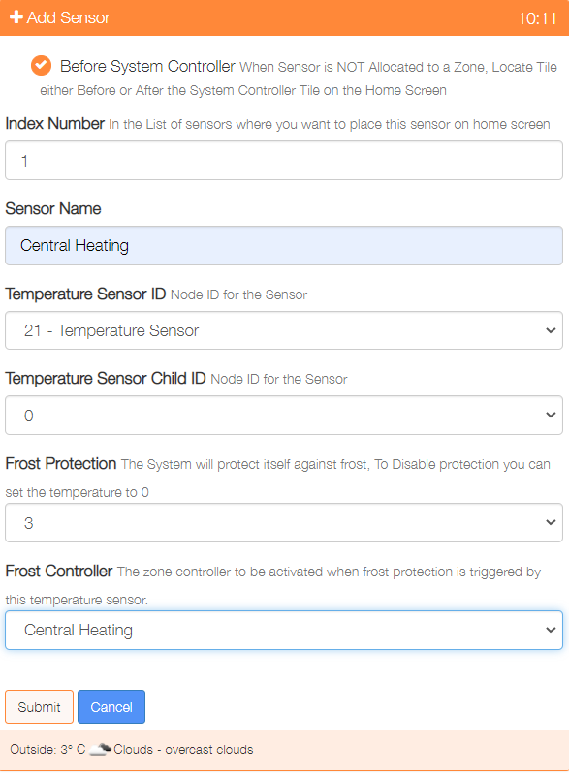

Set the trigger temperature or 0 to disable

Select a controller relay to be activated by the trigger

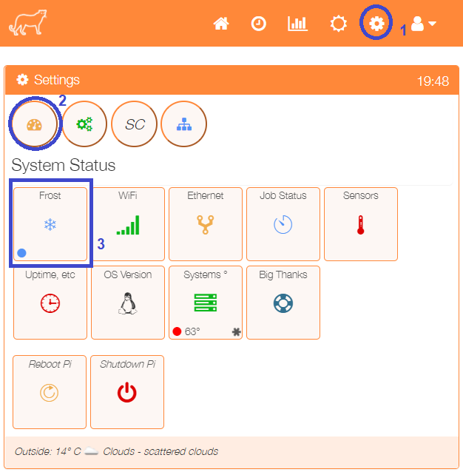

The Frost Protection configuration can be view by clicking on the ‘Frost’ menu item in the ‘Settings/System Status’ menu.

The status indicator in the lower left‑hand corner of the ‘Frost’ tile will show the current state of Frost Protection:

* Blue – No Frost Protection
* Red – One or more zones in Frost Protection mode

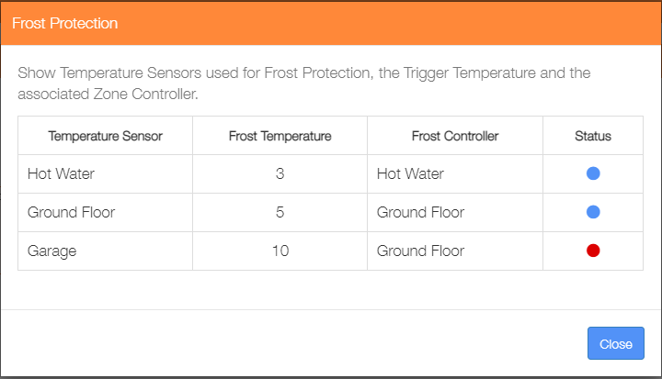

This example shows the Hot Water Sensor triggering the Hot Water Zone at 3°

The Ground Floor Sensor triggering the Ground Zone at 5°. The Ground Floor Zone is also triggered by the Garage Sensor at 10°

The Status indicators show that Frost Protection is currently active, triggered by the Garage Sensor.