MaxAir supports nodes based on their type, these types define the basic capability of the sensor:

* A node which is associated with a temperature sensor
* A node which is associated with a humidity sensor
* A node which is associated with a binary switch

A number of Sensor Types are pre-defined:

* Temperature – a sensor returning an analogue temperature value
* Humidity – a sensor returning an analogue temperature value
* Switch – a sensor returning a binary ON/OFF value

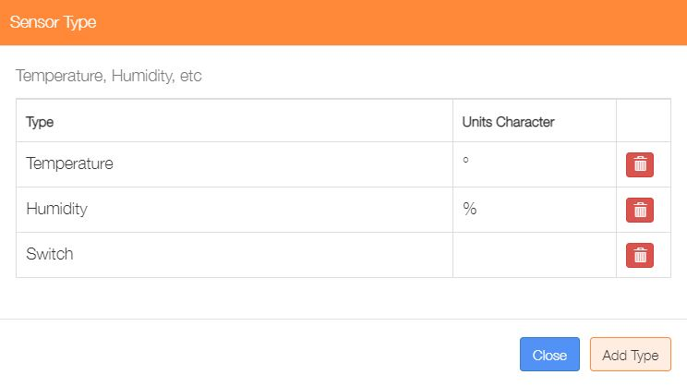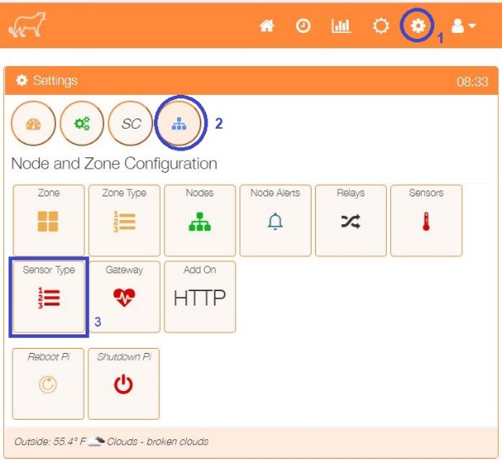The currently defined Sensor Types can be viewed from the ‘Sensor Type’ menu option in the ‘Settings/Node and Zone Configuration’ menu.

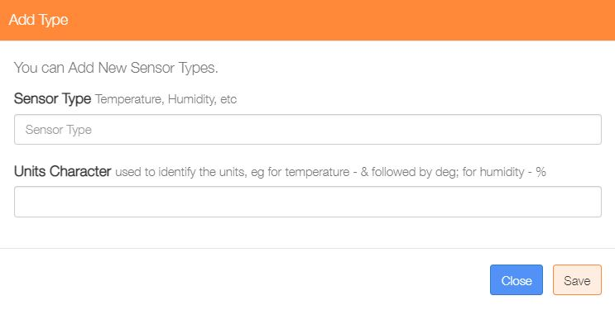Sensor Types can be deleted by clicking on the ‘trash’ icon or addition ones added by clicking on the ‘Add Type’ button.

Enter a name for the new Sensor the and if required enter the unit’s character, that may be a ‘simple’ character such as % for Humidity or a ‘special’ string of character such as &deg; which HTM interprets as the temperature ° symbol. Finally click on the ‘Save’ button.