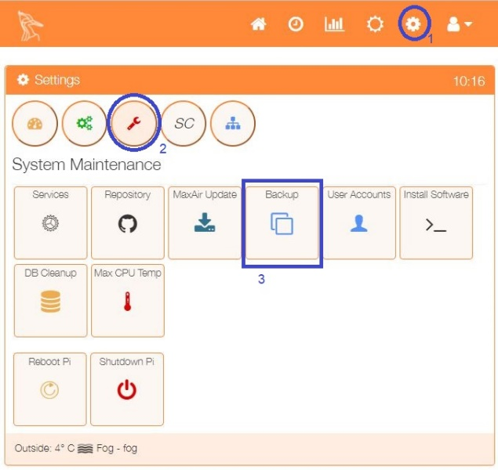

A backup of the current MaxAir database can be created and Emailed to any chosen recipient.

In order to use this feature, an Email account must already have been configured.

Select the Backup option from the Settings/System  Maintenance menu.

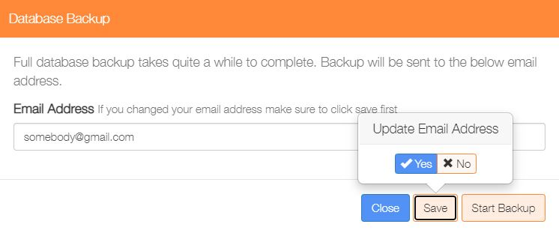

If required enter a new Email address or update an existing Email address for where to send the database backup. Click on ‘Save’ to update the address.

Once the Email address is set, click on ‘Start Backup’.

A compressed copy of the database will be created in directory /var/www the name of the file will be of the form ‘**maxair_2021-12-19_18:34:20.sql.gz**’, where the current date and time are included in the filename.

A copy of this file will be sent to the Email address set above.