# MaxAir HVAC Setup Guide

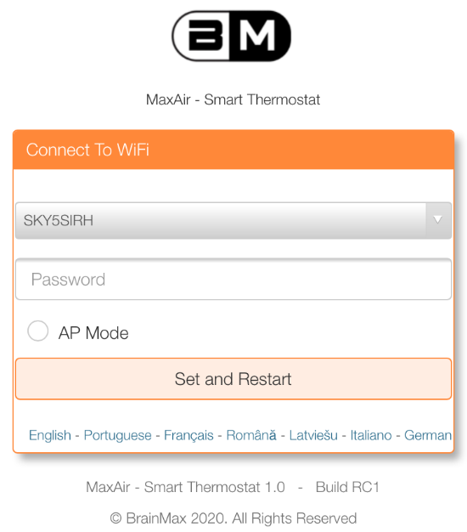

MaxAir will initially be configured as a WiFi AP (Access Point) named MaxAirHotspot, connect to the AP using the password **1234567890** and browse to IP address **192.168.50.5** where you will be presented with the initial connection screen.

Select your local WiFi SSID from the dropdown list and enter the associated password.

Alternatively, if you want MaxAir to operated as a ‘stand-alone’ AP, just click to select AP Mode.

Finally click on ‘Set and Restart.

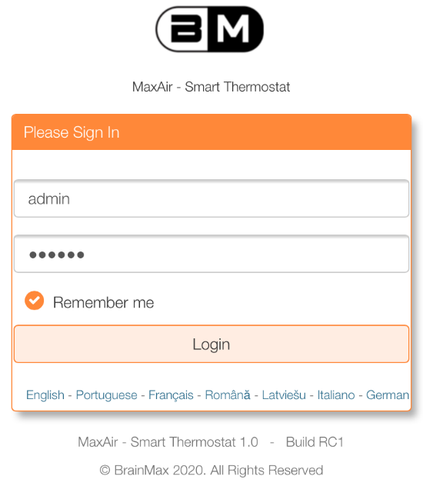If working in AP Mode you will be presented with the MaxAir login screen, otherwise reconnect to your local AP and browse to the IP address associated with MaxAir (if your AP is using DHCP, then access your router to determine which IP address has been allocated).

The system can be accessed from a suitable WEB browser using its IP address on the local network. The system can be configured with both a wireless and/or an Ethernet wired connection.

The default login credentials are username – **admin** and password - **pihome**

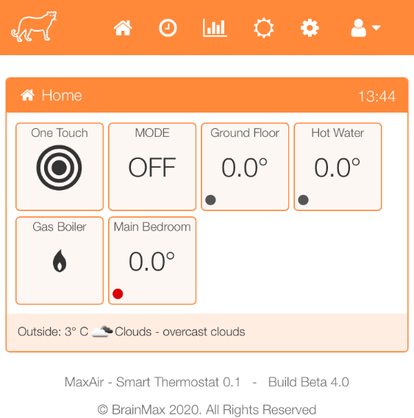The Home screen layout will be dependent on whether the system is operating in HVAC or Boiler Mode. The example shows a system operating in Boiler Mode with two zones. Ground Floor is the central heating zone and Hot Water is the hot water zone. The example system is configured with a ‘stand-alone’ temperature sensor located in the Main Bedroom.

Before use the system must be configured to match the local system to be controlled.

## Configuration

The system configuration follows a four-layer model: -

|  |
| --- |
| **Schedules** |
| **Zones** |
| **Devices** |
| **Nodes** |

Each layer is built from the previous layer e.g. Devices are built using Nodes and Schedules are built using Zones.

### Nodes

The nodes are the basic hardware devices that control the system. Some nodes are auto‑detected, others must be defined manually.

Examples of auto‑detected nodes are MySensors temperature sensors and MySensors relay modules, while examples of manually defined devices are GPIO connected relays, I2C relay modules and Tasmota type switches.

### Devices

Devices define how the system recognises the nodes hardware, devices are either Temperature Sensors or Relays. The devices are defined manually.

### Zones

For HVAC systems a single zone will be created to control the heating, colling and fan components. Further zones can be added for example to control Tasmota switch/s.

### Schedules

Schedules are time related definitions which dictate when the system performs actions and the parameters associated with those actions. An example would be a schedule to control the hot water zone, with a start time 0f 0600 hours, a stop time of 0930 hours and a maximum temperature of 40°C.

## Example Configuration

The system to be configured comprises the following elements:

1. A HVAC system requiring 3 controller relays
2. A MySensors Temperature to control the HVAC system.
3. A MySensors Temperature to measure a bedroom temperature

The above will determine the MaxAir nodes requirements as follows:

1. Two MySensors Temperature Sensors
2. Three GPIO pins for relays
3. A serial gateway device to send/receive messages to/from 1 and 2

### Step 1 – Configure the Gateway

Gateways can be connected directly to MaxAir controller using a serial interface or network connected using either WiFi or Ethernet.

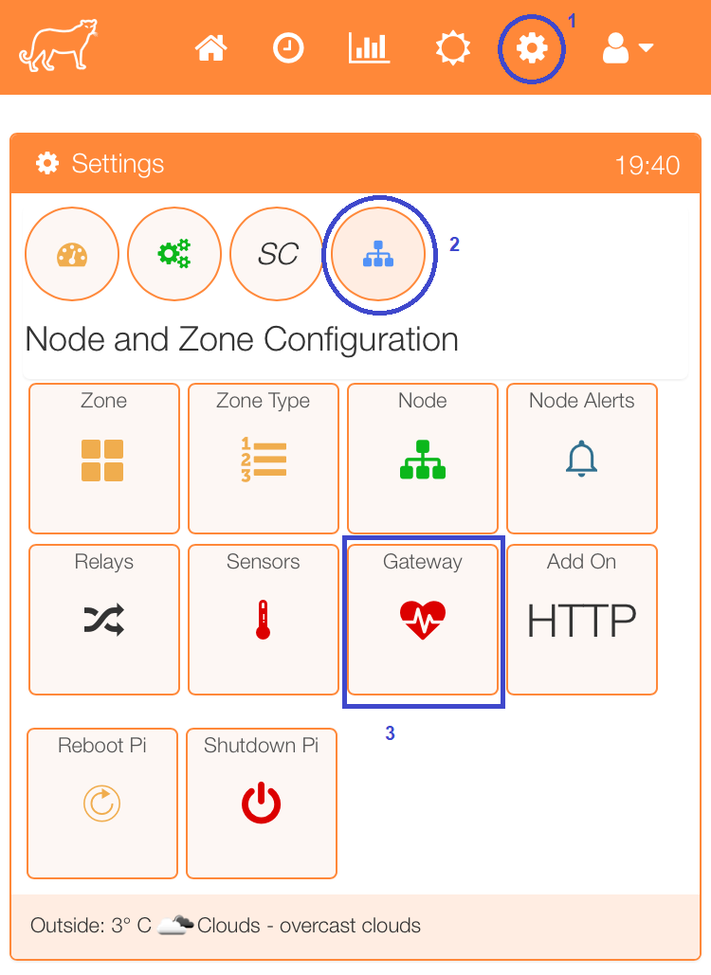

Select the Gateway menu item from the Settings/Node and Zone Configuration menu.

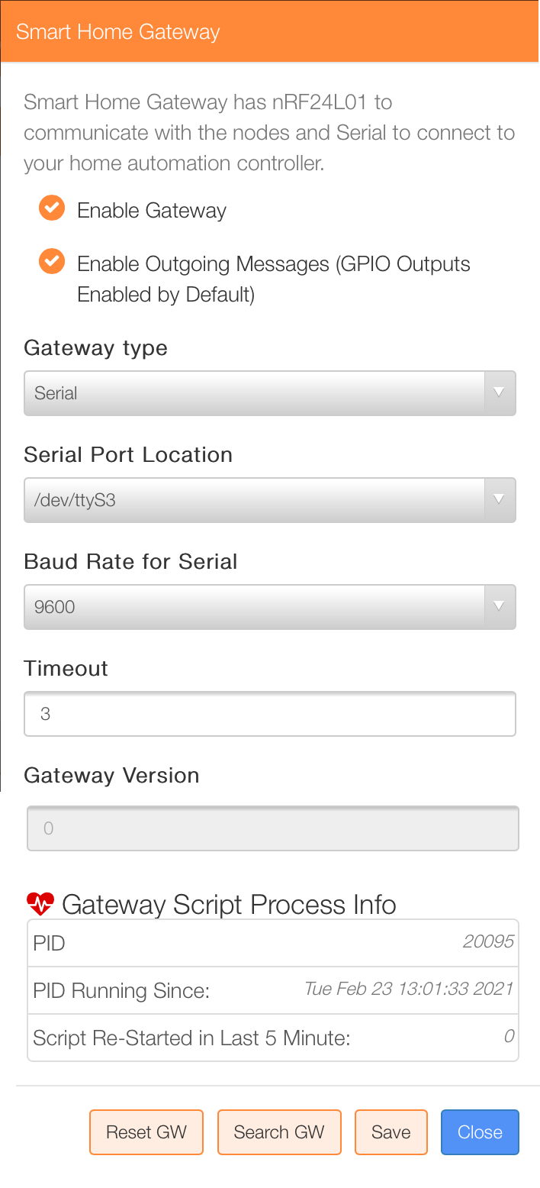

The Gateway configuration screen will be displayed. Enter the required parameters and click the ‘Save’ button.

Once the gateway has been configured, the script file which executes the task on a regular time interval must be set to run, a menu item exits to setup this task.

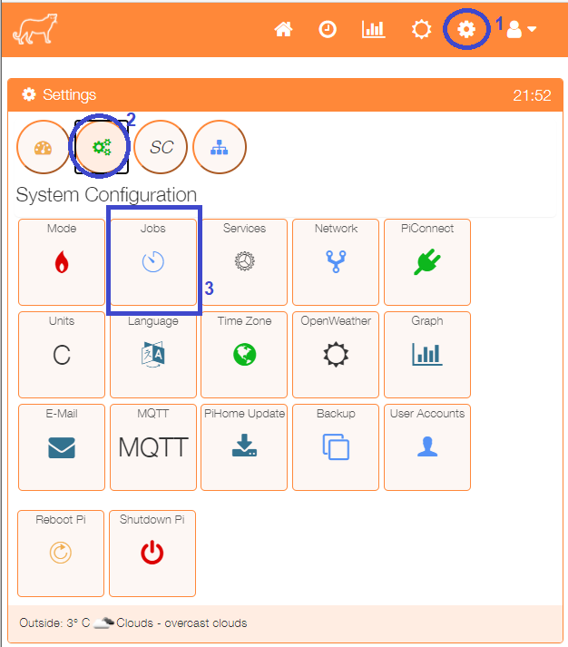

Select the Jobs menu item from the Settings/System Configuration menu.

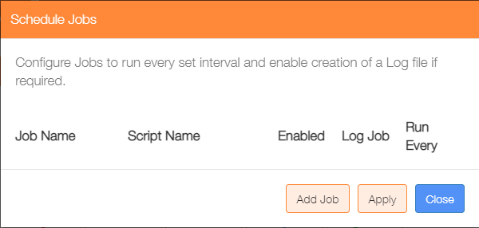Click on the ‘Add Job’ button.

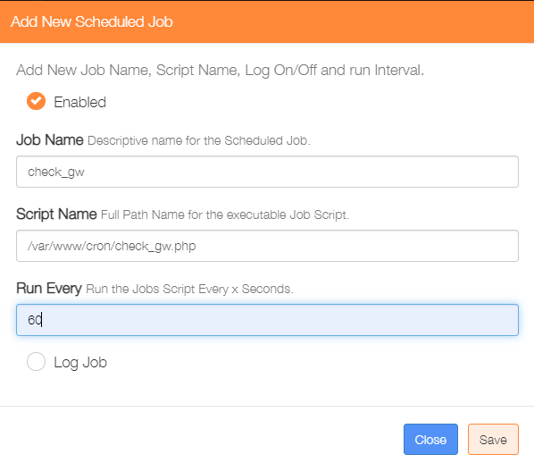

Enable the Job

Enter a name for the job

Enter the full path for the script file /var/www/cron/check_gw.php

Set how often the task should run, see note below

Note: log files will be written to directory /var/www/cron/logs/

Note: If a numeric value ‘*x*’ is entered, then the task will execute every *x* seconds. If a time value is entered eg *’02:00*’, then the task will execute once a day at the set time, in the case of this example at 2AM.

### Step 2 – Layer 1 Configuration - Connect the Nodes

Once the gateway is running, connect the MySensors Temperature Sensor devices, so that they can be detected.

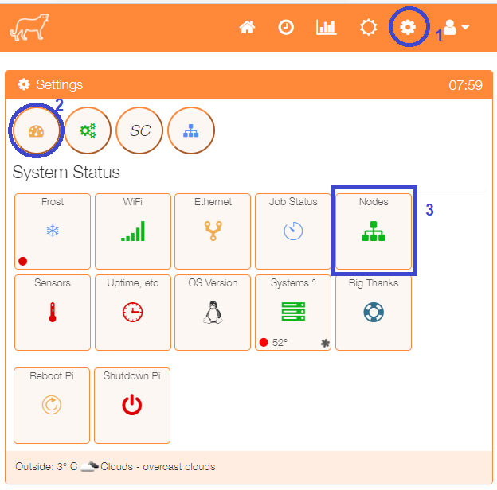To show the nodes currently available select the Nodes menu item from the Settings/System Configuration menu.

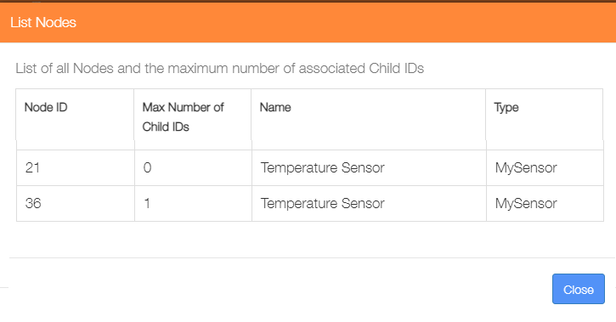The listing shows that three Temperature Sensor nodes have been auto-detected.

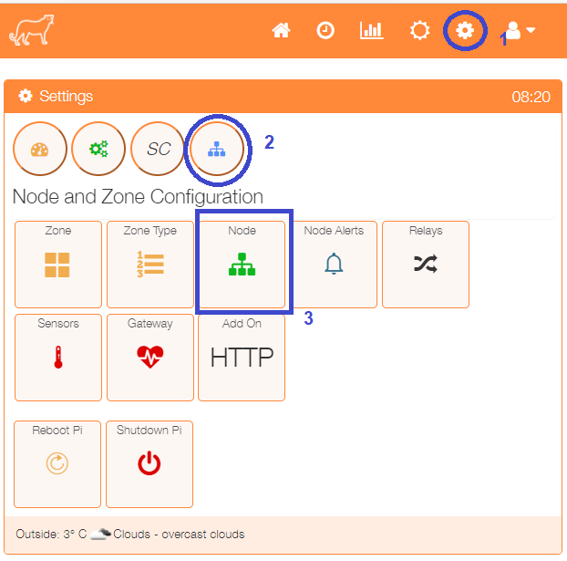The example configuration uses relays connected via GPIO pins, in order to achieve this a GPIO node needs to be created. Select Node from the Settings/Node and Zone Configuration menu.

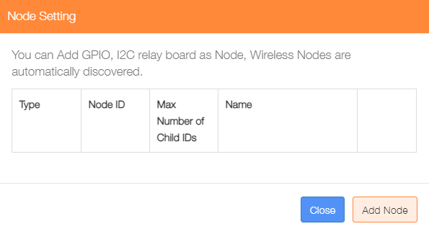Click on ‘Add Node’.

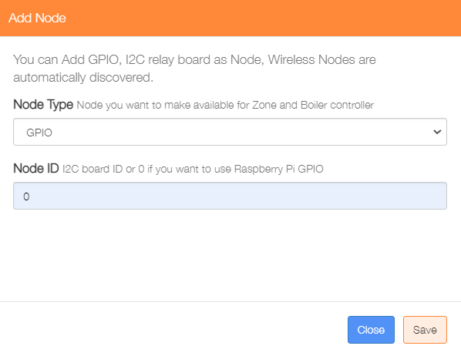

Select GPIO from the Node type dropdown list

Enter a value of 0

Click on the ‘Save’ button to update the nodes table.

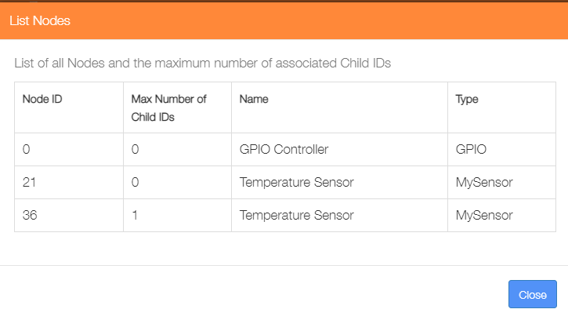

Re-displaying the nodes from the Settings/System Configuration menu will show that the GPIO node has been added.

**This completes the Layer 1 configuration.**

### Step 3 – Layer 2 Configuration - Add Devices

This step will add the Relay and Temperature Sensor devices.

#### Relays

The example system will require 3 relays and 1 boiler relay.

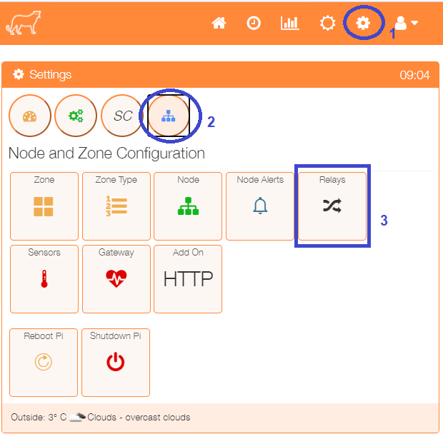

Select the Relays menu item from the Settings/Node and Zone Configuration menu to display a list of any currently configured relays.

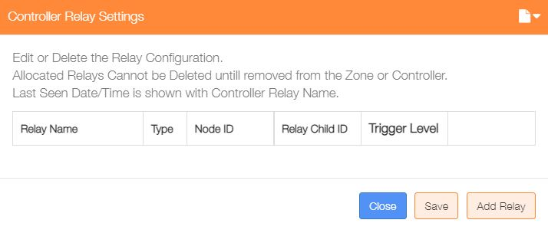Click on the ‘Add Relay’ button to configure the first relay

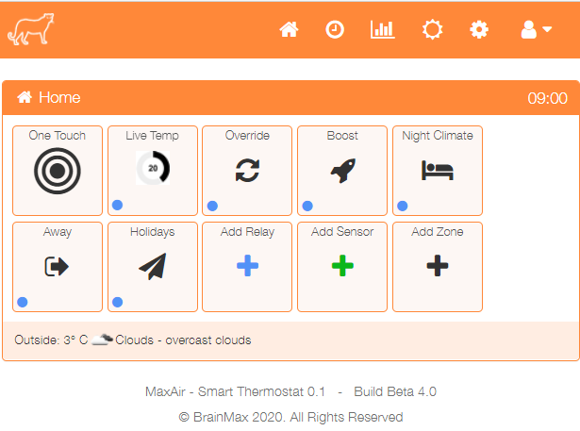

An alternative method to go directly to the Add Relay dialogue, is from the Home screen click on the ‘One Touch’ button then select the ‘Add Relay’ menu item.

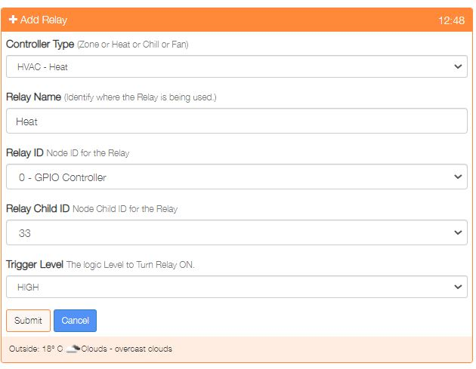

Select the Controller Type e.g. HVAC - Heat

Provide a name for this relay device

Select the Relay ID from the dropdown list of available Nodes

Choose the Child ID from the dropdown list, in the case of a GPIO controller, this will be a GPIO pin.

Select the level to trigger the relay ON.

Click on ‘Submit’ to add the device.

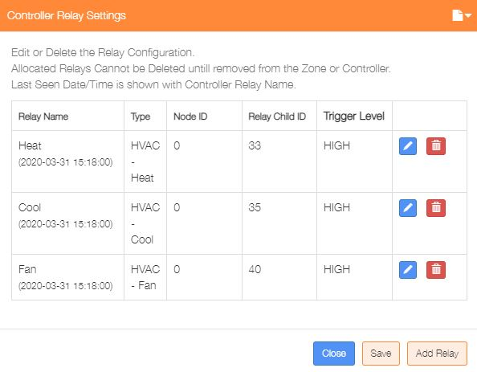Repeat the process to add the two further Controller relays.

Re-selecting the Relays menu item from the Settings/Node and Zone Configuration menu will display the updated list of currently configured relays.

This dialogue can be used to Add/Delete/Edit the relay configurations.

#### Temperature Sensors

The example system will use 3 temperature sensors, one for the Central Heating, one for the Hot Water and a third to monitor a bedroom temperature. The configuration process is very similar to that used to configure the relay devices.

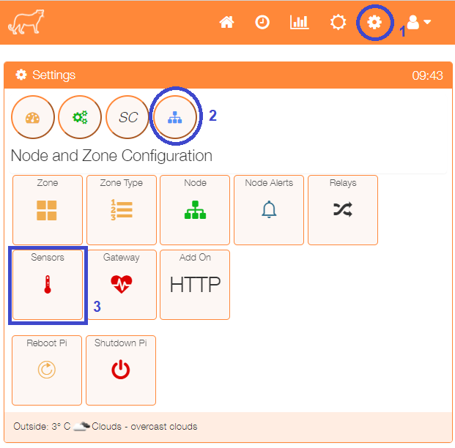

Select the Sensors menu item from the Settings/Node and Zone Configuration menu to display a list of any currently configured sensors.

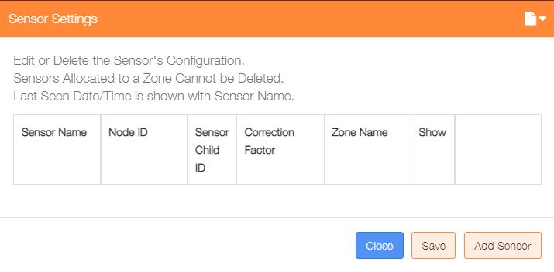Click on the ‘Add Sensor’ button to configure the first sensor



An alternative method to go directly to the Add Sensor dialogue, is from the Home screen click on the ‘One Touch’ button then select the ‘Add Sensor’ menu item.

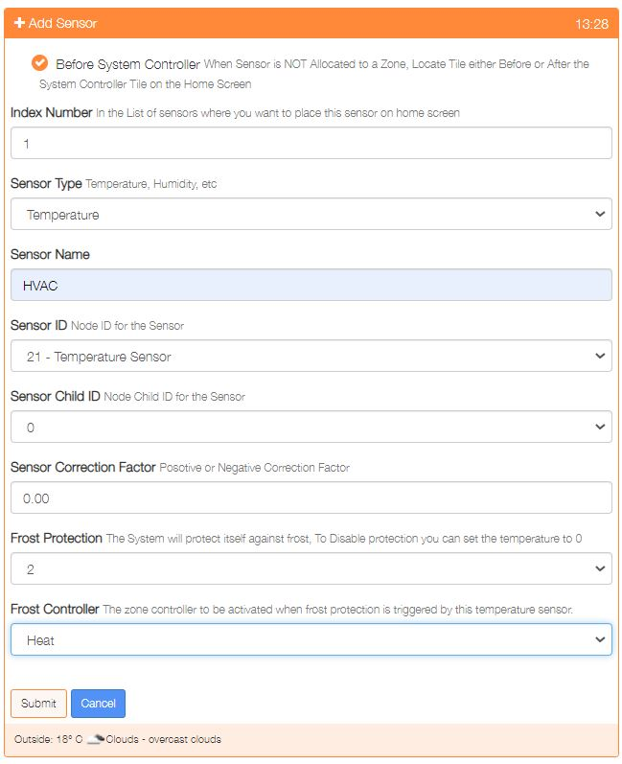

Show either before or after the system controller on the Home screen

Used to order where on the Home screen the sensor is displayed

Select the sensor type, either Temperature or Humidity.

Provide a name for this sensor device

Select the Sensor ID from the dropdown list of available Nodes

Choose the Child ID from the dropdown list, for nodes with only 1 sensor, this will be 0

Enter a positive or negative correction factor to be applied to the sensor reading.

Select the frost protection temperature or 0 to disable this feature

If frost protection is enabled, then select the zone to be activated on protection

Click on ‘Submit’ to add the device.

Repeat the process to add any other temperature sensors.

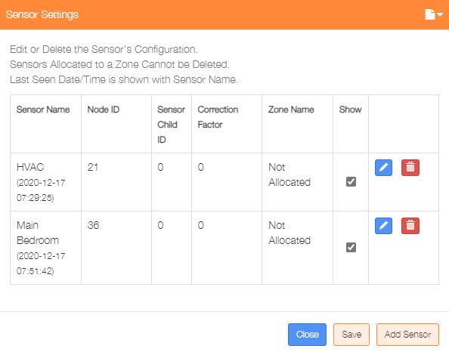Re-selecting the Sensors menu item from the Settings/Node and Zone Configuration menu will display the updated list of currently configured temperature sensors.

This dialogue can be used to Add/Delete/Edit the sensor configurations.

The ‘Show’ tickbox can be used suppress displaying a sensor on the Home screen.

All the sensors are shown as ‘Not Allocated’ until the later zone configuration step has been completed.

#### System Controller Configuration

Three relays are used to activating the heating, cooling and fan functions of the HVAC system, these relays were added as relay devices above and now need to be associated with the ‘System Controller’.

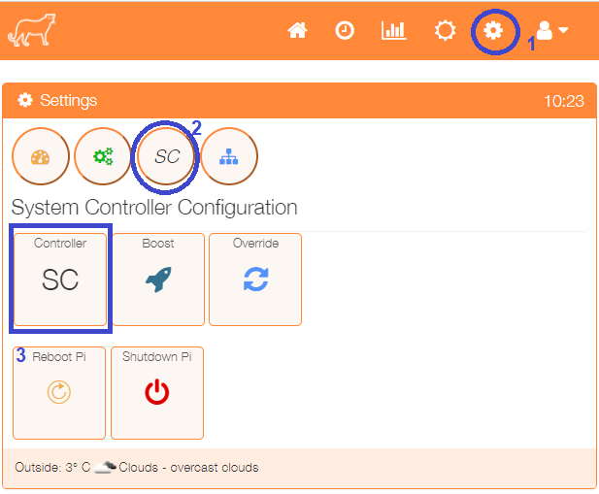

Select the SC menu item from the Settings/System Controller Configuration menu to display the configuration screen.

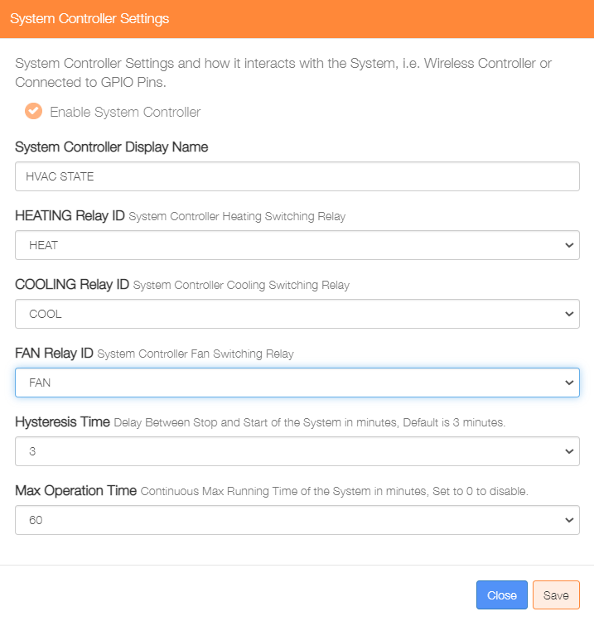

Enter a name for this controller

Select the HEATING relay from the dropdown list

Select the COOLING relay from the dropdown list

Select the FAN relay from the dropdown list

Enter a hysteresis value in minutes

Enter a maximum running time in minutes

Click on ‘Save’ to update

**This completes the Layer 2 configuration.**

**Layers 1 and 2 define the basic hardware configuration of the system.**

### Step 4 – Layer 3 Configuration - Add Zones

The example configuration has a single zone to control the HVAC system..

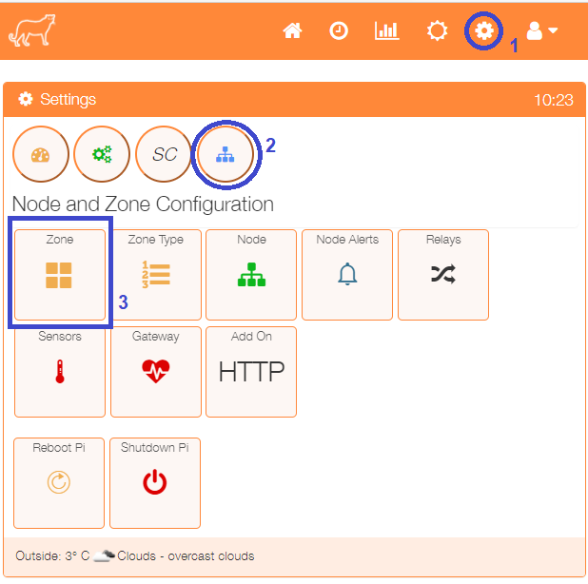

Select the Zone menu item from the Settings/Node and Zone Configuration menu to display a list of any currently configured sensors.

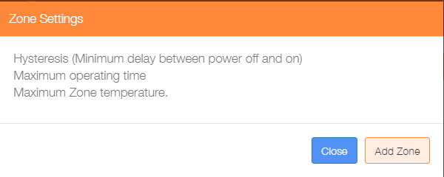Click on the ‘Add Zone’ button to configure the first zone.



An alternative method to go directly to the Add Zone dialogue, is from the Home screen click on the ‘One Touch’ button then select the ‘Add Zone’ menu item.

There are currently three types of zone, HVAC, Immersion and Lamp, the configuration of the Add Zone dialogue will depend on the type of zone selected. Immersion type zones will disable ‘System Controller’ selection, while Lamp type zones will disable all temperature sensor related selections, together with the ‘System Controller’ selection, as these parameters do not apply to these zone types.

The example below shows a typical HVAC zone configuration. Once the parameters have been entered, click on the ‘Submit’ button.

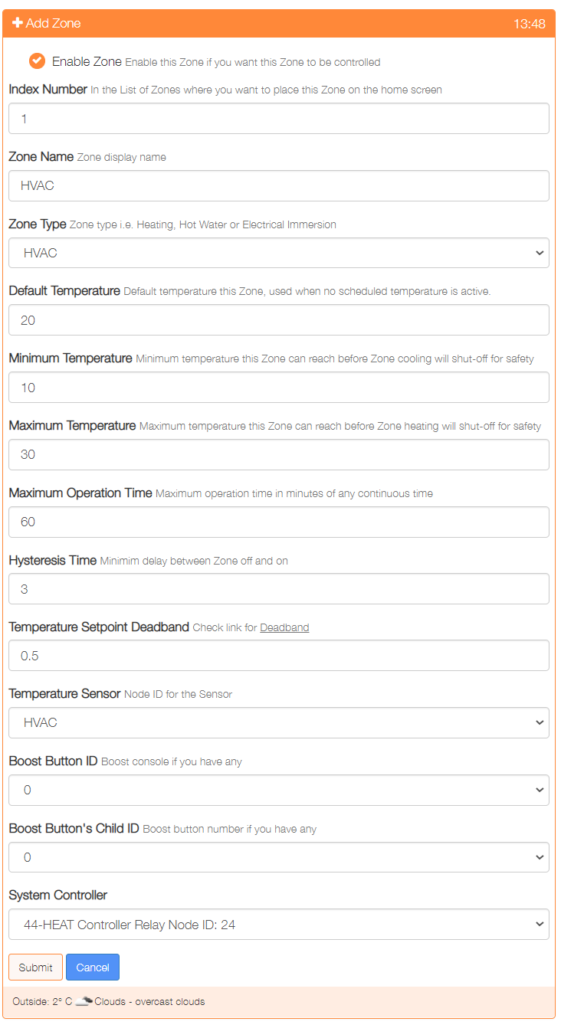

Repeat the process to add any other zones.

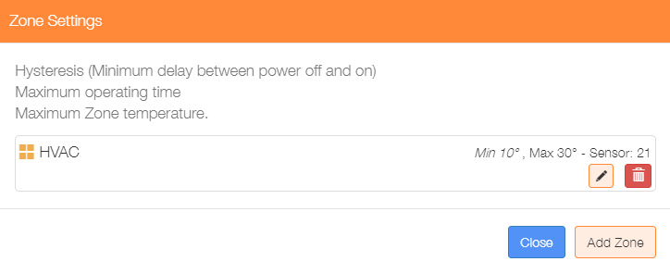

Re-selecting the Zone menu item from the Settings/Node and Zone Configuration menu will display the updated list of currently configured zones.

This dialogue can be used to Add/Delete/Edit the zone configurations.

**This completes the Layer 3 configuration.**

### Step 5 – Layer 4 Configuration - Add Schedules

The example configuration will have a single schedule to control the Central Heating and Hot Water zones.

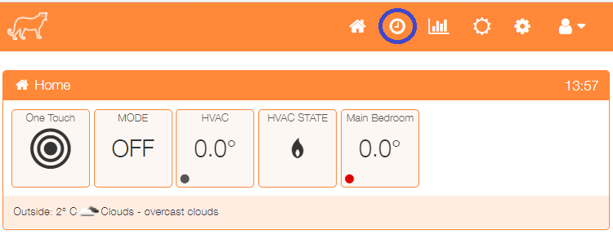Click on the toolbar clock icon to configure the first schedule.

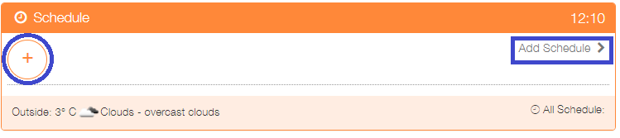

Click on + or ‘Add Schedule’

The Add schedule screen will be presented, the example below shows:

* An enabled schedule
* Operated Monday to Friday
* Titled Weekdays AM
* Operated between 0630 hours and 0930 hours
* Uses 19°C as the Target temperature

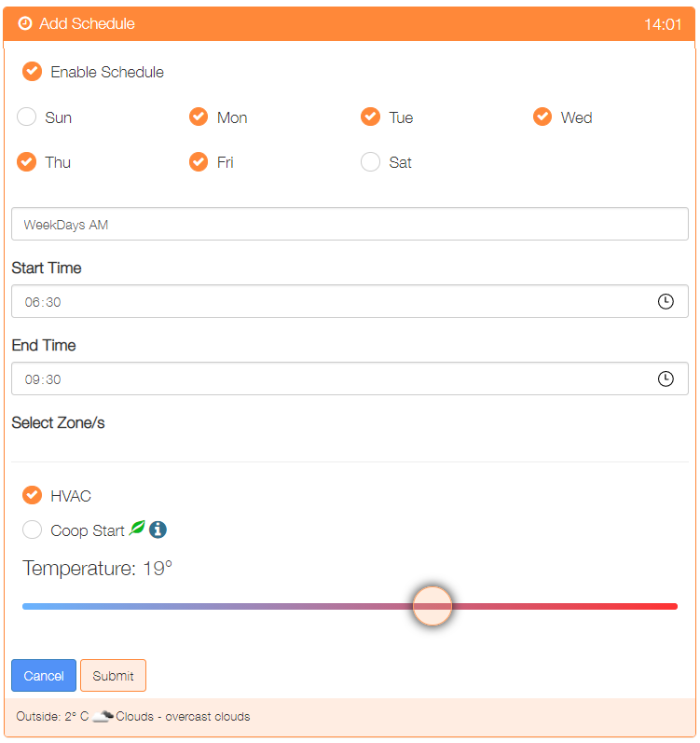

Once configured, click on the ‘Submit’ button to add the schedule.

Add any other schedules as required.

**This completes the Layer 4 configuration.**

### Step 6 – Add Jobs

In order for the system to function a number of tasks need to operate at pre-determined time intervals. We have already enabled the check_gw task, in addition we need to add:

|  |  |  |
| --- | --- | --- |
| **Job Name** | **Script Name** | **Run Interval in seconds** |
| Controller | /var/www/cron/controller.php | 60 |
| system_c | /var/www/cron/system_c.php | 300 |
| weather_update | /var/www/cron/weather_update.php | 1800 |
| reboot_wifi | /var/www/cron/nmcli_reboot_wifi.sh | 120 |

Add each job using the same process as used to add the gateway job



Select the Jobs menu item from the Settings/System Configuration menu.

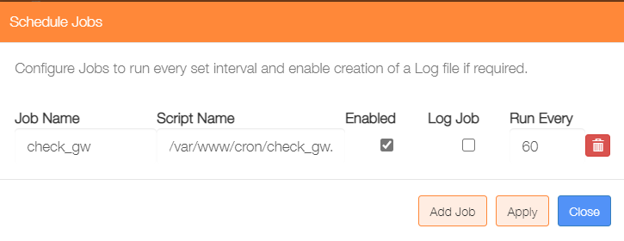Click on the ‘Add Job’ button.

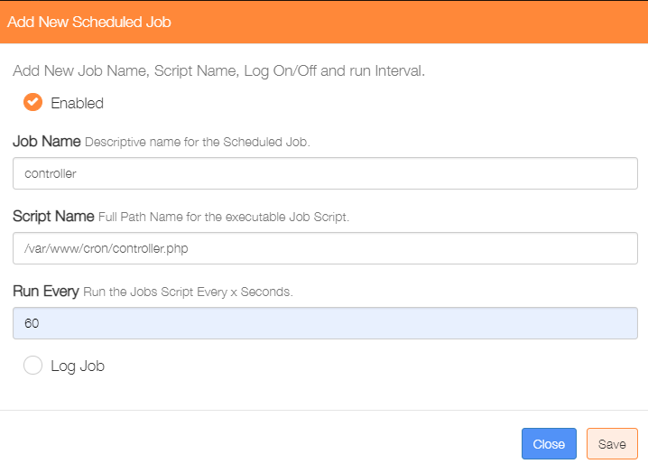

Then add the next job and repeat until all jobs have been added.

**THIS COMPLETES THE BASIC SETUP**