MaxAir communicates with its input sensors and output controllers through the use of two message queues. The sensor and controller devices can be connected to the system either directly using physical input/output ports on the device hosting MaxAir (eg a Raspberry Pi SBC), or remotely using some method to transfer the message queue information between the device hosting MaxAir and the remote input/output device.

The transfer of message queue information is through the use of a Python script file (gateway.py), which runs continually on the device hosting MaxAir.

## Using a ‘MySensors’ Gateway

Probably the most common configuration for MaxAir is to interface the temperature sensor inputs and relay outputs using the MySensors framework.

**MySensors Temperature Sensors**

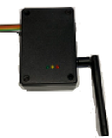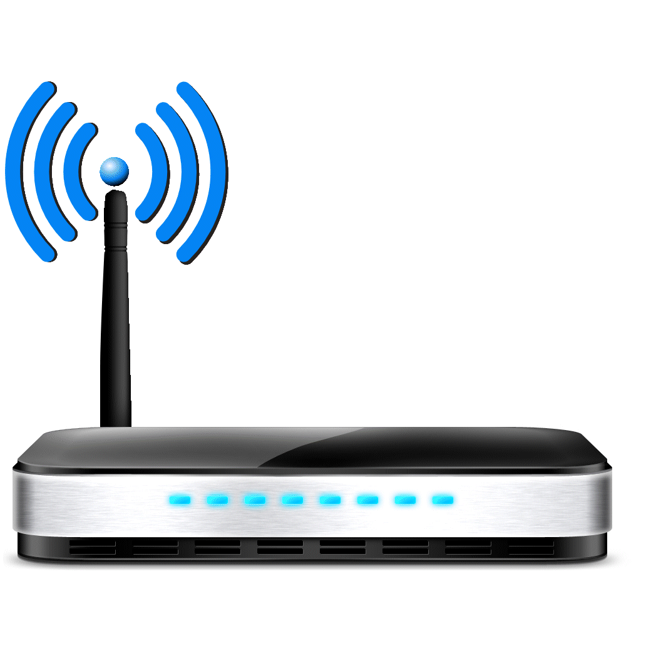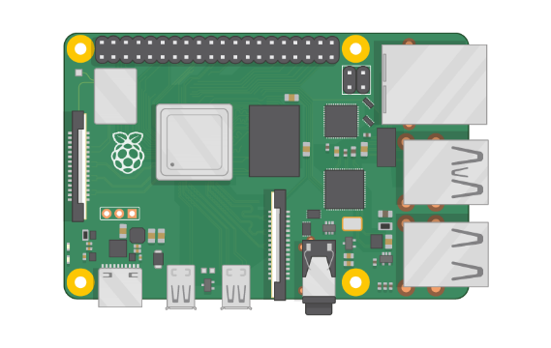

**MySensors WiFi Network**

**MySensors Relays**

**OR**

**WiFi/Ethernet Gateway**

**Serial Gateway**

**Local Network**

## Using a ‘MySensors’ Gateway together with Directly Connected Sensors and/or Relays

Another common configuration for MaxAir is to interface one or all of the relays to the device hosting MaxAir using its GPIO ports.

The same applies to the temperature sensors where one or all of the sensors are connected to the device hosting MaxAir using its 1-wire interface.

**Note: This is a hybrid configuration, which still requires that a MySensors gateway is connected.**

## Using Directly Connected Sensors and Relays

MaxAir can be configures to operate with ONLY directly connected sensors and relays. With this configuration no gateway hardware is interfaced to the device hosting MaxAir.

**GPIO Bus**

**1-wire Bus**



**Local Network**

**1-wire Temperature Sensors**

**GPIO Relays**

## The MaxAir Gateway Script

The way that the Pyton script ‘gatway.py’ operated dependant on which of the above scenarios is being used.

### With a MySensors Gateway Present

If A MySensors gateway is being used, then both the outgoing and incoming message queues are process by the script. If any directly connected 1-wire sensors are being used, then their incoming message queue is managed by a separate Python script ‘gpio_ds18b20.py’.

### With NO MySensors Gateway Present

If no MySensors gateway is being used, then only the outgoing message queues is process by the script. If any directly connected 1-wire sensors are being used, then as before their incoming message queue is managed by a separate Python script ‘gpio_ds18b20.py’.

# Configuring the Gateway

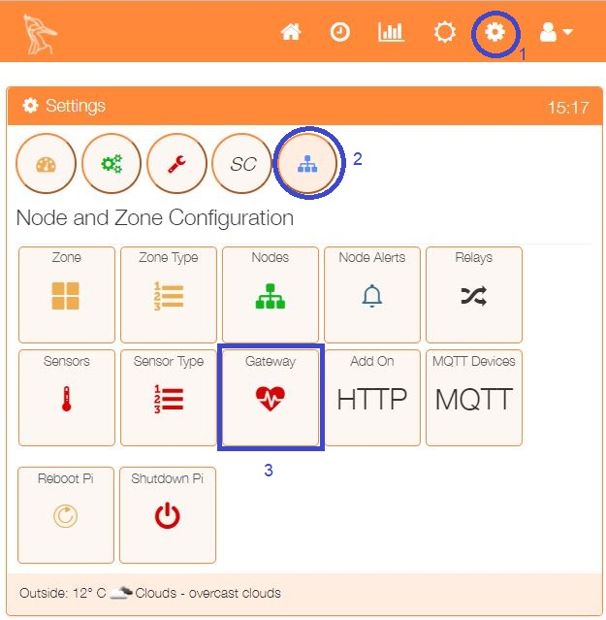

The gateway is configured using the Gatway option from the Settings/Node and Zone Configuration menu.

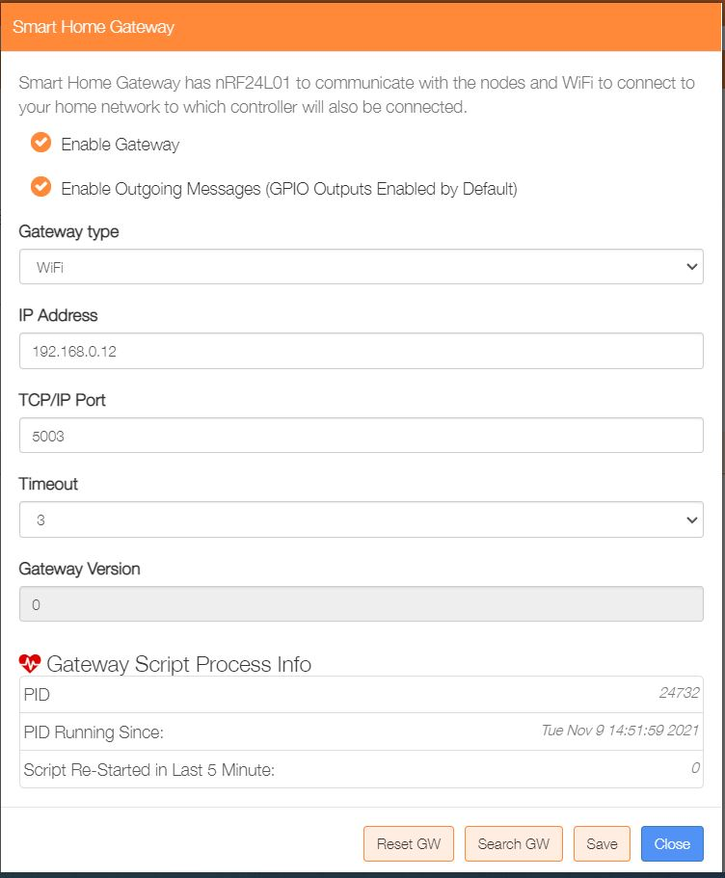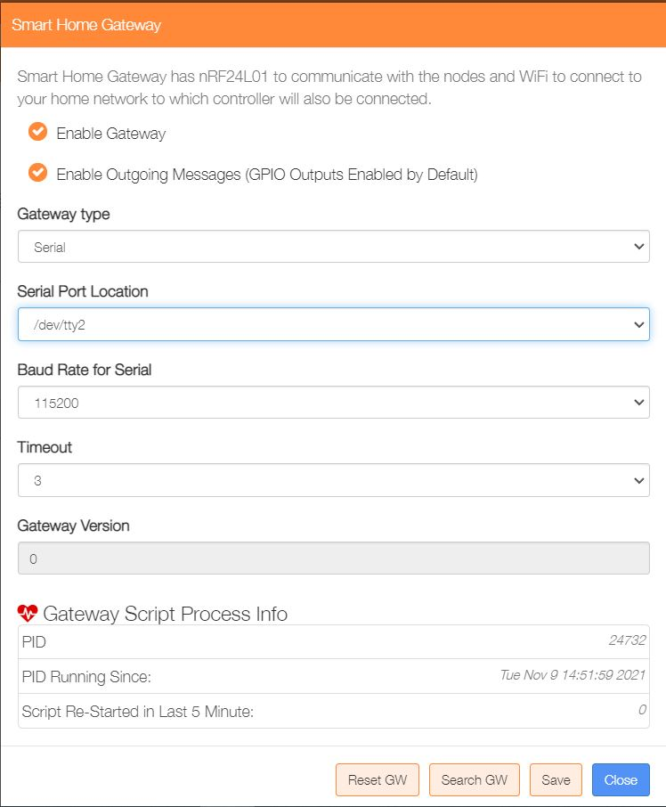If a MySensor gateway is present the configure for either Serial or WiFi.

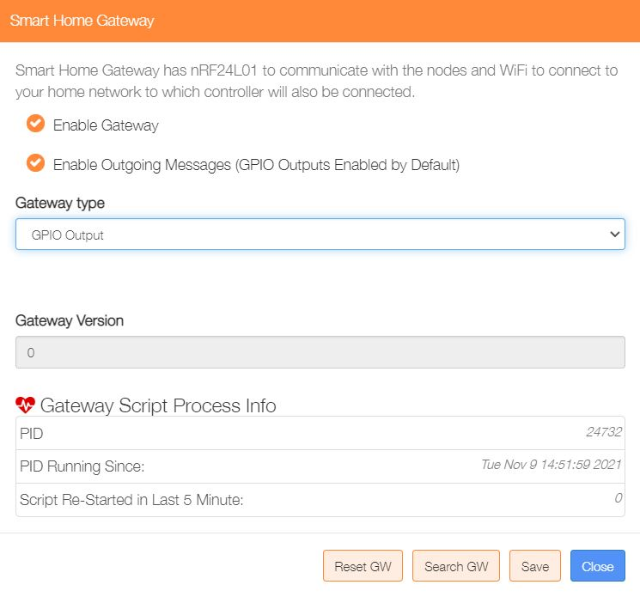If no MySensors gateway is available, then configure a GPIO Output gateway.

## The Gateway Script File

The Gateway Script file ‘/var/www/cron/gateway,py’ is configured to run automatically and it has an associated ‘watchdog’ process, which will attempt to restart it should it terminate for any reason. The Gateway option described above displays information about the current running gateway script.

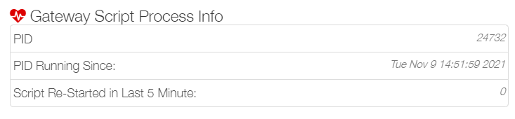

The status of the gateway script can also be checked from the command line using –

‘**ps -aux | grep gateway.py | grep -v grep**’

Information with regards to connecting 1-wire sensors and their operation can be found at MaxAir Documentation in **Setup 1-Wire Sensors**.