MaxAir incorporates an ability to setup a single schedule to control zones within a defined temperature range. A typical use would be as an night time schedule to ensure that the temperature remained within a ‘comfortable’ range.

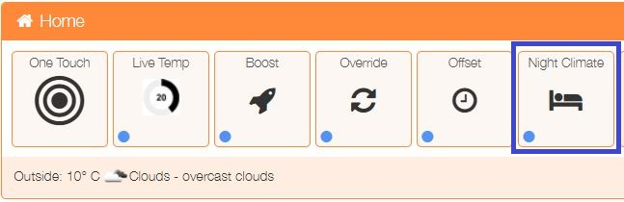From the ‘One Touch’ menu select ‘Night Climate’.

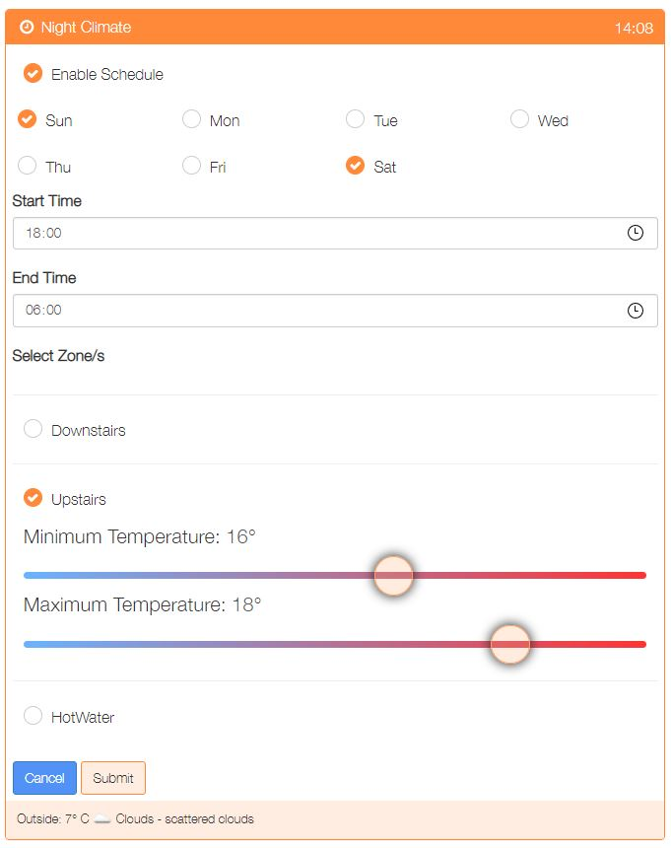

The Night Climate schedule screen will be presented, the example below shows:

* An enabled schedule
* Operates Saturday and Sunday
* Operated between 2200 hours and 0600 hours (next day)
* Controls the Upstairs Zone
* Activates the zone when the temperature is between 16° and 18°C

Once the schedule has been configured, click on the ‘Submit’ button to save.

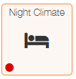

If an enabled Night Climate schedule exists then the status indicator will change from blue to red.