# MaxAir Technical – Creating Sensor Devices

Sensors are created as control devices; they need to be attached to nodes using a ‘node_id’ and ‘child_id’. The nodes will typically be either ‘MySensor’, ‘GPIOSensor’ or ‘Dummy’.

## Identify the Node_ID and Child_ID

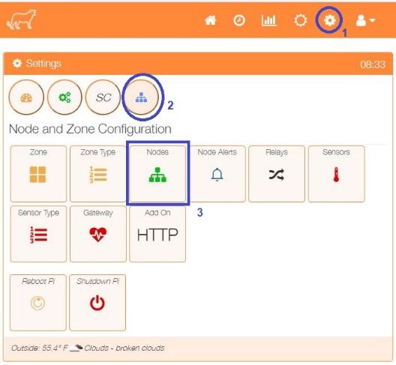To show the nodes currently available select the Nodes menu item from the Settings/Node and Zone Configuration menu.

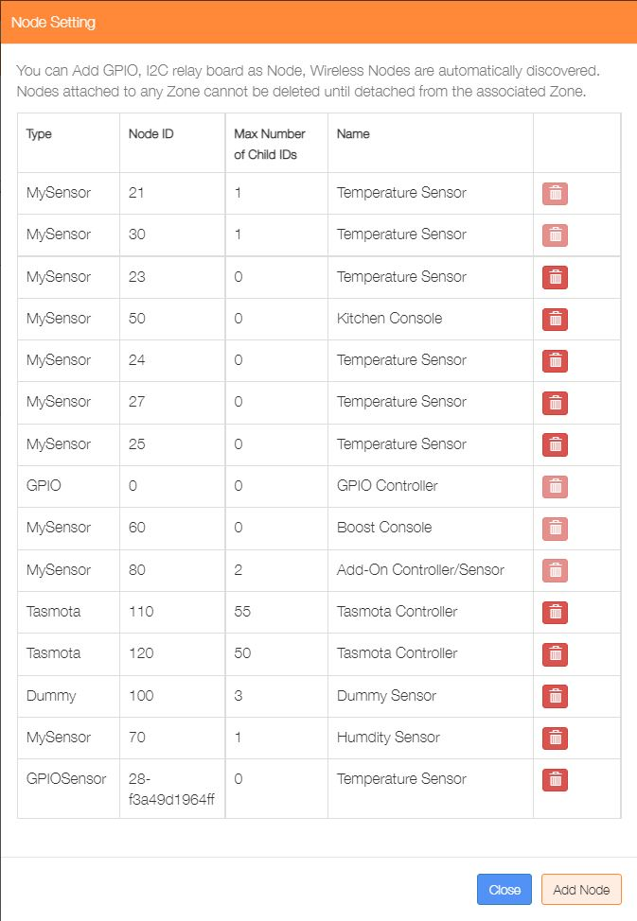The listing shows a number of Sensor nodes and a GPIO Controller Node. For this example, three sensor devices will be attached to the relevant nodes.

For this example, will use three temperature sensors, one for the Central Heating, one for the Hot Water and a third to monitor a bedroom temperature. We will use the sensor attached to Node 21, Child ID 0 for the Central Heating, Node 20, Child ID 0 for the Hot Water and Node 28-f3a49d1964ff, Child ID 0 for Bedroom 1 (Note: this is a 1-wire sensor, connected directly to the controller device.).

## Sensor Types

MaxAir is capable of supporting different sensor types, by default Temperature and Humidity sensors are supported. Sensor readings will be displayed and their data stored in the database depending on their type, for instance Temperature Sensor data will be displayed with a degree unit symbol and the value converted to either Centigrade or Fahrenheit, depending on if MaxAir is configured to work in either Centigrade or Fahrenheit.

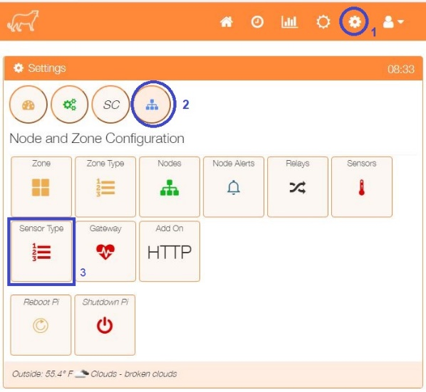To show the Senor Types currently available select the Sensor Types menu item from the Settings/Node and Zone Configuration menu.

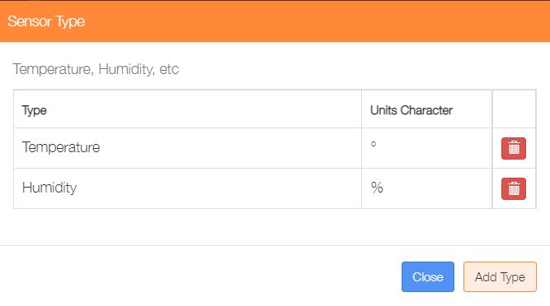

Sensor Types can be deleted or added. To add new type click on the ‘Add Type’ button to open the ‘Add Type’ menu.

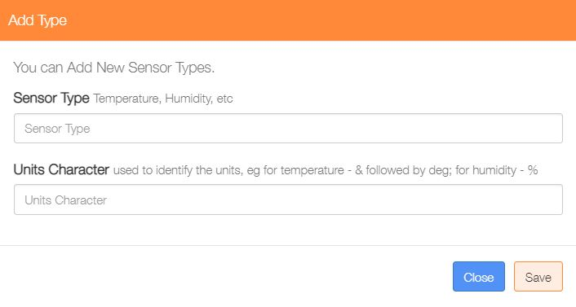

Define a name for the sensor and the character to be used for the units. In some instance to it may be necessary to use a ‘special’ sequence of characters to display the unit’s symbol, for example to display the temperature degree symbol ° enter &deg;

Click on ‘Save’ to finish.

## Adding a New Sensor

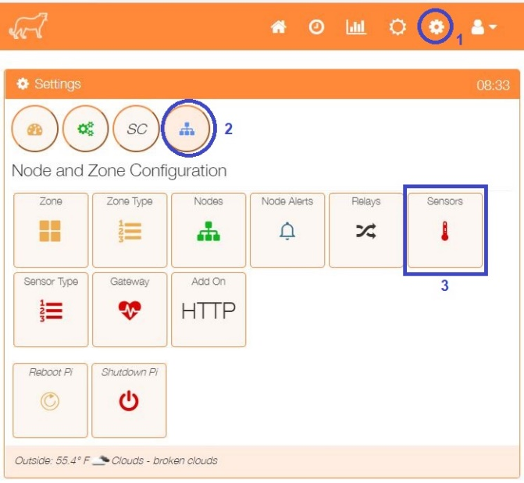

Select the Sensors menu item from the Settings/Node and Zone Configuration menu to display a list of any currently configured sensors.

Click on the ‘Add Sensor’ button to configure the first sensor

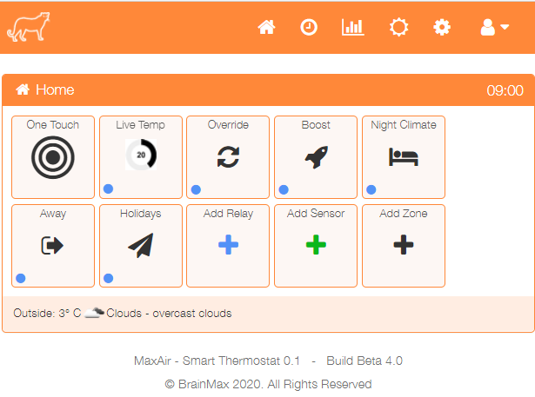

An alternative method to go directly to the Add Sensor dialogue, is from the Home screen click on the ‘One Touch’ button then select the ‘Add Sensor’ menu item.

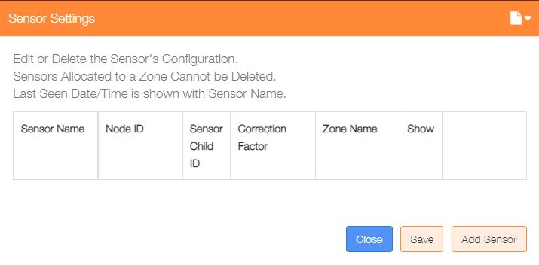

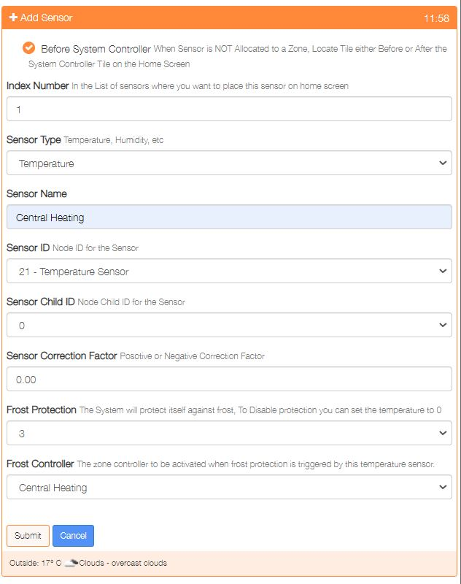

Show either before or after the system controller on the Home screen

Used to order where on the Home screen the sensor is displayed

Either Temperature or Humidity

Provide a name for this sensor device

Select the Sensor ID from the dropdown list of available Nodes

Choose the Child ID from the dropdown list, for nodes with only 1 sensor, this will be 0

Positive or Negative correction to be applied to the sensor reading. correction factor

Select the frost protection temperature or 0 to disable this feature

If frost protection is enabled, then select the zone to be activated on protection

Click on ‘Submit’ to add the device.

Repeat the process to add any other temperature sensors.

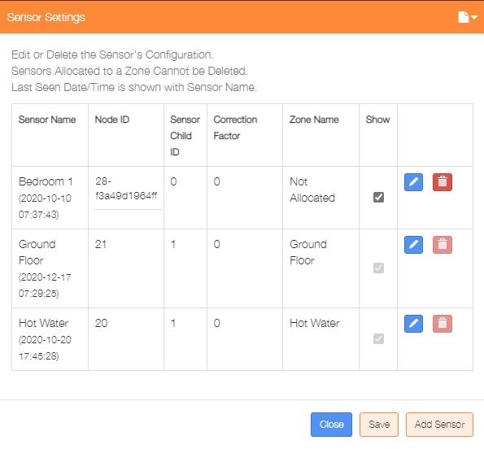Re-selecting the Sensors menu item from the Settings/Node and Zone Configuration menu will display the updated list of currently configured temperature sensors.

This dialogue can be used to Add/Delete/Edit the sensor configurations.

The ‘Show’ tickbox can be used suppress displaying a sensor on the Home screen, with the exception of any sensors allocated to a zone.

This example shows one unallocated and two allocated sensors.